PSA, Inc.

Wireless 9000

Desktop

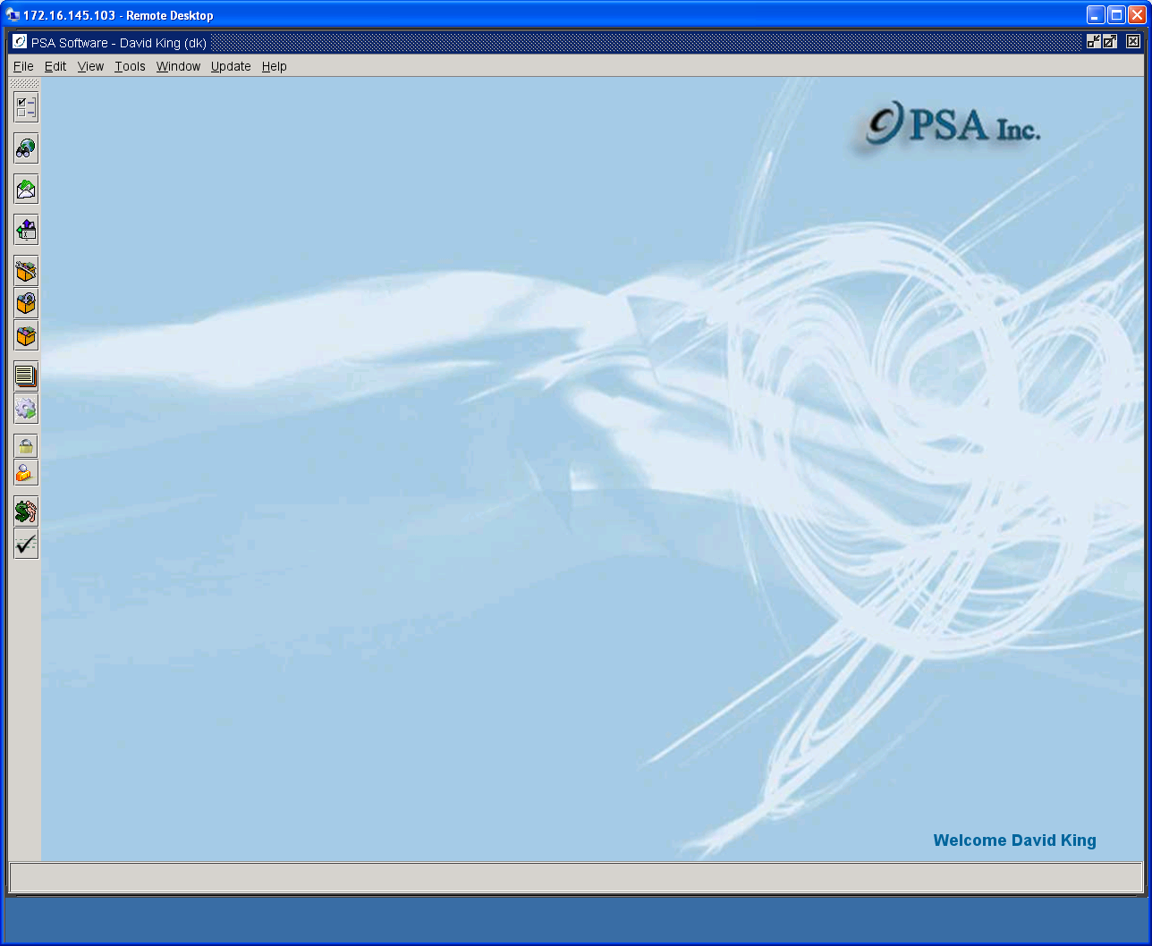

Customer Care

Point of Sale

Table of Contents
Information Search 6
Smart Search 6
Detail Search 9
Account Level Screen 11
Main Account Level Fields: 11
Alert Message Tab 12
Treatment Options Tab 12
Credit Card Information 13
ACH Information Tab 14
Prepay Information Tab 15
Bill Copy Information Tab 16
Print Options Tab 17
Miscellaneous Taxes Tab 19
User Defined Fields Tab 20
Service Level Screen 21
Main Service Level Fields: 21
Move Service Number to Another Account 22
Manual Suspensions 25
Reconnect Functions 28
Disconnect Dialog 29
Change Disconnect Code 31
Disconnect with Installments 31
Dates Tab 33
Provisioning Numbers Tab 34
Print Options Tab 35
Marketing Information Tab 36
Miscellaneous Taxes Tab 37
Deposit Tab 38
Refund Deposit 38
Internet Tab 40
User Defined Service Level 41
Packages/Plans/Features 42
Package/Plans/Feature Screen 42
Rate Plan or Feature Changes 44
Ala Carte Items 52
Adding Ala Carte Items 52
Removing Ala Carte Items 55
Establishing the Primary MDN for Corporate Plans 59
Free Calling Group Setup 59
Adding Free Calling Numbers 60
Removing Free Calling Numbers 62
Reactivating Free Calling Number 64
Reports 65
Account Summary Report 66
Account Receivable History 67
Account/Service Item Summary 68
Adjustments Report 69
Bill History Summary Report 70
Bill Image Report 71
Billed Effects to Account 72
Change History 73
Comment Report 74
Credit Card Response History 75
Current Call Report 76
Current Call and Data Summary Report 81
Current Contract 83
Create ‘New’ Contract 84
Data Usage Report 86
ESN History 91
Free Numbers/Calling Group 92
IMEI History 93
Item Summary – All Services for Account 94
Transaction History 95
Payments – All Dates 96
Payments – Last 60 Days 96
Provisioning Results 97
Re-Rate Inquiry Report 98
Sales Report 99
Sales Return Report 100
Status – Blackberry Services 101
Transaction History – All Dates 102
Transaction History – Last 60 Days 102
Transaction Summary 103
Write Off Inquiry 104
Various Switch Reports 105
Comments 106
Documents Tab 108
View Post Bills 109
View Invoices 110
View Contracts 111
Account Level PDF’s 112
Service Level PDF’s 113
CPNI Tab 114
New Activations, Add-On Customers, Number Changes 116
Adding a New Customer 116
Credit Checking (optional) 117
Insert Screen 124
CDMA provisioning type: 127
GSM Provisioning Type 129
Internet Provisioning Type 130
Port-In Provisioning Type 130
Address Validation (optional) 132
Linking Phones For Minutes/Data Sharing 138
Pending Service Orders model 141
Add a Phone 143
Edit Provisioning Options 145
MDN/MIN/IMSI Change 146
Rate Plan Changes and Linking 146
Linking Outside New, Add a Phone, or Edit Provisioning 149
Unlinking Phones 151
Adding Bonus Certificates 152
Point of Sale/Cash Drawer 153
Purchases 153
Serialized Items 154
Serialized Items on Installments 157
Collecting Monies for Transactions 161
Payments 168
Payments on Monthly Charges 168
Payments Against the Principal on Installments (with optional installments module) 169
Adjustments 170
Writing Off Account 171
Writing Off Installment Balance 171
Creating a Deposit on Account 171
Service Items 172
Returns 172
Returns for Entire Invoice 176
Walk-In Point of Sale 183
Drawer Balancing 184
Overrides 198
User Information/Password Maintenance 205
Appendix A 207

Information Search

Click on the Customer Administration icon on the left toolbar.

Smart Search

The smart search will return values for various types of criteria. Currently these consist of Customer Last Name, First Name, Service Number, Account Number, and Social Security Number. The red description to the right of the search field will show the search pattern, where ‘%’ is any variable.

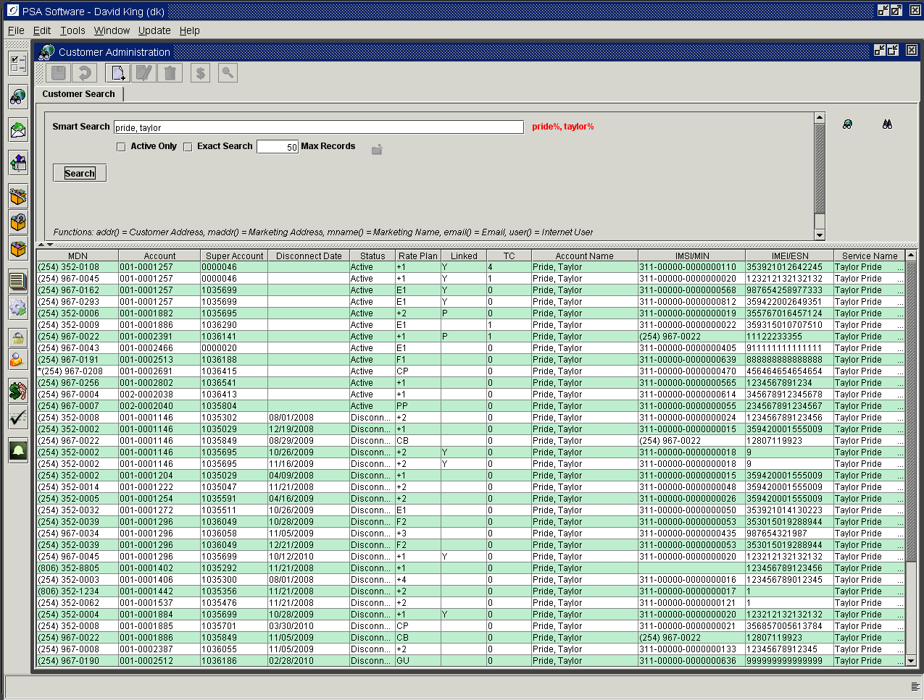

Last Name search: Hick - will return Hicks, Hickson, Hickman, etc. If you want to only find Hick without the variables, then you can check the Exact Search Box. This will only return ‘Hick’.
Exact search works only with name fields.
Last Name, First Name search: Hicks, Bill - Unless the exact search is on, this could return Bill Hicks, Billy Hicks, Bill Hickson, etc. The search is defined Hicks%, Bill%. Additionally you can search Hicks, B; which would pick up Bill or Billy.
Service Number/MDN search: The data can be entered in multiple formats – (806) 358-8928, 806-358-8928, 8603598928, 806 358 8928.
Account Number search: The formats for account numbers are 1-2568741, 001-2568741, or 2568741. Valid searches for the number 016-0000012 would be 016-0000012, 16-0000012, 16-12 or 12.
Social Security Number search: Formats for social security number – 123456789 or 123-45-6789.
Super Account Number search: To search super account number you must put an ‘S’ at the beginning of the number. S1238876
IMSI search: Search formats are 123-45678-1234567891 or 123456781234567891.
IMEI search: The format is 15 characters, enter leading zero if necessary. 010824001778142
Marketing Name search: Requires a format to return values – mname(Amy Adams). The fields in the ( ) are not case sensitive.
Marketing Address search: Requires a format to return values – maddr(123 Tobacco Road) or maddr(123 Tob) for wider search would return 123 Tobacco Court, 123 Tobacco Road, 123 Tobacco Lane, etc. or maddr(123) would return any marketing address with 123 anywhere in the address. A more complete/accurate address will return a closer match.
Billing Address search: Requires a format to return values – addr (123 Tobacco Road). This works the same as marketing address.
Internet User ID search: Requires a format to return values – user(amya@psasoft.com). This field is displayed on the Service Screen.
Primary Email Address: Requires a format to return values – email(amy@psasoft.com). This field is displayed on the Account Screen.

Additional Selection Criteria:

Active Only: Displays only active services in the sub list. This box will retain the selection until the user manually changes the check box.
Exact Search: If you only want exact matches returned on the Name search, select this box. For example, when the box is un-checked, Simpson, Billy will return Simpson, Bill and Simpson Billy. If the box is checked, then only Simpson, Billy will be returned.
Max Results: This number determines the number of records that will be returned in the search sub list. The higher this number, the slower the return response time. Fifty records is the default. If you have a customer that has 78 active service records and you would like to see all those, change the number to around 100-125. Remember disconnect records will be included unless you check the Active Only. If you use the Active Only, you could select 78.

Column Headings on the Search Results page

MDN – Service number, you may see one or all of these designations following in the MDN:
D – will be present if the number has a deposit on record,
R – indicates that this number is the MDN of Record, where all CPNI, Bill Ready, Payment Post, and Usage notifications will be sent,
P – if the service is linked to several other services (all with corporate rate plans), the service number that will receive the primary charge will have the P designation. (This is set on the rate plan screen for the number that will carry the primary plan charge.)
Account Number – Cycle number and Account Number. Phones with the same account number appear on the same bill.
Super Account Number –Phones with the same super account number are linked to share minutes.
Disconnect Date- Disconnect date for disconnected MDN’s.
Status – A = Active, D = Disconnected, N = Suspended for NonPay, S = Manually suspended, W = Write off, C = Collections, W = only WAP Suspended in conjunction with Advance Pay Module.
Rate Plan – last two characters of the plan designation.
Linked - ‘Y’ shows if the service is tied to another service number for minute sharing. ‘P’ indicates that this phone was previously linked to another phone during this billing cycle. This serves as a warning to re-link phones after a plan change. The ‘P’ is cleared once the account has been run through billing to either a blank or a Y.
TC – Ticket Count, shows the number of outstanding tickets for the service and a grand total of ALL tickets on the account – active or cleared.
Full Name - Customer full name.
IMSI/MIN- Displays IMSI if GSM service, MIN if CDMA.
ESN/IMEI – Displays ESN if CDMA service, IMEI if GSM.
Service Name - Used to identify a Customer for Internet Billing.

Detail Search

Allows for targeted, more specific searches. Click the Binoculars icon at the right of the screen.

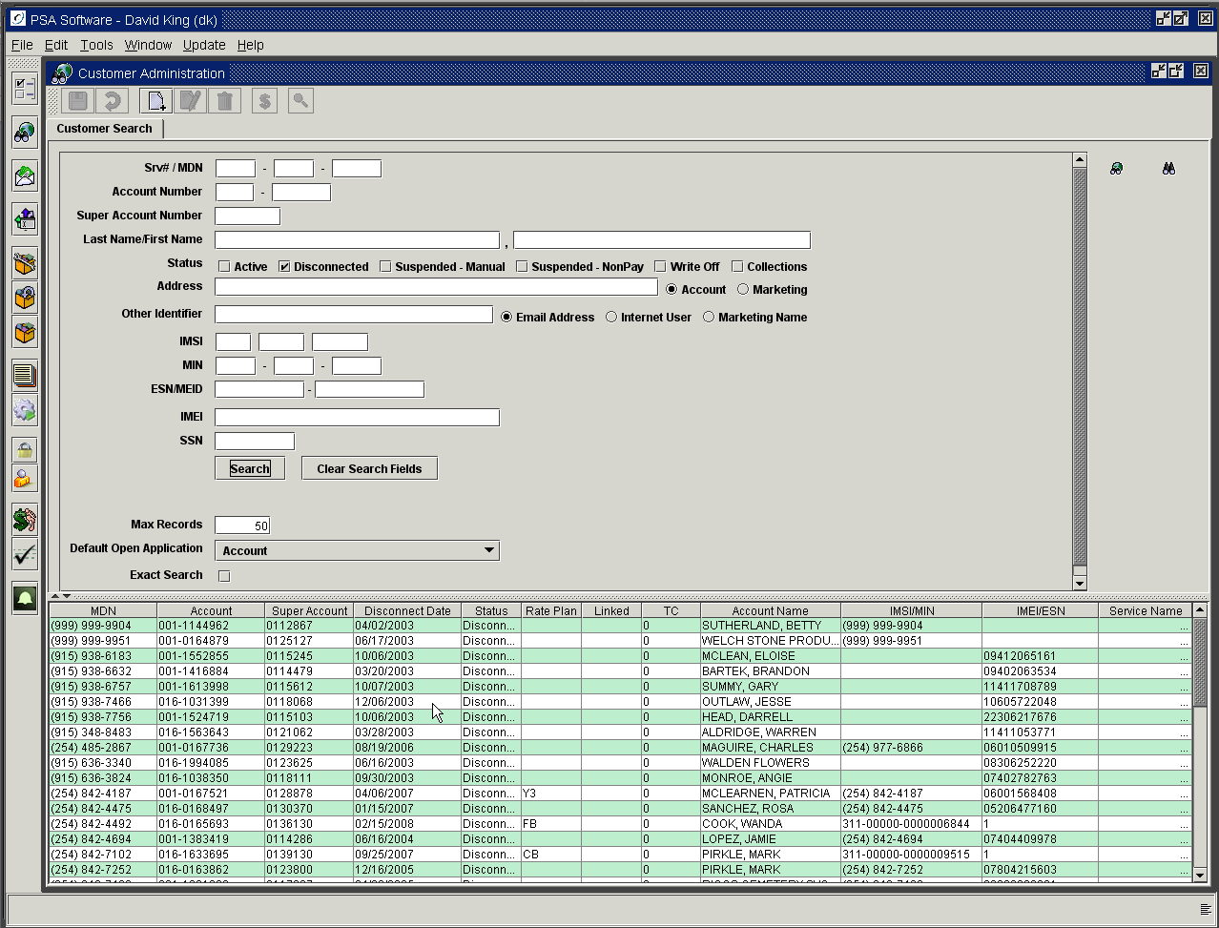

You will enter the search criteria in the appropriate field and press the Search button. Clear Search Fields removes all entries in the search boxes.

Status: Selecting a status type will only return the service records for that type. You may use this in conjunction with other search fields of if you want to see all instances, do not enter any search criteria and select a single status. If you want to see all Suspended – Non-Pay, do not enter any search criteria other than selecting the status. You will need to change the Max Records field to the expected number of returns. If you enter more 250, you should expect to wait several minutes to complete the search and return the results. If you need this information on a regular basis, ask PSA to create a report in order to get the information in a more timely fashion.

  - Active – returns only active services
  - Disconnected – returns only disconnected accounts
  - Suspended Manual – returns manually suspended accounts
  - Suspended Non-Pay – returns all suspended accounts created by the Customer Treatment process.
  - Write Off – returns only written off accounts
  - Collections – if you use a collection process, you can search for only those accounts.

Max Results: This number determines the number of records that will be returned in the search sub list. The higher this number, the slower the response time. Fifty records is the default. If you have a customer that has 78 active service records and you would like to see all those, change the number to around 200. Remember disconnect records will be included unless you check the Active Only. If you use the Active Only you could select 78.

Default Open Application: This dropdown box contains options on what screen or report will display when the account is opened. This selection can be changed by the individual user and remains at that setting until changed by the user at a subsequent time.
None: displays only the tabs upon selection of record from the list.
Account: opens the Account Level tab.
Service: opens the Service Level tab.
Account Summary: opens the Account Summary Report under the Reports tab.
Exact Search: If you only want exact matches returned on the Name fields, select this box. Ex: When the box is un-checked, Simpson, Billy will return Simpson, Bill and Simpson Billy. If the box is checked, then only Simpson, Billy will be returned.

To open the service number, double-click the line in the return results list.

Account Level Screen
Fields can in many cases become required fields determined by your individual company. Some fields can be defaulted by company settings.

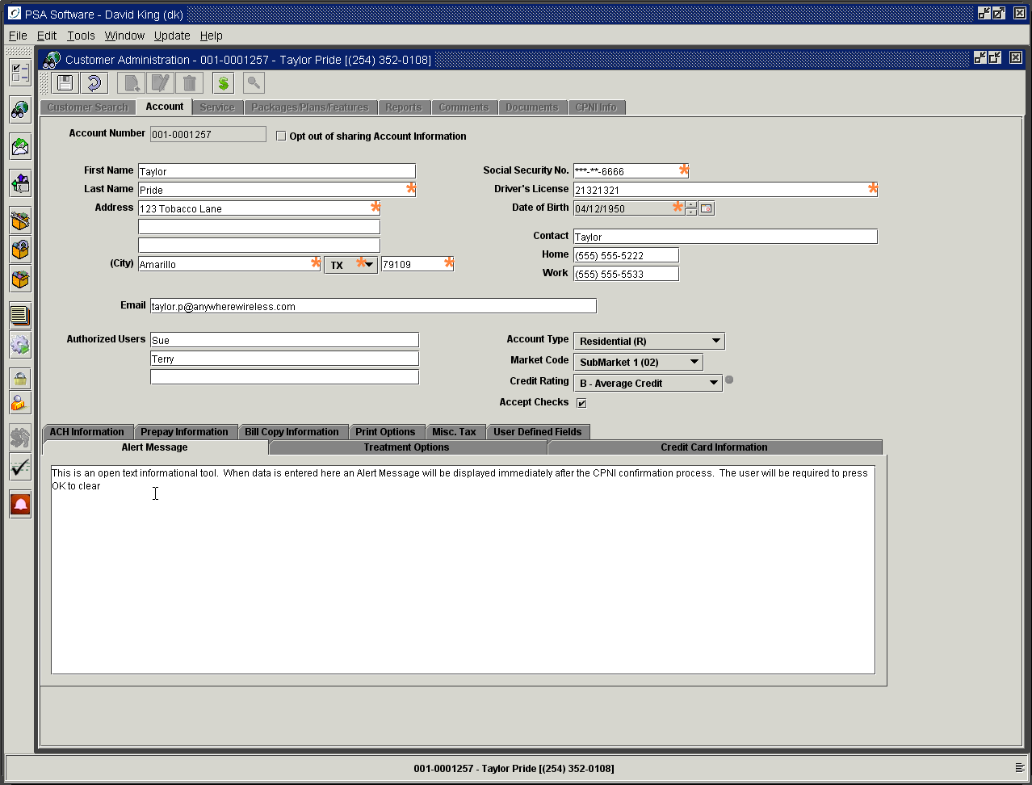

Main Account Level Fields:

Account Number: a combination of the cycle number and a unique 7-digit number.
Opt out of sharing Account Information: check box: determines whether or not the customer wants your company to share or use the information on the account for marketing purposes. If checked, your company should keep the information private.
First Name, Last Name, Address lines 1-3, City, State, and Zip: composes the primary billing address. City and State can be defaulted by Zip Code. If this is a corporate account, put the full company name in the Last Name field. An ‘In care of’ specification would be entered on the first address line.
Social Security Number: this will display according to authority level after initial entry. Secure formats include last four numbers, all numbers or no display of number.
Driver’s License number: company optional field.
Date of Birth: must be entered through the calendar icon.
Contact Name: would be the person associated with the account that is responsible for managing this account.
Home and Work numbers: additional contact points that can be used for personal or corporate accounts.
Email: can be used for multiple purposes. If your company chooses to use email as a valid form of CPNI change notification, the program will use this address for notification of changes on the account. In post paid, this is also used in conjunction with Print Electronic Bill. If the electronic bill flag is set to yes, this is the address that will receive the notification that their bill is ready to be viewed on line.
Authorized Users: determined by the primary contact on the account, usually at initial activation and determines who may make changes on the account. This can be altered later if required.
Account Type: creates a flag to separate types of accounts for reporting purposes. (I.E. Residential, Commercial, Municipal, etc.) Your company can define the types needed in your market.
Market Code drop-down box: provides selection of market if your company has separate marketing areas in your service area.
Credit Rating: a scale set by the individual company. Your company will provide business rules relating to the credit rating.
Accept Checks: When checked, the option to pay by check is activated in the Point of Sale screen. Unless this is checked, the option for checks is not active.

Alert Message Tab

When information is entered in this area, an alert message is created. When a customer is selected from the search screen, a pop-up box with this comment will display immediately after closing the CPNI information pop-up and prior to opening the first screen from the original search screen. The alert box will require the user to press OK to close the box indicating that the user did have the chance to review the information. This should be used to provide information deemed crucial to servicing this particular customer.

Treatment Options Tab
Normally these values are defaults and should only be changed by supervisory permission.
Send Reminder (Y/N): Determines if the customer is to receive past due reminders.
Reminder Type: Sets the type of reminder to be sent. Your company may have reminders specific to individual accounts vs. corporate accounts vs. municipal accounts.
Past Due Treatment: This determines when the customer is first considered past due.
Charge Interest Past Due: This determines if the customer will be charged late fees.

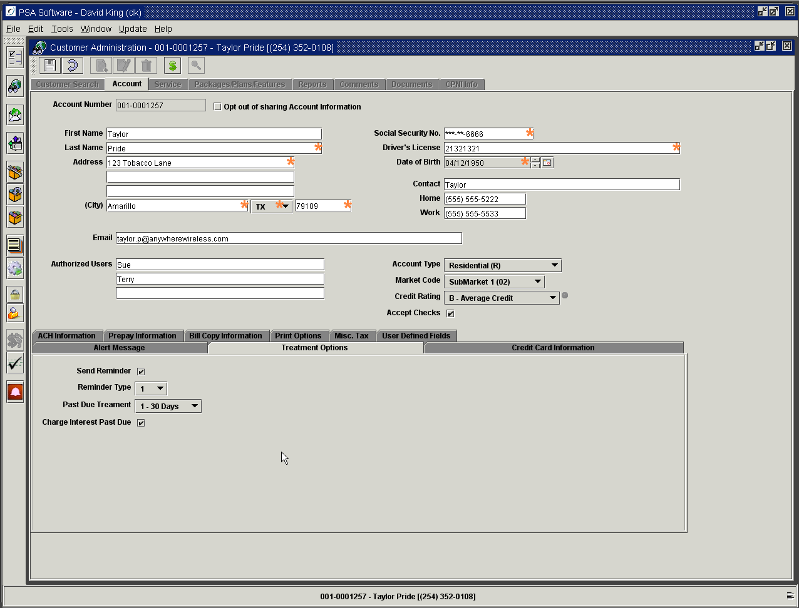

Credit Card Information
If the customer requests to pay his monthly statement automatically via credit card, this tab captures all the information for the transaction.

Check the Bill To Credit Card Box. Information will be submitted to credit card vendor for tokenization. If you un-check the Bill To box after initial install the token will be deleted and a new token created. The credit card information will be cleared and the word ‘Token’ will appear on the tab with the type of card and the last four digits of the card. The expiration date will remain for review as needed.

Name on Credit Card: Exact name as displayed on the card.

Card Number: Enter the card number or scan via card reader.

Expiration Date: Select the expiration month and year; enter 01 for day.

Max Amount: Entering an amount here limits the amount to be charged to the credit card monthly. This can be helpful for those on a fixed income or people on a budget. If the balance on the statement is more than the collectable amount, the statement will show the payment by credit card and the remainder of the balance owed.

Credit Card Limit: Not used at this time.

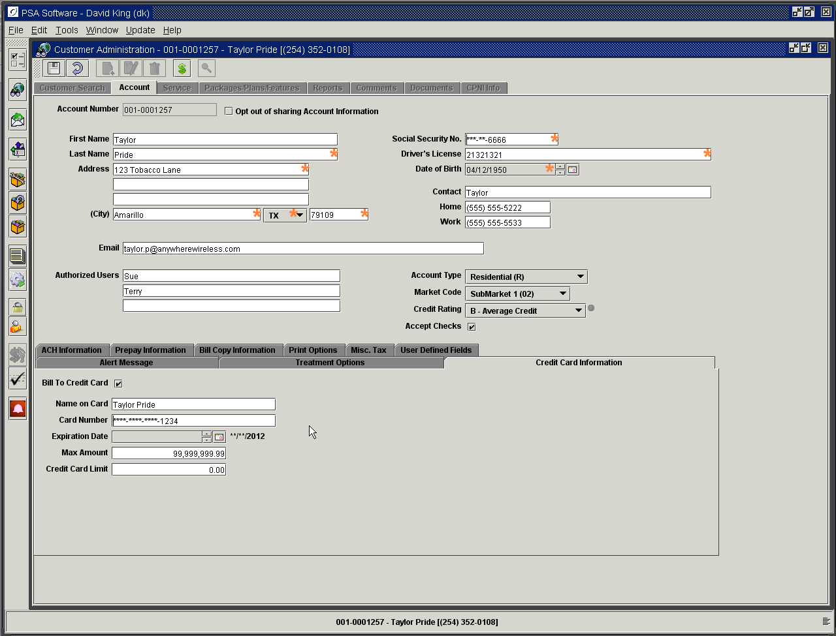

ACH Information Tab
Used if the customer wants to draft his checking or savings account monthly to pay for his service.

Check the Bill to ACH box. Information will be submitted to Authorize.net for tokenization. If you un-check the Bill To box after initial install the token will be deleted and a new token created. The account number and transit records will be cleared. Information will be cleared and the word ‘Token’ will appear on the tab with the last four digits of the account number.

Account Number: Enter the individual’s checking/savings account number.

Transit Number: Enter the customer’s bank routing number.

Max Amount: Entering an amount here limits the amount to be charged to the checking/savings account monthly. This can be helpful for those on fixed incomes budgets. If the balance on the statement is more than the collectable amount, the statement will show the payment by check and the remainder of the balance owed.

Checking Account: Mark this box if this is a checking account. Leave the box blank for other types of accounts.

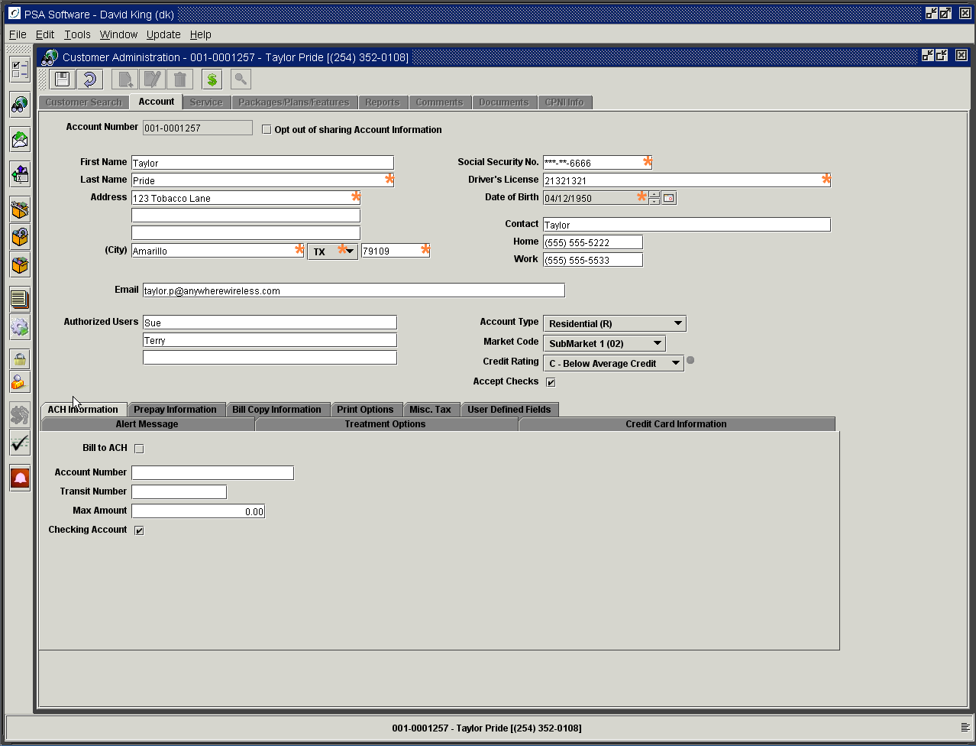

Prepay Information Tab
Only if you are using the PSA Local Prepay Only module, will you need to provide entries on this tab. If your company is not offering prepaid services, then this tab will not exist.

Prepaid account: This box must be checked for all prepaid accounts.
Prepay Due Date: This is the date that the prepaid plan must be renewed. On ‘New’ install this date will be defaulted to the effective date plus the number of days selected by Prepay Renewal Days field. The calendar is not functional to set the due date. To change the due date, you will need to use the Prepay Renewal Days field.
Prepay Renewal Days: Allows you to choose the length of the prepay period. Period lengths can be added under Prepaid Valid Renewal Controls. During a ‘New’ install the period will use the current date to determine the due date. When edit provisioning is used to change the due date, the effective date set at the beginning of the edit will be used for date calculation. The blue arrow will move the Prepay Due Date by the number of days in the Prepay Renewal Days field. On a ‘New’ customer insert, the Prepay Due Date will automatically be moved forward one cycle. If the customer wants to pay for two- 28-day periods, press the blue arrow.
Automatic bank drafts and credit card charges can be set up for prepaid accounts. To do this, click on either the ACH Information tab or the Credit Card Information tab and fill in the customer’s information.

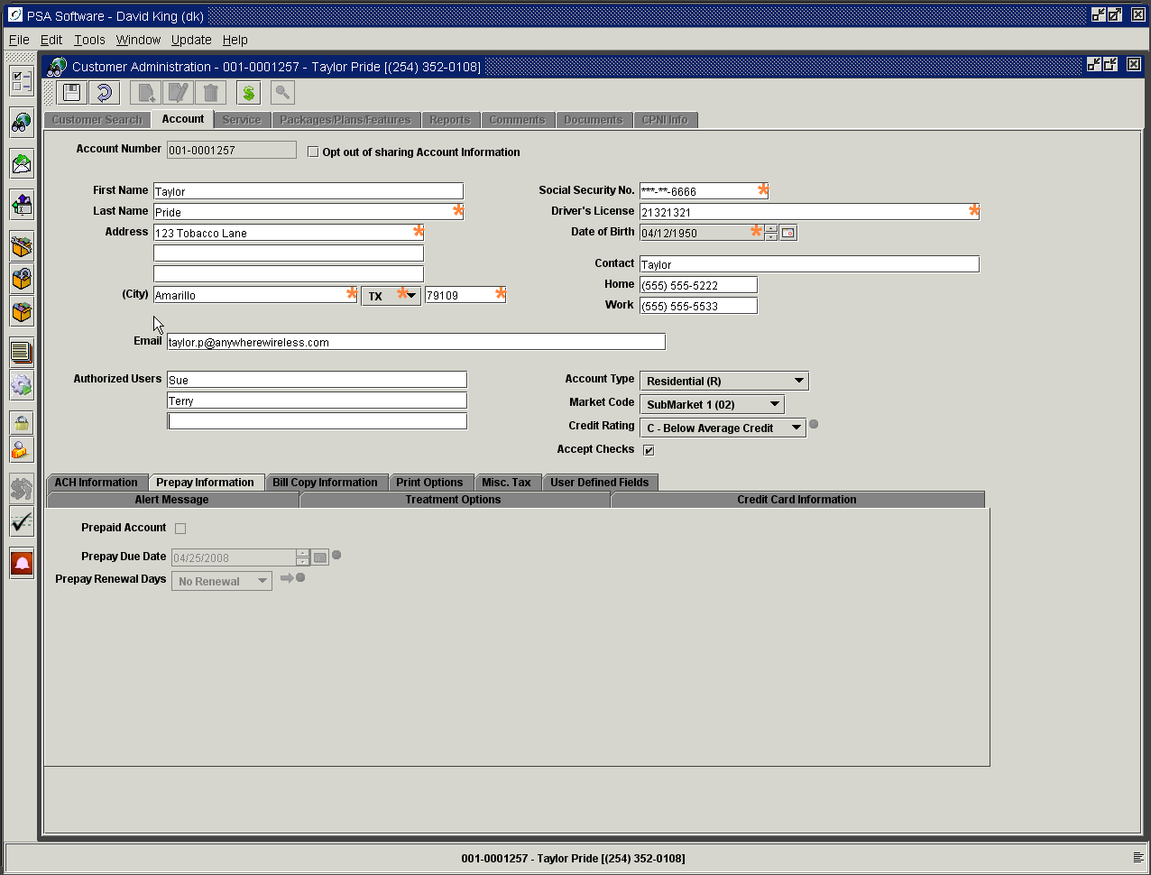

Bill Copy Information Tab
Add more addresses when multiple copies of a bill need to be printed for an account.

Select the ‘New’ icon inside the tab to create an additional address.
Use the Trash Can icon to delete an address no longer needed.

Sequence: As you add ‘New’ addresses to the file, a sequence number will be created for the address.

Enter the Name, Address, City, State and Zip Code.
Enter the Email address if needed.

Place a check in the box if the statement should have Detail Print.

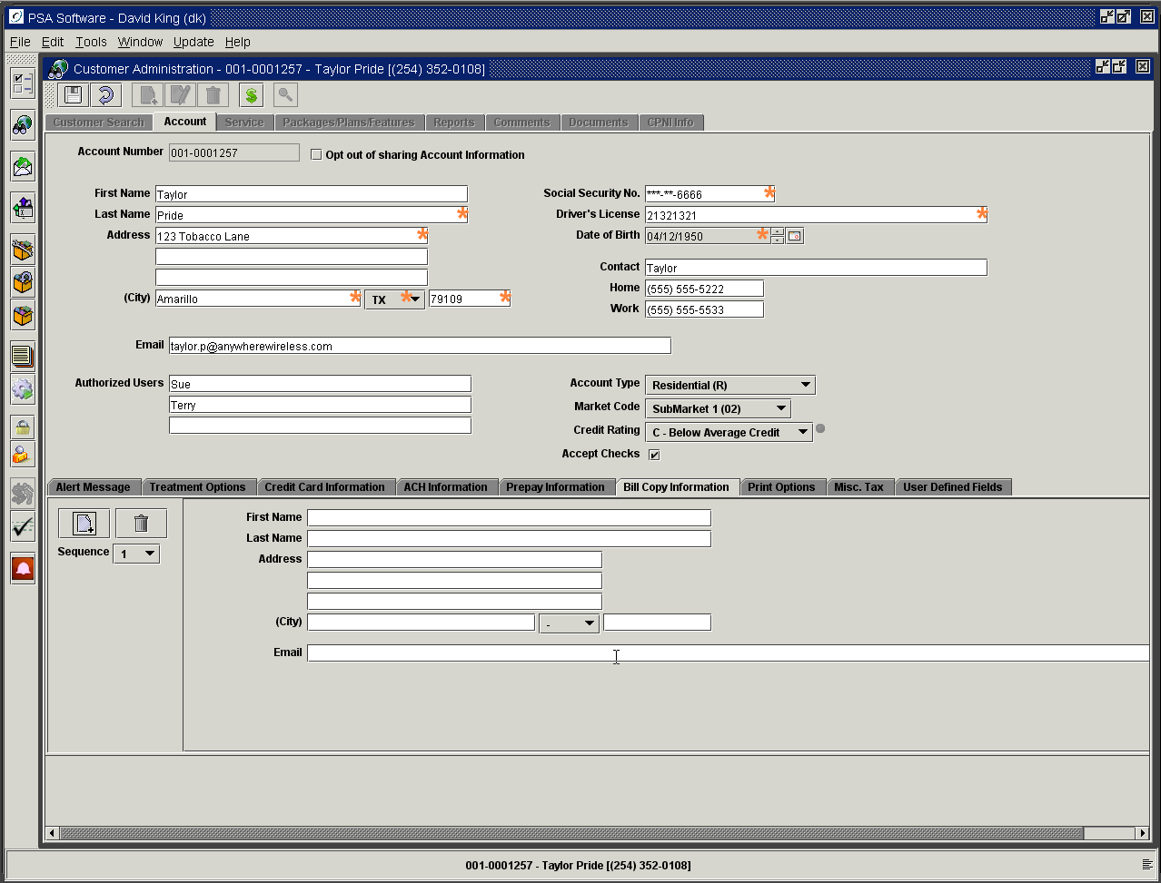

Print Options Tab
Determines the format of a paper statement and/or electronic bill.

Print Bill: Establishes that a paper bill should be created and mailed.
Do Not Print Bill: No paper bill should be printed.
Pull Bill: This option creates a paper bill. But instead of mailing the statement to the customer, the bill is mailed to your company for review and subsequent mailing.
Send Electronic Bill: This sends an email message to the customer saying the statement is available to be viewed/ printed from your website.
No Electronic Bill: No message will be sent.
Reseller: Includes this customer in a file to be sent to a reseller such as TracFone.
Print Caller ID: If marked the detail call records (if selected) will show the incoming or calling number.
Do Not Print Caller ID: Restricts printing of caller ID.

Print Bill and Send Electronic Bill are mutually exclusive flags; both may be on but both can’t be off.

The following are from an optional module for notifications, not all companies will see these options.
Email Notification when a Bill has been prepared: Sends email to end-user when bills are loaded from print vendor.
SMS Notification when a Bill has been prepared: Sends SMS message when bills are loaded.
Email Notification when a Payment has been received: Sends email message whenever a payment is posted to this account.
SMS Notification when a Payment has been received: Sends SMS message when a payment is posted.
Email Notification on Airtime Usage over Threshold: Sends email to the email of record on the account screen when a threshold has been reached, applies to voice only.
SMS Notification on Airtime Usage over Threshold: Sends email to the MDN of Record on the account when a threshold has been reached, applies to voice only.
Email Notification on Data Usage over Threshold: Sends email to the email of record on the account screen when a threshold has been reached, applies to SMS and Data thresholds.
SMS Notification on Data Usage over Threshold: Sends email to the MDN of Record on the account when a threshold has been reached, applies to SMS and Data thresholds.

The last two fields show the last notification date for either email or SMS notifications.

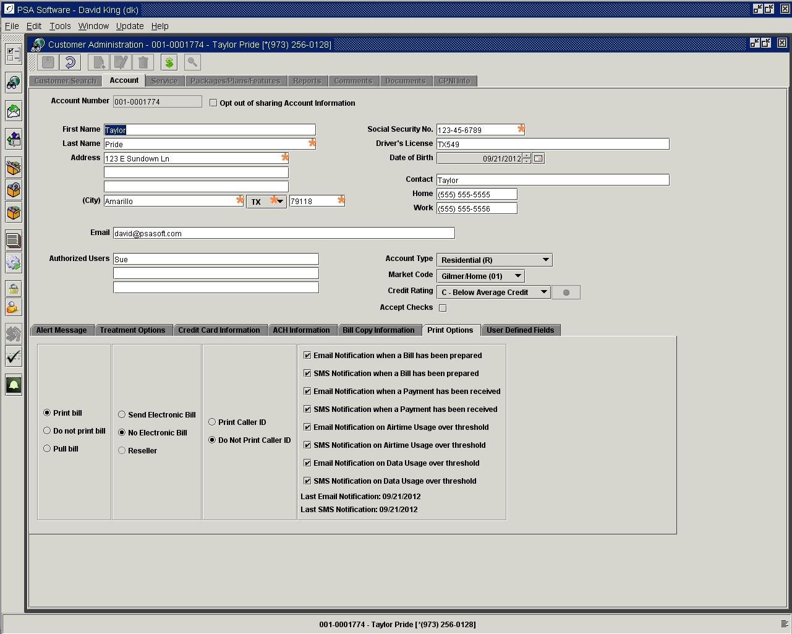

Miscellaneous Taxes Tab

These are miscellaneous surcharges established by your company. Most surcharges apply to the individual services so generally these will be defaulted to empty fields. PSA can default the miscellaneous surcharges per your company’s specifications; further changes by CSR should not be required. This account level tab will be available only when needed.

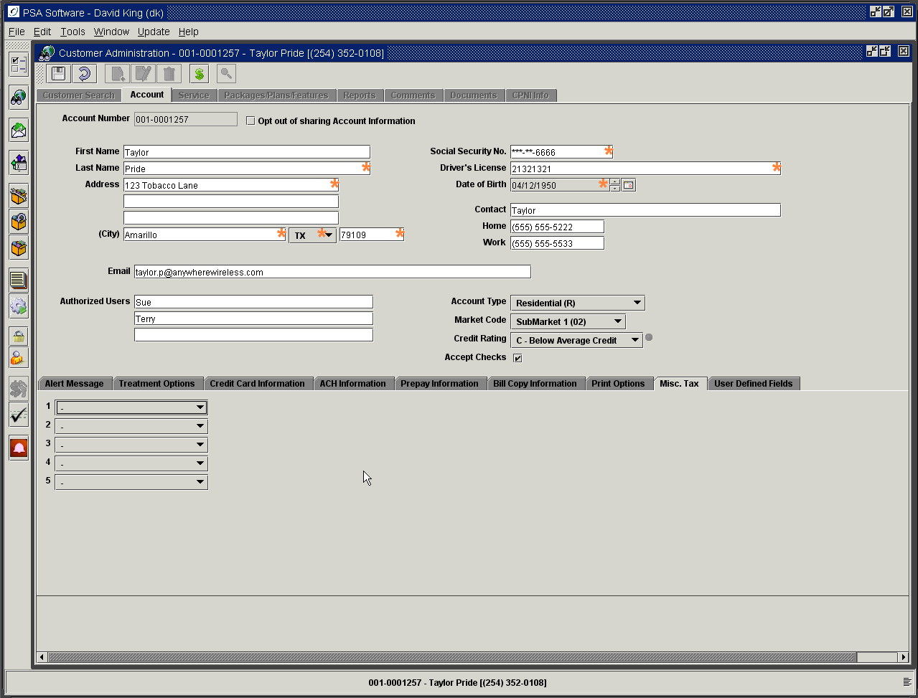

User Defined Fields Tab

These are user labeled fields for storing information not on the main screens. These fields can be created by someone with admin authority under Options>User Defined Fields. You will select whether the new field will display on the Account level screen or the Service level screen. The company defines the label, field type and length. Additional types of fields are: check boxes for yes or no answers, radio buttons for responding to yes or no questions, and date fields with active calendar.

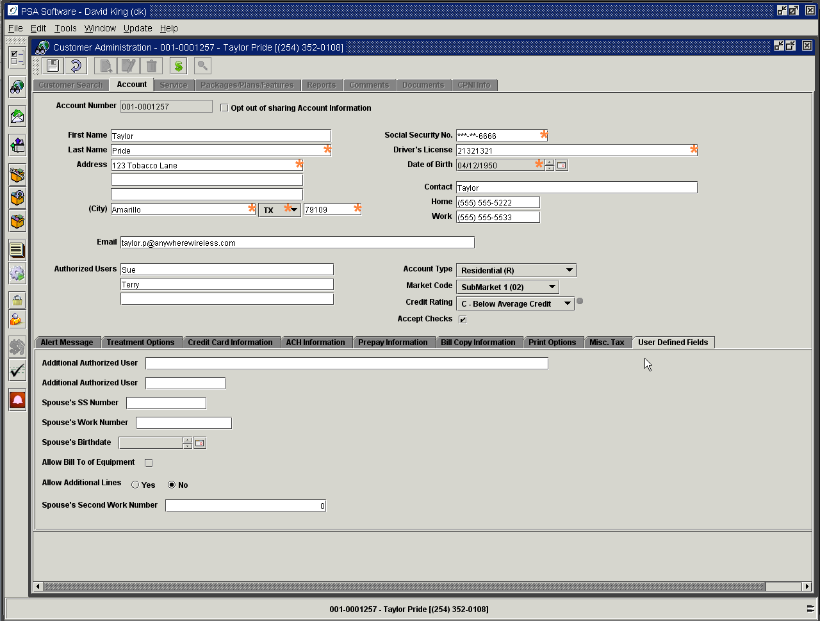

Service Level Screen
Information on this screen is specific to the individual phone.

Click on the Service tab at the top of the screen.

Main Service Level Fields:

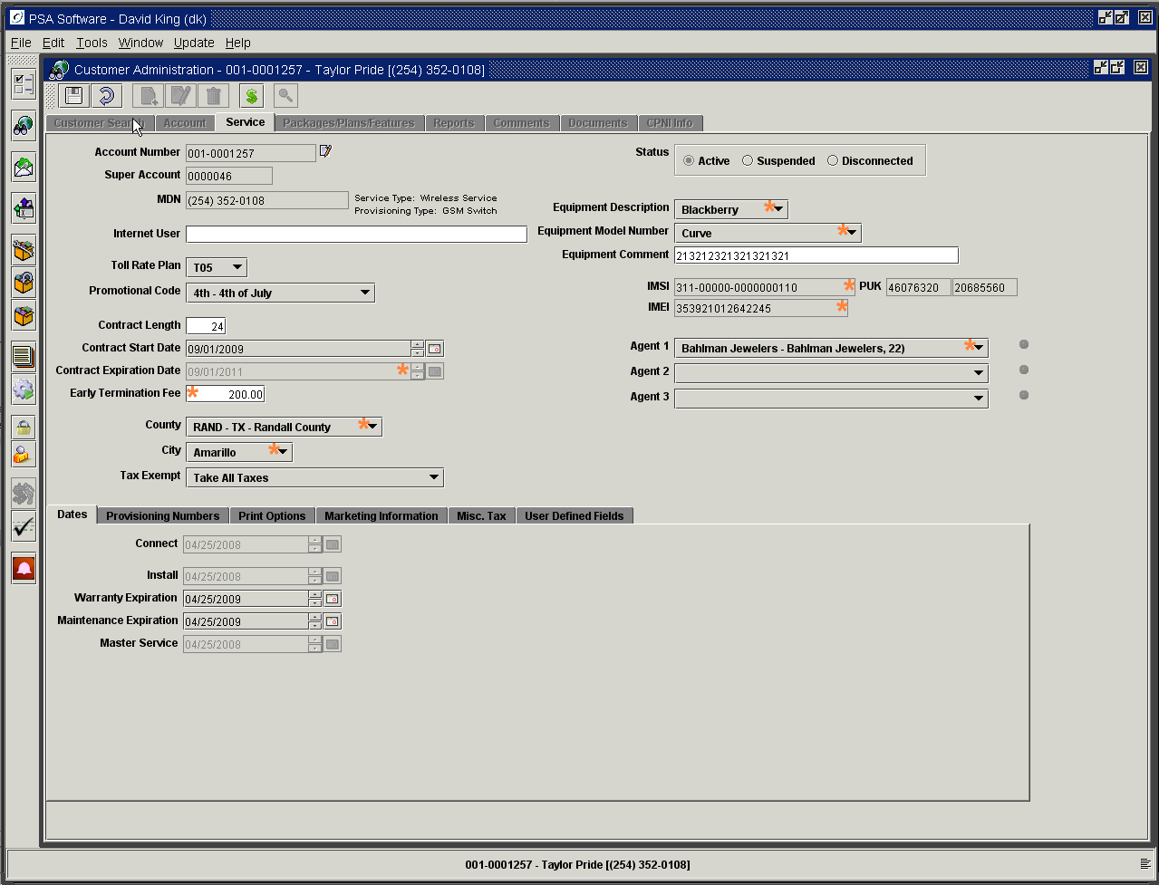

Account Number: The account number to which the phone is attached.
Move Service Number to Another Account icon: The icon next to the account number opens a dialog that allows you to move the service number and associated features to a ‘New’ or existing account.
Super Account Number: Displays either a unique number or a matching number from another phone. Phones having the same super account number are linked for sharing of minutes/data or for corporate rate plans. (Display only – the number is edited on the Insert screen)
MDN: Mobile Directory Number or Service Number. (Display only – the number is edited on the Insert screen).
Internet User Name: This field is used when billing Internet services via Wireless 9000.
Toll Rate Plan: If your company offers add-on toll rate plans to supplement rate plans, they will be listed in this drop down.
Promo Code: Select a promotional code when available. This code is a reporting item that can be used to report on the success/failure of promotions and/or gather additional marketing information. This field does not add the promotional discount to the customer’s account; it is for reporting purposes only.
Contract Length: Enter the length of the contract in months.
Contract Start Date: The day that the contract started.
Contract Expiration Date: This date will be calculated using the contract length and the contract start date. This is normally a required field and would be used to determine if early termination fees should apply.
Early Termination Fee: If your company has a set value for early termination penalty, that amount should be entered here. If you use a schedule, no entry is required.
County: This field is defaulted by the zip code field entered on the account level screen. Selected will be the county in which the service will primarily be used. This establishes the taxing authority for airtime, access fees, features, etc. but not Point of Sale transactions.
City: This field is defaulted by the zip code field entered on the account level screen. Selected will be the city in which the service will primarily be used. This establishes the taxing authority for airtime, access fees, features, etc. but not Point of Sale transactions.
Tax Exempt Status: If the subscriber is qualified for tax-exempt status, select the corresponding exemption from the drop down.
Equipment Description: Select the manufacturer of the handset being used in connection with the MDN.
Equipment Model Number: Select the model number of the handset.
Equipment Comment: This is an optional field that can be used for serialized equipment that IS NOT a handset. An example would be for Internet users who have a modem serial number.
MIN: Mobile Identification Number – (Display only – the number is edited on the Insert screen).
ESN/MEID: (Display only – the number is edited on the Insert screen).
IMSI: (Display only – the number is edited on the Insert screen).
IMEI: (Display only – the number is edited on the Insert screen)
PUK: Display only - This field displays the first PUK or reset code for GSM handsets.
Agent Number 1: Used for calculation and reporting on commissions.
Agent Number 2: Used if specified by your company.
Agent Number 3: Used if specified by your company.

Agents can vary in use from company to company. Agents are defined by type, although it is not visible on this screen. Agent types can be internal sales personnel, outside sales, dealers, servicing agents, etc. Commission calculations can be attached to agent types. Agent numbers are created and attached to a type. Your company will determine which of the three agent fields will be used and how they will be applied. One example: Agent 1 = Activating agent, Agent 2 = Servicing Agent, Agent 3 = Marketing agent.

Move Service Number to Another Account

Select the effective date for moving the service number when you begin the Edit on the Service screen. Press the icon immediately to the right of the Account Number field; this will open a new dialog box to move service to another account. You must determine if you want to create a ‘New’ account or move the service number to an existing account. If you choose the ‘New’ Customer Account Number option, all the information with the exception of the billing information will be copied over to the ‘New’ account number, which the application assigns, and displays in the cycle and account number fields. If the cycle needs to change you cannot use the Move function. You will need to disconnect the old number and create a new account from the beginning. Once you press OK, you will then move to the Account Level screen, where you will establish the ‘New’ billing information for the service number.

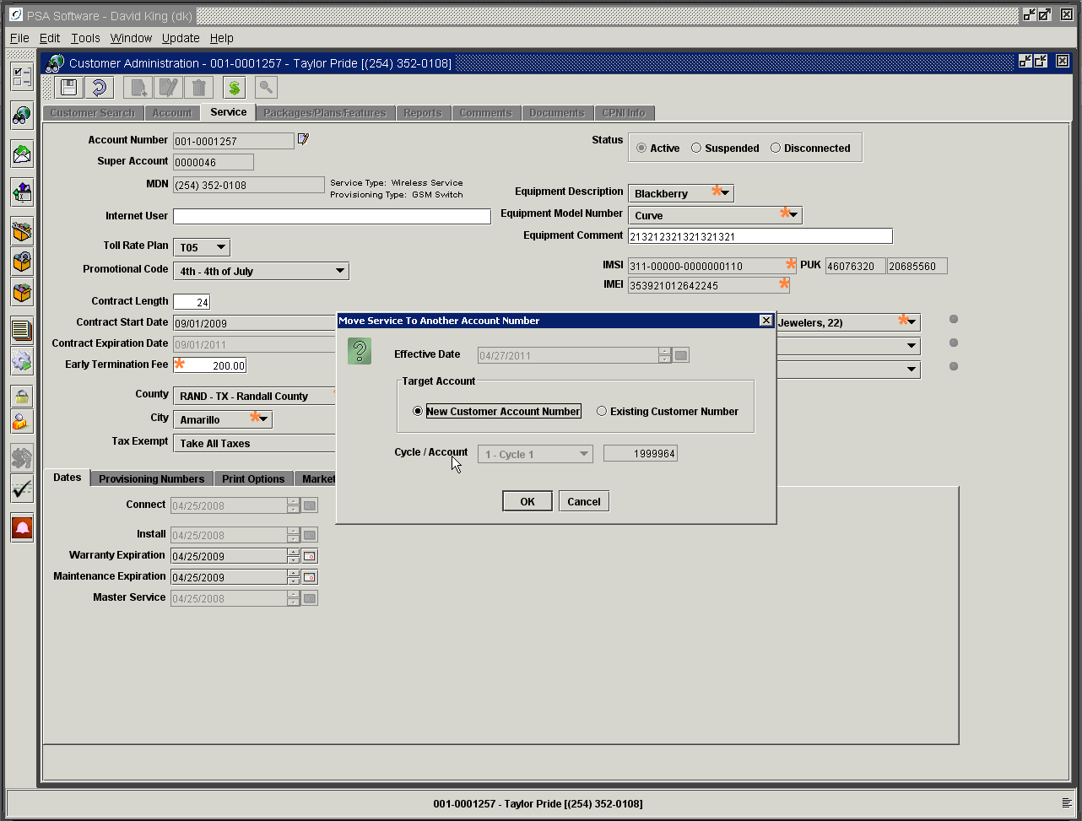

Prior to the copy you will get one opportunity to stop or proceed prior to the action.

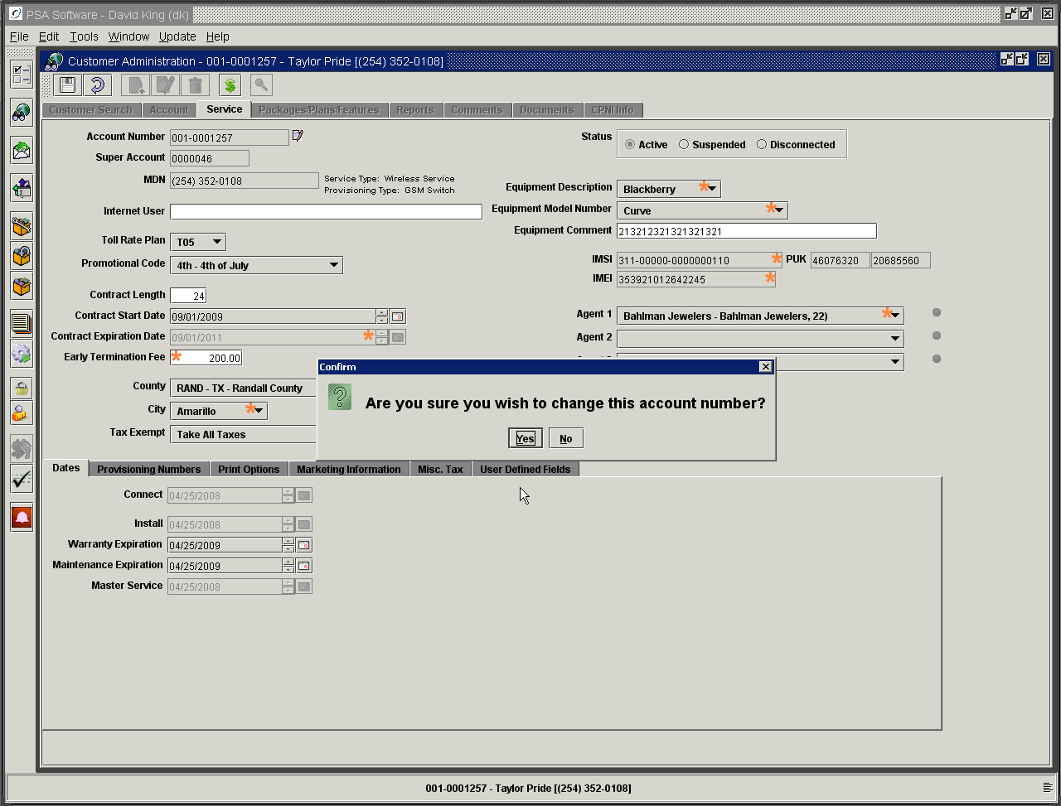

If you answer yes, a blank account level screen will be displayed.

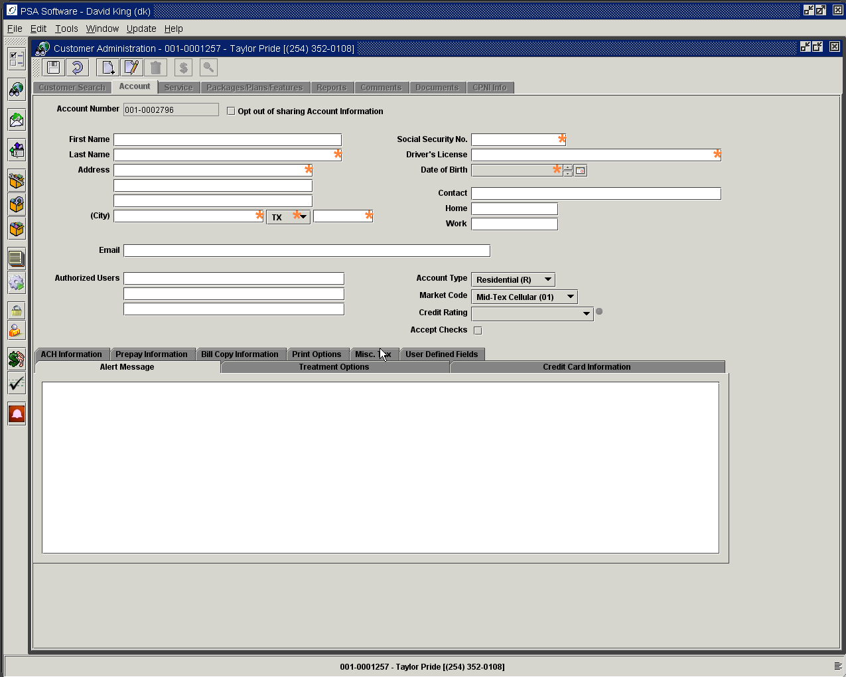

If you select Existing Account you are given a search screen to locate the account.

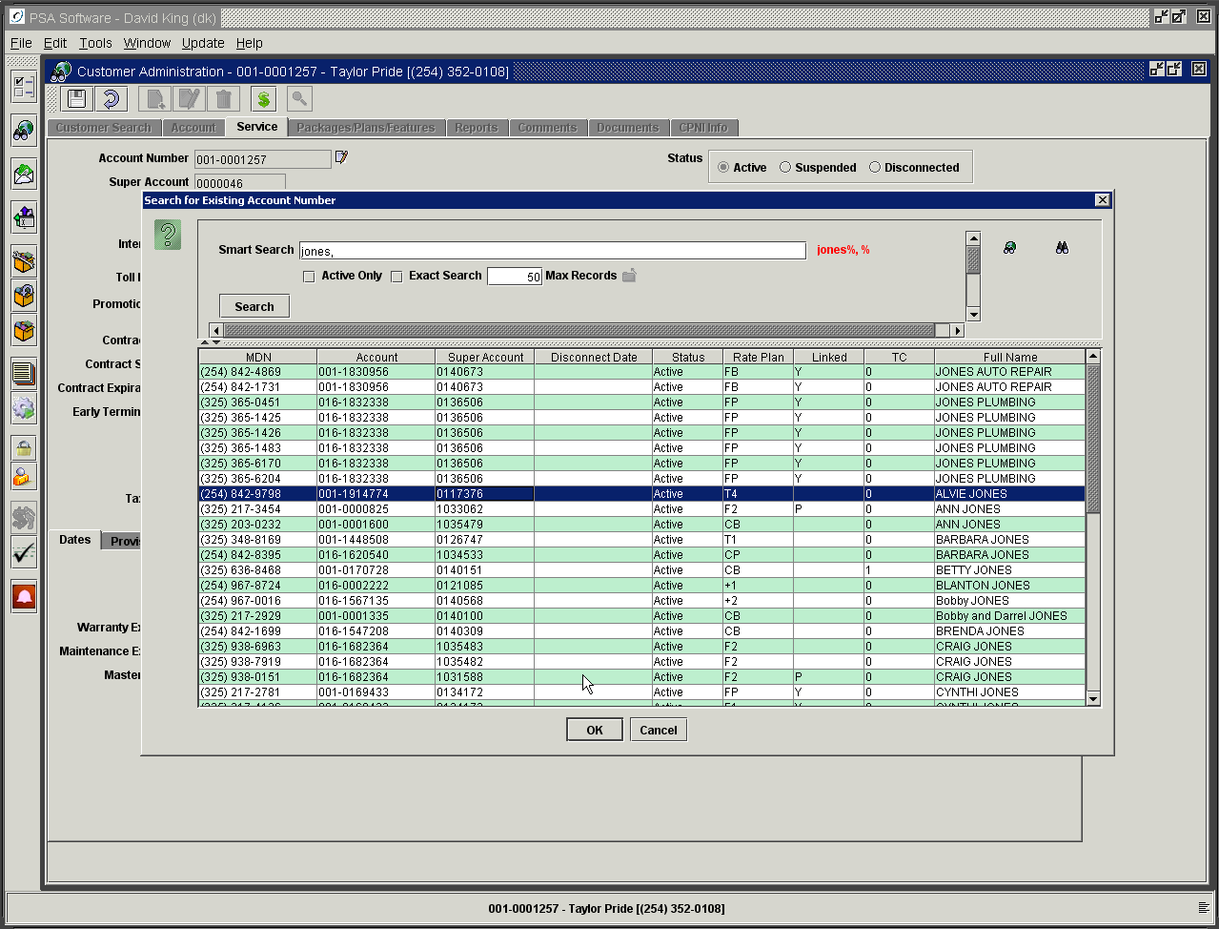

Enter any valid search criteria to locate the existing customer account to merge with the account. Highlight the account; press OK. You will be asked to confirm the move. This is your last opportunity to stop the move; pressing OK posts the information. The accounts will now be merged. As with as service order changes you will be asked to enter a comment after the move takes place. The application restricts the use of the Move function to one time per day per account. If you make a mistake and move the service to the wrong account you will have to wait until the next day or contact PSA to reverse the move.

Status- This bar not only shows current status on phone but also has additional functions attached to the radio buttons.

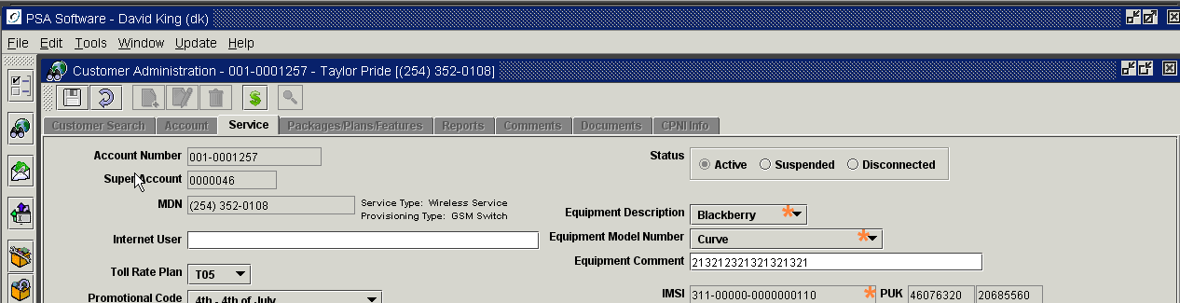

When the Active radio button is selected, the phone should be active in both billing and the switch.

When the Suspended button is marked, then the number could be suspended for two different reasons.
The first reason (Suspended – Manual) would be CSR intervention, where a phone needed to be temporarily turned off in the switch. An example would be a lost phone that was suspended to prevent unauthorized calls being made on the phone. To move the phone from this status back to Active, press Edit on the service screen. Then press the Reconnect Service icon (U-shaped arrow) and respond as needed. See full explanation under Reconnect topic later in the document.

The second reason (Suspended – NonPay) for the service being suspended is the customer has been suspended due to lack of payment by the system. NonPay suspension is not available within the Desktop application; this will remain an iSeries back office program for the near future. To reactivate the phone if it was suspended for non-pay, the customer must make a payment or you may force the reconnect using the Reconnect Service icon. Edit the service level screen, press the Reconnect Service icon and respond to the screens presented. Once a phone has been turned off in the switch and/or billing, its status will show Suspended.

Should the CSR need to disconnect this phone, they must first return the phone to Active status. Once the phone is Active once more, edit the service screen and select the Disconnect radio button. (See more under Disconnects)

Manual Suspensions

To manually suspend a service the user must have ‘Service Order – Allow Service Manual Suspend/Reactivate’ authority. This can suspend the service in the switch only or suspend both the billing and switch. This is an option on the suspension challenge screen. Manual suspends can be used for lost phones, holding a service number while the customer has left your market (a service man on a overseas tour or snowbirds), grounding teen agers, etc. All suspensions of phones occur immediately on Save; you cannot future date a suspension or disconnect.

Manual Suspend Switch Only – This option only suspends the ability to make/receive calls or use data features. These items continue to accumulate monthly reoccurring fees etc. The items will remain visible during the suspension.

To accomplish a manual suspension:
- Open Customer to Service Screen
- Press Edit and select the effective date
- Press Suspended radio button in the Status box
- At this point you will see a challenge question asking to confirm the suspension, ‘Are you sure you want to suspend this active service?’ Respond yes or no. If you choose No then a message will display saying the service was not suspended. Press Cancel to move to the next service order

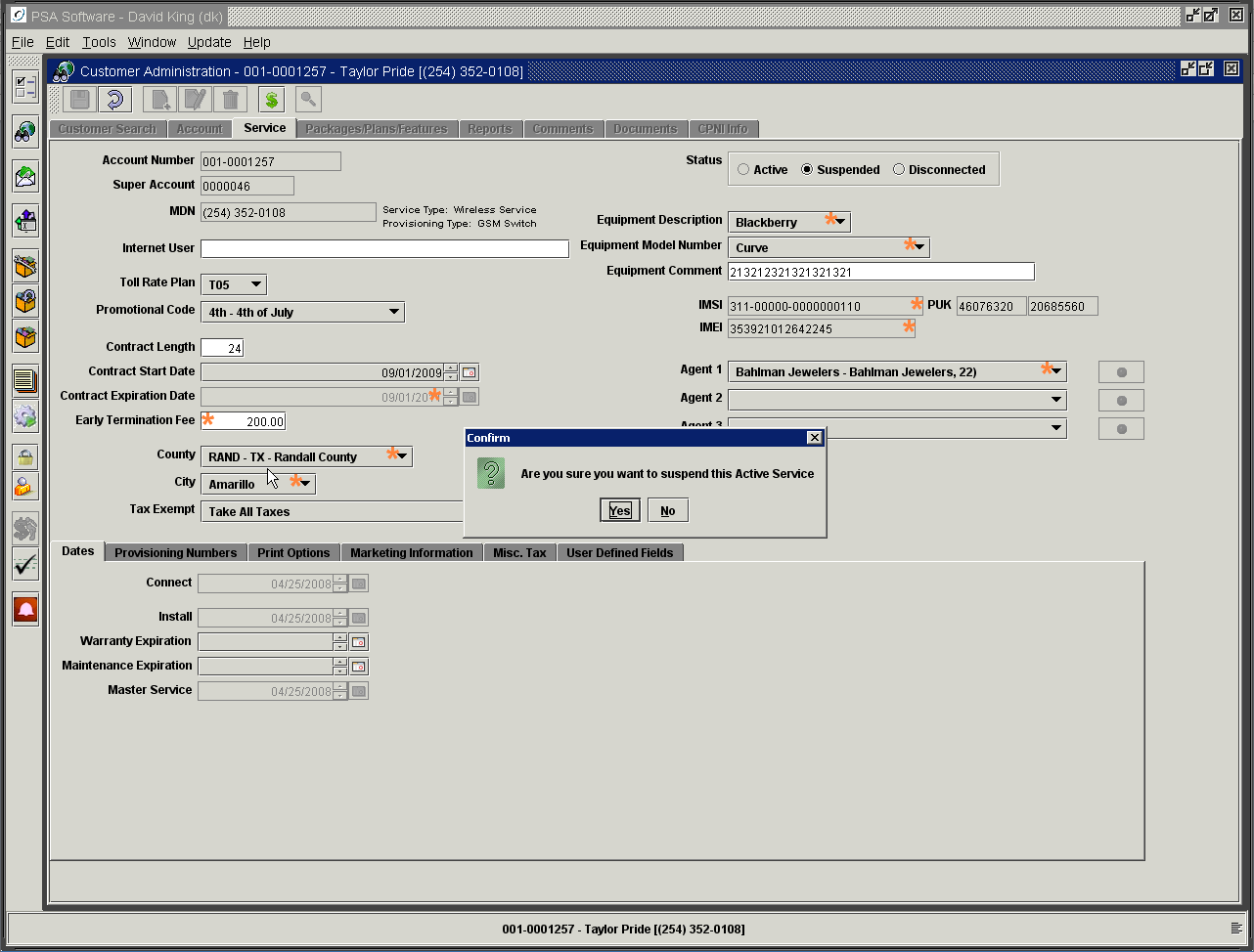

- Press Ok to suspend and then Press Save to post the order. As with all service orders you will be asked to enter a comment. Detailed comments could be very useful in suspension orders.
Manual Suspend Billing and Switch - If your company chooses this option that includes suspension of billing, then when the service is suspended the items will go into a Remove status. These items will be removed if the billing runs while the customer is suspended status. If you open a suspended customer after a billing the Package/Plan/Feature tab will be empty. However reconnecting the customer on a selected effective date during the current cycle will reinstate them. The items will come back in as Install items. These will change to On Hand after the next billing.

The suspension process is the same as a manual suspension with the exception of the challenge questions dialog box.
If the option selected includes billing, a second question will be in the popup, ‘Remove Item on Suspend?’ If you have the billing and switch option selected the default setting for the check box is checked. Where there is an exception, if you have the authority you may uncheck the box and not suspend the service in billing. If you don’t have the authority then there is an override red button immediately to the right where you can have someone with the higher authority override and change the setting. Once the flag is properly set for the service, press ‘Yes’. The service will now be suspended in both areas.

Complete the suspend order as you did on manual suspends.
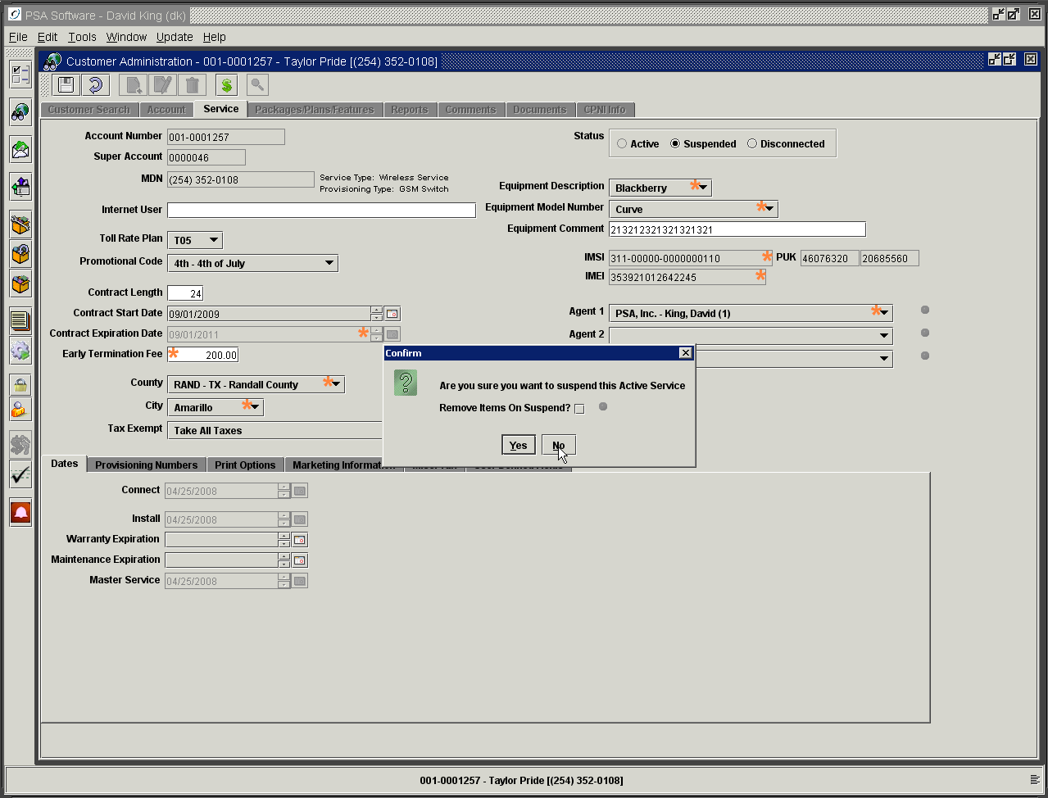

REMEMBER: This will immediately turn the service off in the switch and/or billing; there is no future dating of suspensions or disconnects.

The status on the initial search screen will now display as manually suspended.

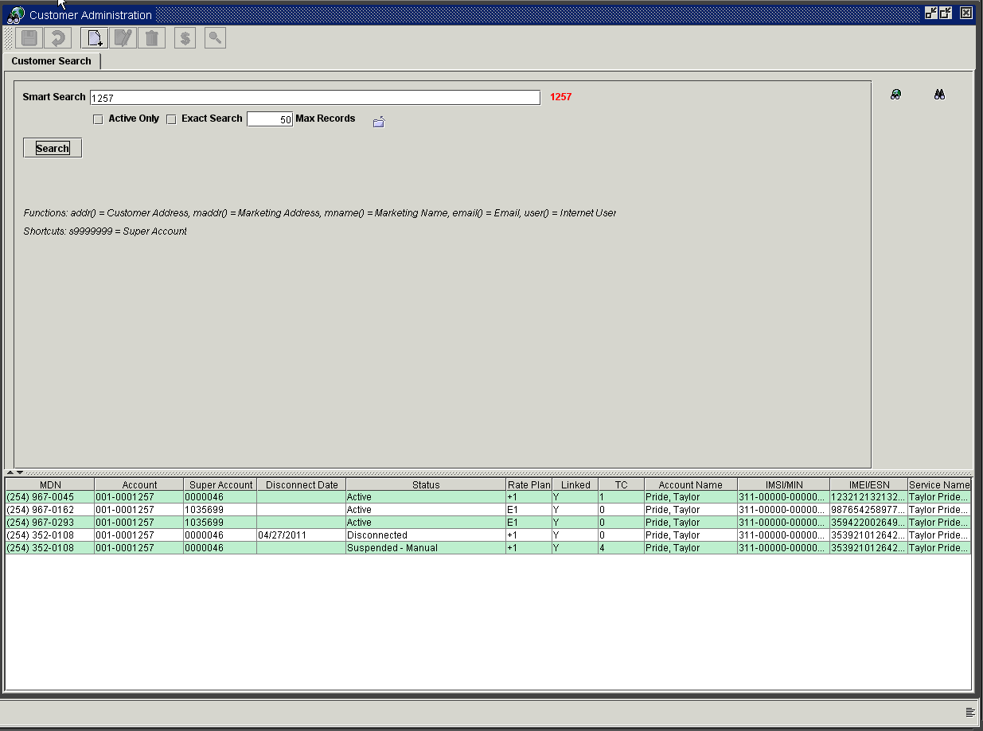

Reconnect Functions
Only if the status on the service number selected is ‘Suspended – Manual’ or ‘Suspended –NonPay’ will the Reconnect icon display. However depending on the status, the application will know which type of reconnect will be required and open the correct dialog boxes. The reconnect icon is the ‘U’ shaped arrow immediately to the right of Disconnected in the Status box. As with the suspend process you cannot future date a reconnect. The service will be active as soon as the reconnect order is posted.

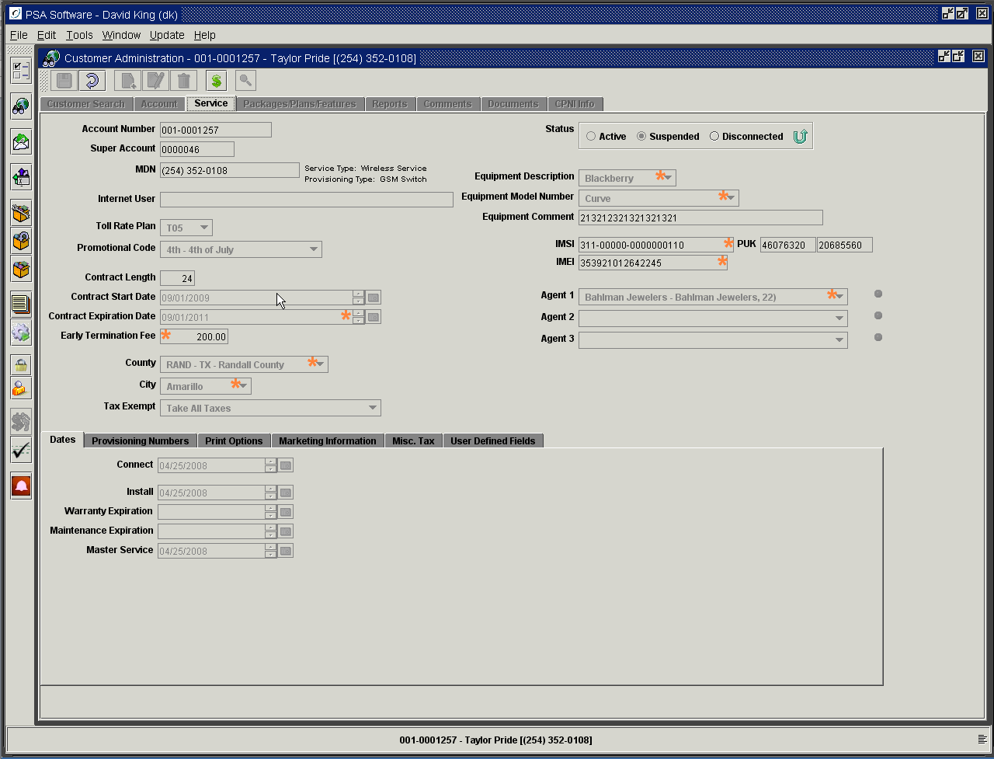

Reconnect from Manual Suspend – requires ‘Service Order – Allow Service Manual Suspend/Reactivate’ authority.
- Open Customer to Service Screen
- Press Edit and select the effective date
- Press the Reconnect icon to the right of Disconnected in the Status box

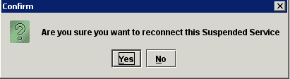

- Respond to the Reconnect question – Yes
- Press ‘Save’ and enter comment.

Force Reconnect from Non-Pay Suspend – requires ‘Service Order – Allow NonPay Suspend Reconnect’
- Open Customer to Service Screen
- Press Edit and select the effective date
- Press the Reconnect icon to the right of Disconnected in the Status box
- Respond to the Reconnect question – Yes
- Press ‘Save’ and enter comment – Promise to Pay comment type.

Disconnect Dialog

Open the service screen in edit mode and go to the Status box. Selecting the Disconnected radio button will display this initial dialog box.

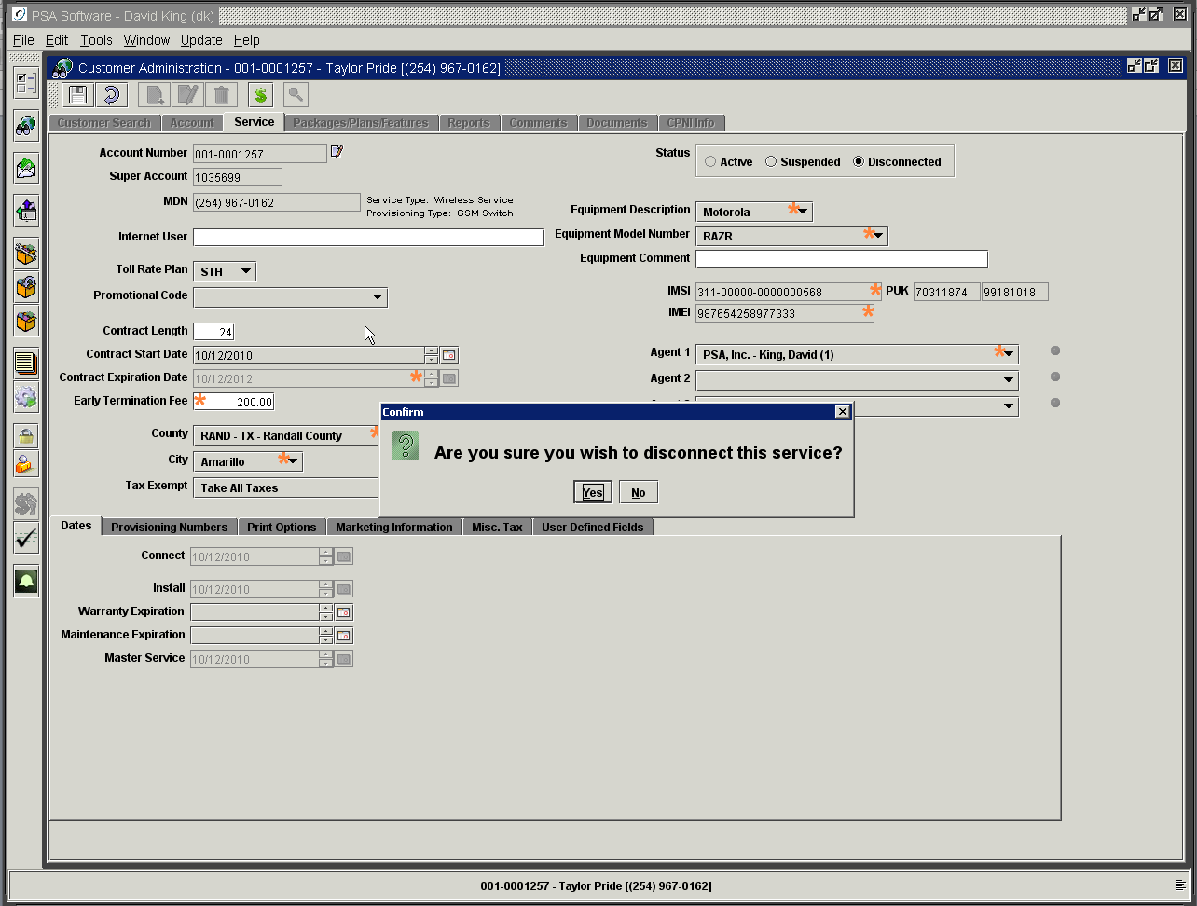

Responding yes will begin the process and move to the following screen. This is your first chance to leave the service connected by pressing No.

This dialog box is interactive with the user and the billing system. Depending on settings or selections, the disconnect dialog box will change and display different fields or information. The initial step would be to select the Disconnect Reason code from the drop down box. If the customer has met his contract commitment, the early termination field will be blank/empty. The dialog box shows the contract expiration date but it is not editable. If not, the amount that will be charged to the account on disconnect will be either be the flat rate amount from the field on the service screen or be calculated from a formula supplied by your company. The field is editable only with the proper authority.

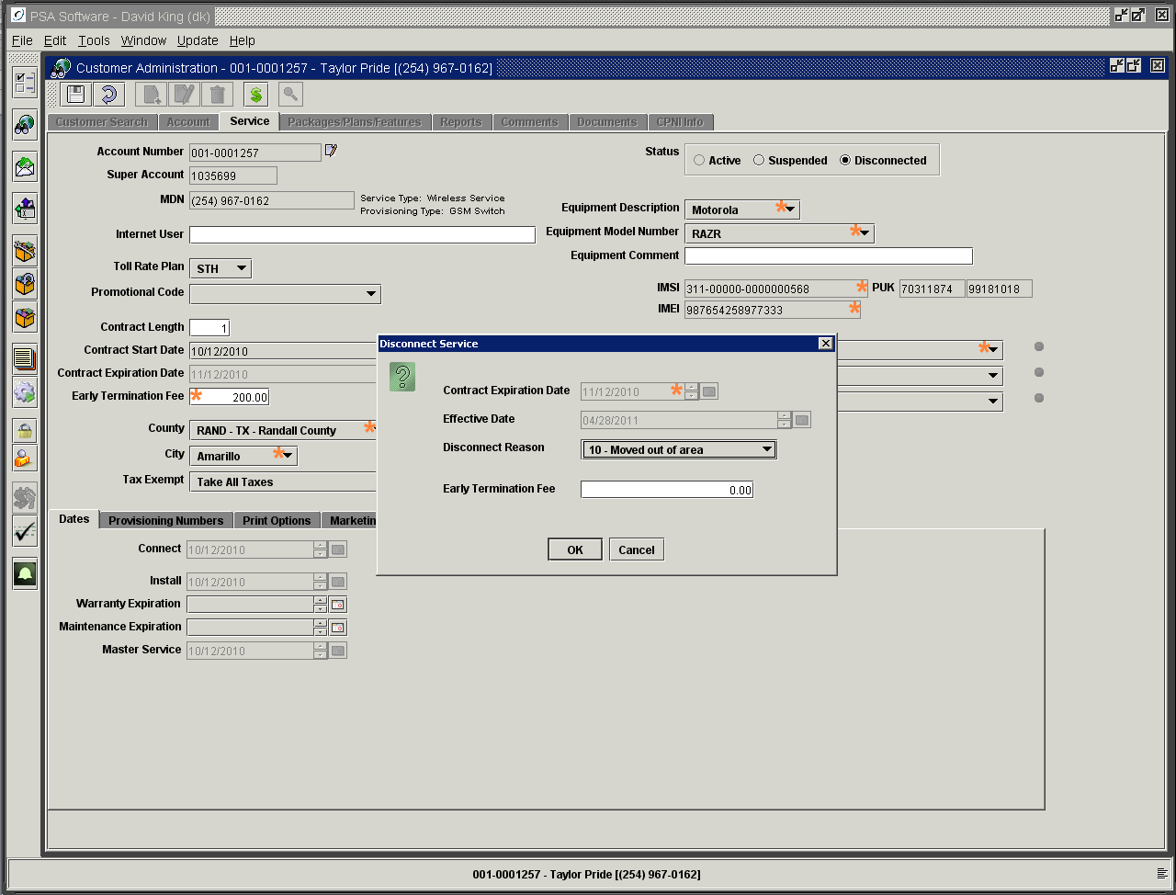

If the Disconnect Reason code selected is a ‘Port Out’ type code then you will see an additional dropdown box of carriers. The CSR will need to select the carrier to which the number is being ported.

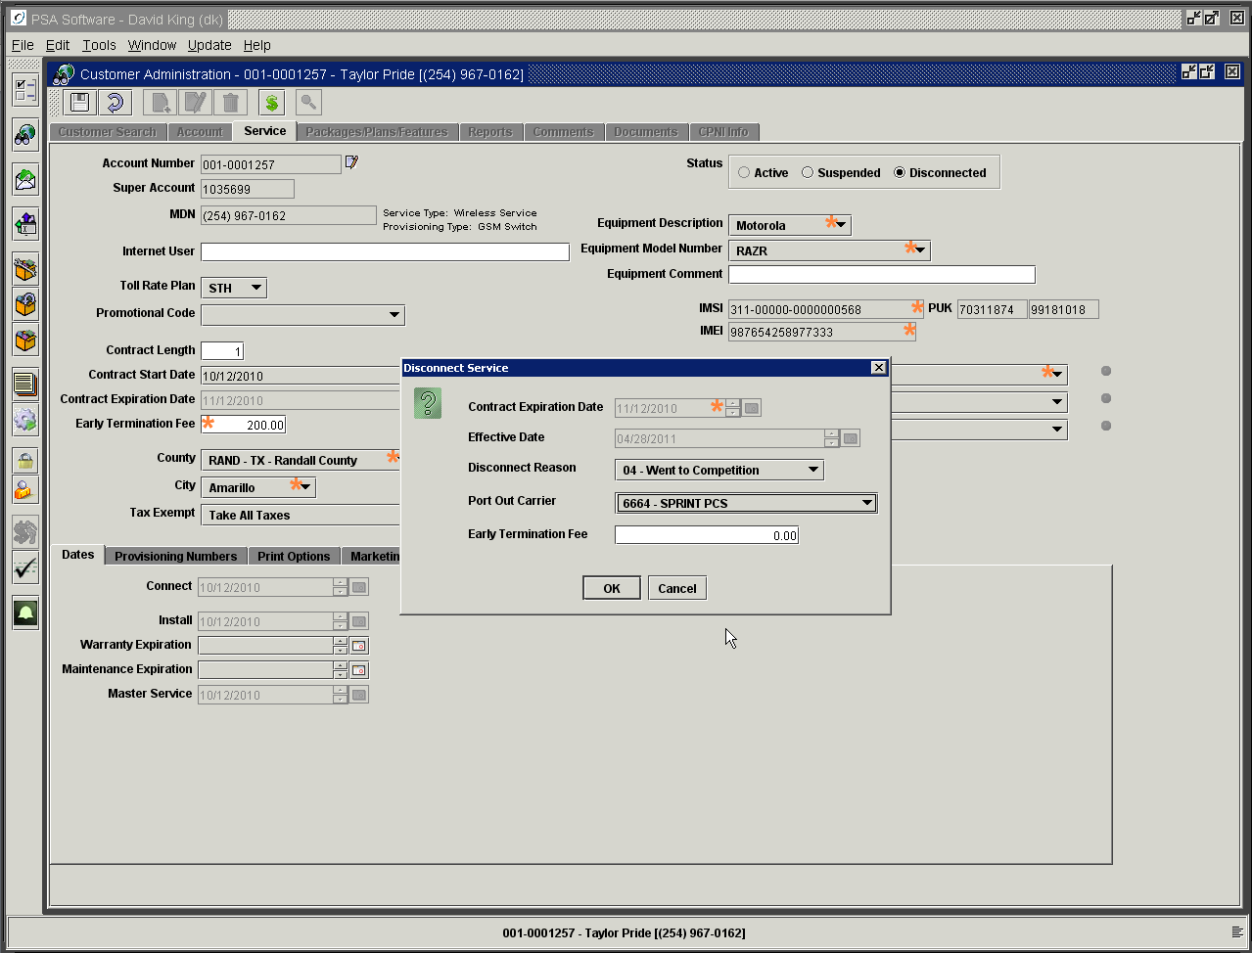

If you press OK, the phone will be permanently disconnected in billing and in the switch; and an early termination charge will be added to the account if applicable.

NOTE: A Permanently Disconnected Post Paid service requires the CSR to use the Add-A-Phone service order to reinstate the customer’s service on the account. You may need to release the MDN for assignment if the quarantine period for the MDN has not expired.

Change Disconnect Code
This process allows the disconnect reason to be edited after the disconnect process is completed. Once a service is disconnected then a new dropdown will display the disconnect reason code within the Status box. To change the code, open the Service screen in edit mode and select the new code from the Disconnect Reason dropdown box. The user must have authority to be able to change the disconnect reason code.

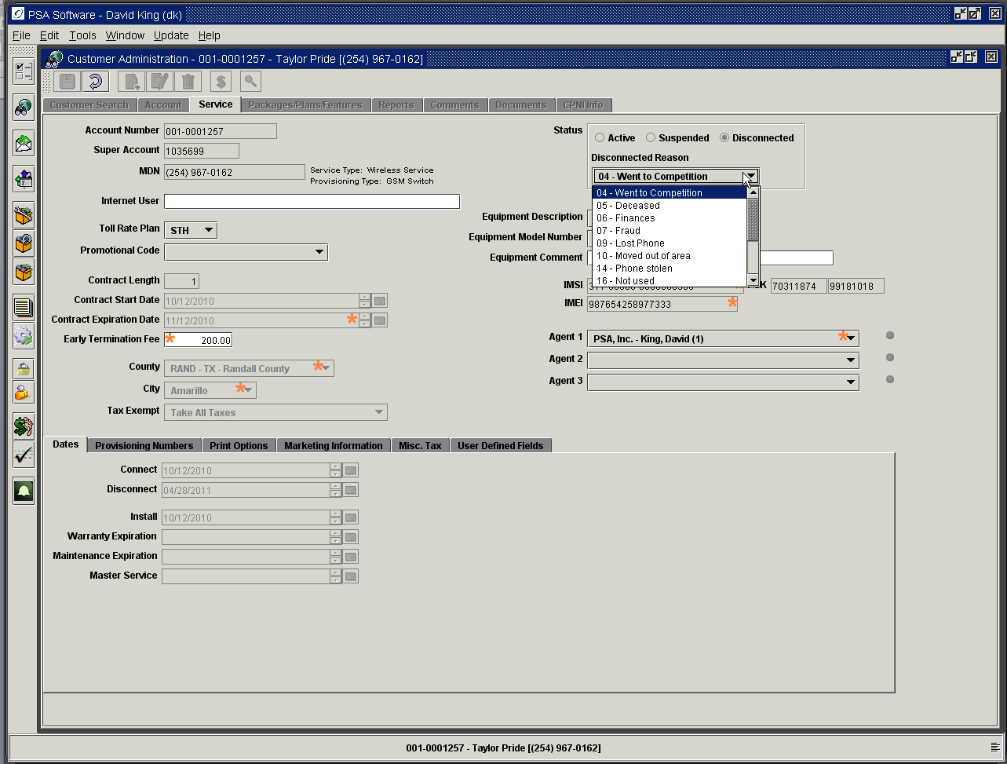

Disconnect with Installments

Your company has two options regarding the balance on an Installment.
Option 1: When the service disconnects the balance on the installments remains in the installment table.
The balance must be dealt with manually using the specific adjustment codes dedicated to Installments.
Option 2: When the service is disconnected the balance of the installments will be moved to the Package/Plan/Features screen and the full amount will be billed on the next billing cycle.

Your company will let you know which option they have chosen and how to handle installment balances if Option 1 is selected.

Dates Tab

Connect Date: This is the date when this service was added to the account. (For companies using the Pending service order model this date is the day the original service order is done on the service and optionally provisioning is done on the various servers.
Install Date: This is the date the current ESN/MEID/IMEI was activated on the service number. (For companies using the Pending service order model this date is the day the Process is run activating the billing of the service on the account.
Warranty Expiration: Store warranty date for future reference. This date can be defaulted to read the connect date and add a number of months to that date establishing an end date for warranty. The default can be created in Billing Admin>Service Order Information>Service Order Defaults.
Maintenance Expiration: If your company offers a maintenance package, store the expiration date here.
Master Service Date: This the date the service number was first added to the account. So if a service disconnects and then at a later point the same service number is added back the master service date will be the original date not the new date. The connect date will be the current date. This date can only be altered by PSA.

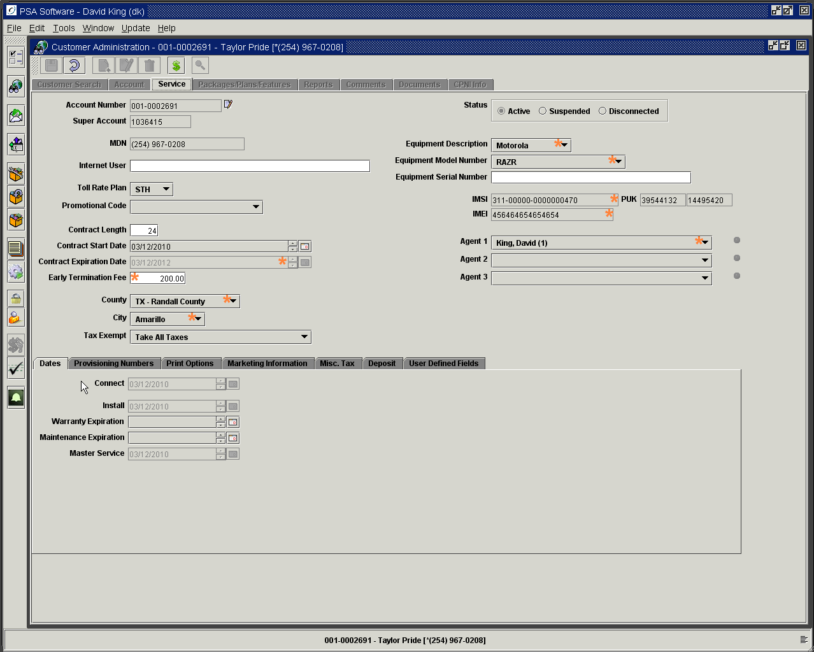

Provisioning Numbers Tab
These numbers can be used in the provisioning process for setup on voicemail or group ringing. If your system requires these numbers, PSA will instruct the user on how to use these fields.

Voice Mail: This will be defaulted to the customer’s MDN. If your voice mail system uses a number other than the customer’s MDN for voicemail, enter that number here. If there is no number in the Voice Mail field, the voice mail server will not be provisioned.
Group Pilot Number: If your company is setup to allow group ring, where incoming calls can ring multiple handsets, enter the pilot number here. The group pilot number is the MDN that when called, will ring through to more than just the main phone with that MDN. The pilot number must be entered here on the primary phone as well as the additional numbers.

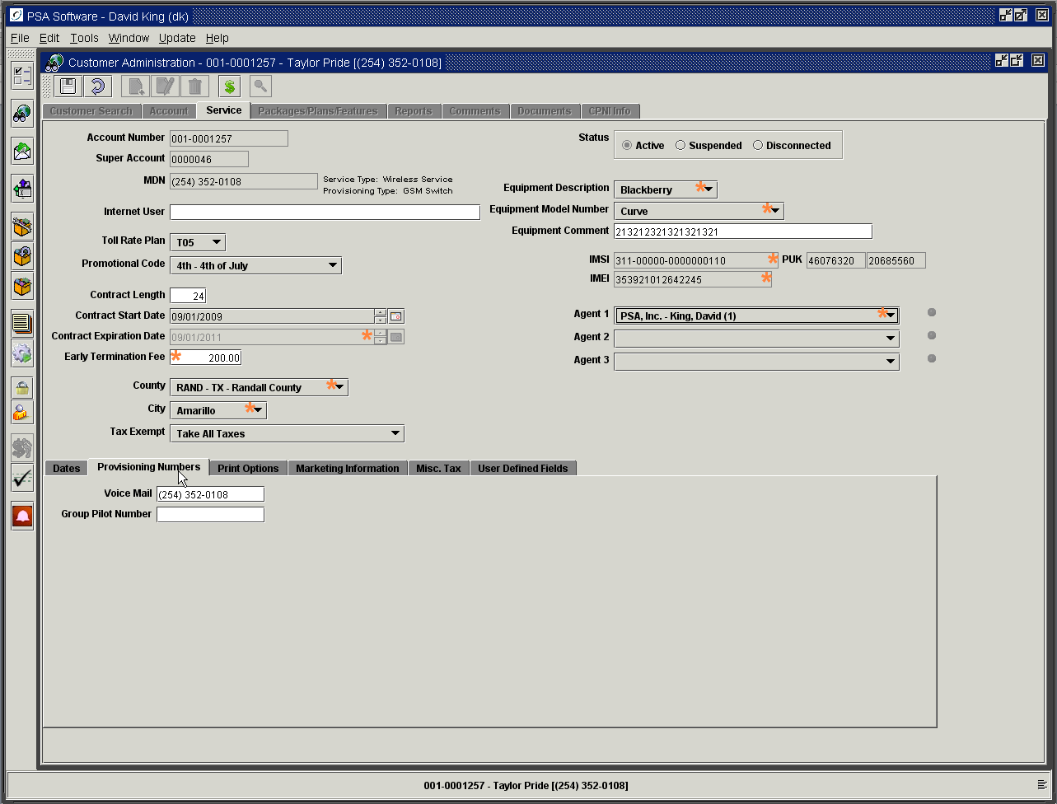

Print Options Tab

Print Call Detail: When selected, all the individual call records will be printed on the statement.
Print Partial Detail: This option will only print call records with charges associated with the record. These charges could relate to overages for rate periods, roaming, long distance, or daily charges incurred when roaming.
Do Not Print Call Detail: If this is marked, then no call records will display on the statement.
Publish: Choose whether the customer wants their number published or not, or given out.

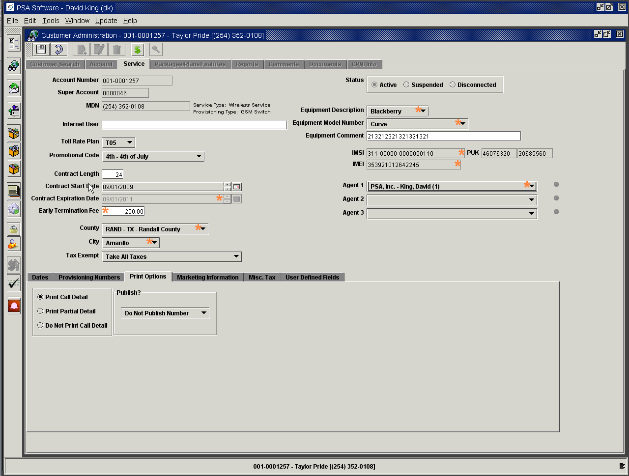

Marketing Information Tab

This is for storing an additional address for marketing purposes that could be different than the billing address. New activations will transfer the billing address here initially. An example use for a marketing address could be a corporate phone where the billing address goes to the corporate headquarters. You might want to send marketing information, promotional pieces, discount offers, etc to the local address of the individual who is using the service, not the corporate accounts receivable department.

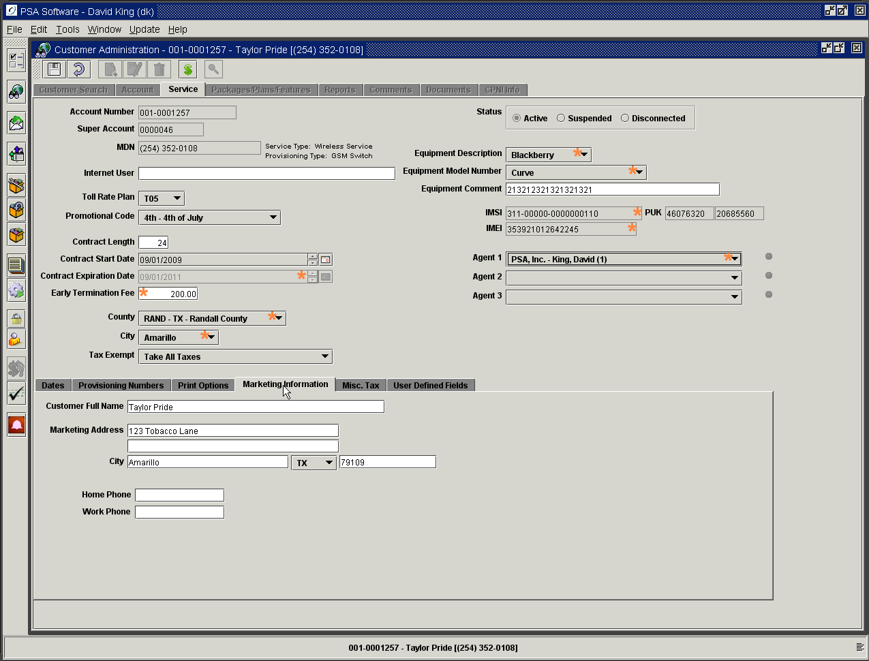

Miscellaneous Taxes Tab

Most companies collect some kind of tax or surcharge at the service level. Some examples of these types of surcharges are Universal Service Fund Fee, Texas Universal Service Fund, Texas Infrastructure Fund, Regulatory Cost Fee, and E911 fee. These fields will be defaulted by the program and should not require changes except in extraordinary circumstances. All miscellaneous taxes/surcharges are listed for selection in the dropdown boxes. CSRs have the option of changing these as needed.

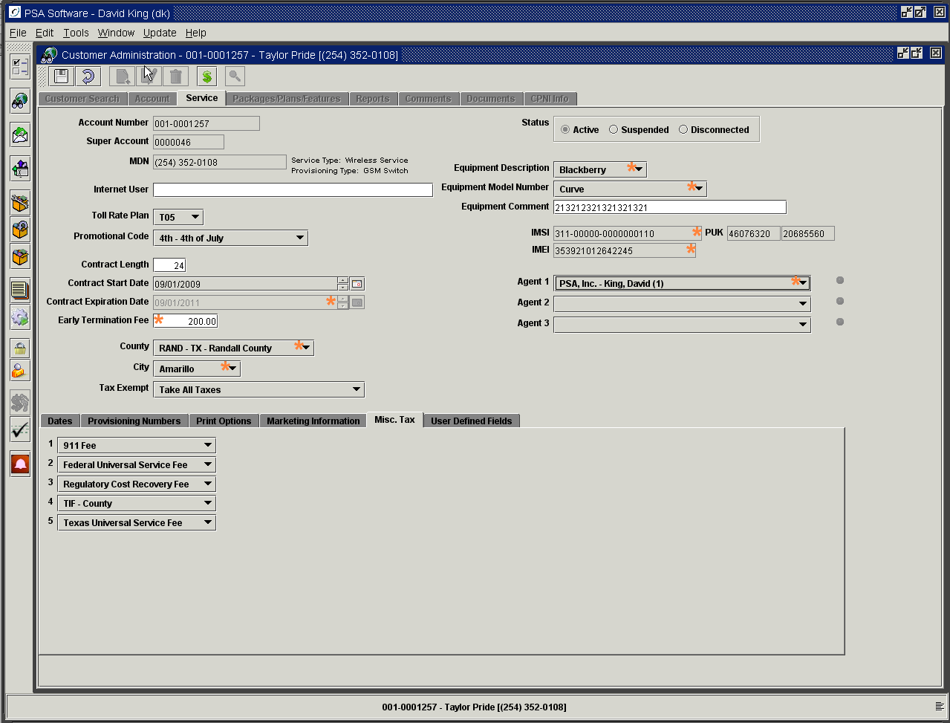

Deposit Tab

If the customer was required to place a deposit with your company, an additional tab will display after the original installation has posted. Using a special adjustment item or temporary item, defined by your company, the application will create a deposit. Most companies use something like ‘DEP’ for a prefix and you may have multiple deposit items. You may use this adjustment in either Point of Sale or Batch Adjustments. If the item is a temporary type then the item will be shown on the Packages, Plans, and Features screen until the next billing is complete when the temporary item is posted. It will not show on the Service screen under Deposit until after billing is complete. If the item is an adjustment type, the item will display on the deposit tab as soon as the adjustment is posted from Batch Adjustments or Point of Sale. If there are multiple deposits for this specific service number, each will be shown in the tree to the left of the deposit fields by entry date. Double click the date and see the status of the individual deposit.

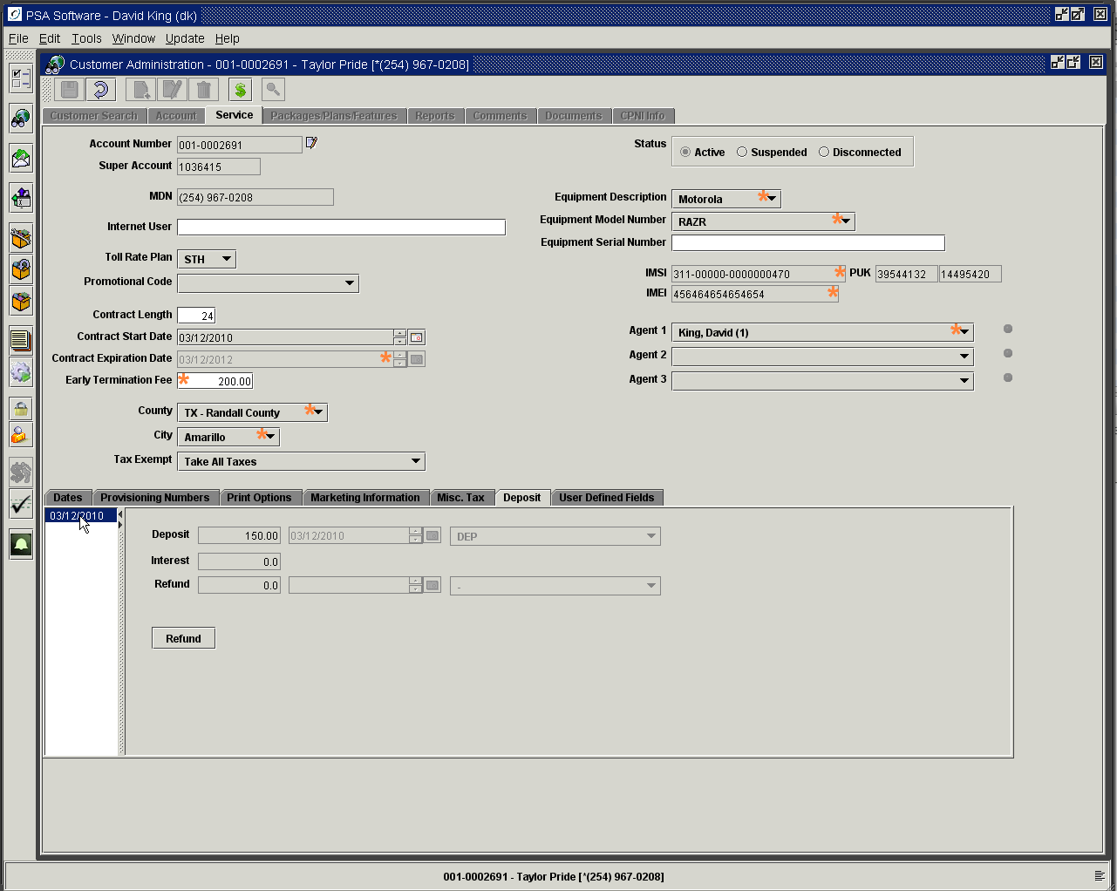

Refund Deposit

Refunding of deposits is controlled by security settings. Select the deposit to refund in the deposit tree and press the Refund button. Begin by selecting the refund date using the calendar icon. Next select how you will refund the deposit from the drop down box. Refund Deposit and Interest returns the deposit plus interest to the customer. Refund Partial Deposit and Interest allows you to retain a partial deposit while returning a portion of the original deposit plus interest. The Refund field will be editable for this type of refund. Enter the amount and tab off the field. The refund and interest will be shown after calculation.

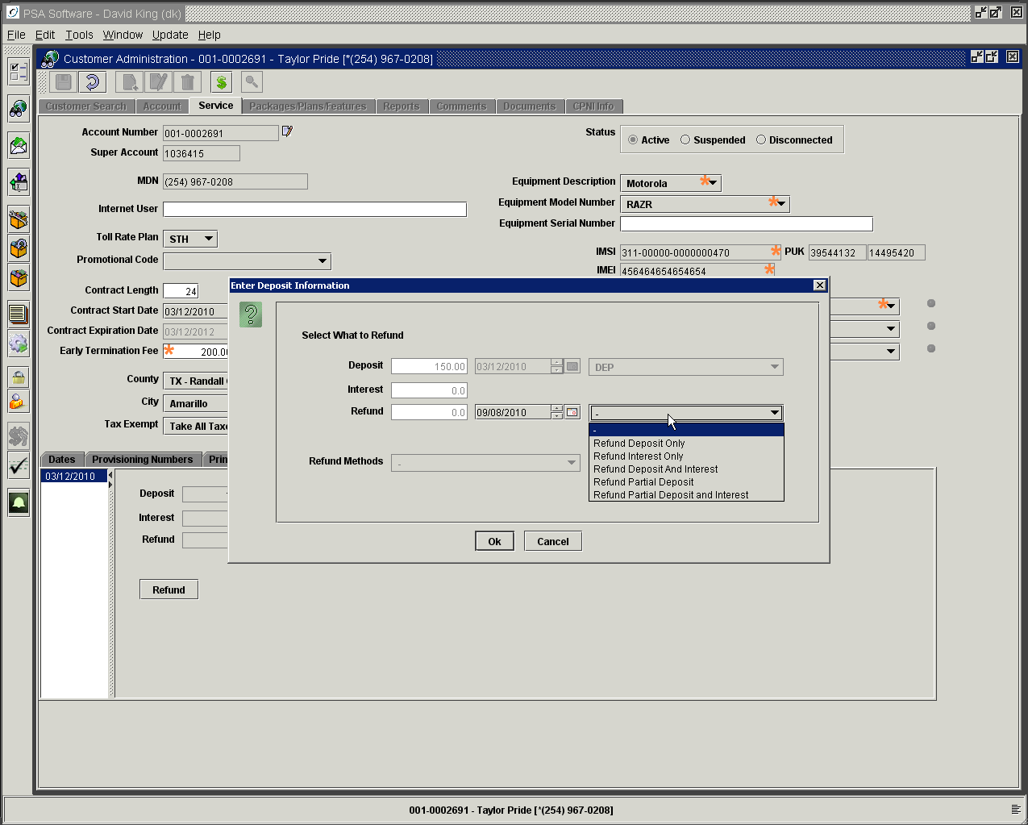

You will need a method to transfer the deposit to the customer. Selecting Voucher will create a print voucher to be given to accounting with the customer’s name, account number, service number, and values for deposit and interest.
Selecting Adjustment to A/R automatically creates and posts an adjustment for the amounts of the deposit and interest on the customer’s account.

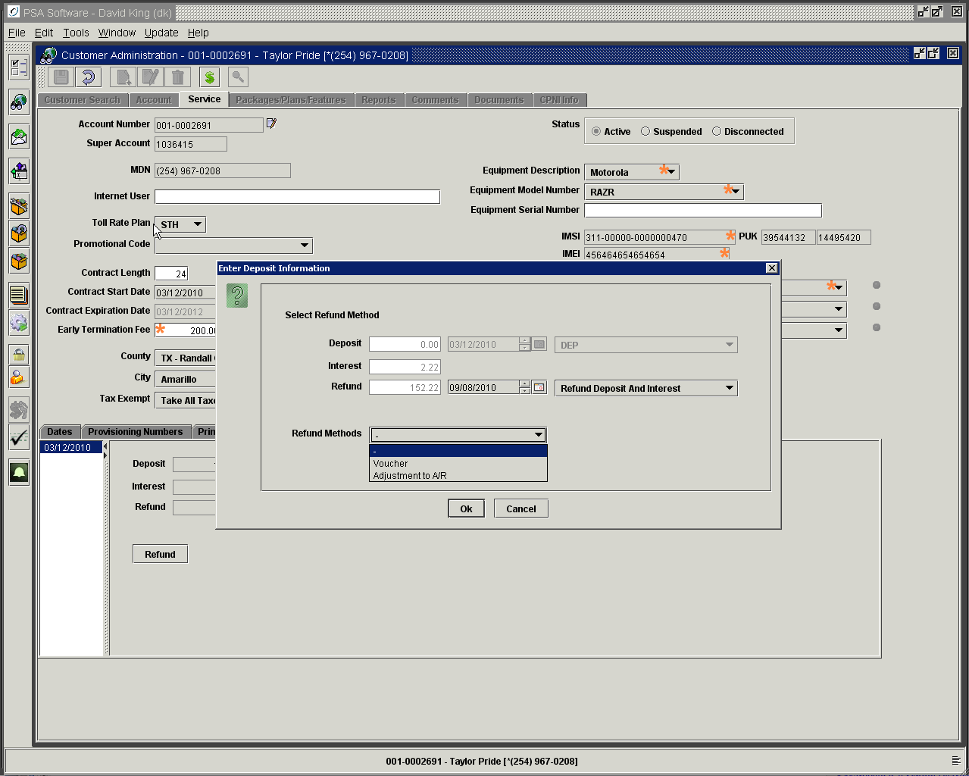

Internet Tab

This tab will only be visible on service numbers attached to an Internet Service type. You may have multiple email address fields and corresponding password fields to store Internet data. These fields are user defined in Billing Admin>Service Order Information>Email Address Types.

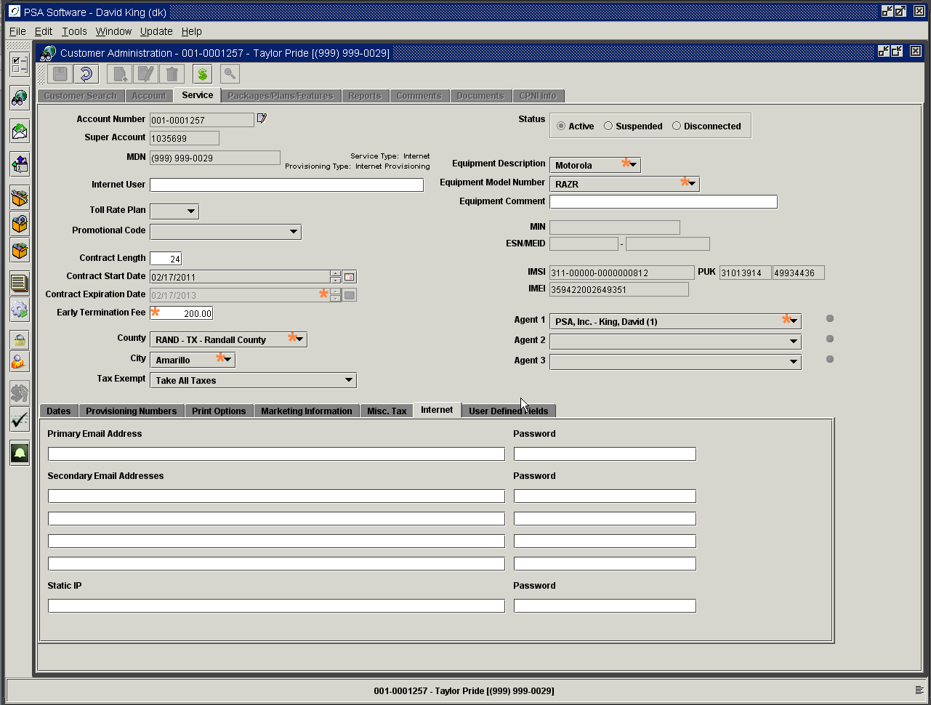

User Defined Service Level

These are user labeled fields for storing information not on the main screens. These fields can be created by someone with admin authority under Options>User Defined Fields. You will select whether the new field will display on the Account level screen or the Service level screen. The company defines the label, field type and length. Additional types of fields are: check boxes for yes or no answers, radio buttons for responding to yes or no questions, and date fields with active calendar.

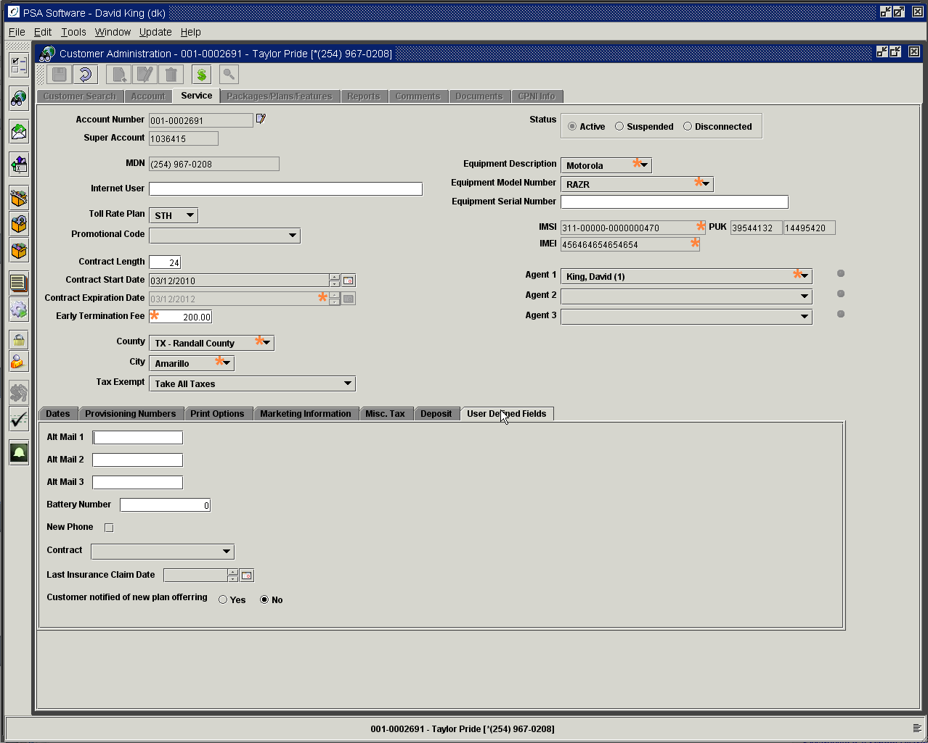

Packages/Plans/Features

In this section you will be selecting airtime plans, individual calling features, data features, certain fees and packages. Packages are groupings of individual items for which you can create special pricing. Packaging also allows for multiple items to be installed with one selection; thereby improving accuracy of service orders. Packages allow companies to establish rules within groups in the package; one such rule could force selection of a number of items within a group. If you have a group under a package that the end user has a choice of one item from that group of items, package rules can force the CSR to select one and only one of those items. Packages can be used as a template for ease of install; however once the package is saved, the package will revert to individual items. PSA will be happy to review all the potential benefits and pitfalls associated with the package function. Items are created at either the account level or the service level. Account level items affect the account as a whole and are billed once for the whole account per cycle. These items will be displayed in the account summary on the customer’s monthly statement. If this item is added to the account, every service on the account will receive the benefit of the item. If the item is created at the service level, only the service number you are positioned to will receive the change and the item will display in the service detail on the customer’s monthly statement. Rate plans would be an example of a service level item.

Package/Plans/Feature Screen

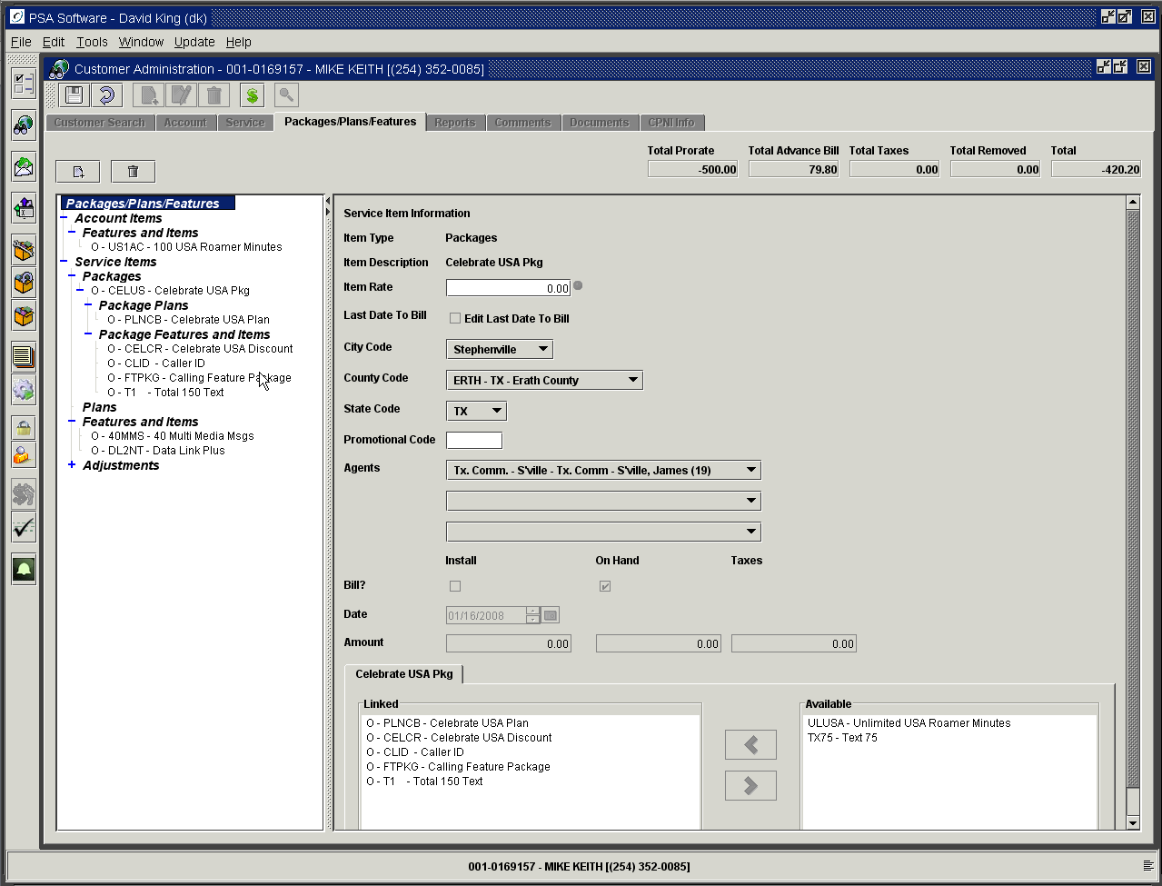

You will view information on the various components of the customer’s service using the Packages/Plans/Features tree. Highlight the item in the tree and see the detail displayed to the right. Total Prorate is a total for all pro-rated components if changes have been made during the cycle. The Total Advance Bill total is the normal ongoing cost relating to the service. Amounts not included in this cost are minute overages, roaming charges, long distance charges, various data cost overages, etc. The Total Taxes will be display for all the components of the cycle, if the individual items are marked ‘Calculate at entry time’. If items have been removed and/or replaced, you will see amounts/credits in the Total Removed field. The total on the far right will be a good estimation of the ongoing cost for the period regarding only access fees on the account. When reviewing the detail on items, you will see individual Install, On Hand and Remove boxes. The Install is a pro-rated amount for ‘New’ service or change in items not at the beginning of the cycle. On Hand is the advance bill portion (full monthly charge) for the item. If the item has a remove, this will be a credit for the balance of the cycle.

Additional information shown is the type: package, plan or feature, the item description that will be shown on the billing statement, and the access fee or rate for the item. The next field ‘Last Date to Bill’ is an optional field, which shows the last day the item will be billed on the service. Once this date has passed, the item will be removed from the service during the next billing run. Following that the taxing authorities are displayed for review and if there is a promotional code attached from the service level screen that will be shown in the following field. Again the promotional code is only for marketing purposes; all discounts etc will be created and applied as features. The agents of record will be shown. Any install, on hand or removes will be shown with associated amounts. If a package is chosen for detail each group will be shown and available for review

In the previous example, Mike Keith has made no changes to his account during the cycle. All the items are shown as O or on-hand. Mike has an account level feature, 100 Roamer Minutes, that will be shared with all service numbers on his account with the same super account number. He has multiple service level items. The Celebrate USA package includes the Celebrate USA plan and additional features of Celebrate USA discount, caller ID, calling feature package, and a text item for 150 text messages. These are items included and selected under the package. In addition to the package items, he has more service level items outside the package group added ala Carte; 40 Multi Media Messages and a Data Link feature are examples. If there are adjustments such as discounts, activation fees, reconnect fees, deposits, etc, these will be shown as either account level adjustments or service level adjustments according the feature setup.

Rate Plan or Feature Changes

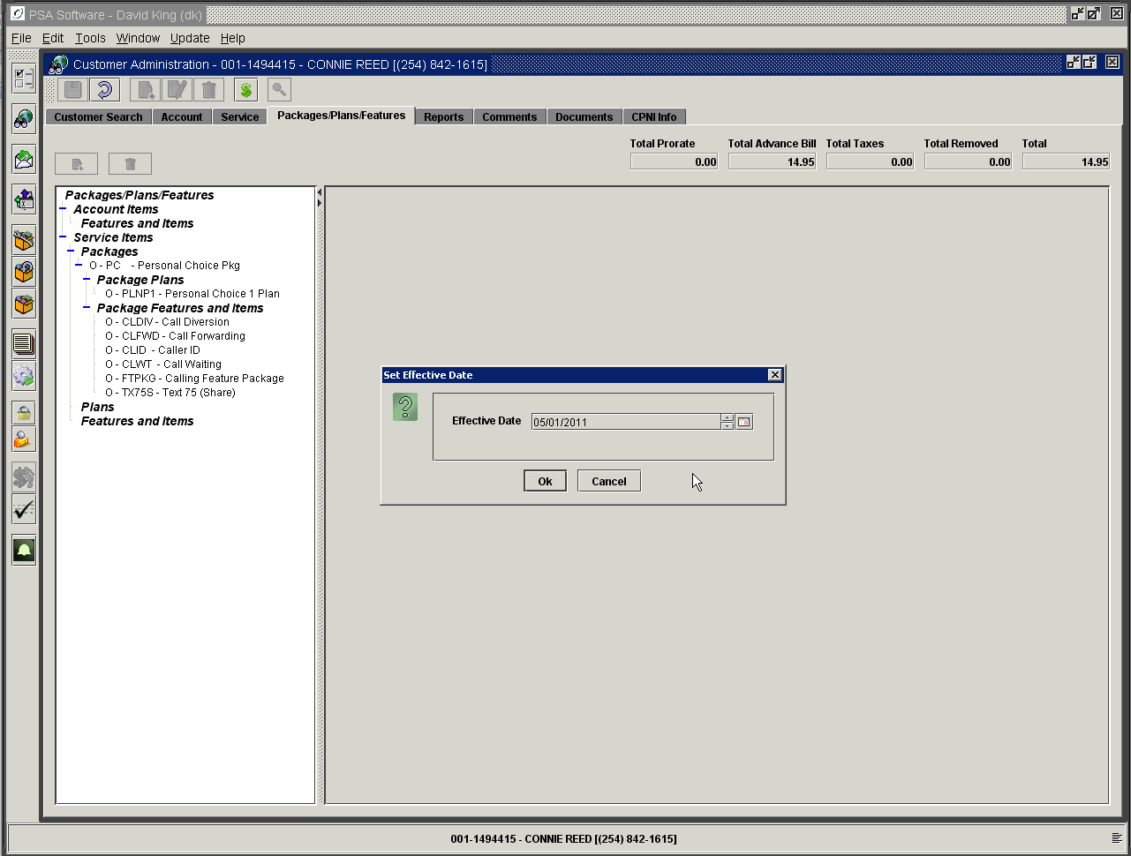

To change these items, use the Edit icon while positioned on the Packages/Plans/Features tree. Select the change date to begin the change order. To change a plan you must first remove the existing plan as no service number can have two active rate plans at the same time. You will use the Trash Can or the ‘New’ icon to institute the changes. Other items can be removed or added in any order. As an item is removed it will be shown with an R status and the remove field with be displayed with the credit amount.

In the following example we removed the Personal Choice package by highlighting the Personal Choice package in the tree and pressing delete (trash can). We were asked to confirm removal of the package prior to the removal. Now all items, which made up the package, have a status of ‘R’; which means removed. Removed items are usually a prorated amount unless you remove them as of a billing date.

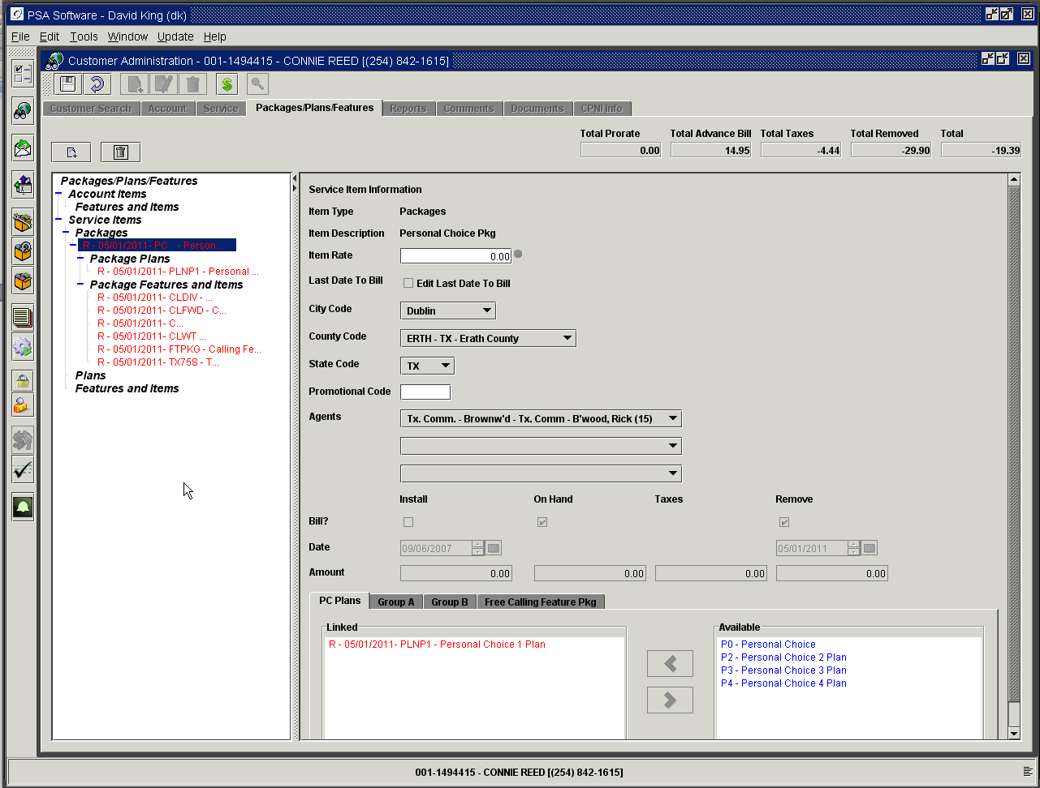

Only package items were affected. Since you removed the plan in the previous step you must replace it with a ‘New’ plan before you can ‘Save’, which posts the change order. So select the ‘New’ icon immediately above the tree and pick your ‘New’ package or plan.

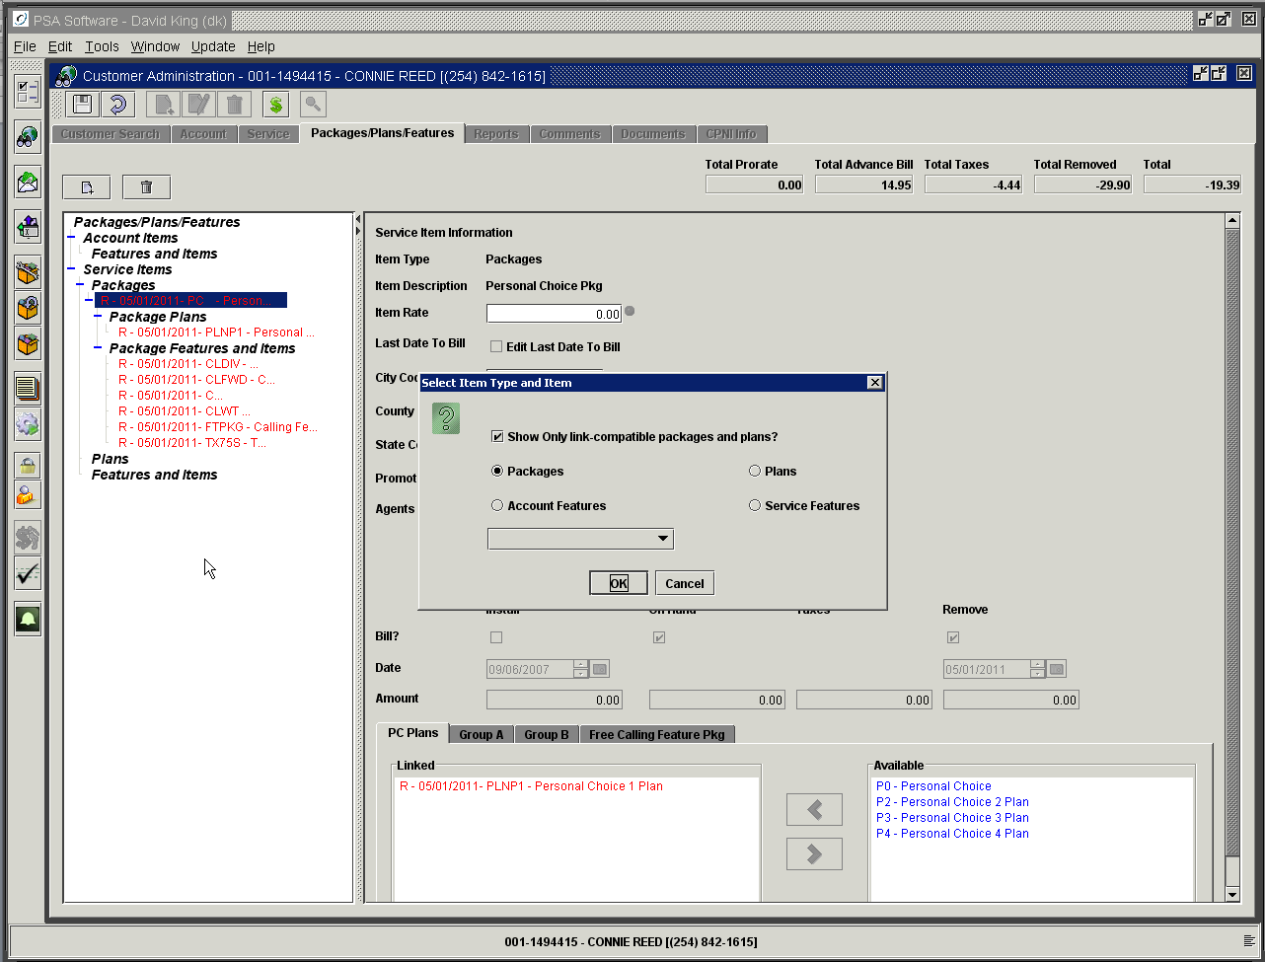

If the service is linked to another service then you may be limited in selection of new package or plan. If the ‘Show Only Link-compatible packages and plans?’ is checked then the application will check the plan on the other service and verify what packages or plans would be compatible. After the validation the application will only show those packages or plans where sharing of minutes or data would take place. The default can be set as checked or unchecked. There are user controls available to allow or disallow individual CSRs from changing the default setting. If that check box is not checked then the package and plan dropdowns will show all available packages and plans. If the user should select a package or plan that is incompatible (i.e. will not share correctly) there will only be a warning stating the incompatibility; they will be allowed to change the package/plan. This is allowed due the nature of plan changes since a group of phones could be changing from one group of plans to another group. An example would be where all services will be changed from a regional plan to a nationwide plan. Once all the phones are changed to the new group and if the super accounts are left in place; then the services should share minutes and data.

Select the new package or plan from the dropdown and press OK. After you select the plan the next dialog box determines whether or not this service should retain its super account number or be reassigned a new number. If the choice is Preserve Service Link, then the super account number will not be changed. This does not necessarily mean the service will share with the other services. If the plan on this service is no longer compatible, it will not matter that the super account numbers are the same; they will not share minutes. If the setting is Break Service Link then when the order posts this service number will be assigned a new unique super account and will not share with any other services in the system. Sometimes it is appropriate to leave a service linked even if the plans won’t match at posting. One instance would be that you are changing other services to the same plan or package group and when these are posted then the services would share minutes without having to go through additional steps to link the phones.

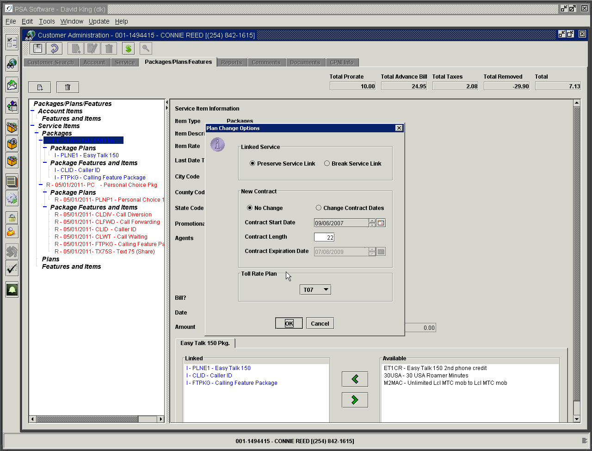

If no change is required, leave the No Change radio button marked. If your company requires a ‘New’ contract when changing plans check the Change Contract Dates and you will have the opportunity to create a new contract expiration date. You may change the ‘New’ Start Date and/or Contract Length; either or both will reset the Contract Expiration Date.

The final choice allows the user to update the Toll Plan. If the new package group or plan requires a different Toll Plan select that from the dropdown. Pressing OK will save these changes for the service order. The order must be completed/Saved for the changes to take place in the database.

If the new selection involves a package the application will apply those restrictions here as well as in new Customer activations. The Personal Choice Plus Package was created with five components: PC Plans group, Calling Features group, Optional Add On Features group, Free Calling Feature group and Activation Fees group. When the package was created, the definition required that (1) a plan be selected, (2) that one and only one item from package Calling Feature group must be selected, (3) that two or more items must be selected from Optional Add On group. (4) all the items are required so all the items in the free calling package will be selected (since ‘all’ were included in the package). PSA will default all the items to be selected, and finally there needs to be one item selected from the Activation Fee group. The next progression of screens will show the changes. Highlight the item in the Available box and press the arrow pointing to the left. That will move the item into the Linked box.

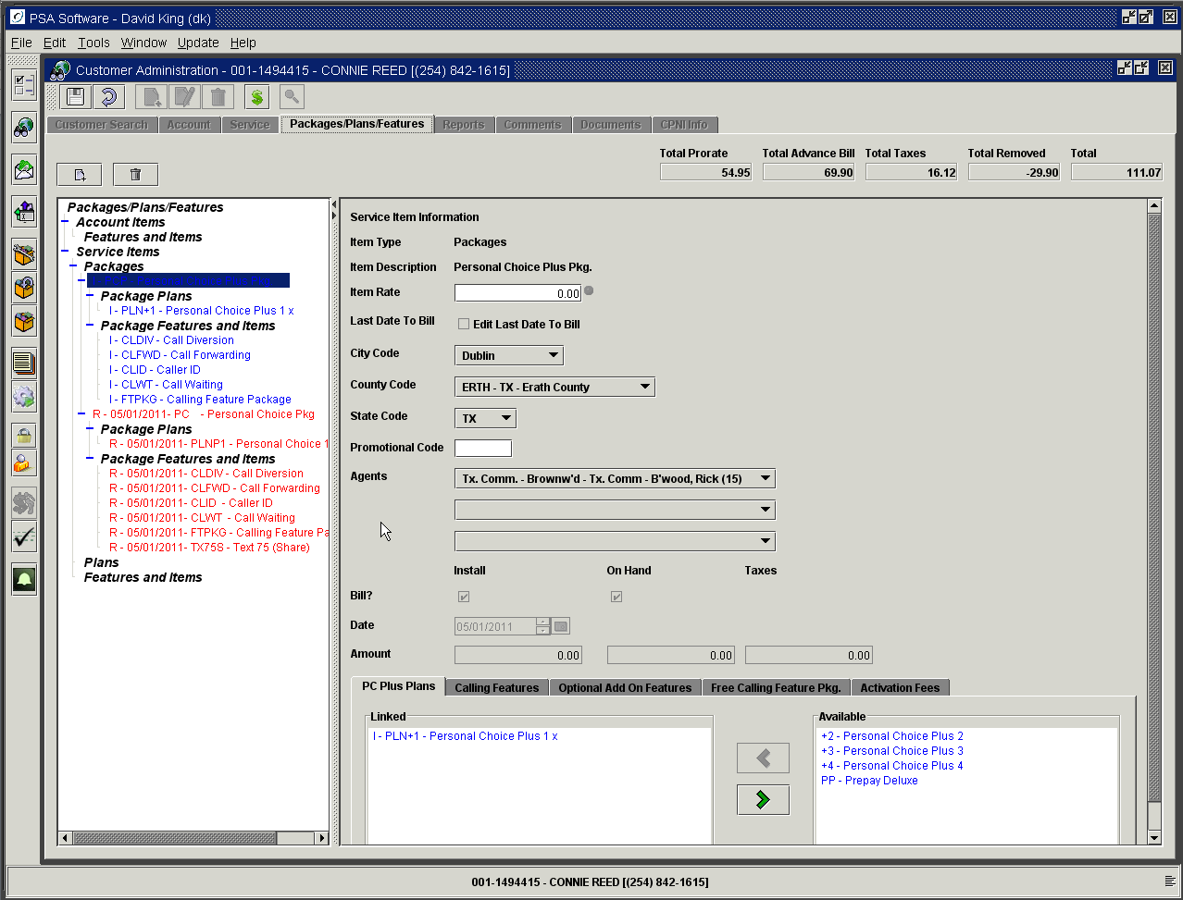

You can reverse the change by highlighting the item in the Linked box and pressing the arrow pointing to the right. Then select another plan and move it to the Linked box.

The next step would be to select an item from Calling Features.

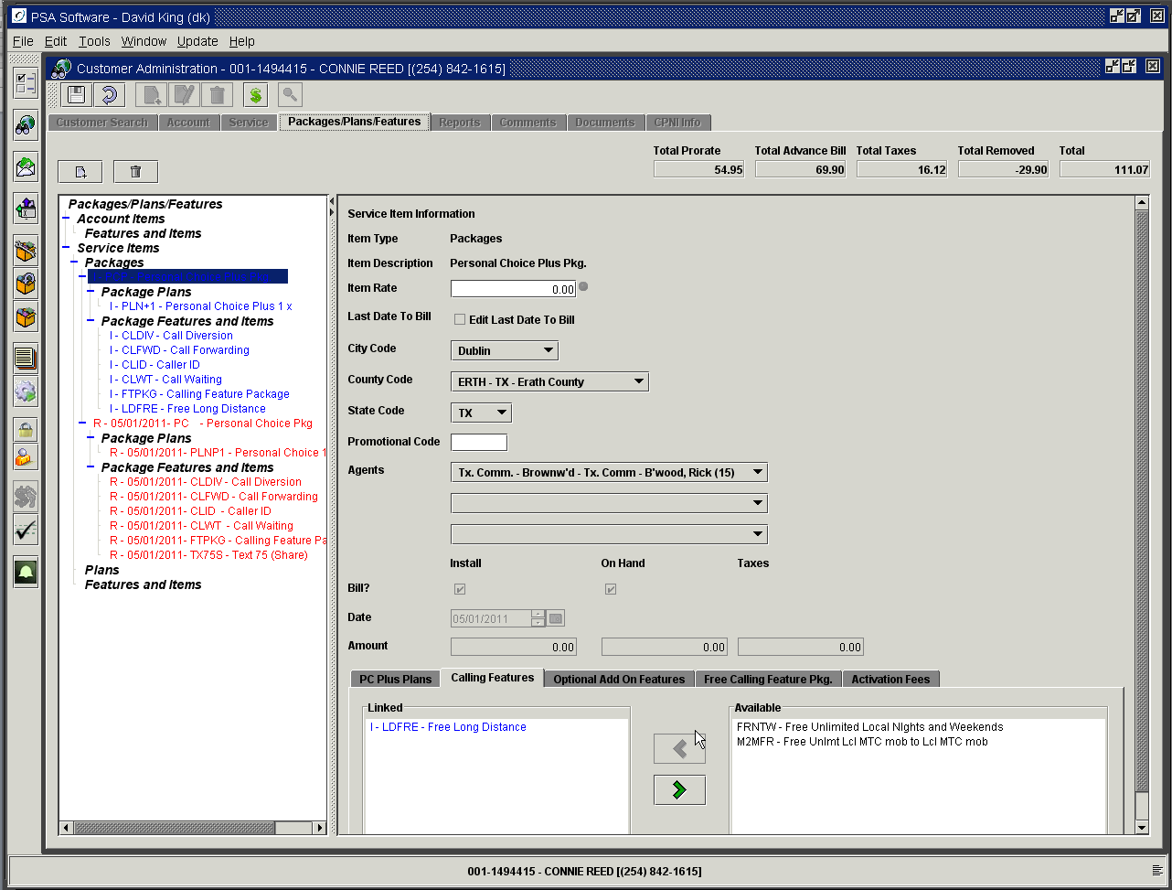

Next, choose options from Optional Add Ons.

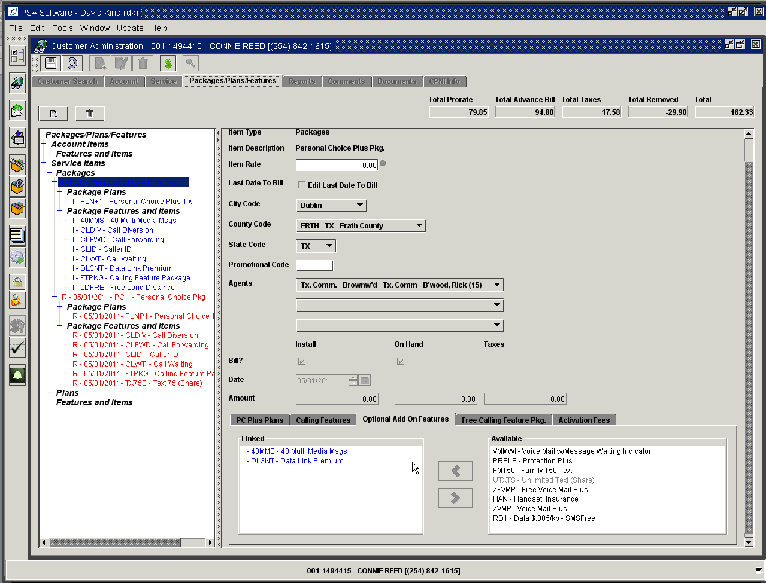

You will notice that when you move to the Free Calling Feature group, all the items will be preselected.

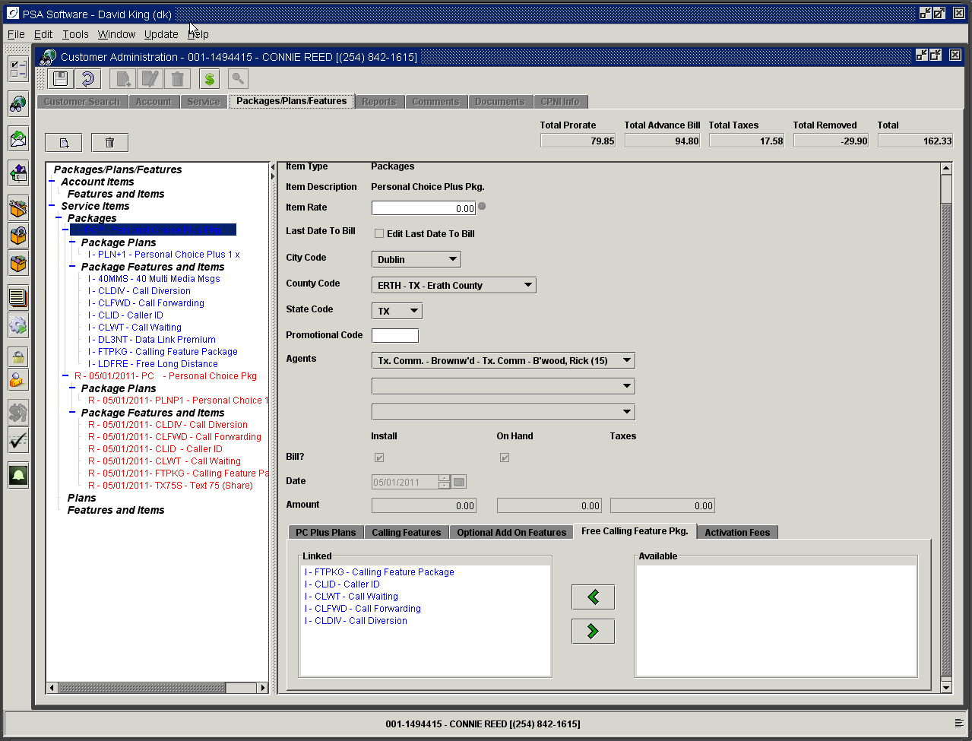

Select an activation fee from the final group.

Also, if you have free calling group you would want to add the free numbers at this point. (See free calling group for more information)

Once you have completed all the steps for this package, press the ‘Save’ icon in the tool bar to post the changes to the account. If all the conditions of the package are not met you will be notified in order what needs to be changed.

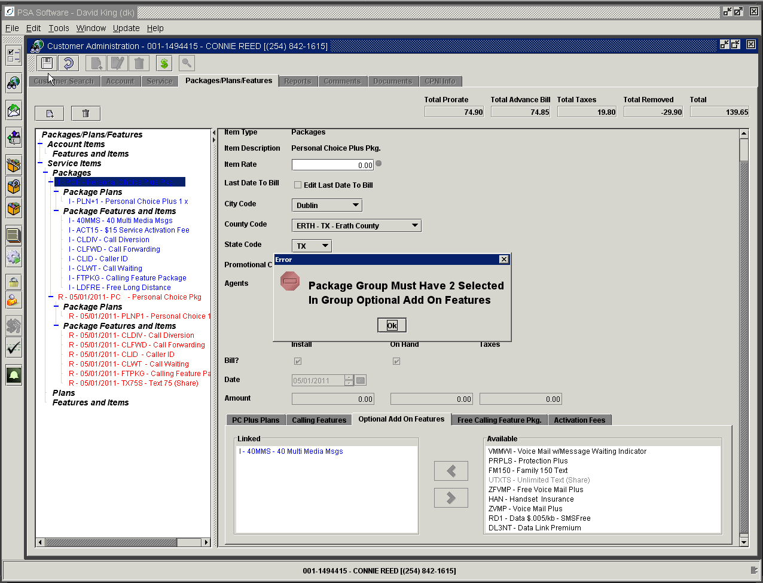

Once all the requirements are met, the CSR will be required to enter a comment regarding the change order.

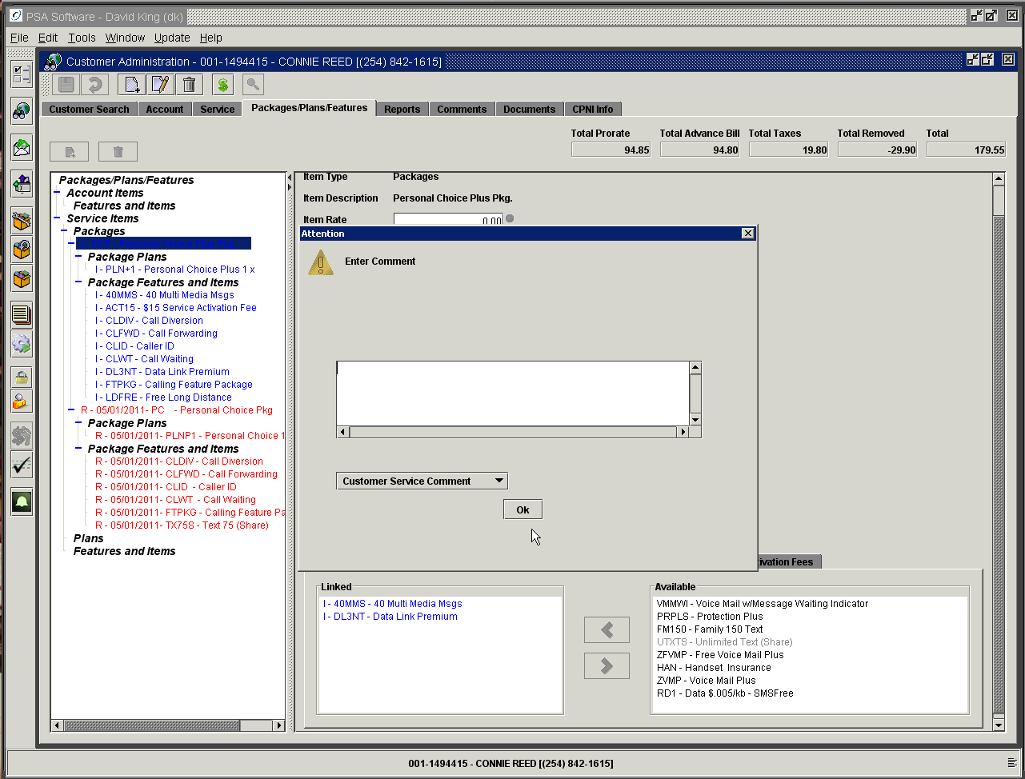

Notice now that all the ‘New’ items are marked as I status. This means they are ‘New’ items for this cycle. When the next billing runs, these items will become O items. The removed items will disappear with the billing run, leaving only the advance bill items or ‘O’ items until the next change is made.

The authority Service Order – Allow Item Deletion provides an additional way to handle unwanted packages, plans, or features. This should be used with caution, as there are no pro-rations done on the item being deleted. A good example of when deletion could be used would be when an item was added in error within the service order or prior to the first billing cycle. If you delete the item then it would not show on the customer’s statement. If you use the Remove option then the item would be shown on the statement with a zero amount. PSA recommends you give this authority with careful consideration.

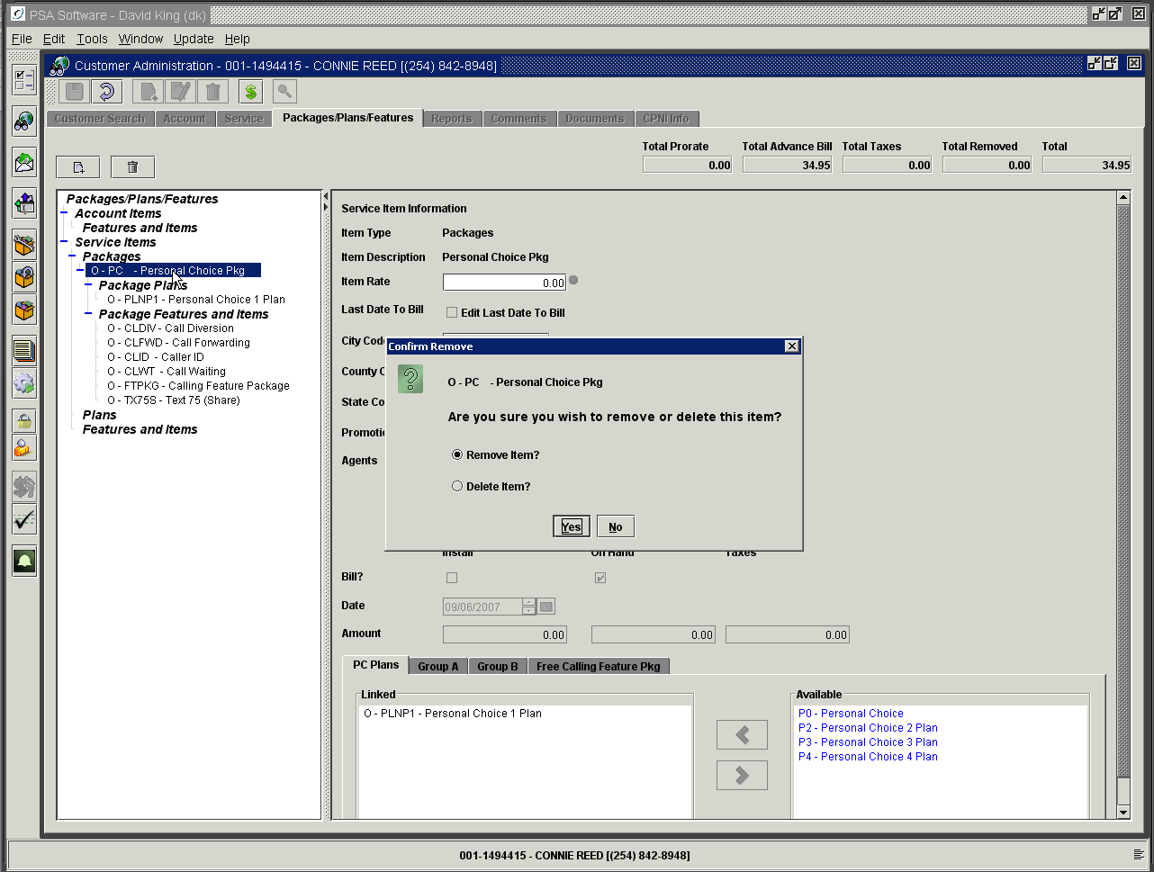

Ala Carte Items

Adding Ala Carte Items

Adding ala Carte items is also done from the Package/Plans/Features tab. Ala Carte items can include account level features, service level features, or plans depending on your company’s business rules. To add items select the customer and open the Package/Plan/Features tab.

Account level features are added by pressing the ‘New’ icon. Select the Account Features radio button and use the drop-down box to select the item.

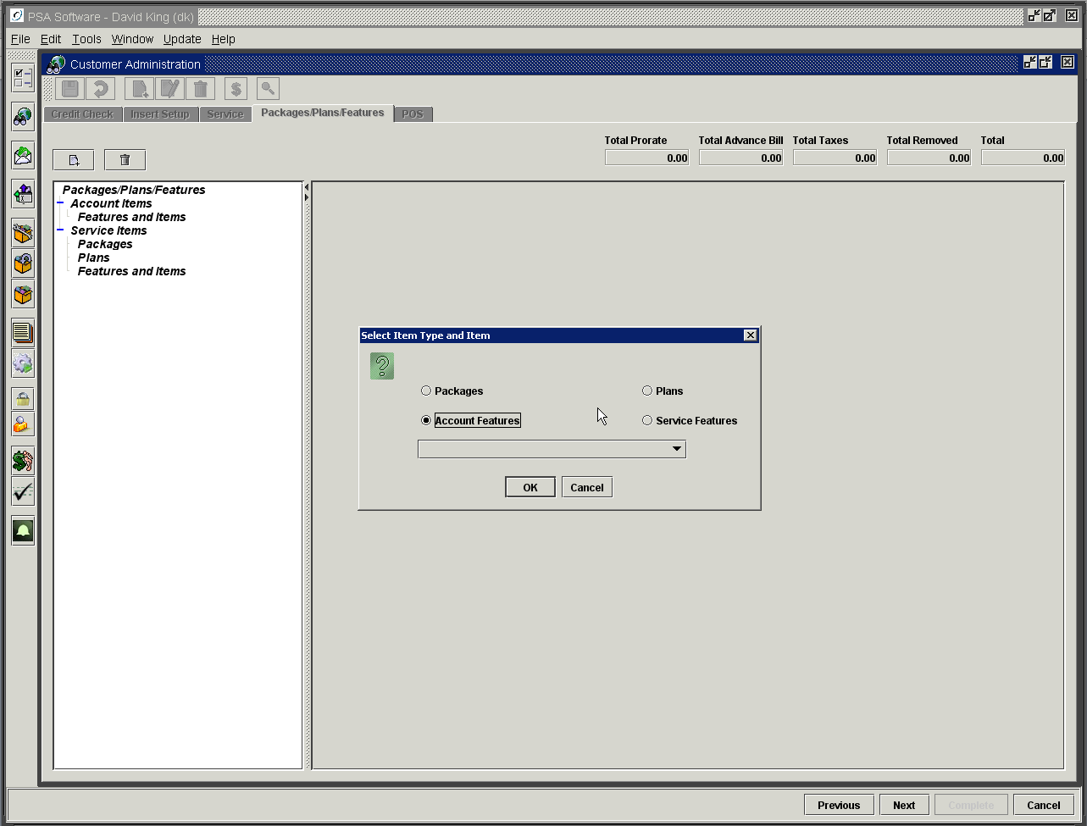

Press OK to add the items. Once added, an account level item displays in the Account Items section of Packages/Plan/Features tree. Being an account level item this will show in that section on every service on the account. If you use Add A Phone to create ‘New’ service on an account with account level features, those features/items will already be on the service. Account level items are charged one time per account per cycle regardless of the number of services on the account.

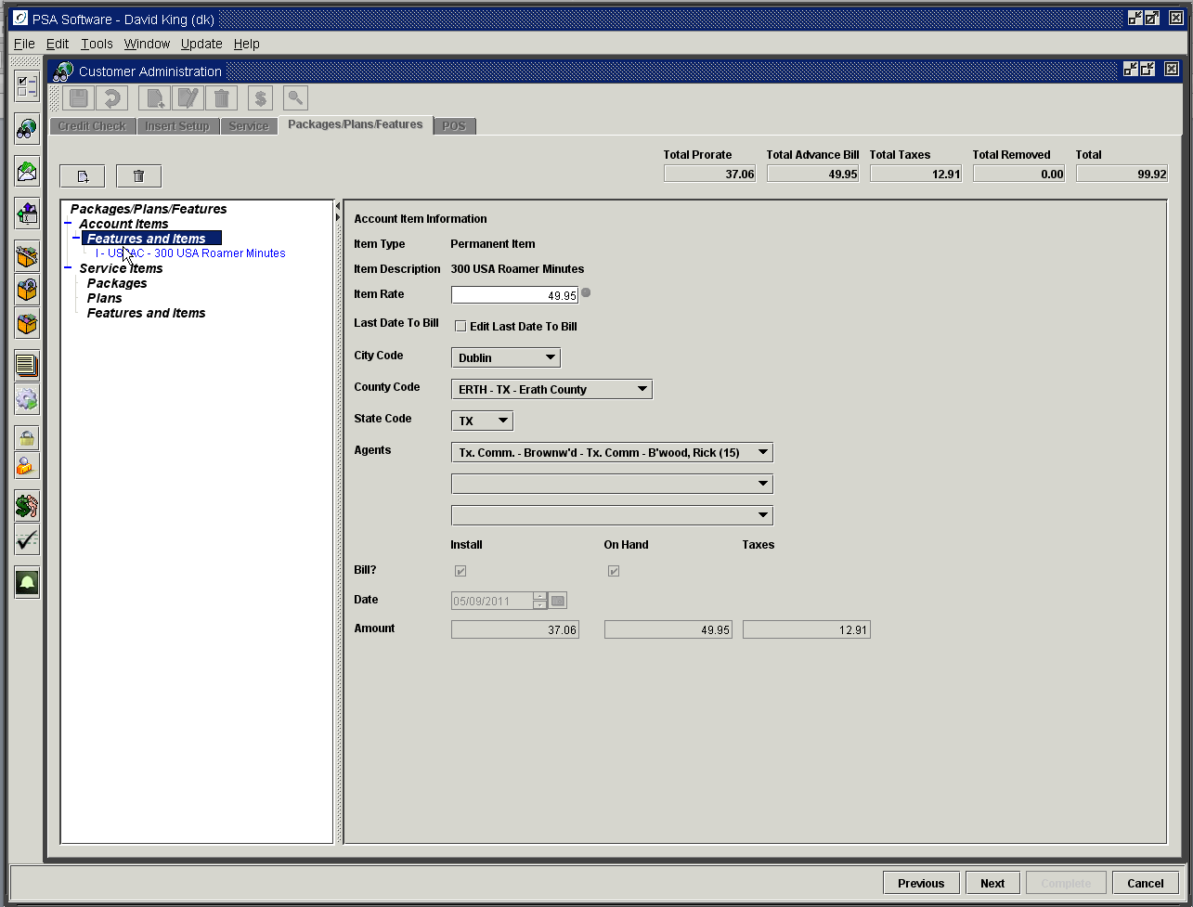

The same actions apply to Service Items. However within service items you have the option to select either Plans or Service Features. If your company does not include the plan within a package, you would add the plan in the following steps. Press the ‘New’ icon and select the Plans radio button on ‘New’ display. Highlight the correct plan in the drop down box and press OK to finish the process.

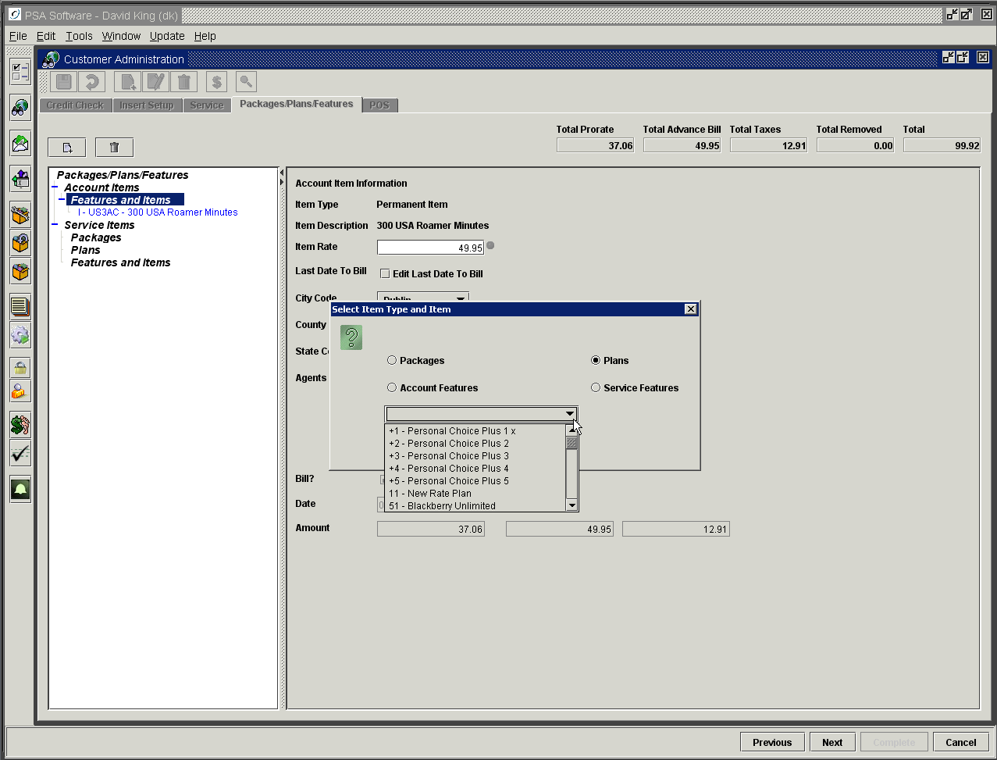
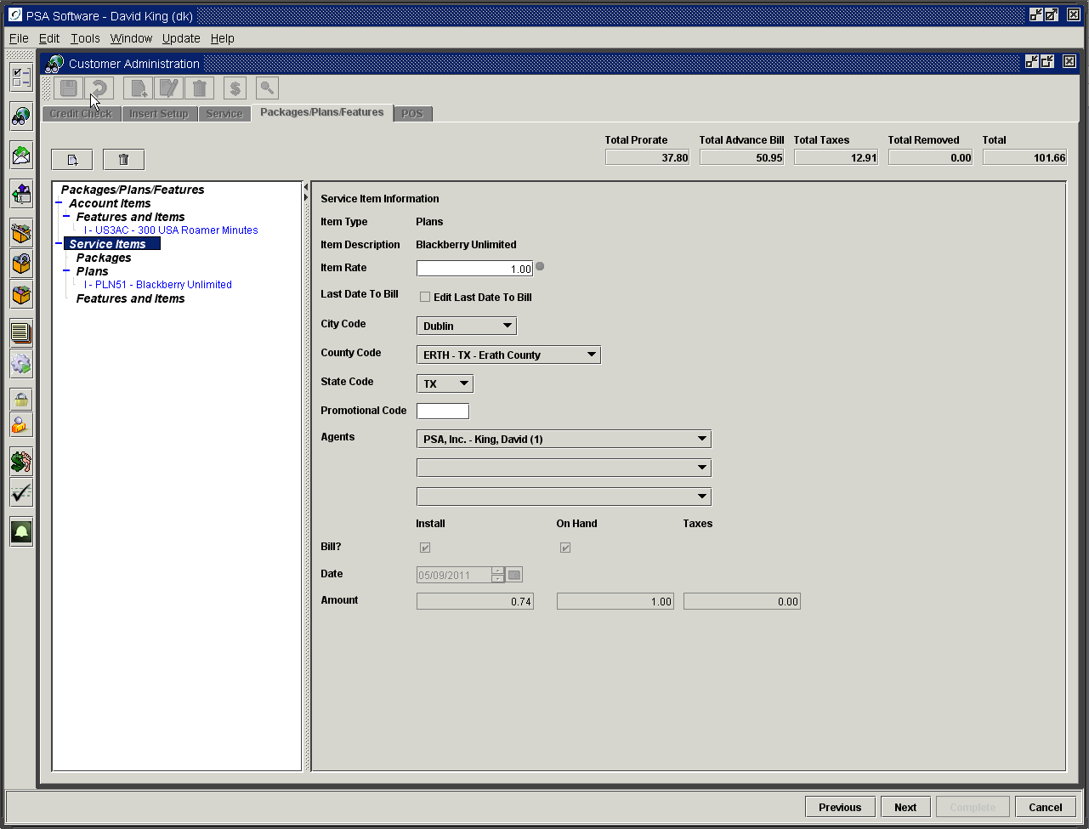

Notice that the plan is under its own category as a sub category of Service Items. Service level items are specific to the selected service number and will show on the service level summary on the bill statement.

Service Items are selected using the same process. Select the Service Level radio icon, which will display only items available at the service level. These items are specific to the service number you are editing.

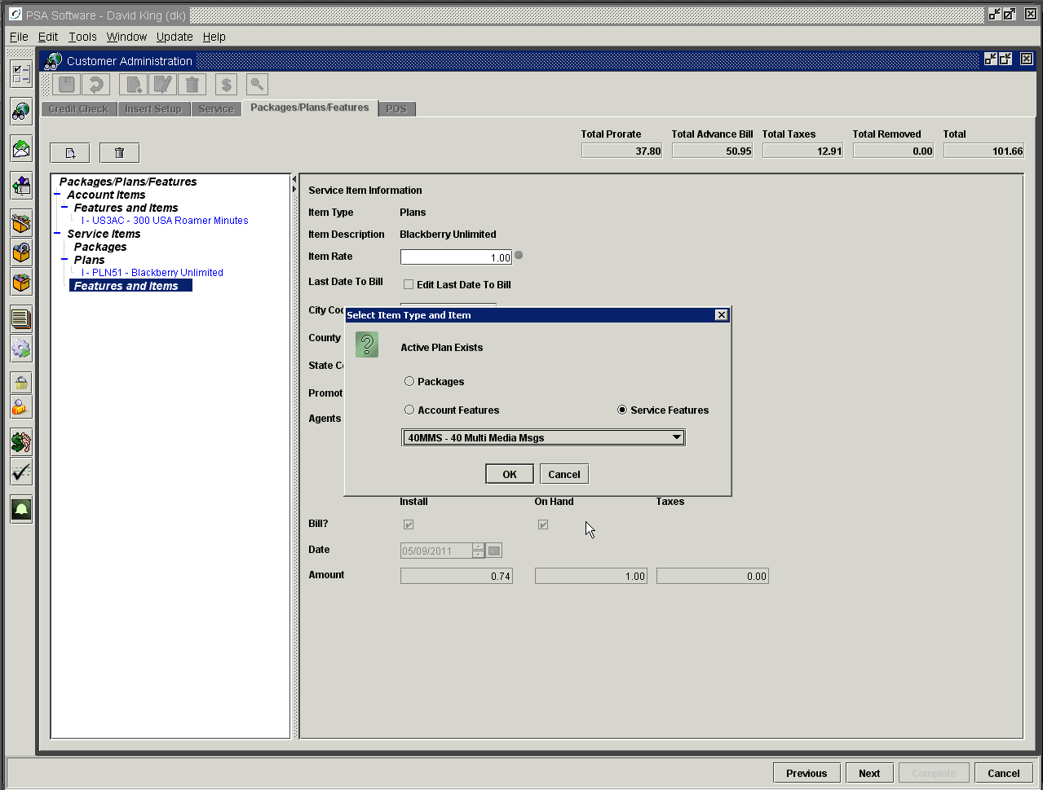

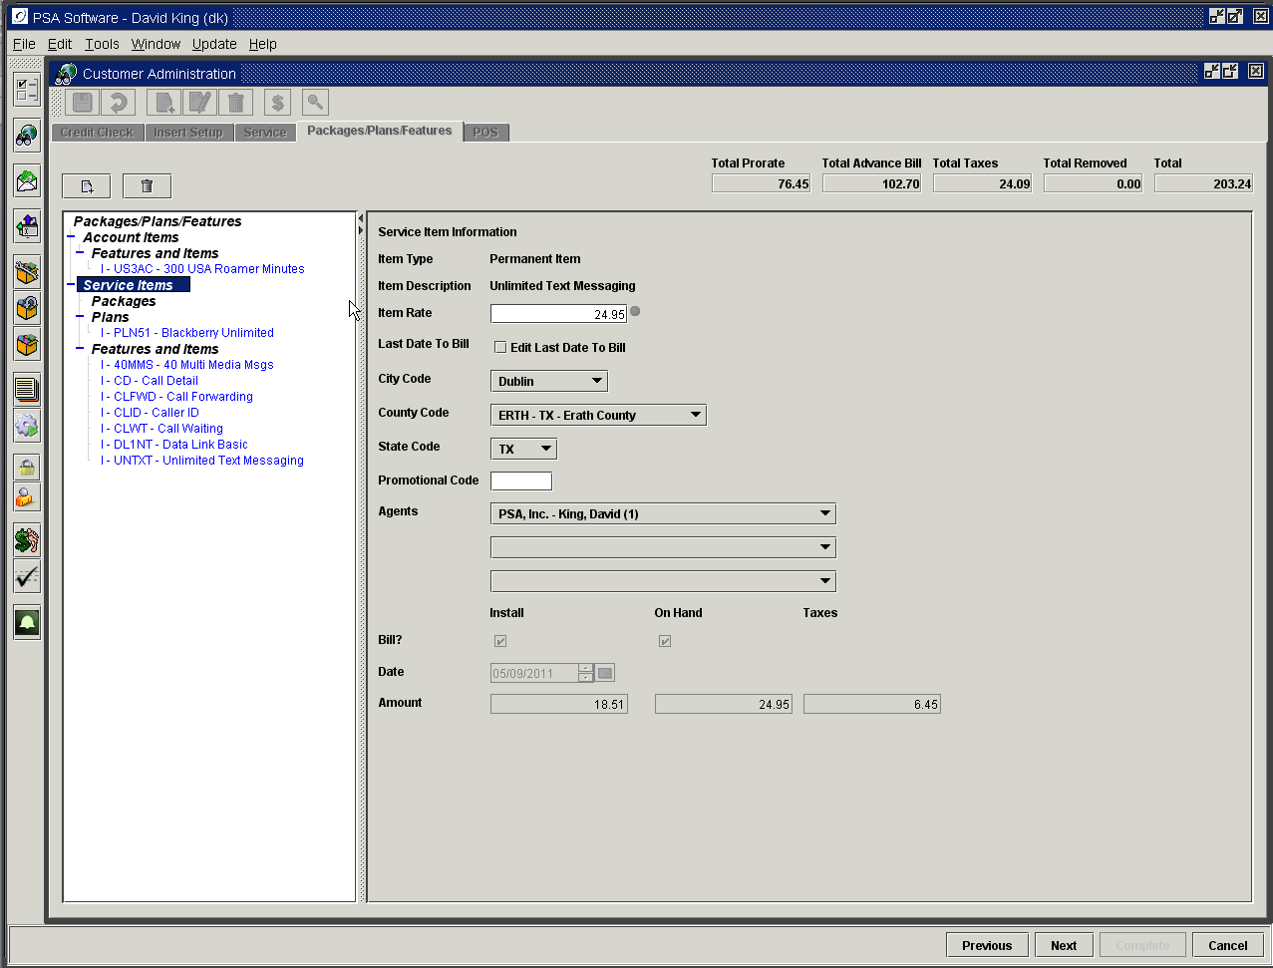

After all the packages, plans or features are selected or changed, press the ‘Save’ icon to post the changes. As a precaution, you will not be allowed to complete a Package/Plan/Feature change order without selecting a valid rate plan. There must be an active rate plan or combination of rate plans for the entire billing cycle.

Removing Ala Carte Items

Ala Carte items can be removed one at a time or simultaneously. This does not work within packages. Packages are removed as a whole or can be converted into ala Carte status on saving. You have two options on the package function. Option one allows you to use the packages function to add rate plans and features with the controls established in the package setup. These items remain together for the life of the package and cannot be changed independently. This preserves the rules of the package. Option two allows you to use the package function and the rules of the setup but at ‘‘Save’’ time the package rules are discarded and the plans and features are independent of one another. Each option has its pros and cons and should be discussed in detail with PSA before changing the function.

The first step is to press Edit on the Package/Plan/Feature tab. Next highlight the first ala Carte item in the tree. To select multiple items to be removed simultaneously hold the CTRL key down and select all the items to be removed. You may also select one item in the tree and hold down the SHIFT key and then select another item in the tree. All items between and including the two selected items will be removed. Release the CRTL or shift key and press the Delete icon. All items selected will be removed.

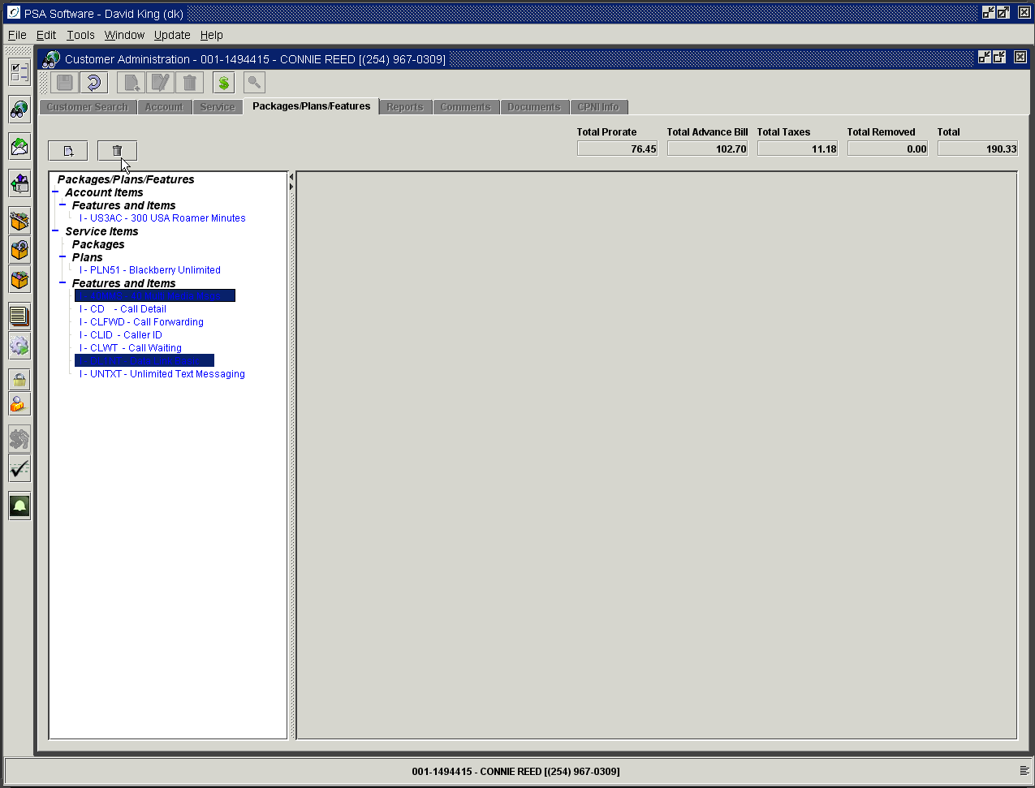

You will be asked to confirm each item selected. In 99% of the cases the user will not have the delete option. So where there is no delete option, the question will be “Are you sure you want to remove the item?”

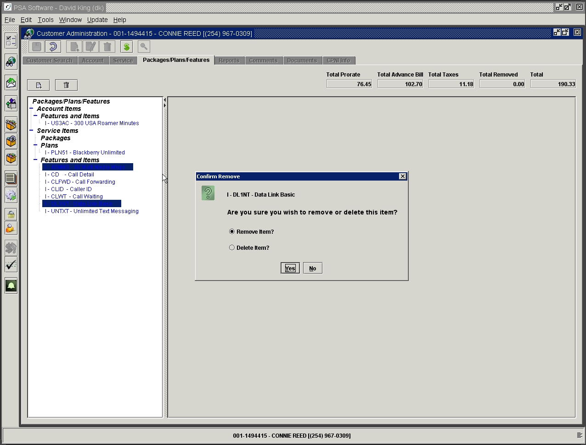

Pressing Yes will remove the item including proration where appropriate and the next Remove Item confirmation will appear. The item description is the first line in the confirmation popup. Carefully remove all the appropriate items by responding to the challenge popup. Once response has been made to all effected items you will see the items in the tree as ‘R’.

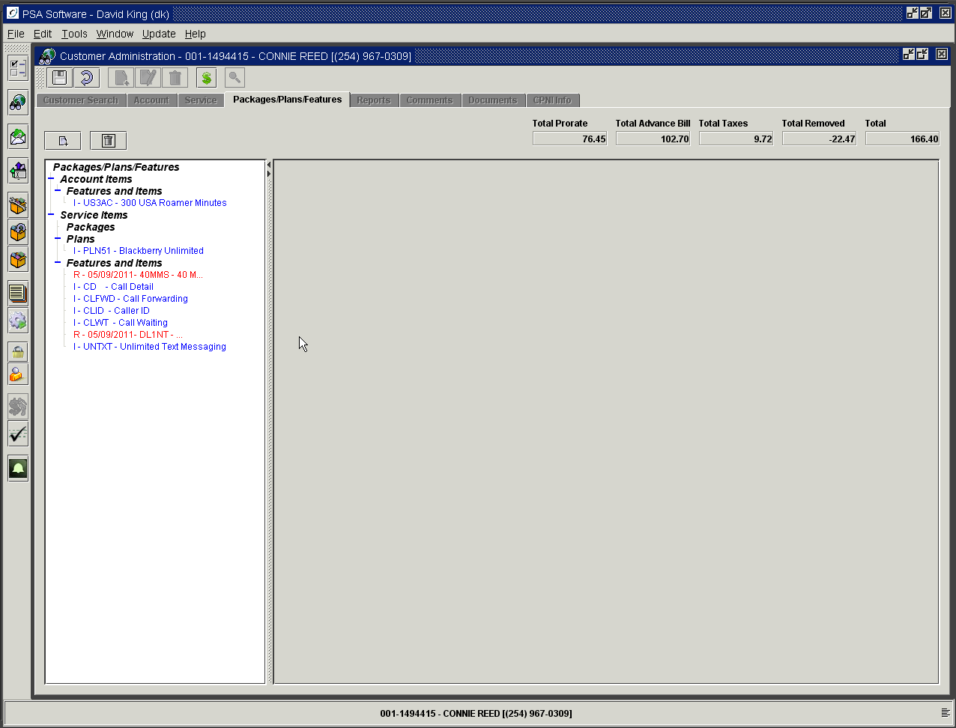

If the item you highlight cannot be removed manually, such as items created by a Free Calling Group feature; you will not be allowed to remove those items. Those items must be removed via the feature or application that created them. So for Free Calling Group features you would deactivate the free number on the appropriate date to remove the item. Many cases items such as free calling group items are not prorated so they will not have a removed amount upon removal.

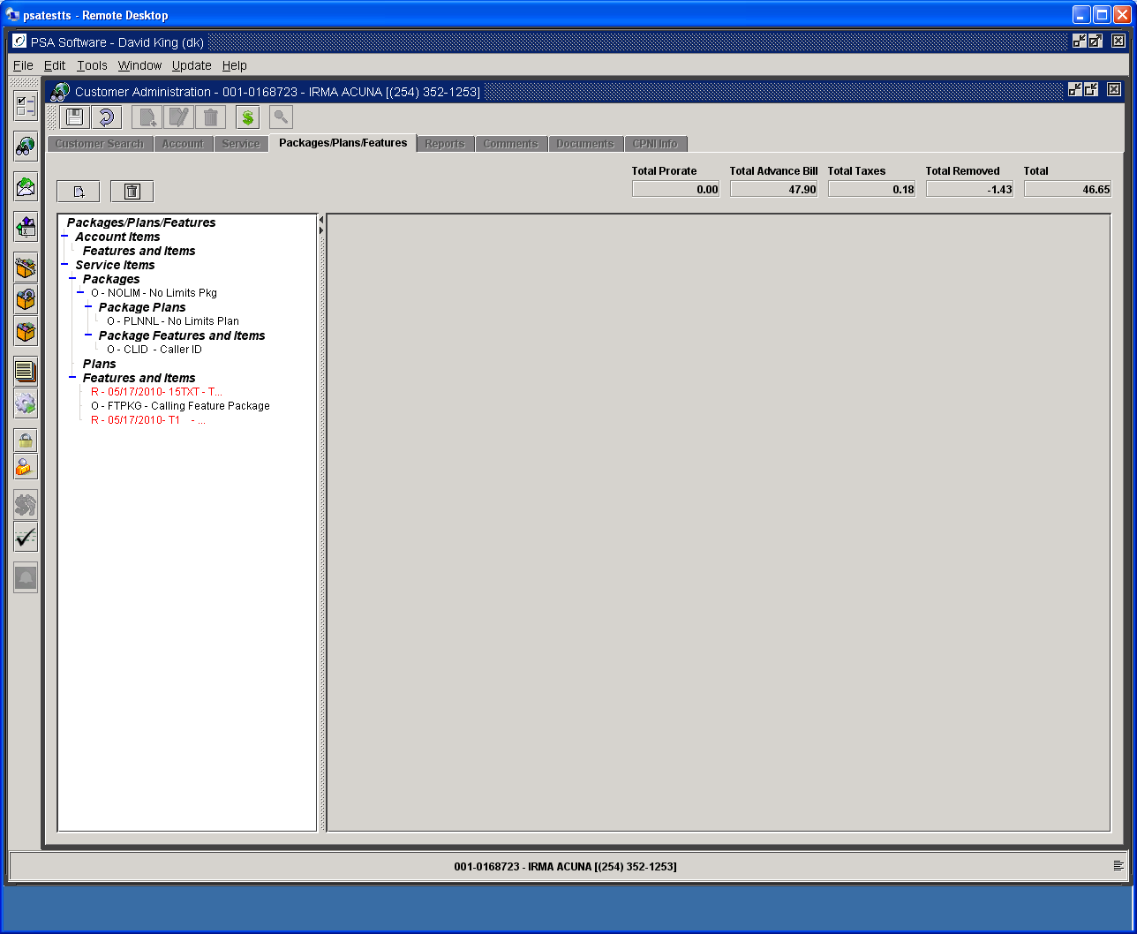

Review the removals and if correct press ‘Save’ to complete the service order. If you remove a plan in the process remember you will need to add back a plan prior to pressing ‘Save’.

NOTE: Removal of an Installment Item: Removing the billing item on the Packages/Plan/Features screen does not automatically charge the balance (if any) on the Installment. You must manually adjust the balance using one of the installment adjustment items.

Establishing the Primary MDN for Corporate Plans

When a service is installed with a corporate plan you have the option to select a service to be charged the primary charge in the corporate setup structure. That is done by opening the plan screen on any service with multiple services linked by super account and selecting the ‘Primary’ number from the Primary MDN drop down box. That number will remain the primary charged number until disconnect or a change is made on another phone within the super account group. There can only be one primary per super account group. If a super account group loses its primary service number due to disconnect or unlinking then a notification will be sent to someone within the company letting them know there is a super account group without a primary service number. If there is only one number left on the super account group with disconnect of the primary service then that service will be made the primary service number on the super account.

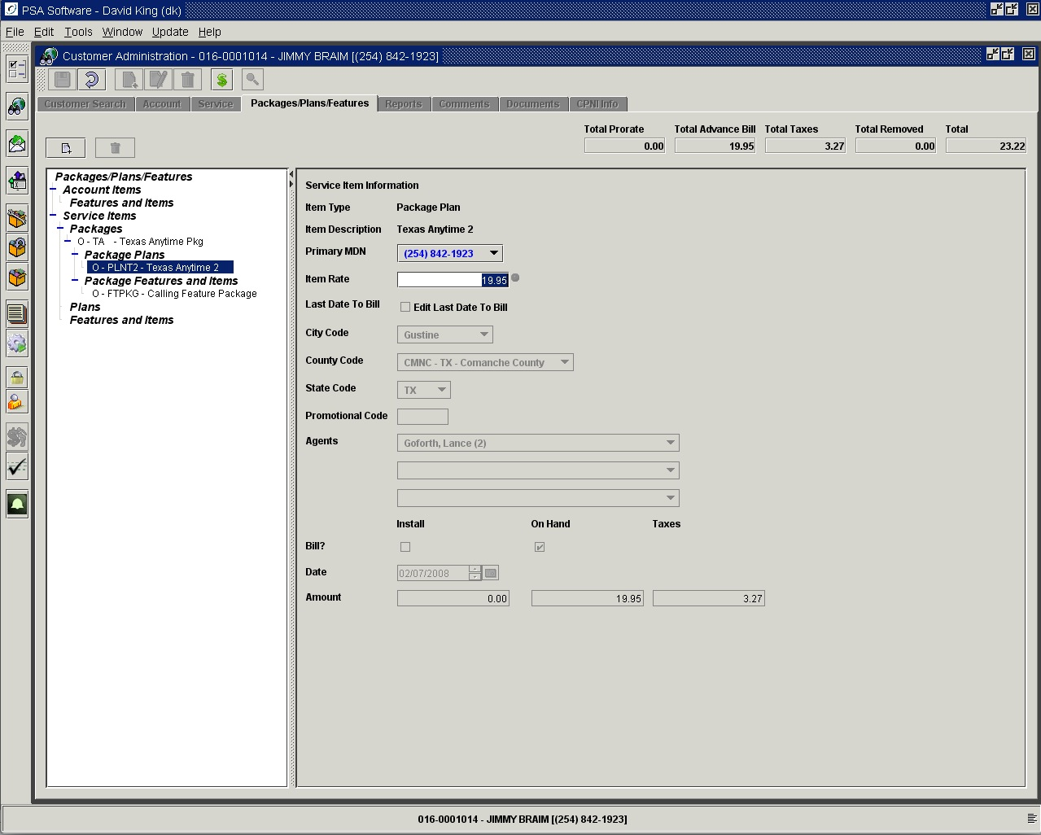

Free Calling Group Setup

Adding Free Calling Numbers

If your plan has the Free Calling Group functionality then you will see the following additions to your plan screen. Highlight the plan in the tree to add free phone numbers and press Insert Number button. You may edit these numbers after the install by opening the Package/Plan/Feature tab in Edit mode and highlighting the plan in the tree. The table will display below the plan information. All numbers that are entered or removed during the cycle will be displayed; the bill run will update the list to only show active numbers. If the Insert Number button is grayed out, then the maximum number of free group numbers has been met.

If the free calling feature has a charge associated with each line added; you will see the charge feature appear in the Features and Items section AFTER the ‘Save’ is done. Each line will have a corresponding charge. These features are controlled as any other feature in regards to proration and advance billing. The enhanced website application will also add and remove features when required.

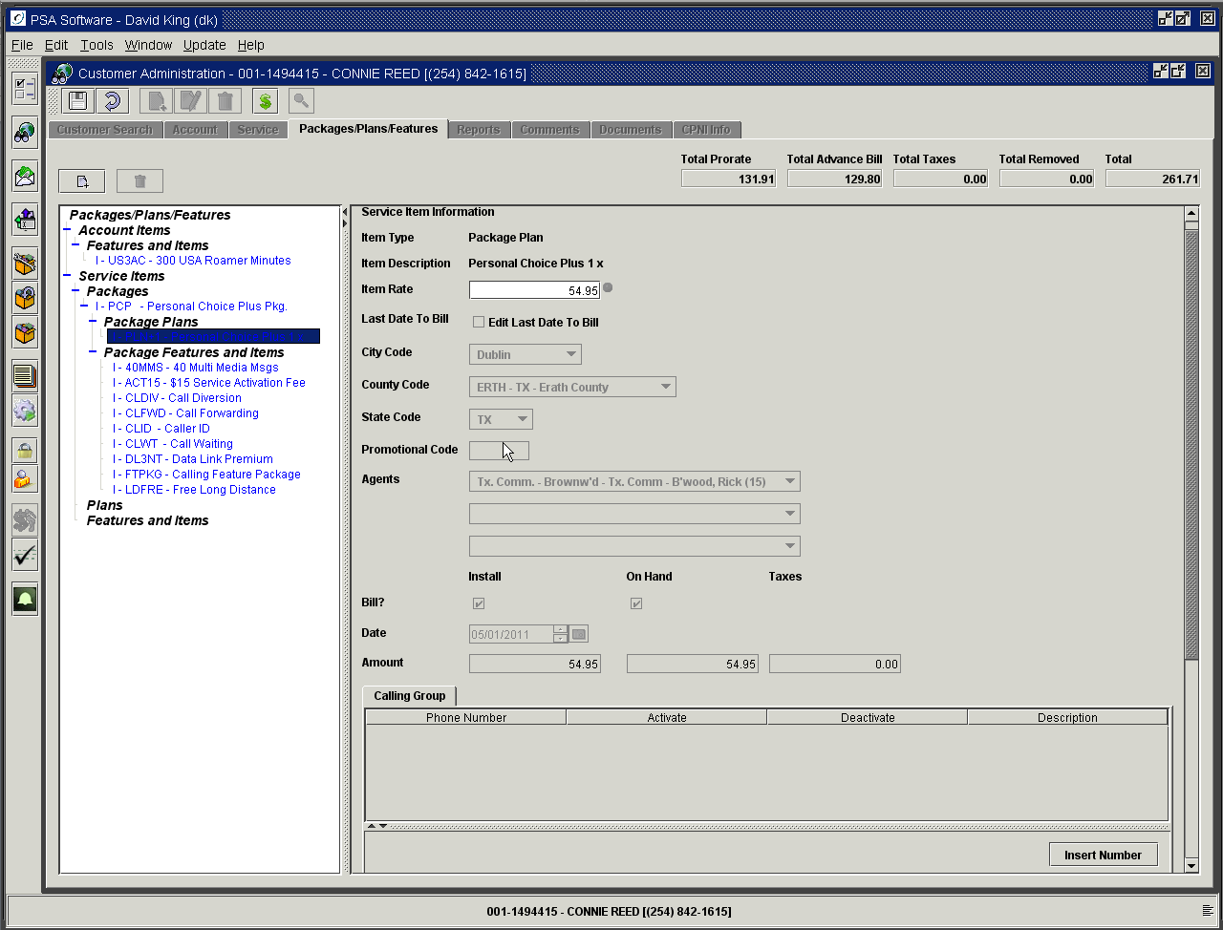

Phone Number: Enter the number to be included in the group: you may not select the service number you opened, or 000-000-0000. Enter the description for the associated phone. This helps identify the number for easy recognition; this number can also be displayed on the customer’s statement.

Effective Date: If you have the authority to change the activation or deactivation dates, select the date carefully to insure there is no overlap. The system will help in detecting invalid dates in some cases. If you don’t have the authority to change the date, the system will set those dates for the CSR. The system will monitor for the maximum number of phones with each activation or deactivation and disallow actions on the list accordingly.

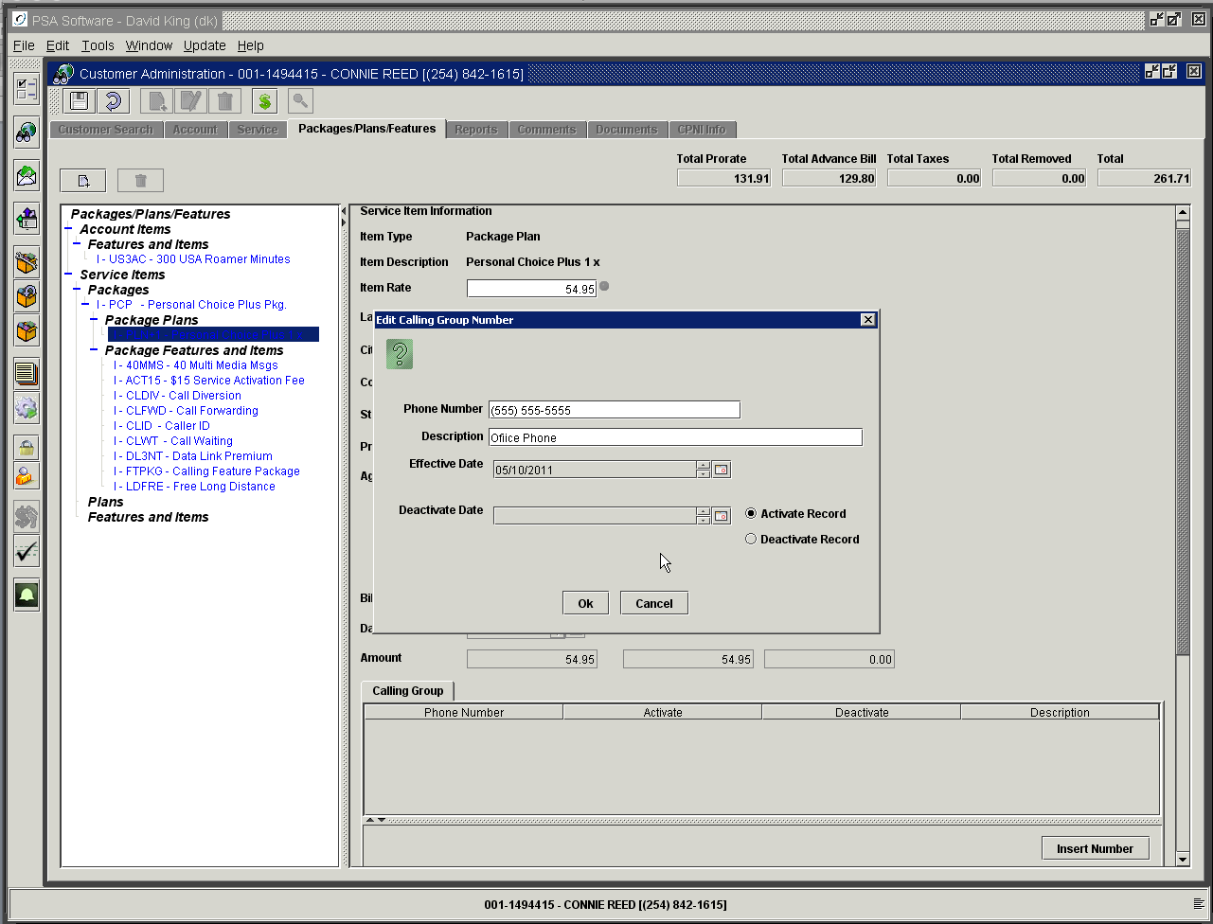
Depending on what is occurring in the application the next field could show either of the two following date descriptions. This date is normally defaulted by the application but may be changed by the user if they have the additional authority to access the calendar icon on the right of the date. The choice of activation vs. deactivation is controlled by the application.

Activate Record: Indicates this number should be included as of the date selected.
Deactivate Record: Indicates this number should no longer be included in the group after the date selected.

After adding the ‘New’ numbers or editing existing numbers, press ‘Save’ to complete the action. The following example shows the table with completed entries.

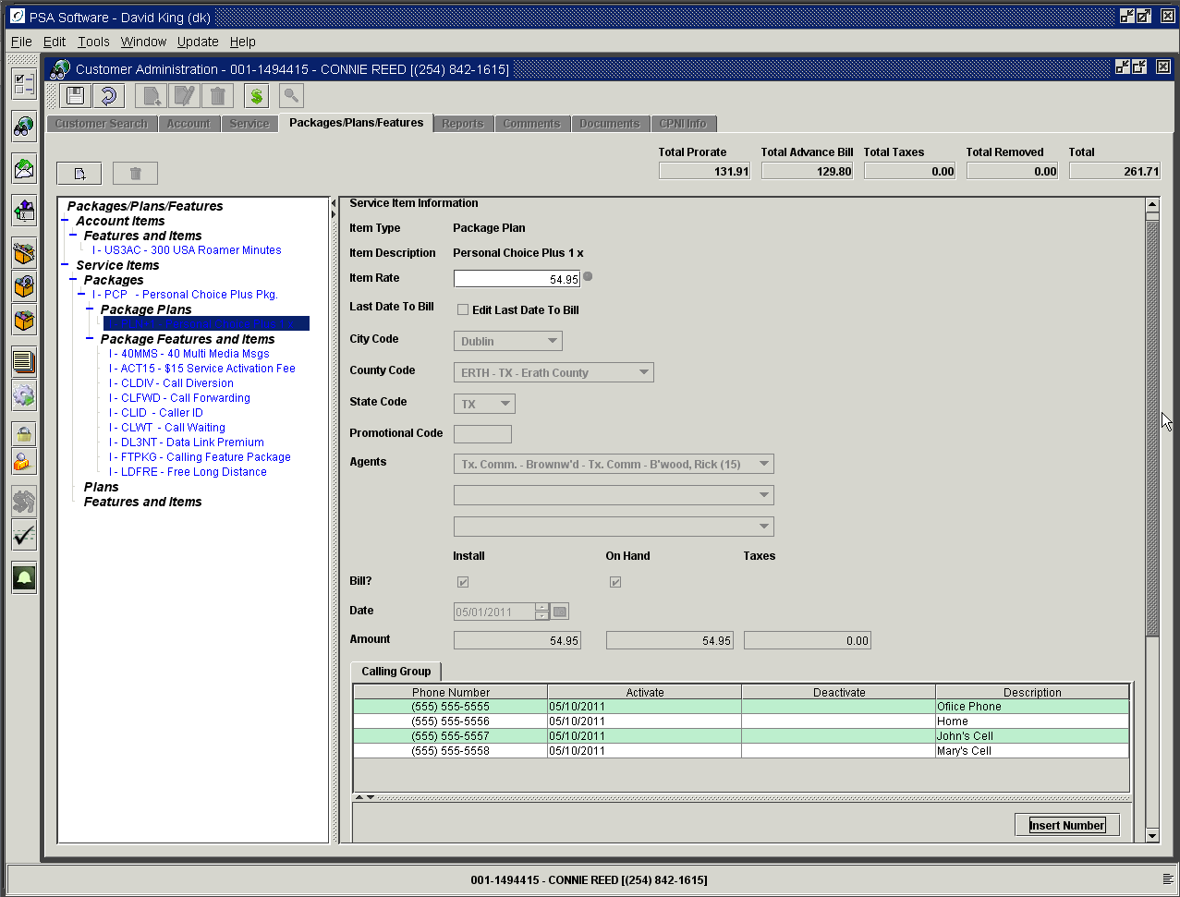

Removing Free Calling Numbers

To remove a number from the list, double click the number in the list. This will display a dialog box from which you deactivate the number. Once the dialog box is open select the Deactivate Date using the calendar icon. The calendars are active only if the user has authority to edit them; otherwise the current date will be the date used on deactivation. This will change the setting to the Deactivate Record radio button. Pressing OK will change the status and create a deactivate date on the record.

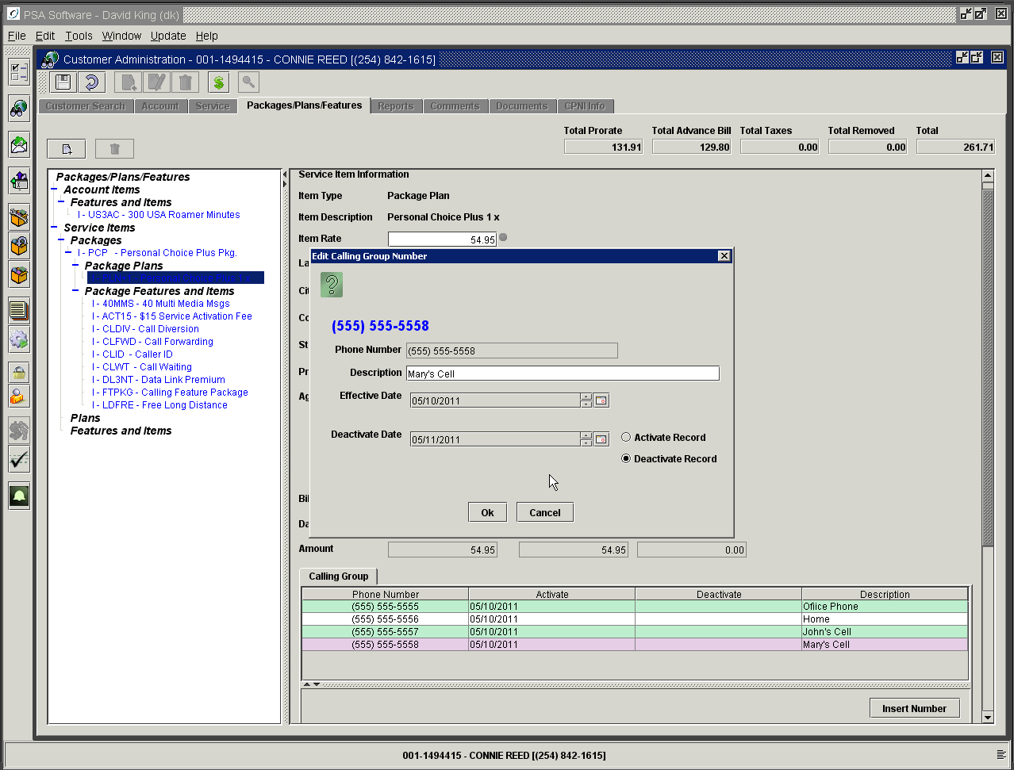

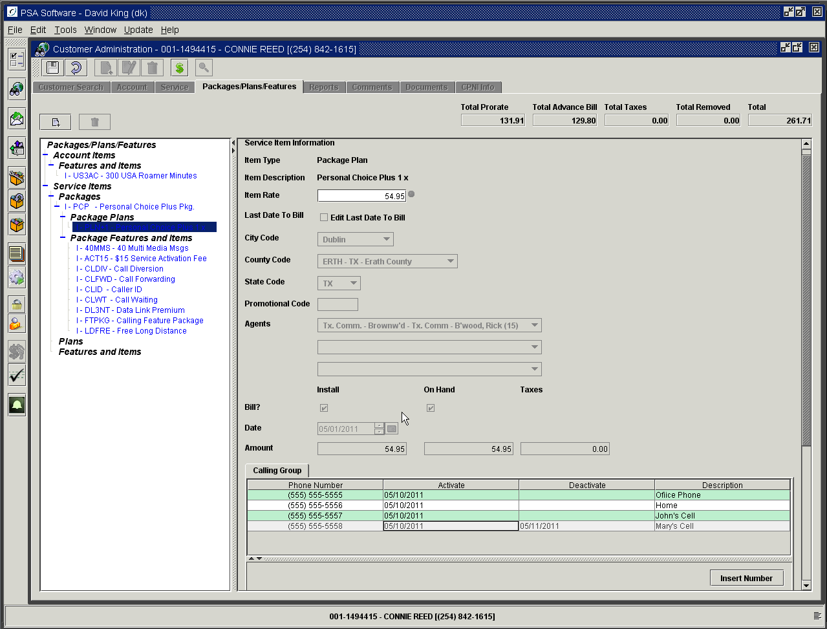

Reactivating Free Calling Number

If billing has not processed and the deactivated number still appears in the free number table, you may reactivate a number by double clicking the number. You will then change the radio button from Deactivate Record to Activate Record, which will add the number back on the list. You must remember that if the maximum records on a free calling group have been reached, numbers must be first removed before you can add or reactivate a numbers.

If you use the PSA Electronic Bill Presentment and Payment module then end users can have the ability to add or remove the free calling numbers on the website. They will be subject to restrictions for dates of activations and deactivations so as to not allow abuse. If the free calling group feature has a charge per line then that will be handled on the website as well. They will see proration of additions and removals on the monthly statement.

Reports

Under reports are various additional information screens. These reports as a general rule are viewed within the application but some larger reports may require emailing so as to open with another program such as Outlook or Excel. All the reports are available to print, ‘Save to a File” or email. Selections include but are limited to: Summary Screen, Accounts Receivable, Bill Images, Bill History Summary, Current Call Report, ESN History, Account/Service Item Summary, Payment History – All Dates, Payment History – Last 60 Days, Re-Rate Inquiry, Transaction History – All Dates, Transaction History – Last 60 Days, and Write- off Inquiry.

Select the display/report from the drop down box and click the View Report box.

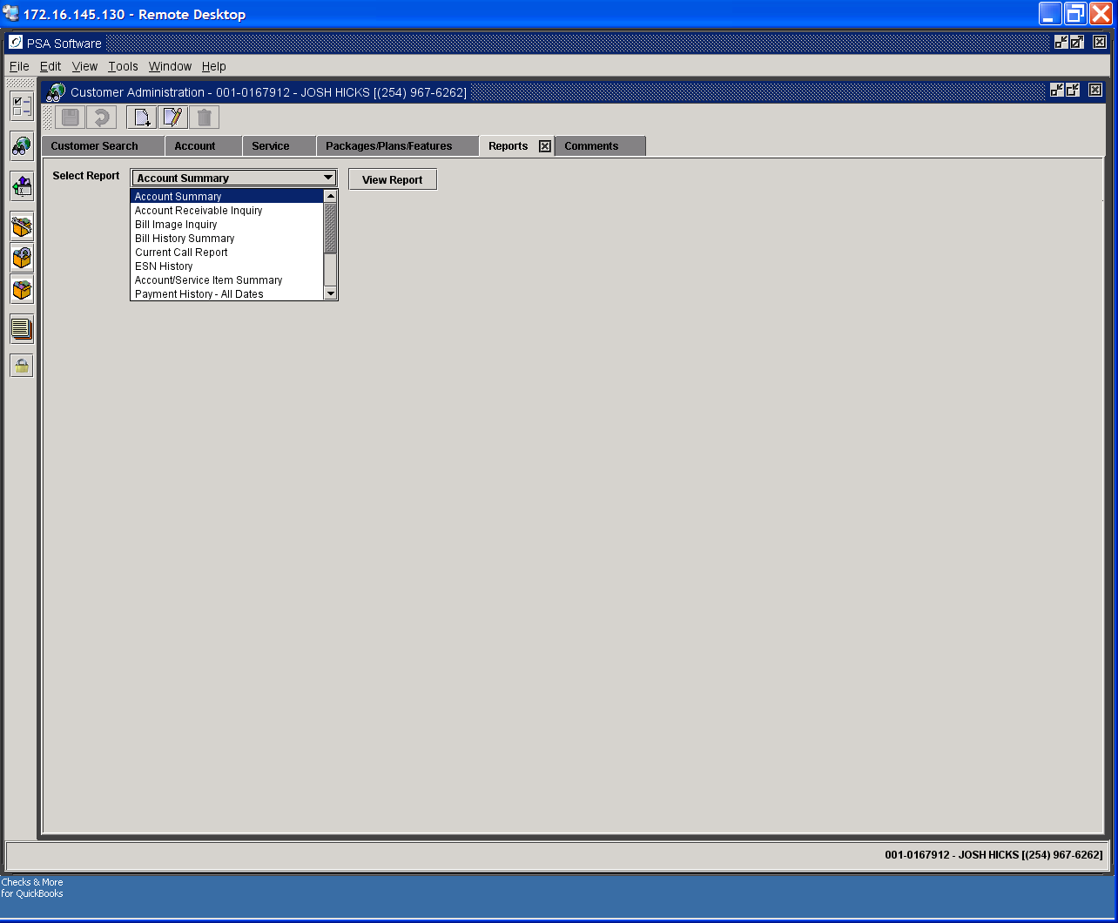

The selected inquiry will then display in a print friendly format in a ‘New’ tab. Additional reports that are opened for this customer will open in its own tab. You potentially could have 10 report tabs open on one customer. You are not required to close each tab when you are finished reviewing the reports; selecting a ‘New’ customer from the search screen will close the Report tabs.

Account Summary Report

Choose the Account Summary report from the drop-down box and press View Report.

First Printer Icon – displays a printer dialog box.
Second Printer Icon – prints immediately to the user’s default printer.
‘Save’ to File Icon – Allows you select the folder to store to, name the file, and select how the report should be saved. Types of ‘Save’ – Adobe PDF opens with Adobe, Rich Text Format (RTF) opens in MS Word, Plain Text, PNG (Portable Networks Graphic) Image opens well in Web pages, TIFF image (TIF), PCL Printer file, Encapsulated Post Script (EPS), Adobe Postscript (PS), HTML which loads well into MS Excel or Word.
Send Email Icon -- Sends a copy of the report to your email.

Additional controls are: first page arrow, back page arrow, next page arrow, and last page arrow. End, Page Up and Page Down are also functional. Zoom function is set from 25% to 300% of image.
Other selections: Fit In Window loads the largest image for one page per frame. Fit Width expands the image where the width fills frame and length is scrollable. Go To Page box allows you to move to specific page, enter the page number and press the icon immediately to the right

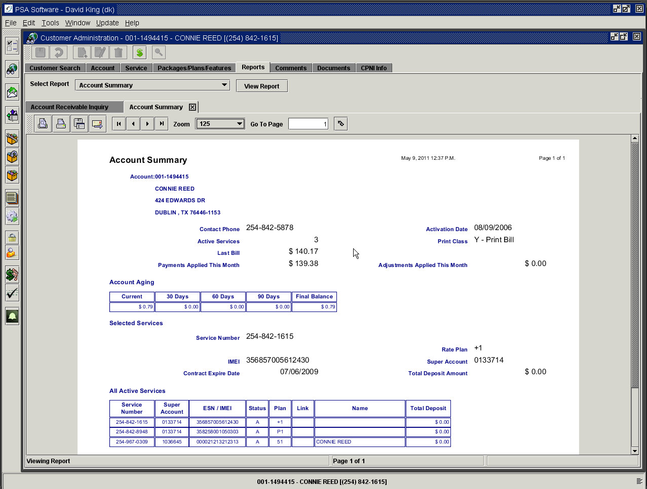

Account Receivable History

The first table shows the balances owed from current charges up to 90+ days with the overall total as the Final Balance.

The second table shows the summary of bill amounts, payments, and adjustments for the previous twelve months. As the ‘New’ bill is produced, the oldest information is replaced with the current information maintaining a running twelve-month balance.

If the customer has received any late notices they will display in the next tables showing each occurrence and the type of notice sent.

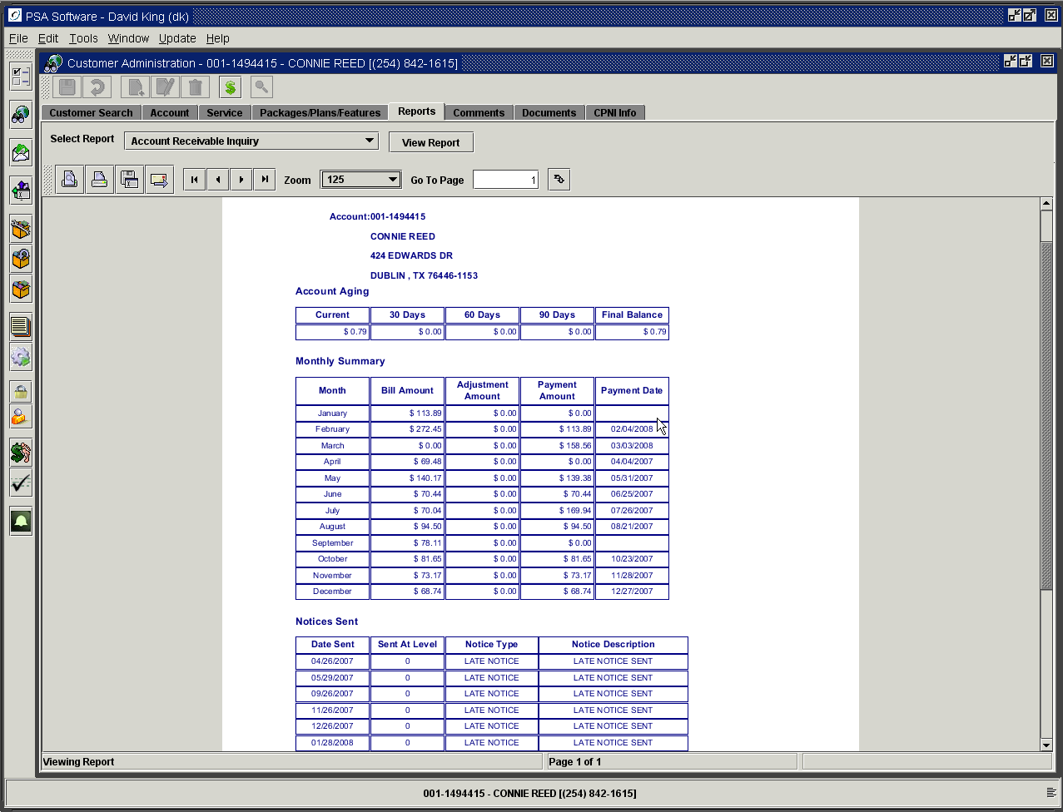

Account/Service Item Summary

The report shows all plans, features, or packages installed on this service number. Charges/Credits are broken out for removals, pro-ration, or recurring items/features.

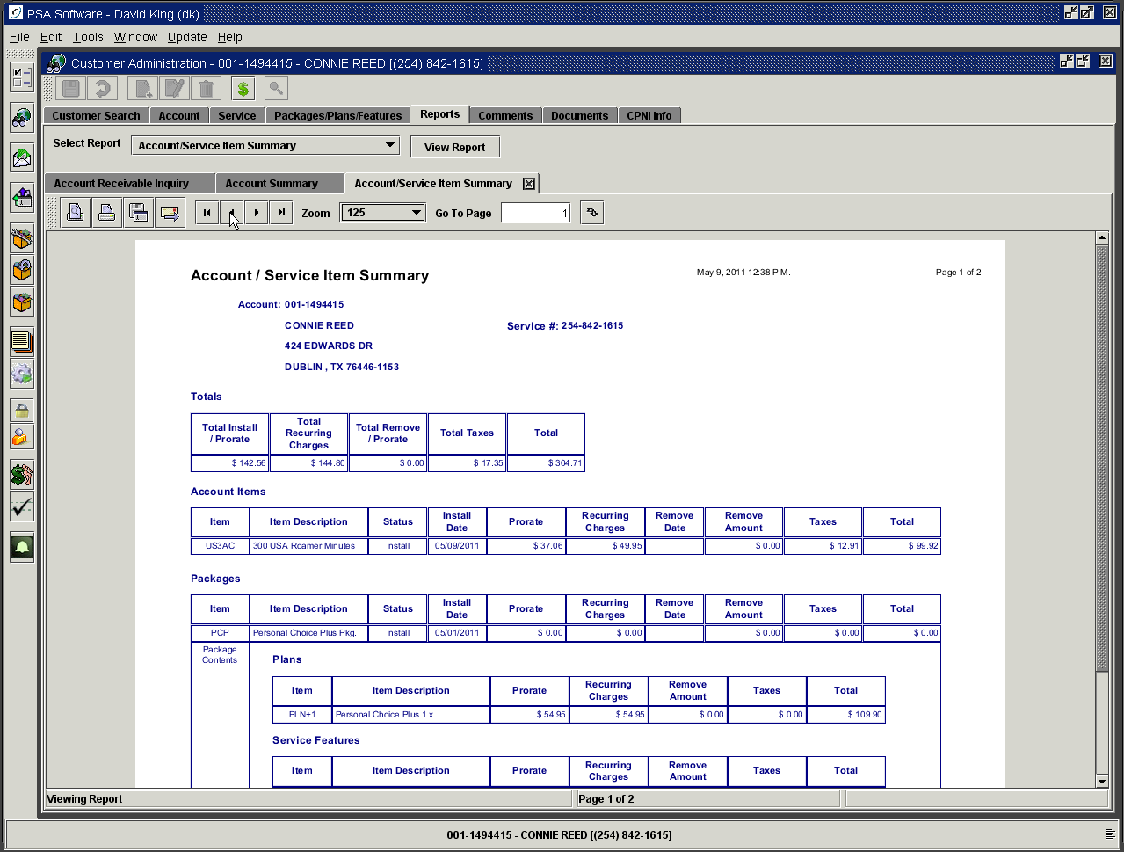

Adjustments Report

This report shows all adjustments (both account and service level) that have been applied to this account. To see if the adjustment applied to the specific service number check the number in the Serv Column.

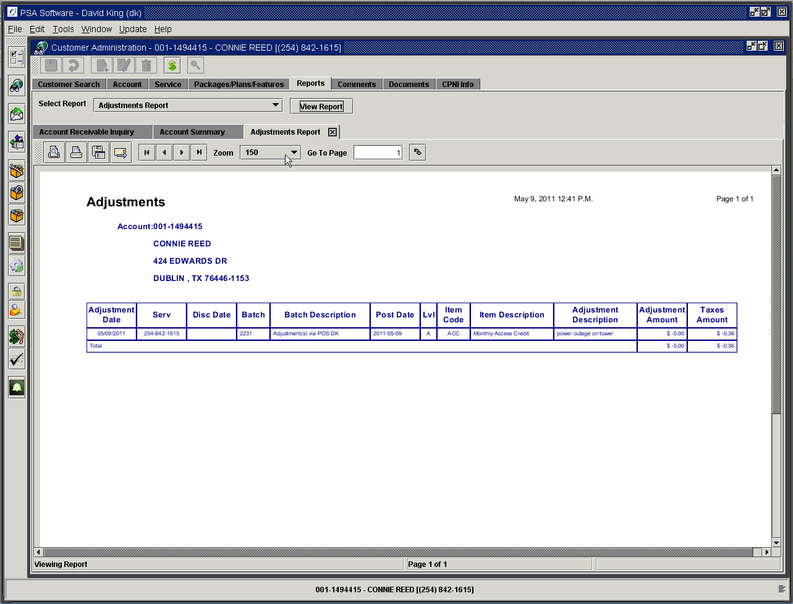

Bill History Summary Report

Overages, long distance charges, or roaming charges trends can be seen at a glance and can be paired to the plan at the time. These are selections from various parts of the statement. The horizontal line will not total to Current Charges. The first section is specific to the service number selected. The second section is summary totals for all services on the account.

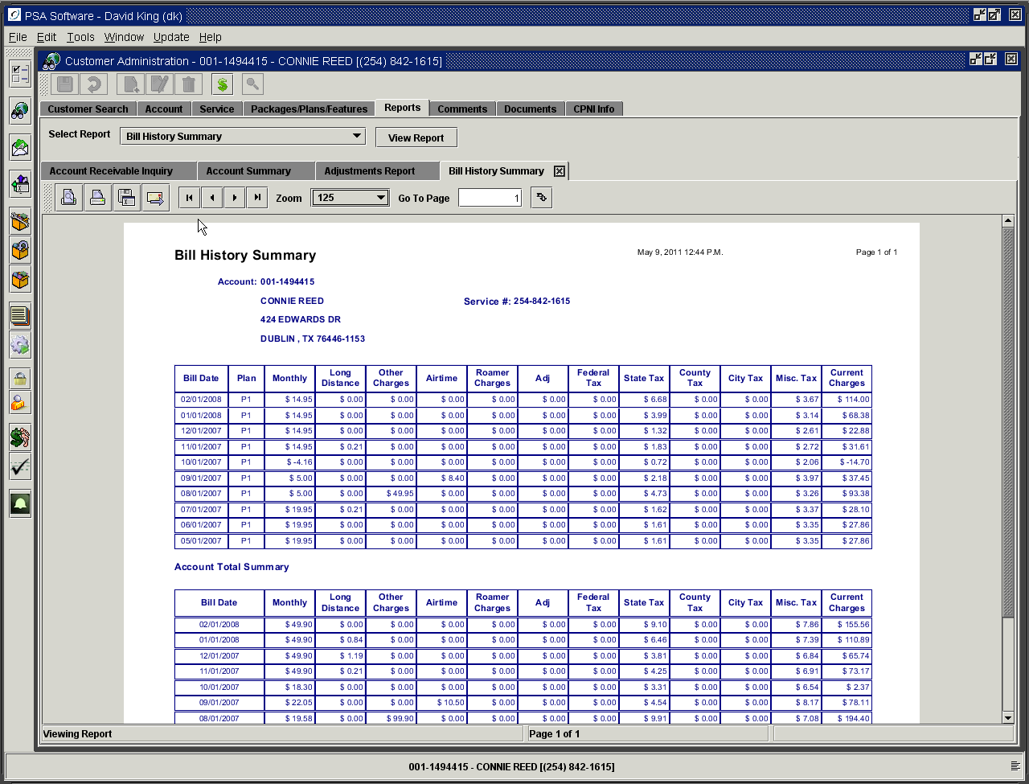

These column represent information gathered for the service number listed at the top of the report only.

Monthly – access fee charged for the rate plan

Long Distance – charges incurred for calling long distance only

Other Charges – charges created by Temporary or Equipment type items

Airtime – charges incurred for airtime overages

Roamer Charges – roaming charges including daily use fees

Adjustments – adjustments applied to the specific service number

Current Charges – total from statement for all charges (access, overage, data, etc) including taxes for the individual service number. This total will match a line in the Account Summary section of the statement for this service.

Bill Image Report

Multiple bill images are maintained on the system. The images shown in this area are HTML documents and will not visually mirror the customer’s actual statement. Regardless the bill print options (where some customers only receive summary bills) this image will always have full detail. This statement is a ‘text only’ copy of the statement, leaving off logos and formatting of your normal statement. The same informational detail is used to create both this statement and the end user statement from your bill vendor. You normally have access to 6 to 12 months previous statements depending on the size of your company.

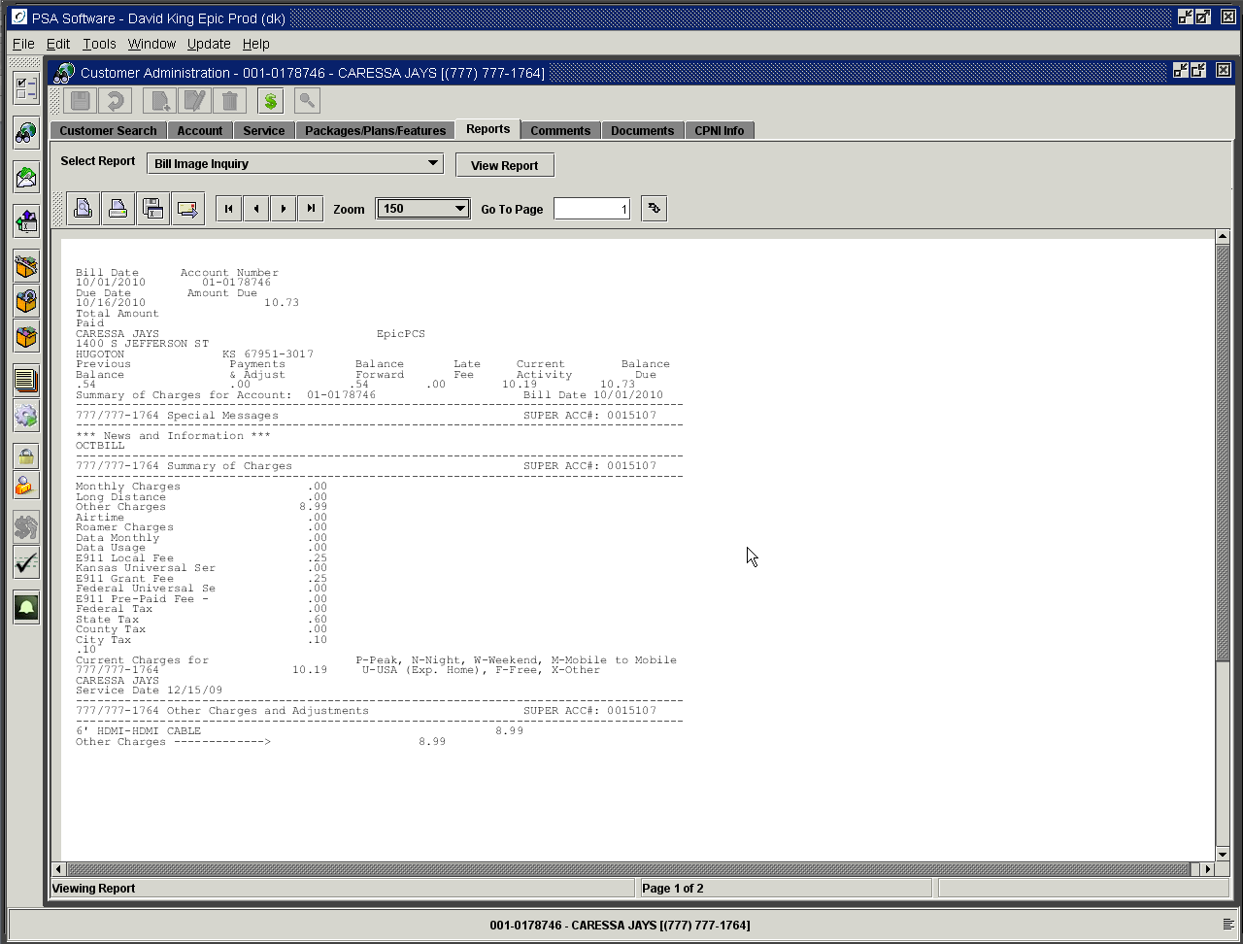

Billed Effects to Account

This report is a compilation of fields from several reports that is ONLY for the current cycle. It has a summary accounts receivable for the current period and then sub-sections for Unbilled Equipment, Unbilled Temporary items, Adjustments and Payments.

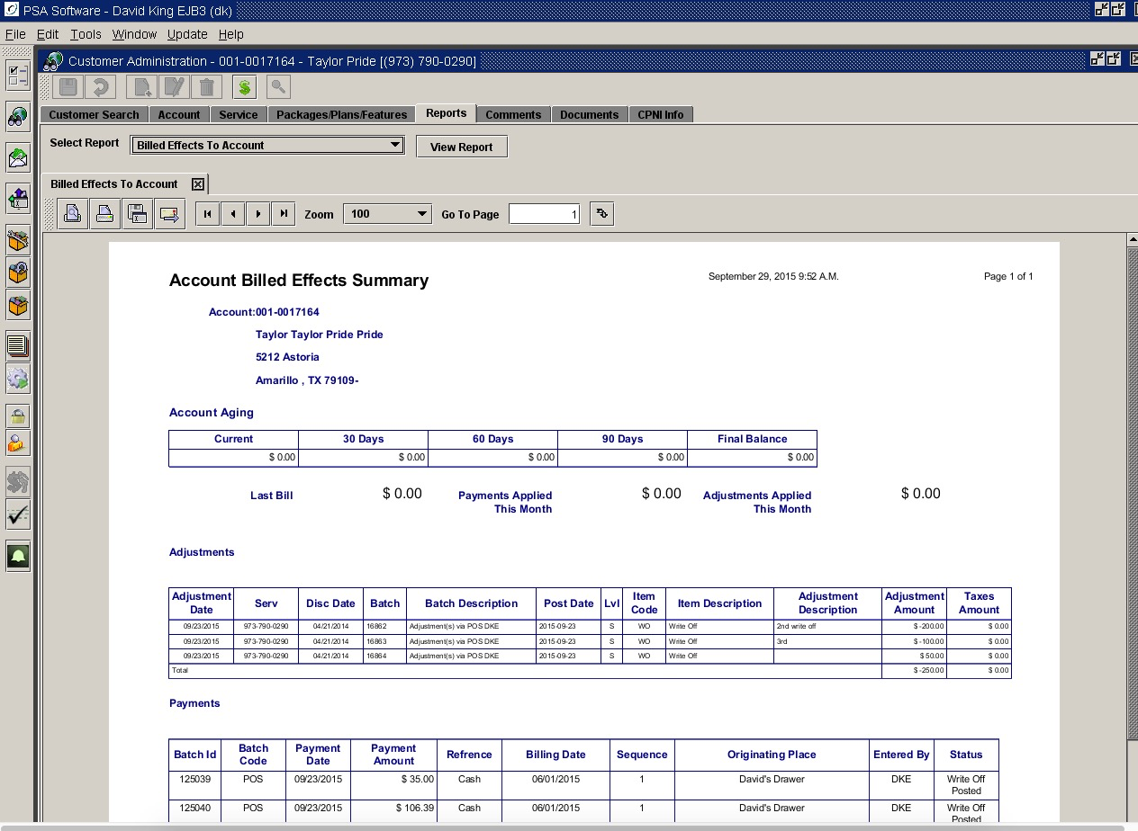

Change History

As you make changes on the customer account, the system will log many of those changes into this file. The changes that affect the customer at the account level will be listed first. Ex: Change of address, change ACH info. Changes affecting the individual service number are listed in the second section. Examples - New service, plan change, new IMSI/MEID. The final section is the Audit table entries for changes made to the various fields showing the before and after values.

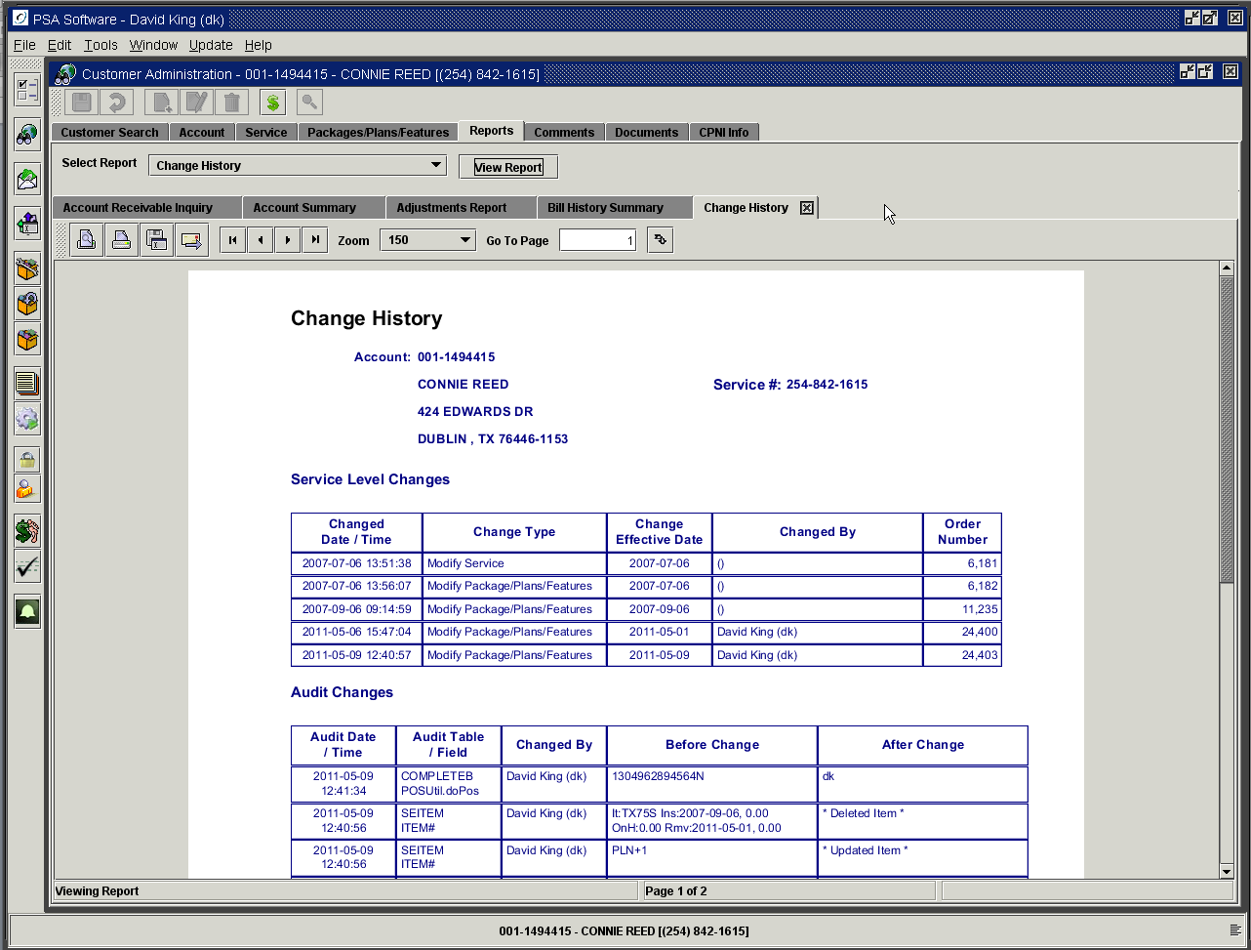

Comment Report

This reports creates a print friendly or email friendly report showing all the comments. The report is divided by color, account level comments are shaded in purple, and service level comments have no shading. The report is in date order by type.

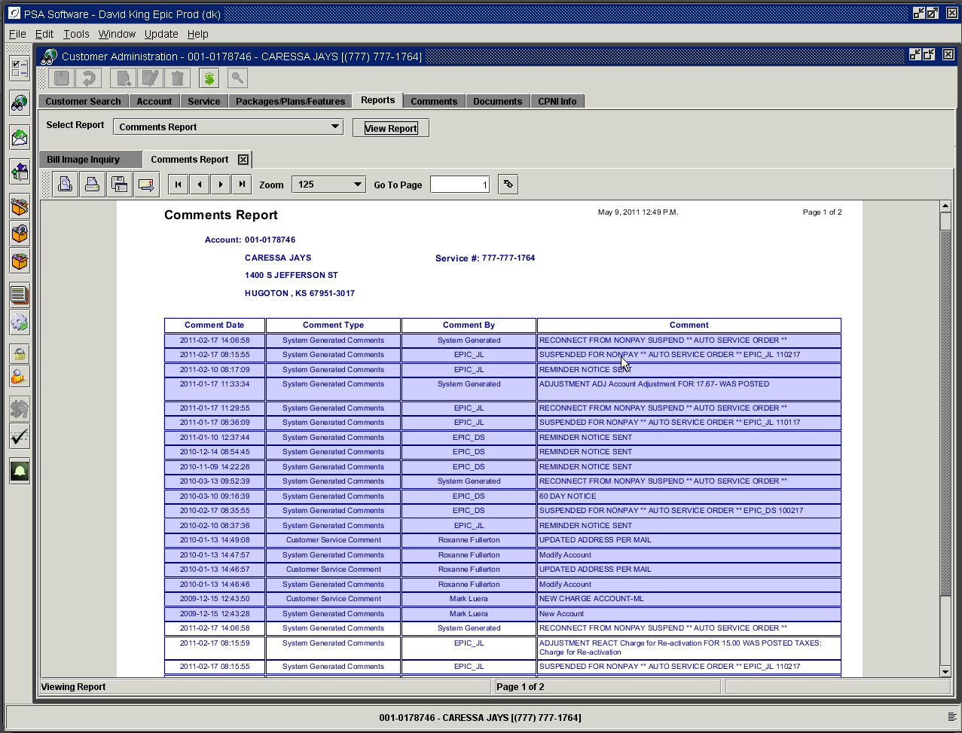

Credit Card Response History

The report stores the response from each credit card transaction. The report is in date order.

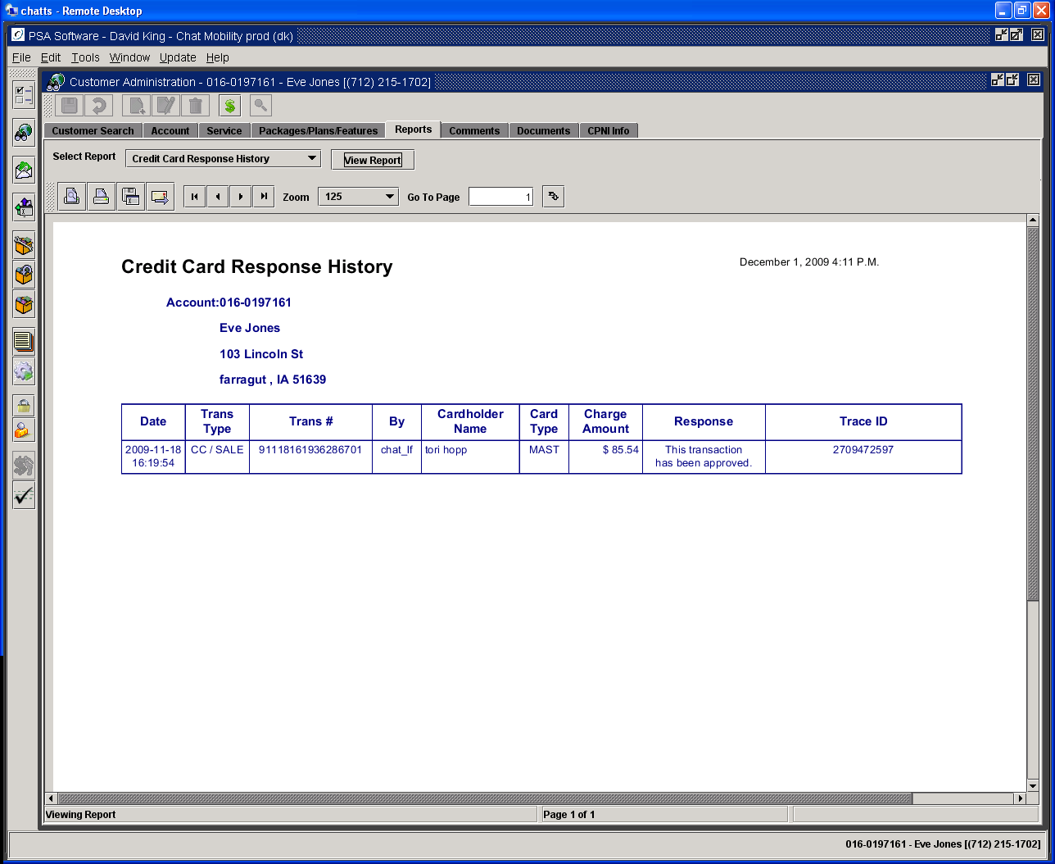

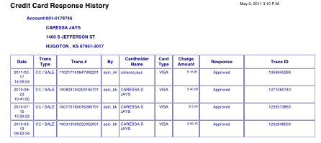

Current Call Report

Not all companies will have all the items described in this section. Example: not everyone provides for carryover air certificates.

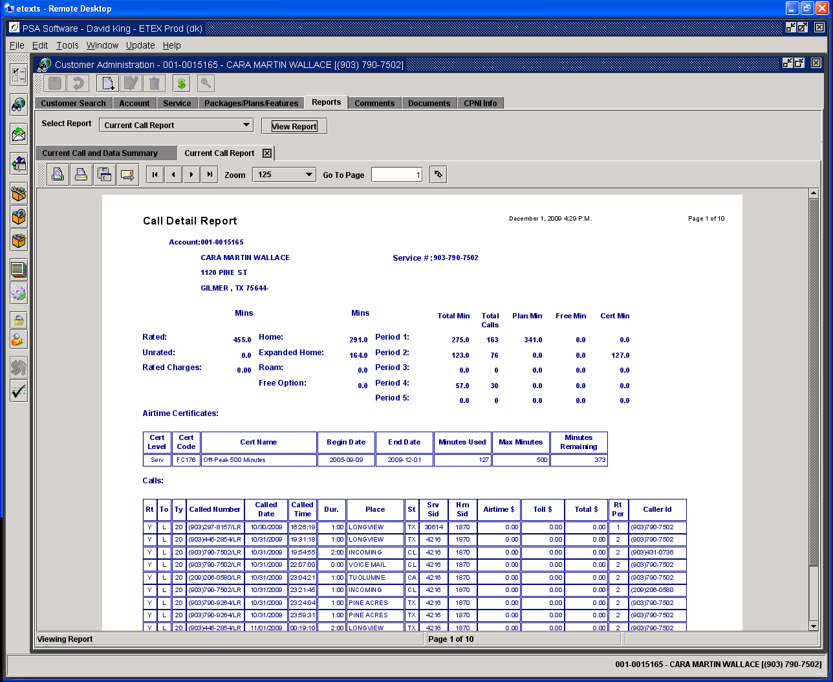

Rated Minutes: With each rating run, minutes are added to this total.
Unrated Minutes: If your switch pushes records to our software or incollect records are processed and rating has not run, then those minutes will display here. Once the next rating runs these will be included in the Rated minutes.
Rated Charges: As records are rated and accumulate charges, the total will be shown here.

Once the minutes have been rated, they are initially broken out in the next fields:
Home Minutes: These minutes are pure network minutes.
Local Roam Minutes: Minutes that are generated outside of the network, but are re-rated to show as home minutes, will accumulate her
Roam Minutes: Minutes created while roaming are totaled here.
Free Option Minutes: These are free minutes given by using the Free Airtime Options setup on rate plan setup. Items that could be included: Days of the Week, Mobile To Mobile, Free Incoming Calls, Free Voice Mail Retrieval, Free Voice Mail Deposit, Free SMS Messaging, Free Rate Periods, Free Charge Indicators (SMS, Browsing/Internet, MMS, Ringtones, etc). If you use the Free Options table to give free airtime then the minutes are shown by period under the Free Min column

Free Option setup on rate plan. Any of these options will create the Free Option Minutes shown on the report.

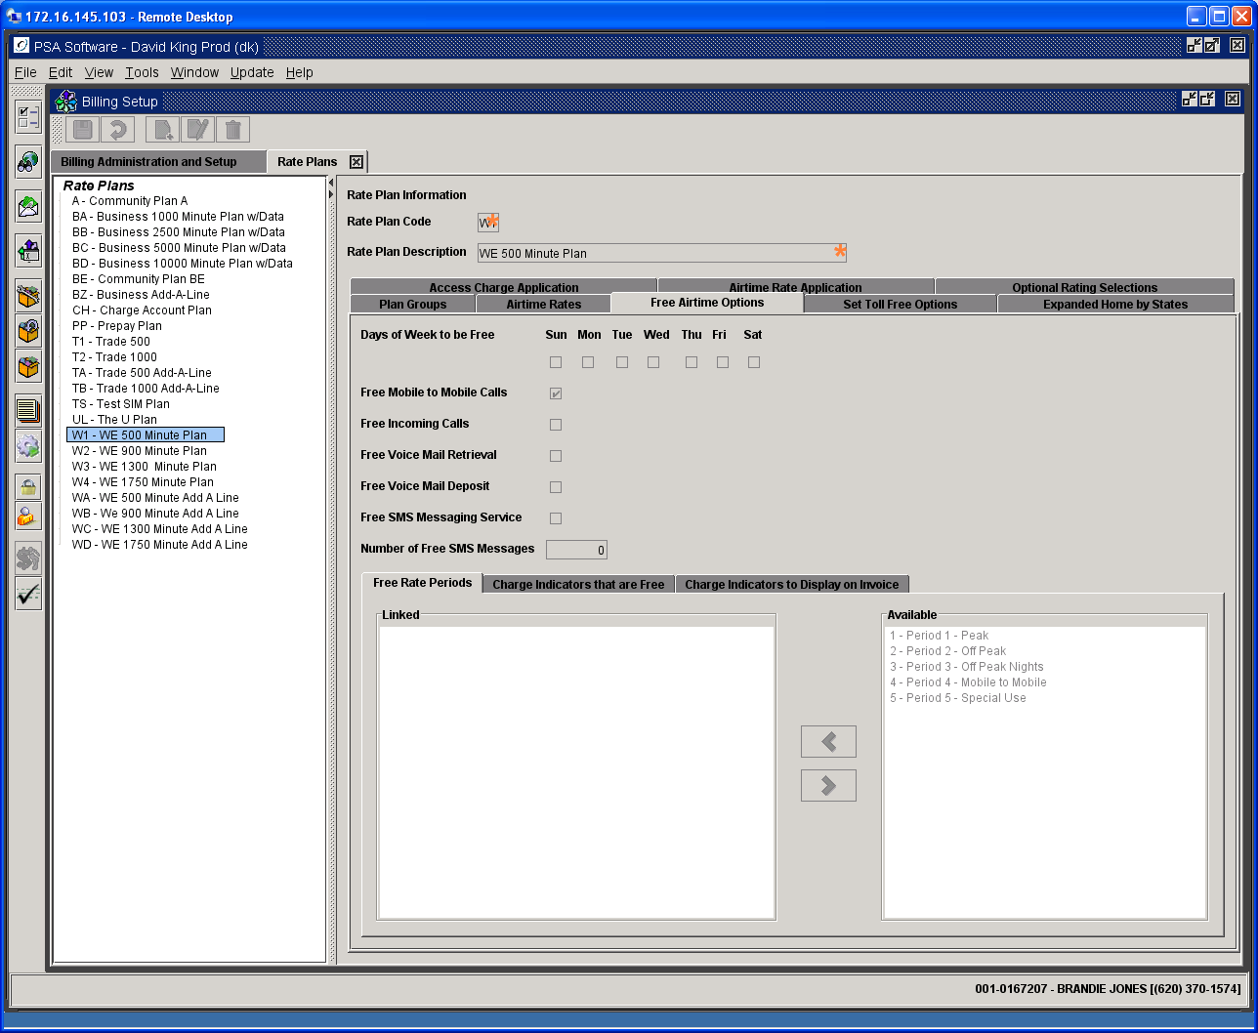

After the first breakdown, minutes are further broken out by period: Your company may have different rate period definitions than defined below, but the standard breakdown is as follows:
Period 1 Minutes: Peak Minutes
Period 2 Minutes: Night Minutes
Period 3 Minutes: Weekend Minutes
Period 4 Minutes: Mobile-to-Mobile Minutes
Period 5 Minutes: Period used differently from company to company.

Additional breakdowns are as follows:
Total Min: The total number of minutes that were used during this period.
Total Calls: The number of calls that made up the total minutes for this period.
Plan Minutes: The number of minutes that deduct from the customer’s plan minutes.
Free Minutes: The number of free option minutes used, broken down by period.
Cert Minutes: The number of minutes used as part of an airtime certificate.

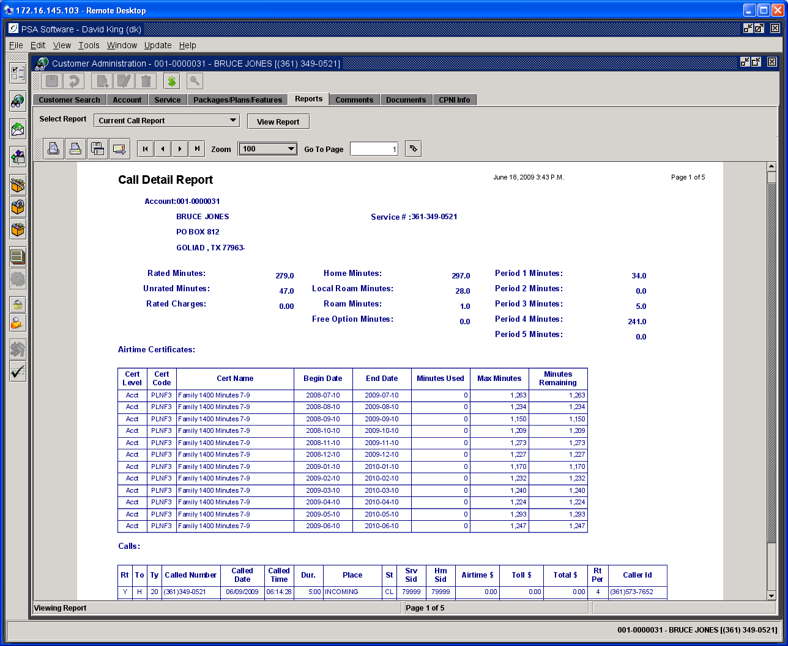

Airtime Certificate Summary Table

Airtime certificates can be used to create Carry-Over minutes, Bonus Minutes, Free Minutes by period, etc. Any free minutes created outside of the rate plan will be created as airtime certificates. There will be an airtime certificate summary for each type of air certificate that applies to the customer under review. If they don’t have an air certificate item then there will be no summary displayed. Carry-Over Minutes will create multiple air certificates for each month as determined by your company set up. Other type air certificates only create one summary entry.

Certificate Level: This indicates whether the air certificate applies to the account in general or to the specific service number.
Certificate Code: This is the item code that created the certificate. In the case of Carry-Over certificates, the plan code will be displayed.
Certificate Name: This is the certificate description of the item code.
Begin Date: This establishes the date the certificate was created.
End Date: This indicates the last date the minutes can be used.
Minutes Used: The column calculates the number of minutes used on this certificate for the period.
Maximum Minutes: These are the free minutes that were available for this certificate period at the beginning of the cycle.
Remaining Minutes: These are the remaining free minutes that can be used this before the certificate expiration date.

Roaming Summary

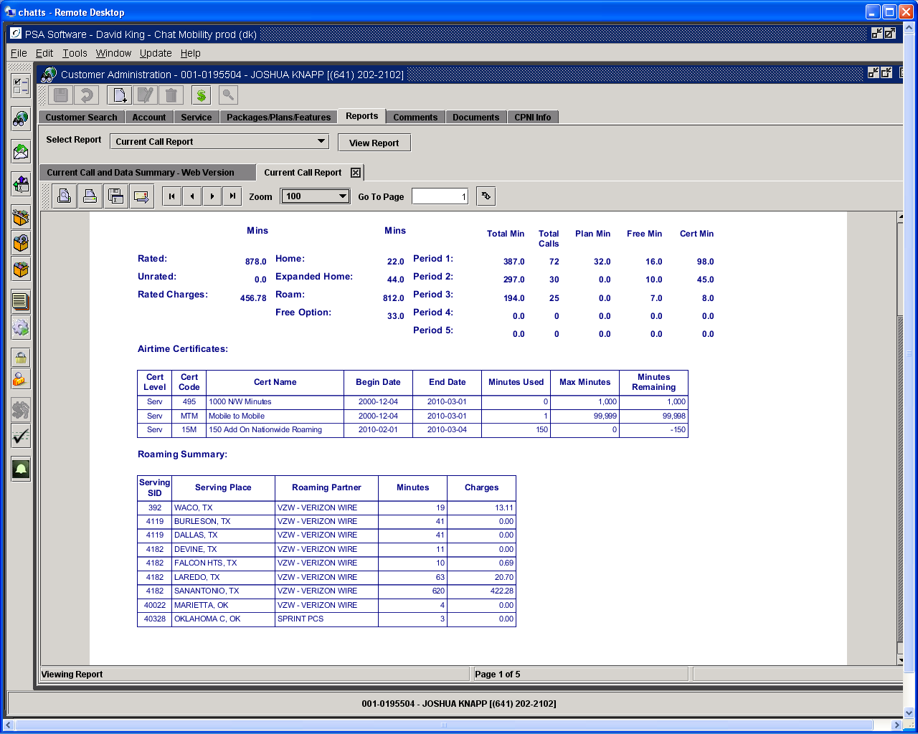

Serving SID: This is the SID where the call was made.
Serving Place: City and State where the call was initiated.
Roaming Partner: Carrier whose tower was used.
Minutes: Length of call in minutes.
Charges: Charges for the roaming call if not in Home or Expanded Home area.

Column Heading Description
Rt- Rated: Shows if the call record has been successfully rated.
To- Type of Call: H indicates the calls have been rated to home calls. R indicates a roaming call. L indicates a roam call that has been re-rated to a home call.
Ty- Record Type: CIBER type, example: “20” - air time/toll, “30” – Directory assistance
Called Number: The number can be the number called or the service number if it’s an incoming call.
Called Date: Date of call.
Called Time: Start time of call.
Dur- Duration: Length of call in whole minutes.
Place: Shows either the called city or “Incoming”
St- State: Displays the state where the call was placed.
Srv Sid- Serving SID: Displays the Serving SID.
Hm Sid- Home SID: Displays Home SID.
Airtime Charges: If there are no free minutes left on the plan, then the overage charges will be displayed here.
Toll $- Long Distance Charges: If long distance charges apply to the call, the charges will be shown.
Total of charges: Total of charges not including taxes.
Rate Period: Establishes the rate period in which the call was initiated. FR indicates a free option minute.
Caller ID: If the initiating number of an incoming call is included in the call record, that number will display here.

Current Call Report Web Version, Data Usage Report Web Version, and Call and Data Summary Report Web Version are additional reports that may be employed. These have the same basic information as the original reports formatted to fit the display on the PSA EBPP website.

Current Call Web version example

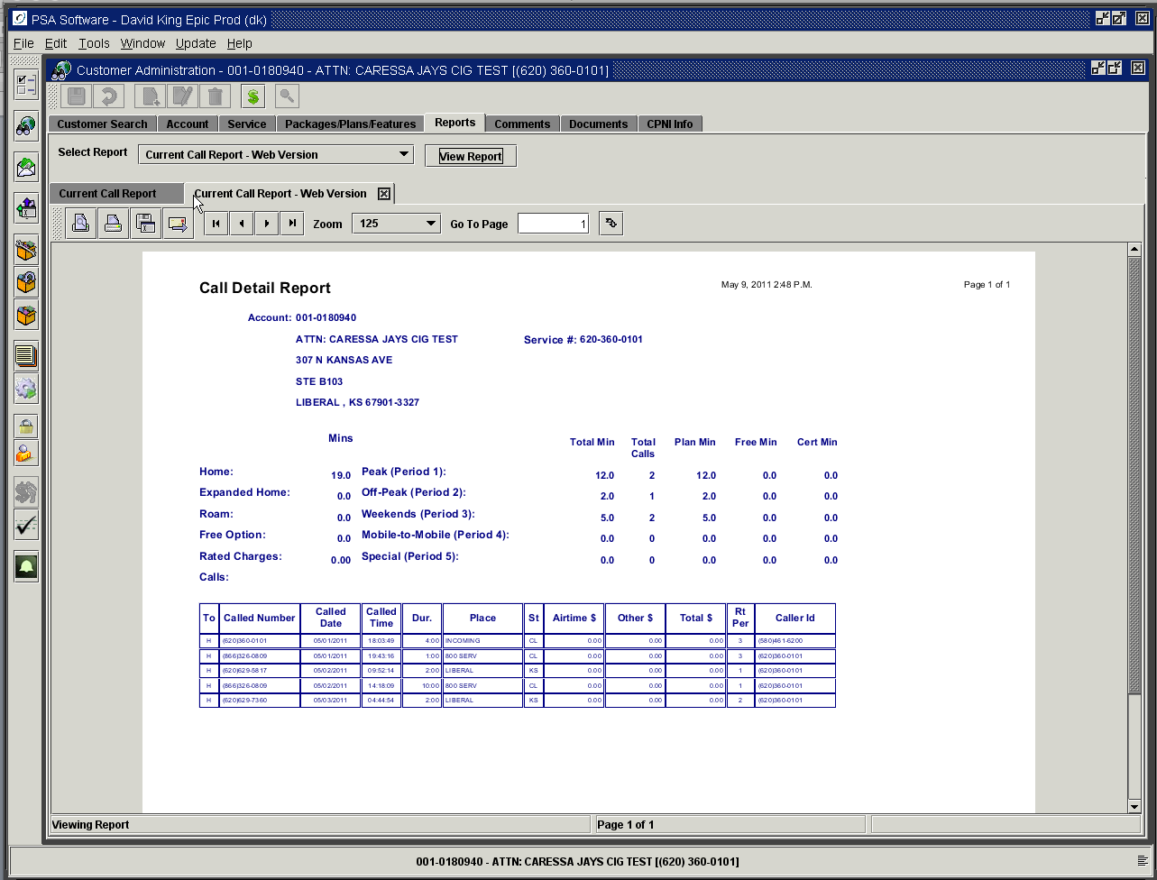

Current Call and Data Summary Report

This provides only the summary information for both types of records- voice and data for the current billing cycle. More detailed information for each of the sections is given in the Current Call Report section and the Data Usage Report section. There are potentially three sections – Voice calls rated by the plan, Air Certificate Minutes rated by feature or plan (usually Carryover or Bonus Minutes) and the Data Summary which can have multiple sections within that summary.

This report provides the fastest return of summary information regarding the usage for the cycle. Use this report if ‘detail information’ is not required and you are only interested in total usage and overages for the cycle. The Current Call report and Data Usage Reports, which display the detail records, take considerably longer to compile and display. The more the service is used the longer it takes to provide the individual detail for all the voice or data records.

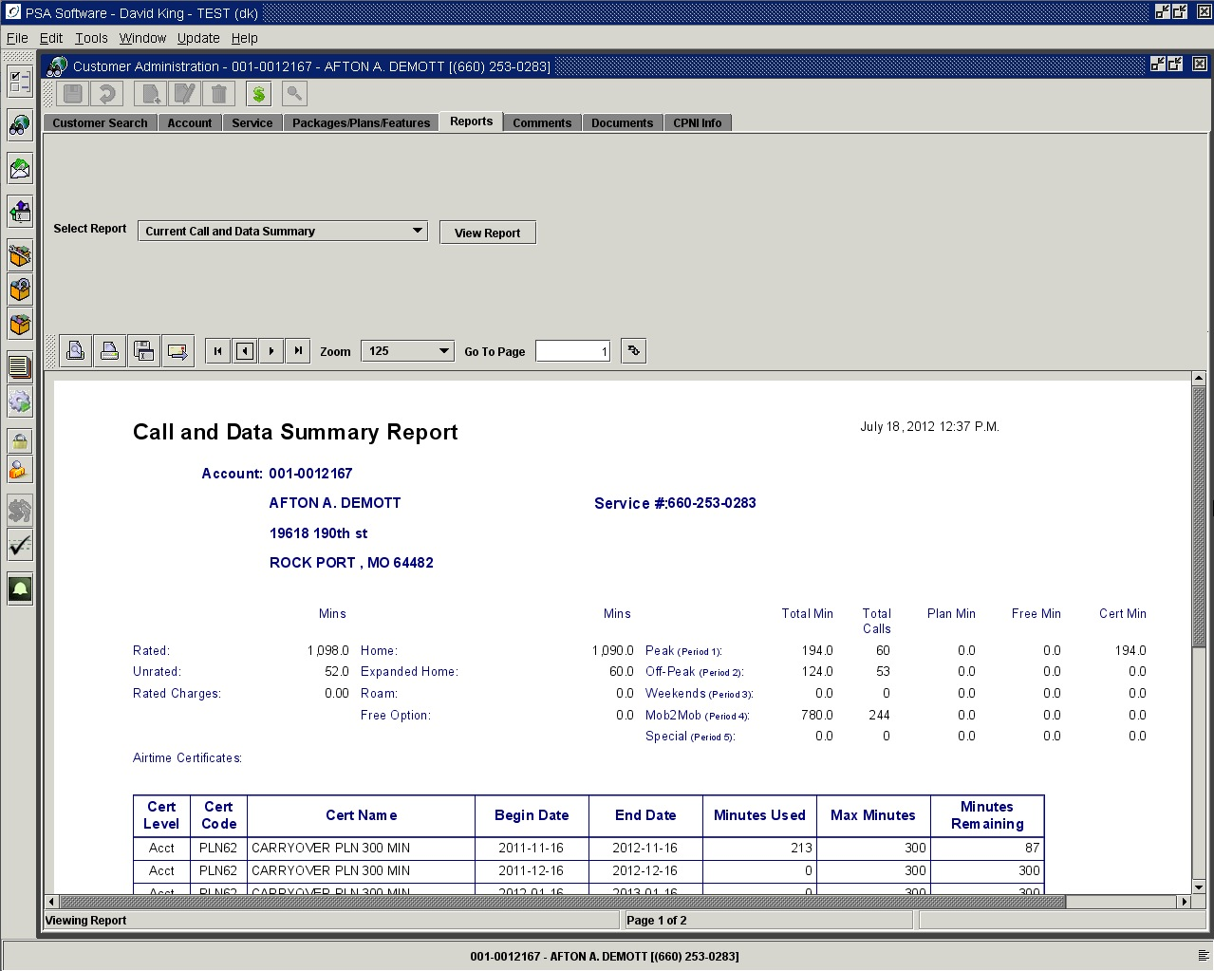

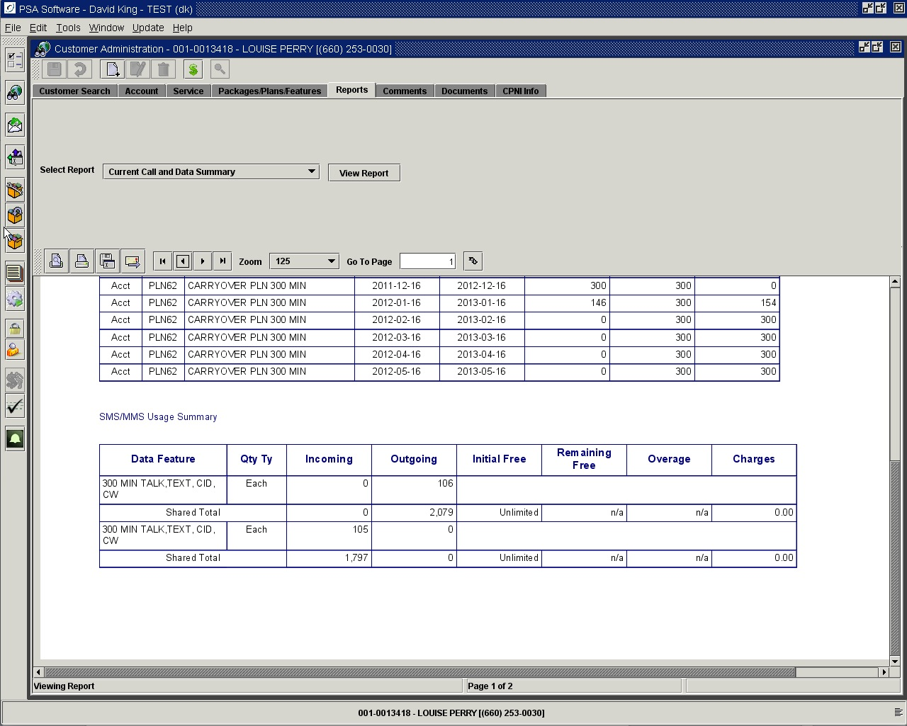

Call and Data Summary – Web Version

The report mirrors the Current Call and Data Report shown in the Customer Care Reports section in Desktop.

Current Contract

This section displays the contract, as it would exist if the contract were created today. As with all reports, the display can be printed, emailed or ‘Save to File’. To view the contract, go to the Documents tab and select the View Contracts radio button.

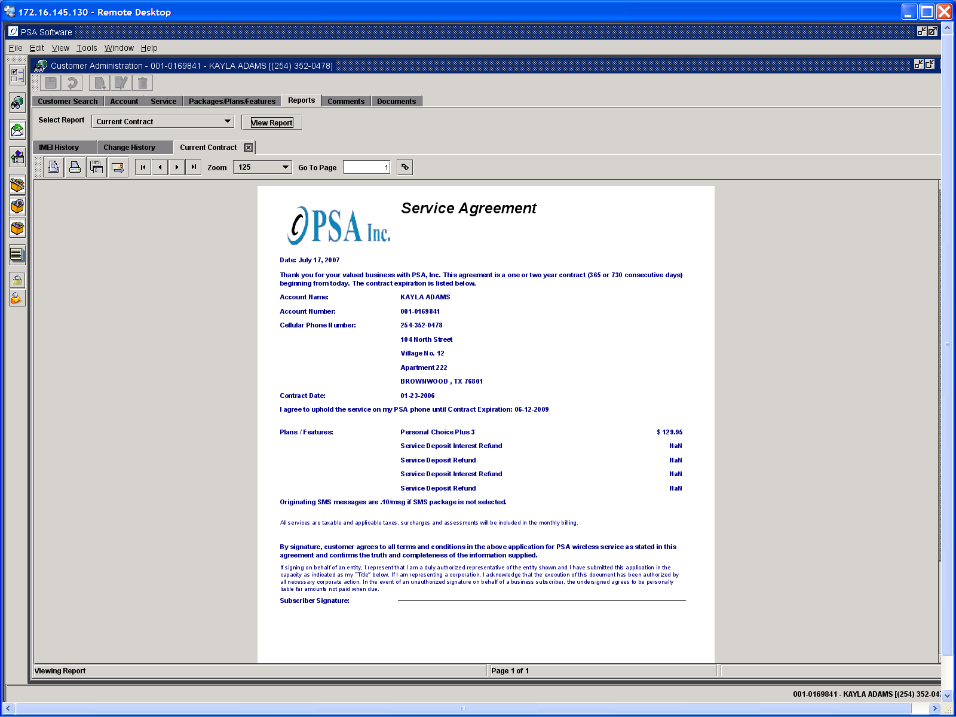

Create ‘New’ Contract
If you have changed customer information, which requires a ‘New’ contract, select Current Contract. Don’t press the View Report if you want to capture a signature.

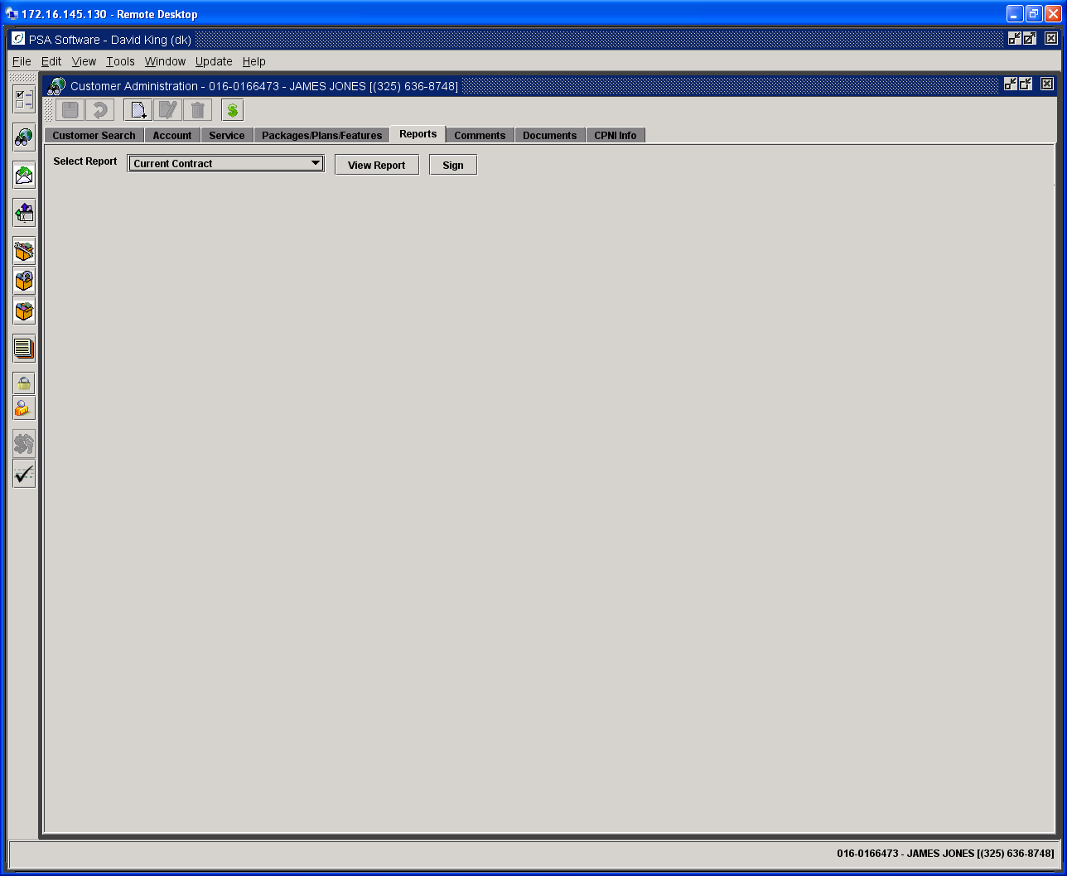

If you have signature pads attached to your system, press the Sign button. You will see the signature capture box. If you don’t have a signature pad, skip this step.

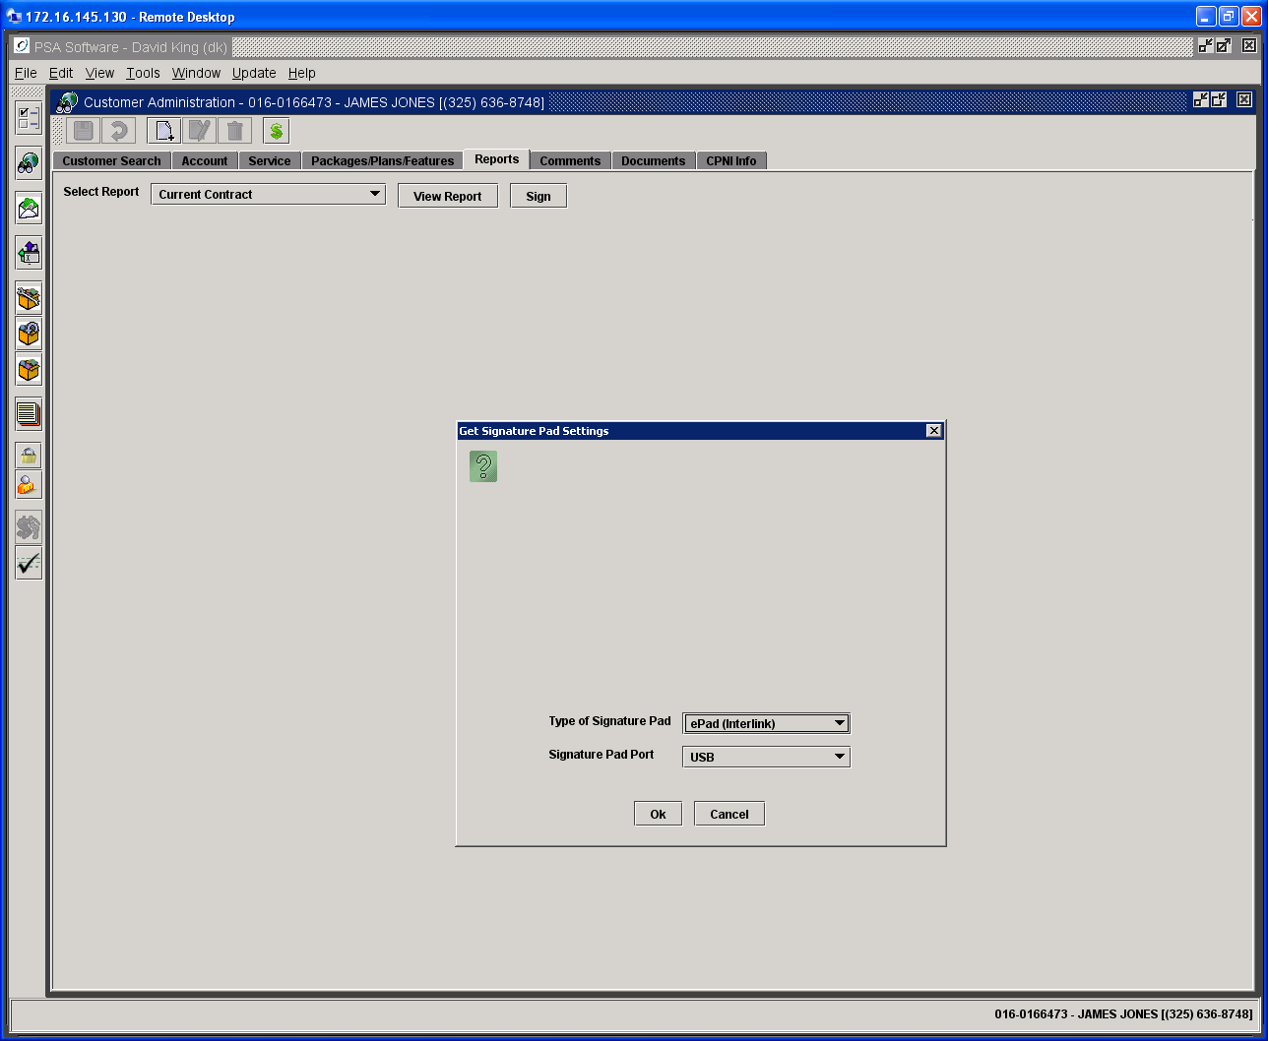

Once you have a valid signature, press the View Report button.

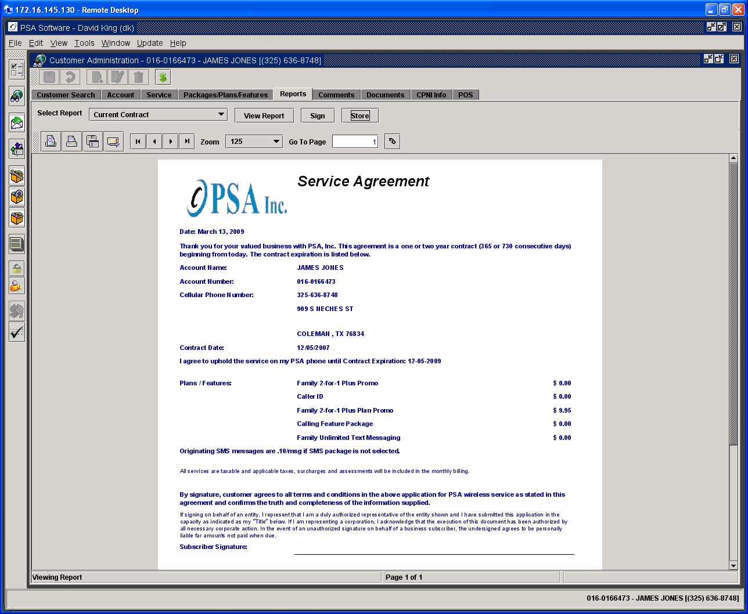

At this point you have several options. The Store button will be visible to the right of View Report. This will ‘Save’ the document as a PDF and store it under View Contracts on the Documents Tab.
You will be asked to confirm the Store; this does not change or over-write the previous contracts. From the Documents tab, you may retrieve and print any or all the existing contracts using Adobe as shown below.

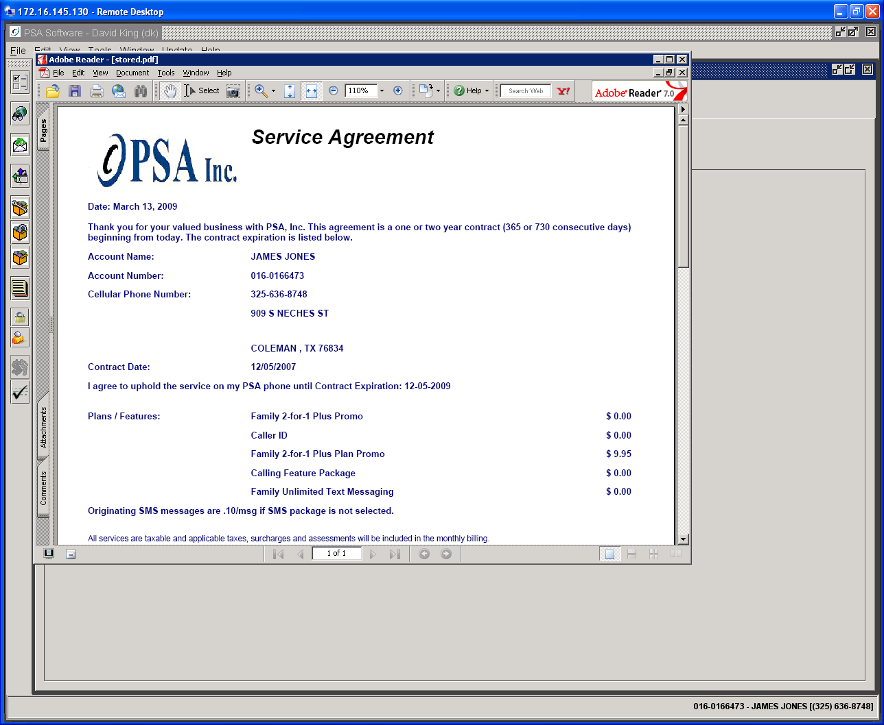

Data Usage Report

Data usage records are summarized by individual charge indicators. As you set up the data-rating database you can create multiple types of charge indicators for your data. This report will show a summary for each charge indicator (ex. Charge indicator 12 indicates SMS, 19 could be browsing, 50 usually MMS, 51 content like ringtones/games, etc.). Incoming and Outgoing sections give usage summaries of the activity for each charge indicator. If you have free messages or free amounts of kilobytes, then you will see the result of the free count minus the used count in the Incoming or Outgoing Remaining sections. If there are charges associated with records within the charge indicator, a total will display in the summary line. The detail record section is somewhat different from the voice records because of the volume of data records. Multiple records to the same service number within the same day will be grouped together and show as a summary. If 12 SMS messages are sent to the same service number on the same day, then there will be only one record where the Unit Count would be 12. If particular records are disputed, PSA can help locate and print those records. These can be extremely large reports; please allow extra time for report creation.

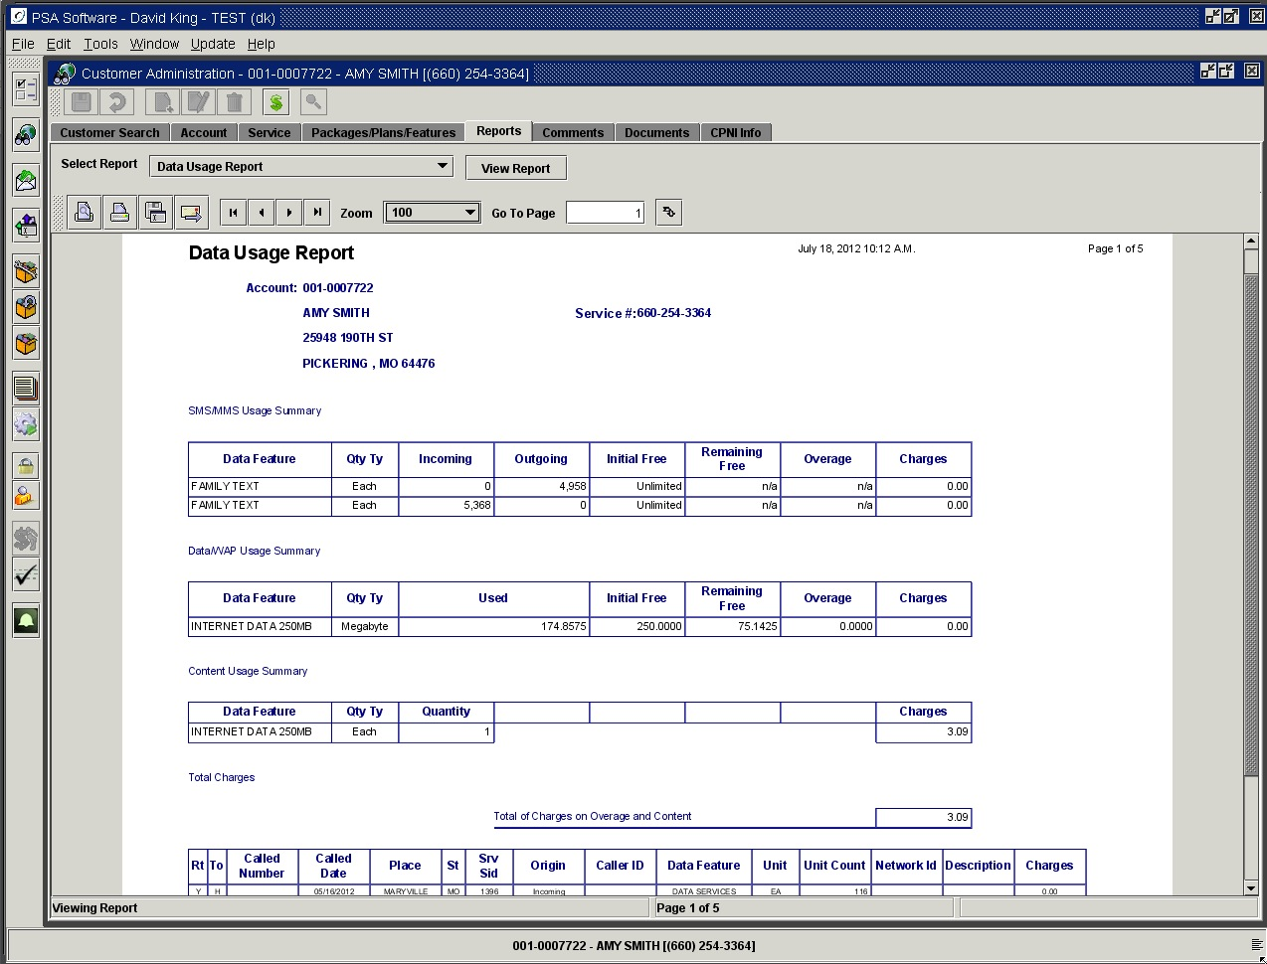

Summary Record
SMS, Data/WAP, MMS, and Content will be shown in their own section. There are some cases where SMS and MMS will be in the same section as one item due to the setup design of the specific data feature. Each section will show the rating feature description that rated the records.

In this example, there are two rating items – a feature (Family Text) and a plan (1000 MIN TALK, CID, CW) that rated text messages over the cycle. For this to occur one or the other of the features would be for one date range and the other the remainder of the cycle. You may only have one data feature rating messages/volume for a given time period within the cycle. If you have multiple data rating features active at the same time, we cannot assure the accuracy of the report or the rating.

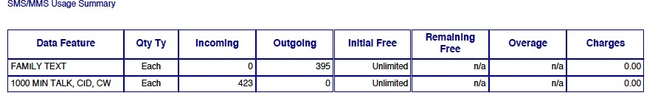

Non-sharing SMS and MMS, being “each” type, may have incoming and outgoing counts broken out. You will see the free number displayed and remaining free if appropriate. If they use all their free messages then overage counts will display as well a charges. These charges will be totaled with other charges at the bottom above the detail section. If there is no distinction between the rating of incoming and outgoing messages then there will only be a single line for summary text.

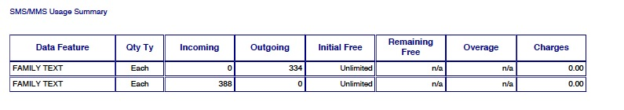

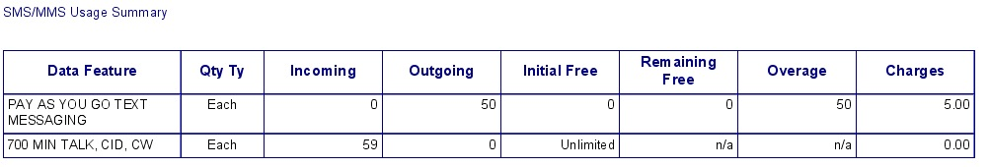

Sharing SMS and MMS features display both the service and the shared information. The first line is the usage of the individual service and will only show the number of incoming or outgoing messages. The second line will show the shared summary for all services with this same feature with the same super account number. To share data, a group of service numbers must have the same data rating feature and be linked by super account number otherwise they will rate singularly by the rating feature. The initial free, remaining free, overage and charges will show for the sharing group under the service level display. Any charges accrued will be included in the grand total show immediately before the detail section.

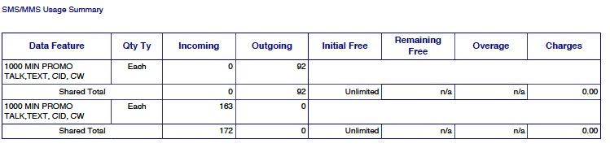

Non-sharing Data/WAP will show the quantity type (KB, MB, GB) and the amount used, initial free, remaining free, overage and charges.

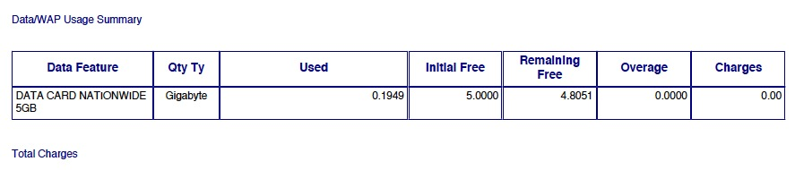

Sharing Data/WAP features will show both the service level and the shared summary. The first line shows the usage of the service number that you have open. The second line displays the shared usage totals - Initial Free or unlimited, Remaining Free, Overage and Charges. In this example there are two different sharing features on a service. The Data Share 1GB is using the ‘aggregate’ method of rating. Normal rating reads the session, determines the usage for that individual session and applies that to the free bucket and if appropriate assesses a charge. The aggregate method combines all the usage for all the individual sessions for the period and rates the usage and charges from the grand total.

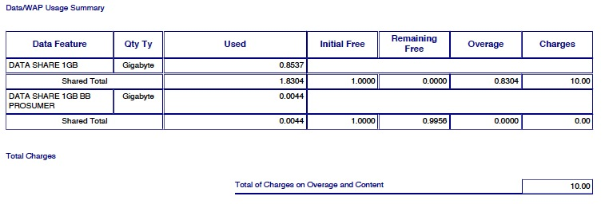

Content Usage

Content (charge indicators 51 and up) are usually games, ringtones, applications, etc. You may divide the various types by charge indicator in the feature setup; however they will all be grouped together in the content summary section. The summary lists the number of purchases/downloads for the period and any associated charges. Content items are normally single access where the charges are passed through instead of falling within the rating process.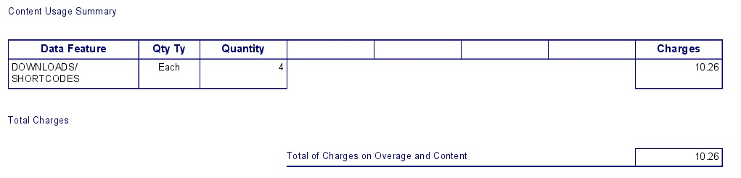

You can look in the Detail section for specific information indicating what items encompass the charges.

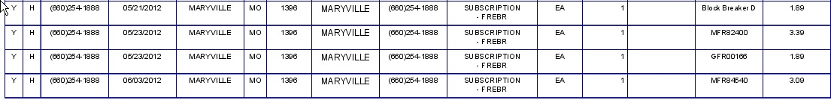

Data Detail Section

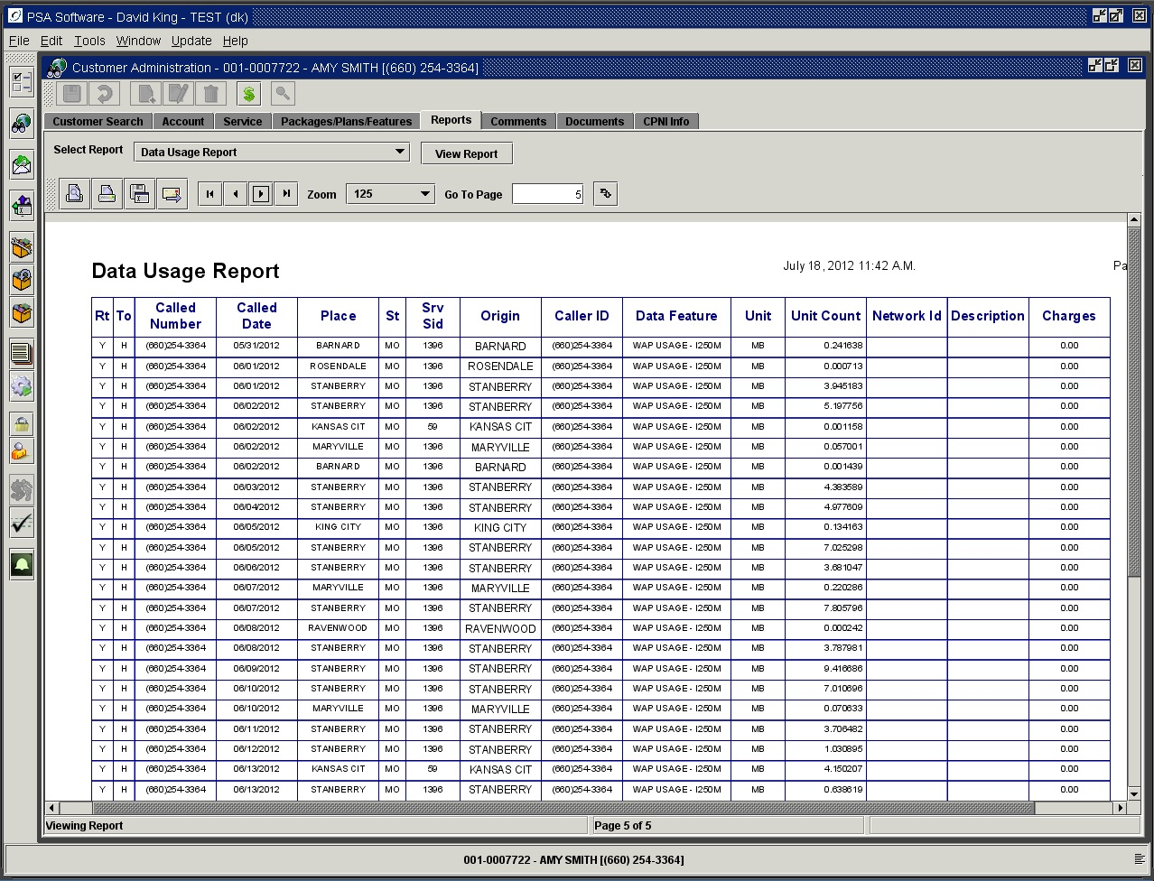

Column Heading Description
Rt- Rated: Shows if the call record has been successfully rated.
To- Type of Call: H indicates the calls have been rated to home calls. R indicates a roaming call.
Called Number: The number can be the number accessed/messaged or the service number if it’s an incoming message.
Called Date: Date of call.
Place: Shows either the called city or “Incoming”
St- State: Displays the state where the call was placed.
Srv Sid- Serving SID: Displays the Serving SID.
Origin: Indicates where the call originated or if incoming
Caller ID: If the initiating number of an incoming call is included in the call record, that number will display here.
Data Feature: This describes the charge indicator and the data feature on the customer account that is used to rate this record.
Unit: This is the unit of measure and indicates the way the records are accumulated. SMS is each, which means the messages are counted as individual items. WAP/GPRS are usually by kilobytes but can be accumulated by any grouping. KB = Kilobyte, MB = Megabyte, etc.
Unit Count: Show actual rounded up usage by the unit. So if ten SMS messages were sent to the same number on the same day, this number would be 10. If WAP then this would be the number of units used during a session. 1024 KB.
Network ID: If network Id is used to distinguish different types of the same charge indicator that network id will be displayed here.
Description: This description comes directly from the usage record. Most times it will be blank but sometimes the record carries a code or description that identifies the content. For more code translation you would need to contact your content provider for specific details; PSA does not have access to this information.
Charges: If there are no free units left on the plan or feature, then the overage charges will be displayed here.

Data Usage Report Web Version

This report is what is displayed on the website when applicable. The Data Usage Summary will be the same as in the Desktop Data Usage report but the company can choose what columns are shown in the detail section of this report for the end user. Example we can remove the Network ID column if your company would rather not display that on the website.

ESN History

Displays the last ten ESNs attached to this service number and change date. The ESN is shown in HEX, 10 digit and 11 digit formats. These are past ESNs, the current ESN/MEID is on the Service screen.

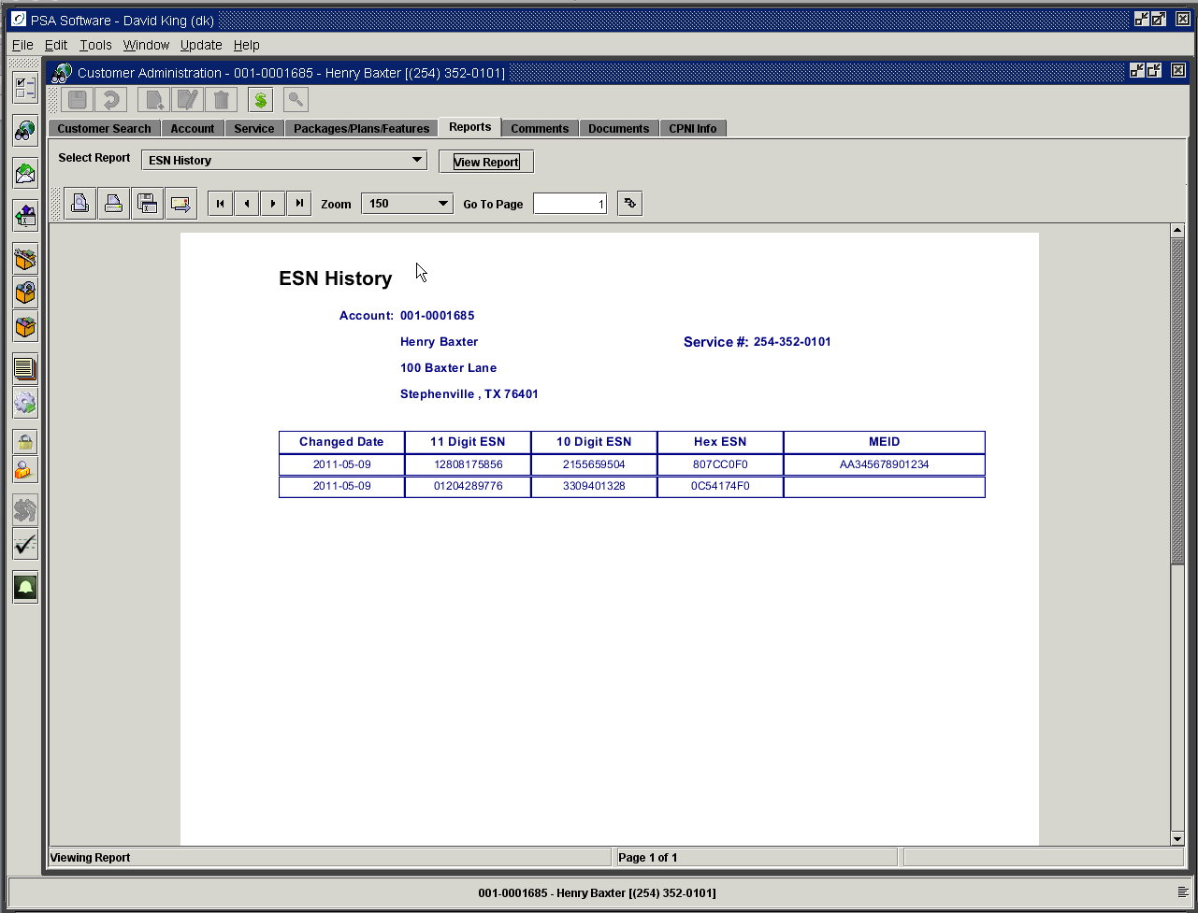

Free Numbers/Calling Group

Provides a listing of all free calling numbers for the selected service number.

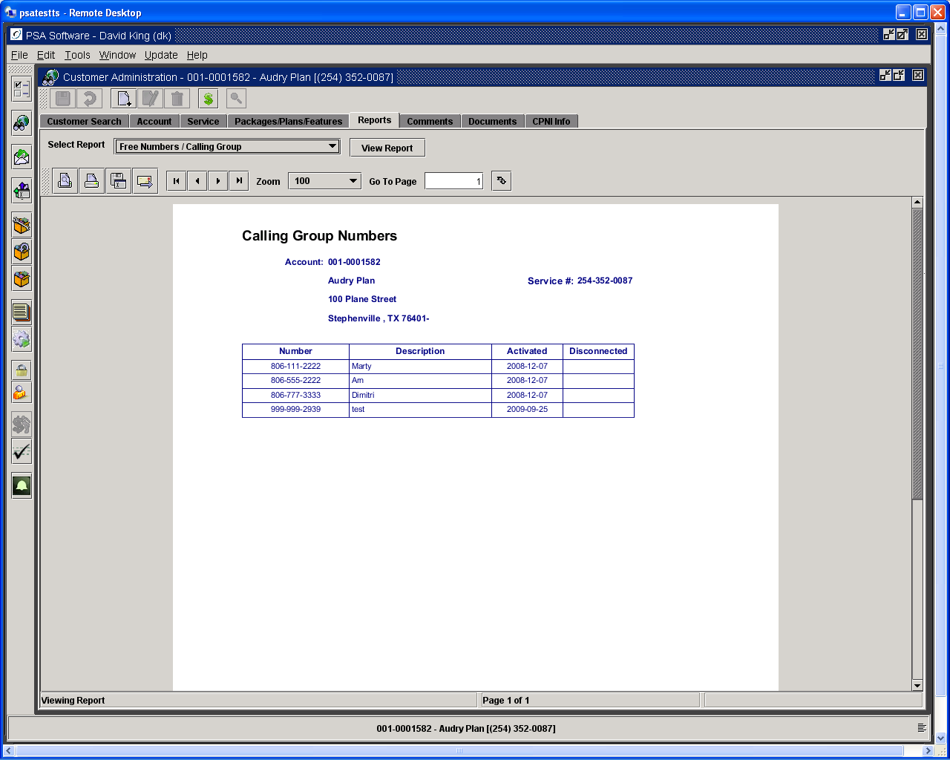

IMEI History

As customers change phones and the service level screen is updated; this screen will begin to record the old IMEI’s. The system will store the last 10 IMEI’s for each customer along with the date the IMEI went out of service. The current IMEI is shown on the Service Screen.

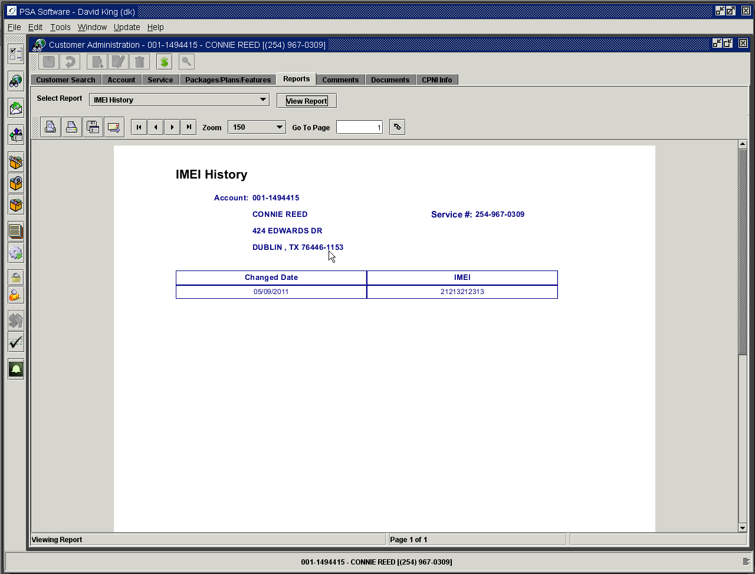

Item Summary – All Services for Account

Show a text description of all items on all services. Item in black are On Hand items, in blue are Install items and those in red are Removed items.

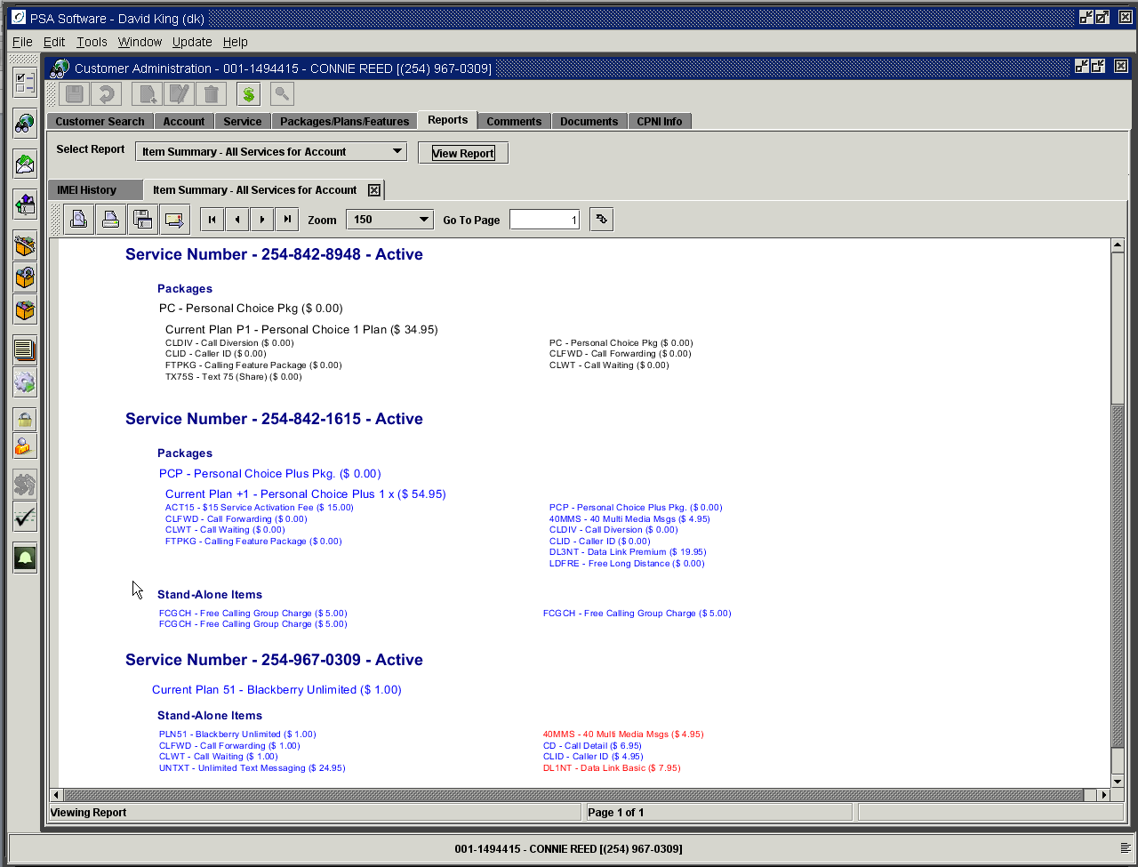

Transaction History

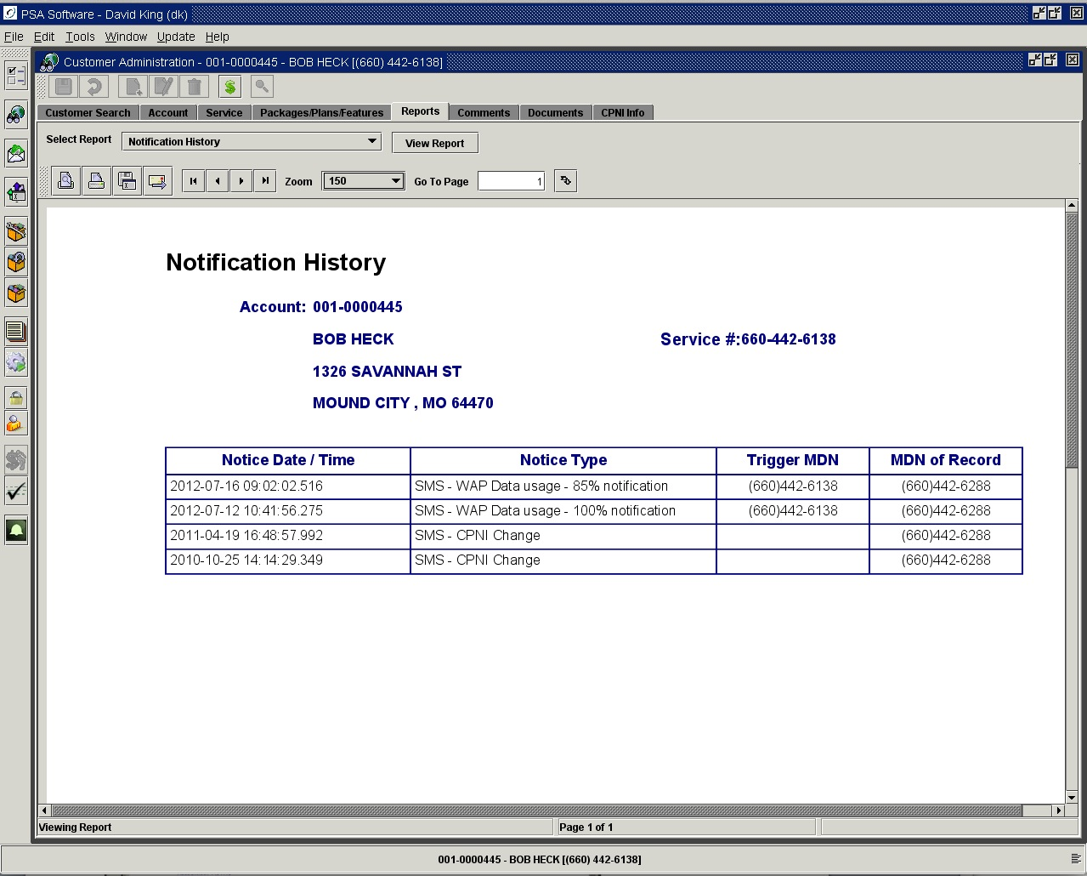

If the notification is a usage notification, the number that either used the minutes or data that caused the usage to meet the notification threshold will be shown as the Trigger MDN. MDN of Record is where the notification was sent.

Payments – All Dates

This is a complete listing of all payments with associated details. PSA does not purge old payment information.

Payments – Last 60 Days

Same details will display but only for the last sixty days.

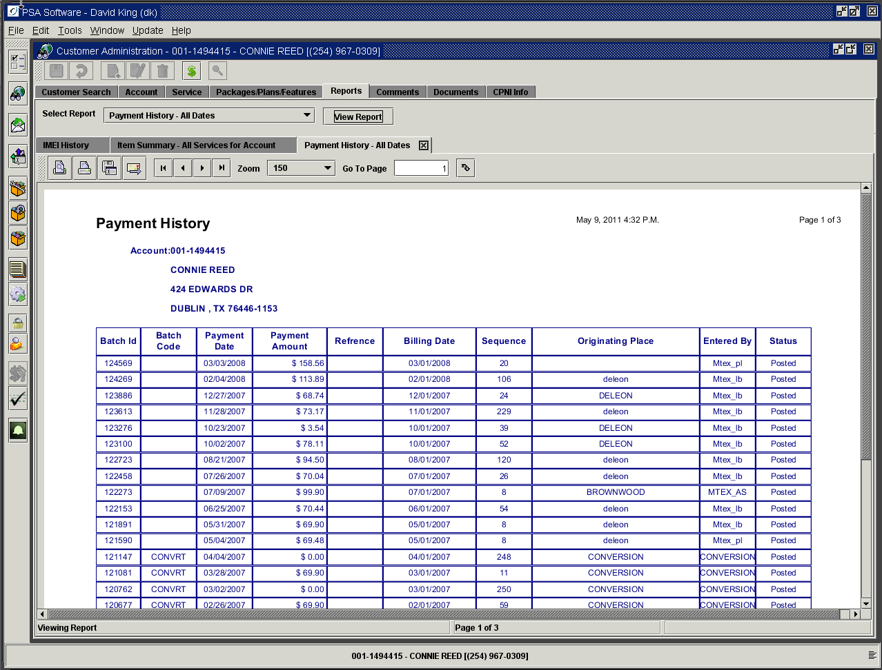

Provisioning Results

The information contained in this report is determined by the access granted by your company and the type of switch. Hence if there are switches not provisioned by the application, we will not be able to report against those switches. The following report show completions/success and error conditions, which are shown shade in orange. This report is for only the selected MDN.

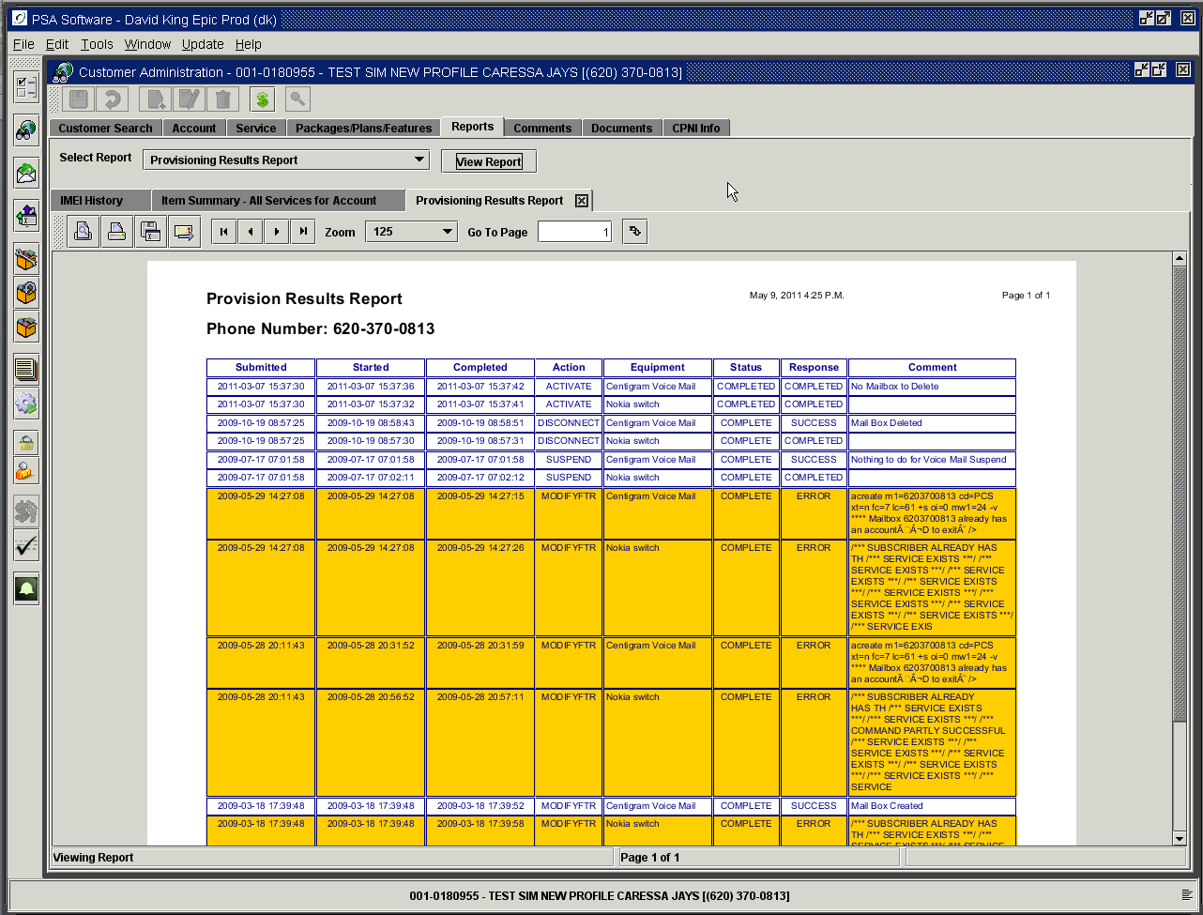

Re-Rate Inquiry Report

Account Level Analysis:
Date: Date of analysis.
Profit or Loss: States position.
Difference: The amount of profit or loss aggregated across the whole account. Many times a service number on a multi-service account could show loss but the account as a whole is profitable.

Service Level Analysis:
Date: This is the date the analysis was run.
Service Number: Customer’s number.
Profit or Loss: States position.
Amount: This will show the dollar amount of profit or loss for this individual service.

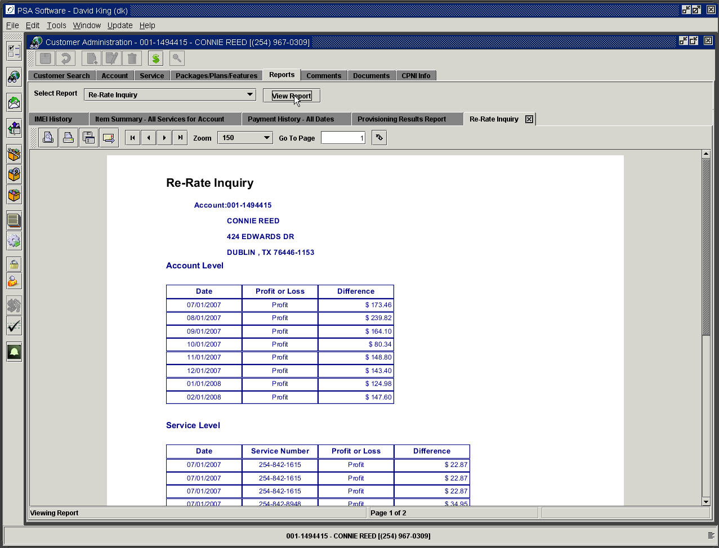

Sales Report

A summary of all Point of Sale equipment sale transactions is displayed in this report. The detail/invoice for each transaction is stored under the Documents Tab. If the sold item is serialized the serial number will display in the Serial field.

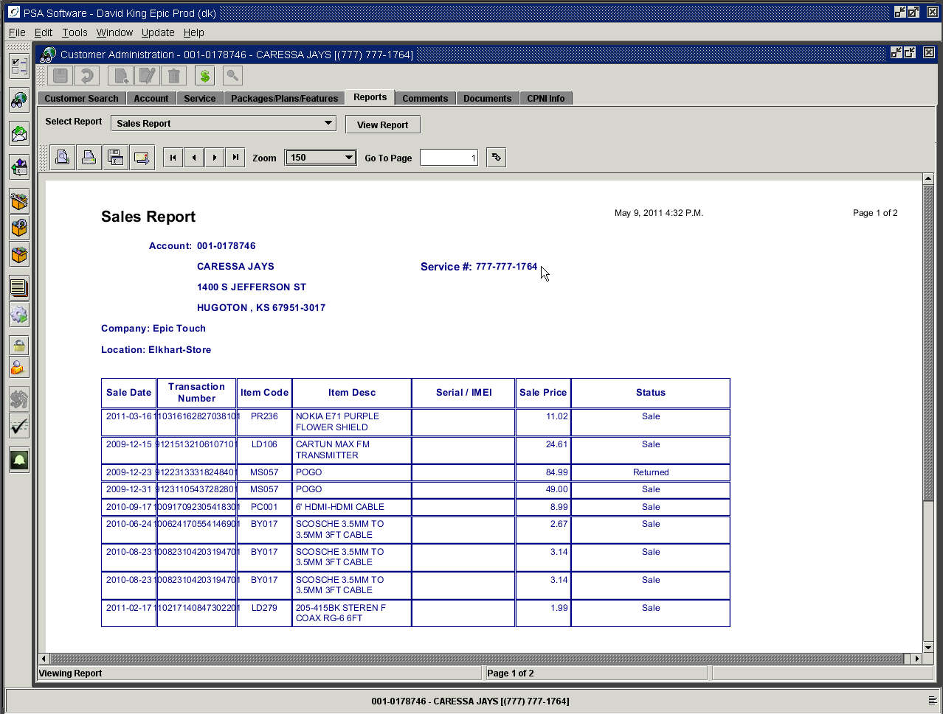

Sales Return Report

A summary listing of all transactions that involve a return to inventory from Point of Sale are shown here.

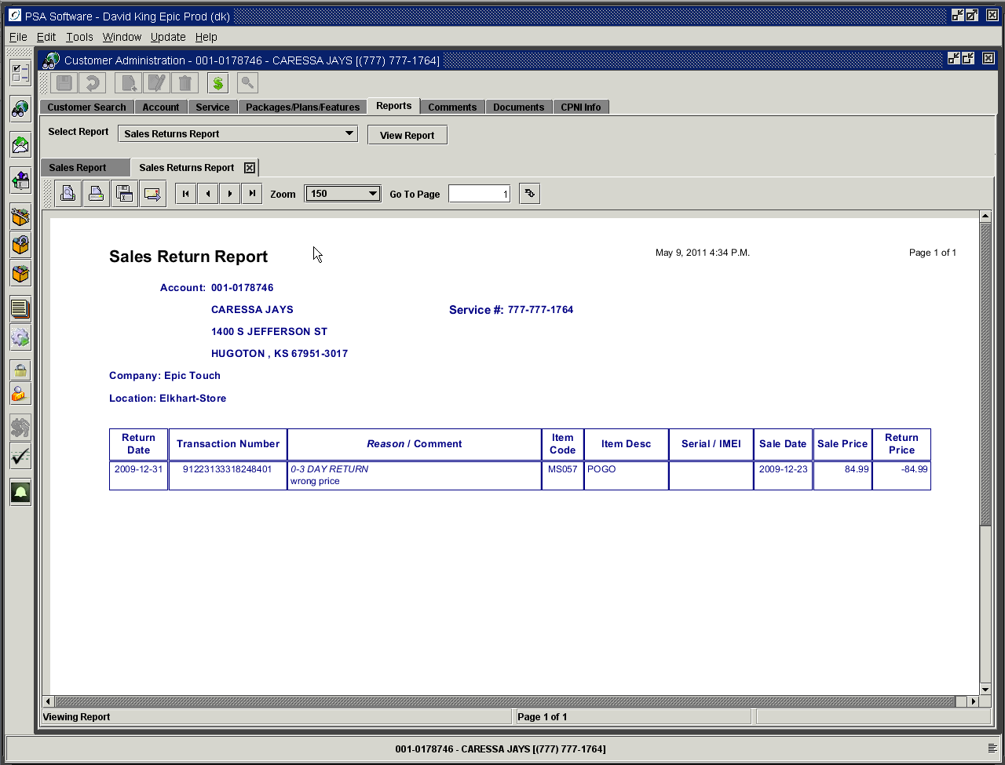

Status – Blackberry Services

Detail information for service numbers provisioned through Blackberry.

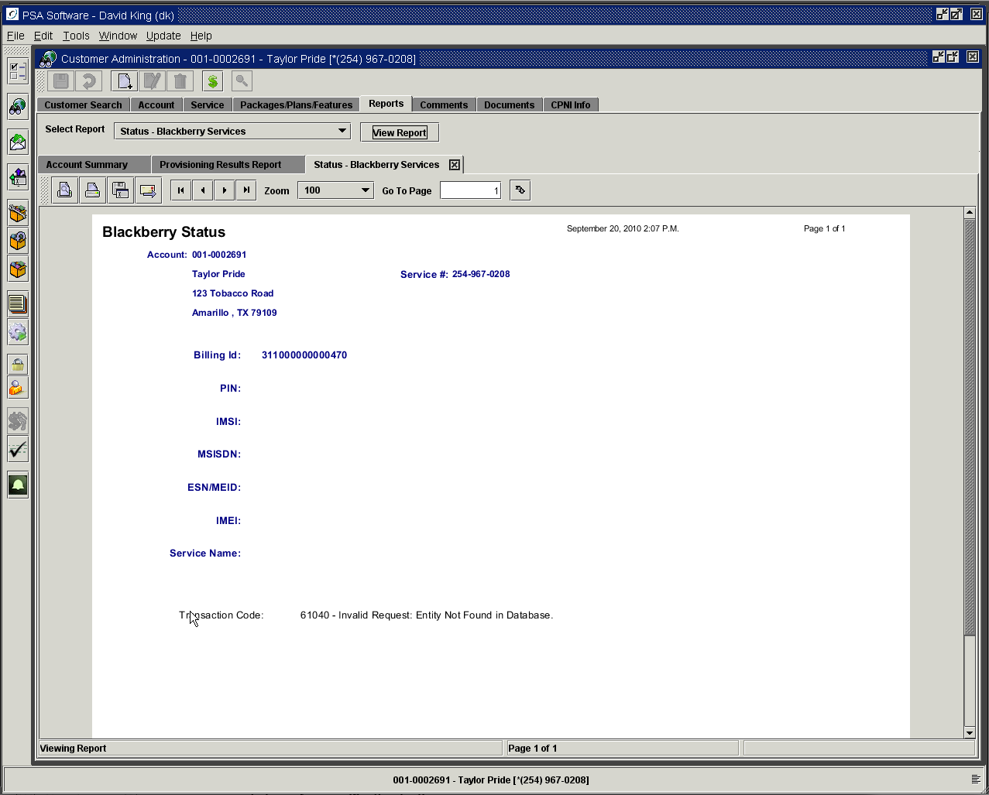

Transaction History – All Dates

Displays Bill Amounts, Payments, Adjustments or Temporary items by date. The amount shown with the Bill transaction will equal Current Activity plus Late Fees (if any) from the statement. The balance on that line should equal the Balance Due from the statement. Each individual payment or adjustment will be listed on date received/created. If temporary items are added in batch adjustment entry, they will display here also BUT not be used in the total, as they are part of the Bill Statement value.
Both Transaction History – All Dates and Transactions History – Last 60 Days are detail reports and show all components including taxes for all transactions. The balance on the line for the most current date will equal the balance shown as Current Due on the Accounts Receivable Report.

Transaction History – Last 60 Days

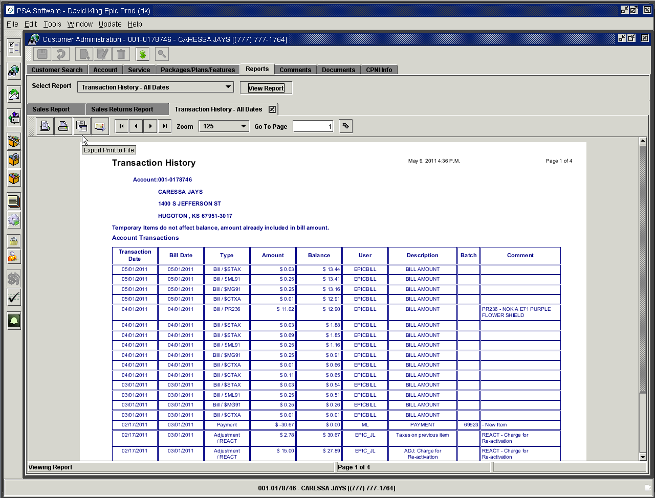

Transaction Summary

This is stated only as a summary for each type of transaction. Bill statements will be only one entry. Payments will continue to show each payment if they are made on separate days. Temporary and Adjustment items will show individually. These are sorted by date so each cycle’s activity can be traced more easily.

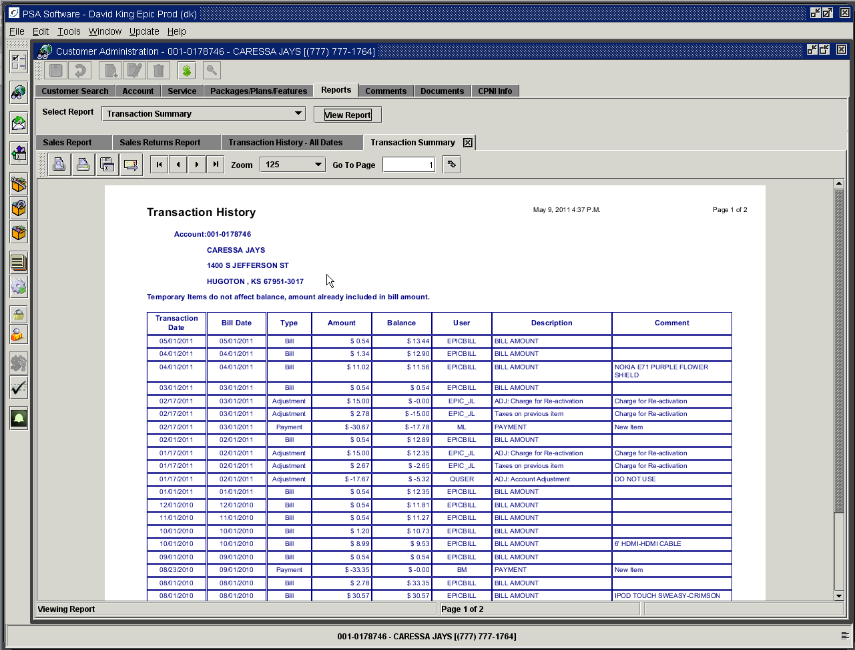

Write Off Inquiry

If the account is written off, you will see notifications on the return search screen in the status column, on the Account Summary screen under Print Class in the upper right hand corner and on the Accounts Receivable screen with a section dedicated to the write off. When an account has to be written off, the active account receivable is adjusted to zero dollars owed. You must use the specific write off adjustment item created for your company. The amount will be entered as a NEGATIVE amount. The balance is transferred to a separate file containing only written off accounts. All payments will be shown here from that point on. The report will show a running total of events on the account.

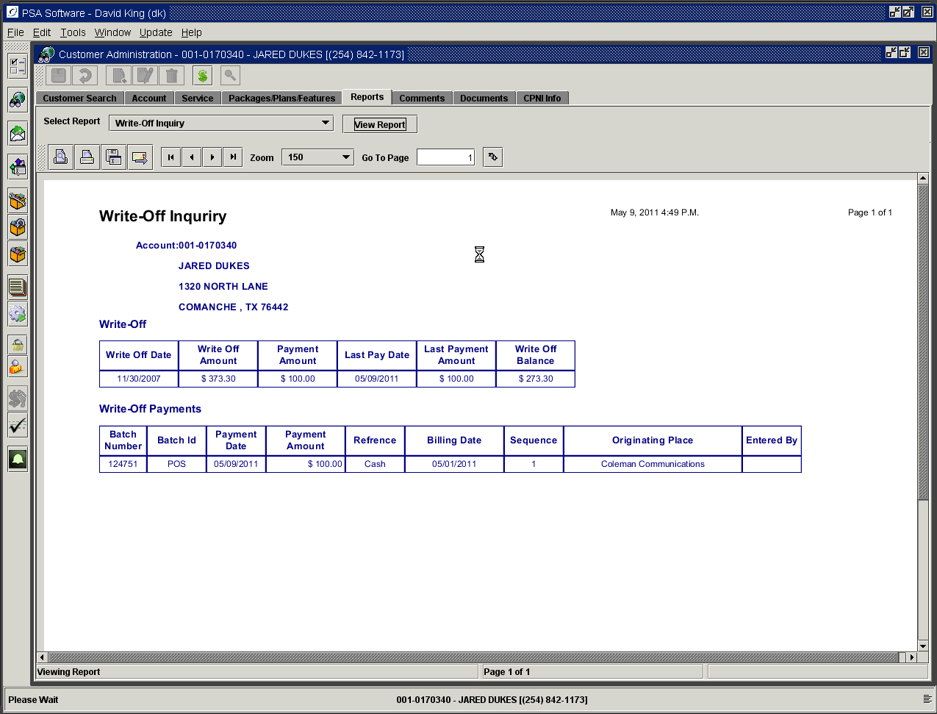

Various Switch Reports

If available from your switch, PSA can run inquiries and report against your specific switch data. Here is an example of an inquiry done on a Lucent switch.

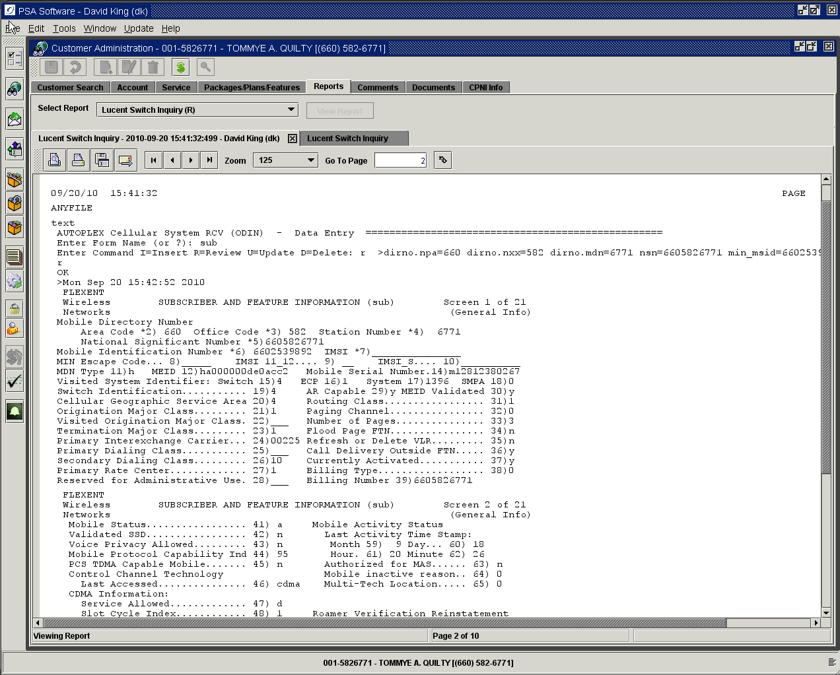

Comments

Comments are broken down into two main control groups, Account Level comments and Service Level comments. Those groups are further subdivided by Comment Types as defined by your company. You can display account or service level at full screen or both with split screen by clicking the circle by the selection. Once you have selected the level, you may select the Comment Type. If the comment type is All, any comment will be displayed in chronological order. To restrict display to a specific type, pick that type from the drop down and only those comments will be shown also in date order. Account level and service level comment type selection is independent of the other.

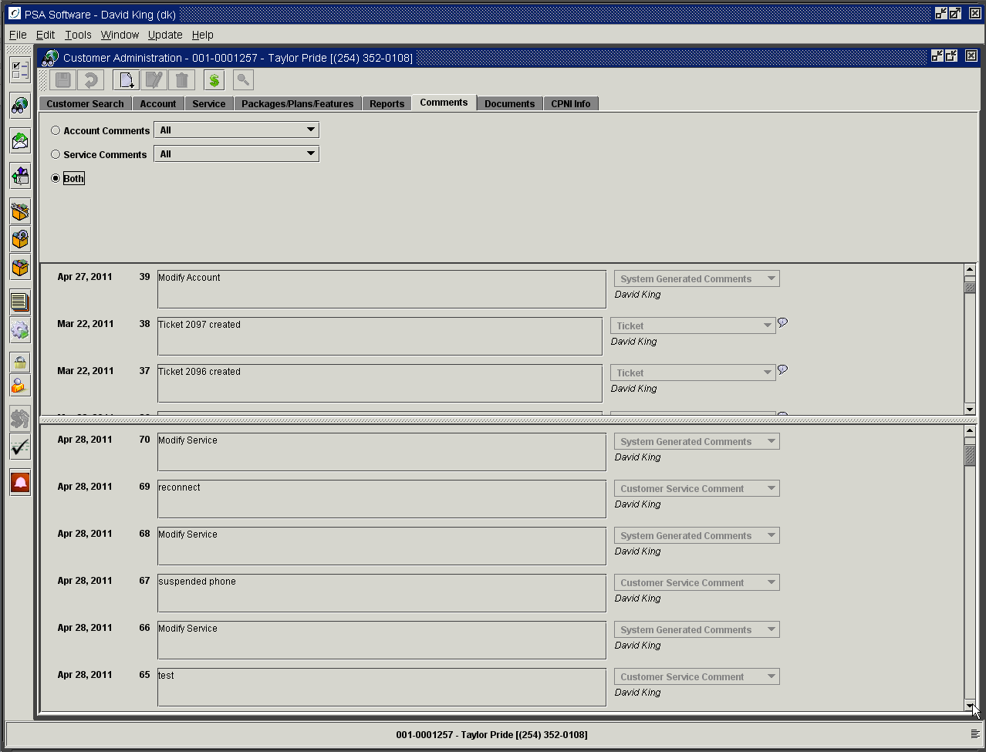

A comment will be created by the system during a service order, which will be a System Generated Comment or a CSR comment. Comments entered by CSR’s at the end of each service order will move to the appropriate level and create the System Generated Comment type. To create a ‘New’ comment outside of service order, the user will open the Comment tab and select the ‘New’ icon in the tool bar.

The first step is to select the level. If the comment should be visible on any service number on the account (ex. Do Not Accept Checks), use the Account Level comment. If the comment is specific to the service number (ex. Plan change), the comment will be Service Level and only shown when positioned to that specific service number.

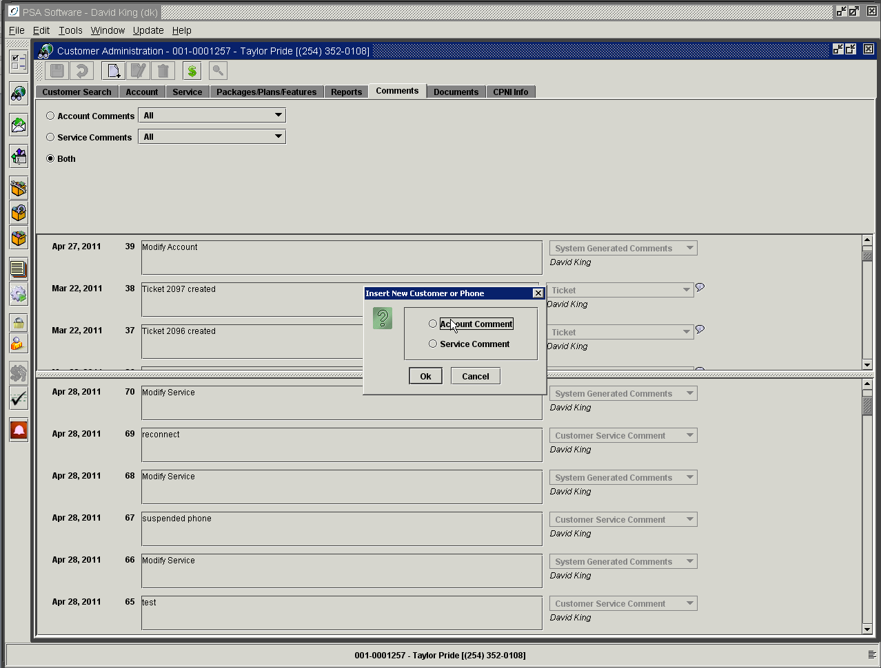

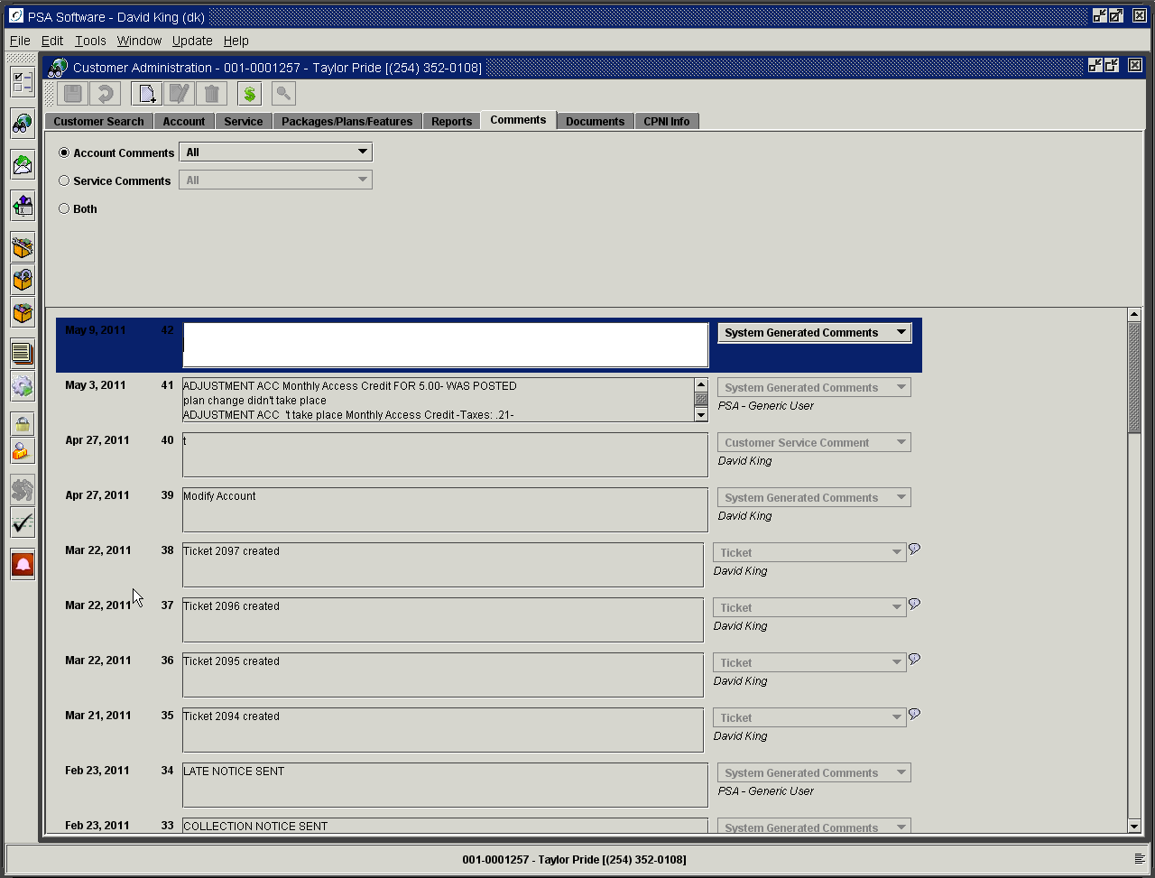

Enter the comment in the box and select the comment type from the drop-down box. ‘Save’ creates the comment.

Documents Tab

Under the Documents tab are five sections: View Post Bills, View Invoices, View Contracts, Account Level PDF, and Service Level PDF. View Post Bills displays stored PDF images of the customer’s statements. View invoices displays stored PDF invoices from point of sales transactions. View Contracts displays stored PDF contracts. Account Level PDF can be used to store miscellaneous account level documents and Service Level PDF is for documents specific to the service number.

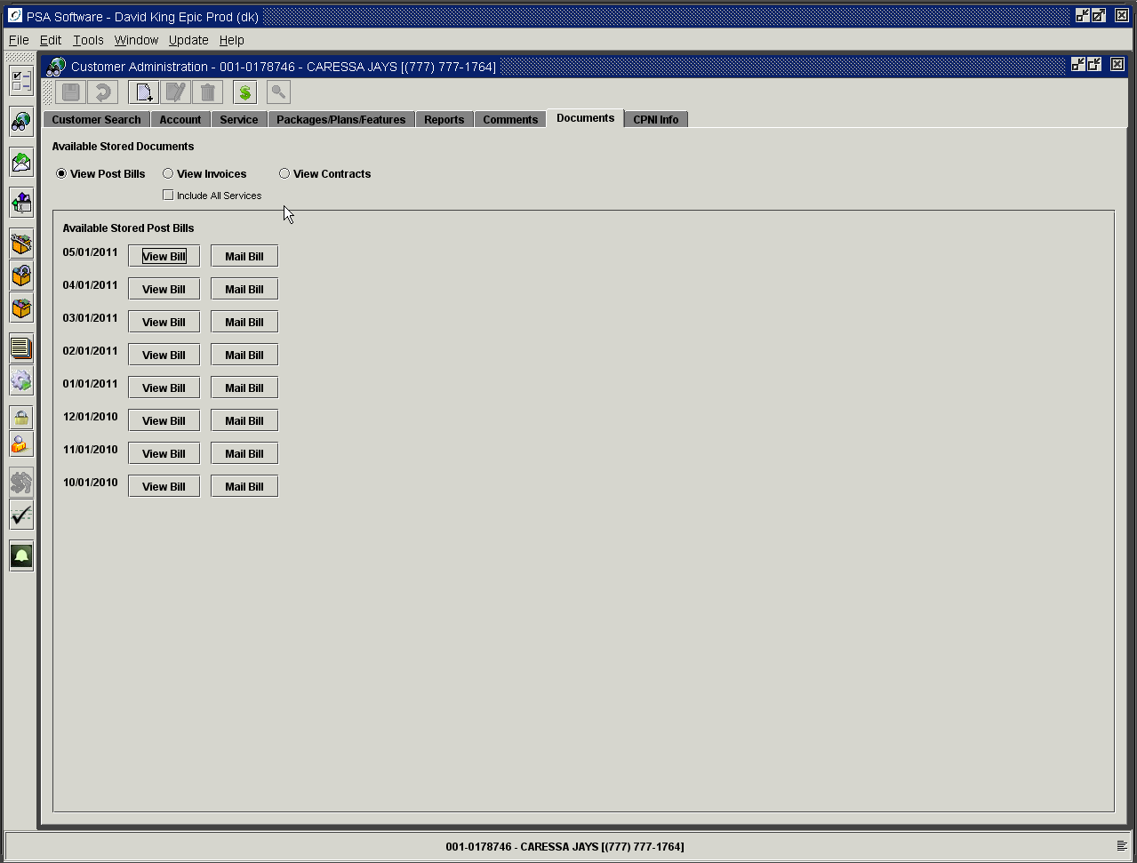

View Post Bills

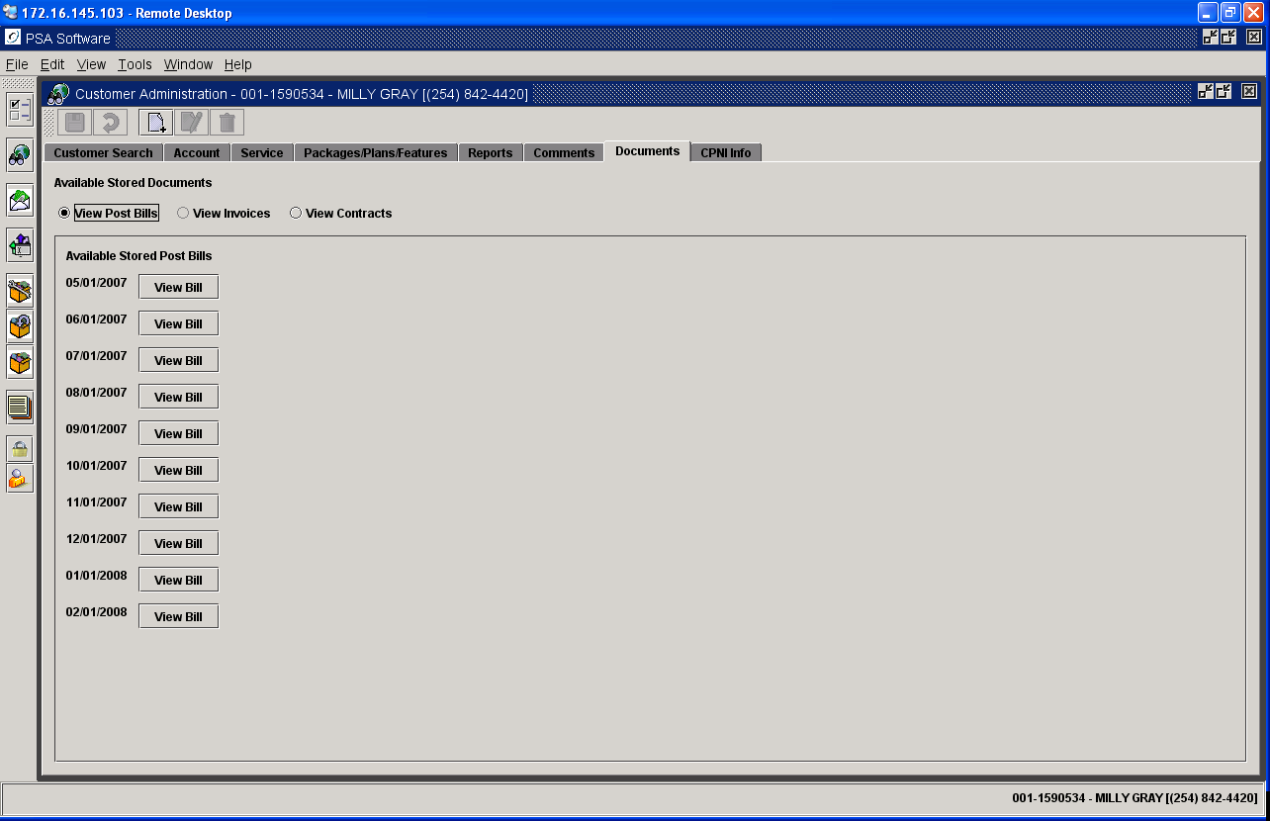

Select the billing cycle date to review and press View Bill. The statement will be displayed in Adobe Reader. You can re-print the statement from here.

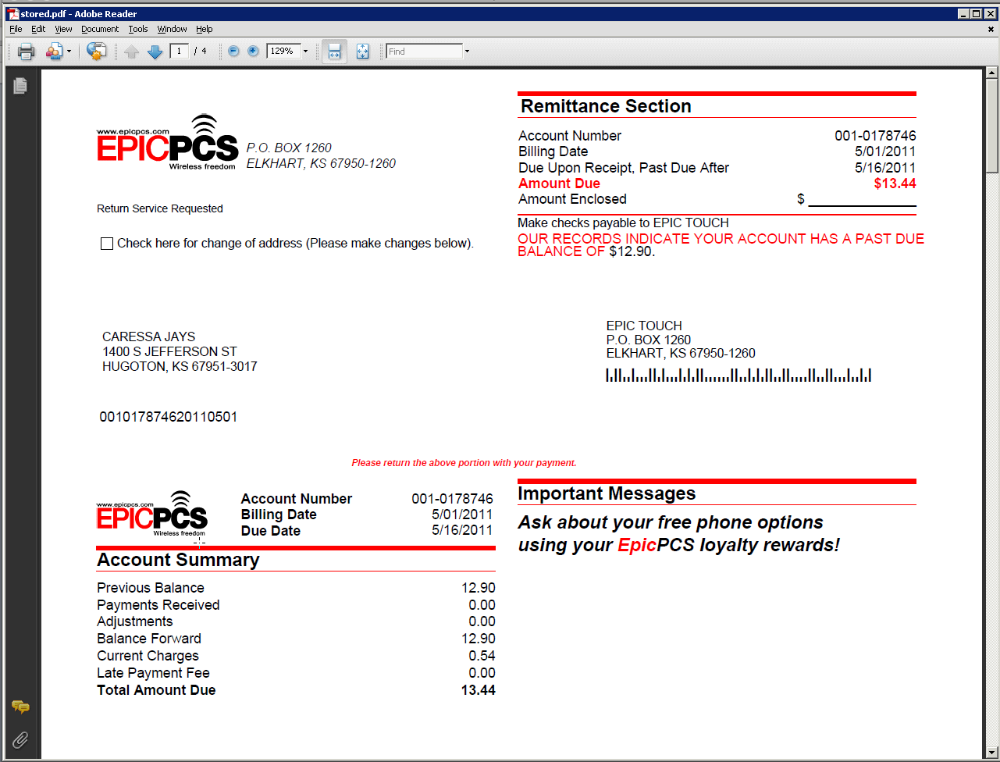

View Invoices

If the customer has purchased items via the Point of Sale, then the invoice are stored here. Old invoices can be reprinted or emailed to the customer when needed. The invoices can be viewed in the original format by pressing View Invoice. The invoice will be opened within the application as any other report for viewing, printing or email.
If you would like to the invoice to be displayed as a PDF and open with Adobe select View Invoice PDF. To email the invoice select Mail Invoice.

The application by default only displays invoices created within the last thirty days; this default can be set to company specifications. Loading a large date range will slow the retrieval process. To see invoices created prior to that you must set a date range that the invoice will fall within by pressing the Magnifying Glass in the top tool bar. A date range selection will be presented with the last month as a default; adjust the dates and press OK.

Invoices are attached to service numbers so if the ‘Include All Services’ box is not checked only the invoices attached to the selected service number will be displayed. Check the box and all invoices will display and subsequent service numbers will be grouped and displayed.

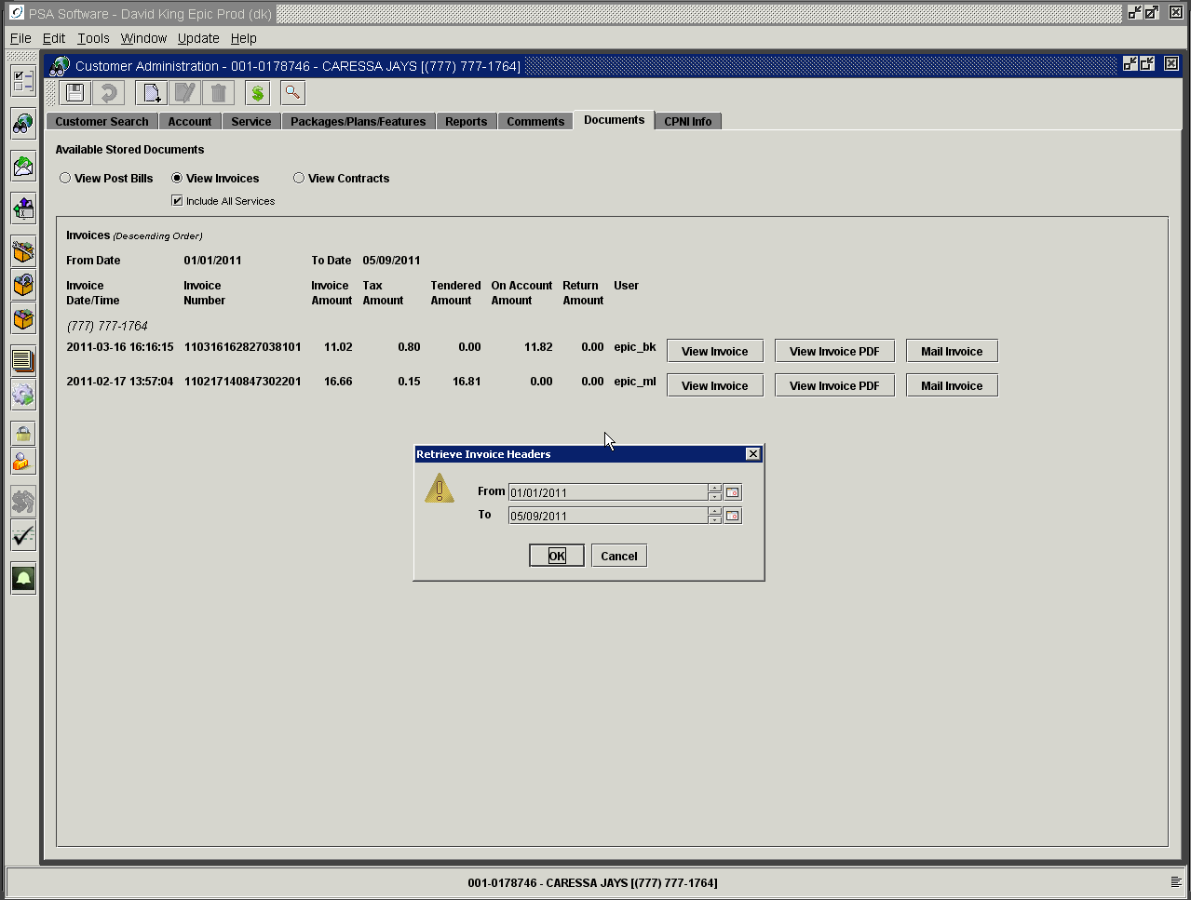

The list provides date/time stamp, invoice number as well as amounts regarding the content of the invoice including invoices where merchandise was returned.

View Contracts

If the customer has a contract or contracts, they will show in date order in this section. To create a ‘New’ contract with the most current information, see information under Current Contract above. Contracts can be reprinted or emailed as necessary.

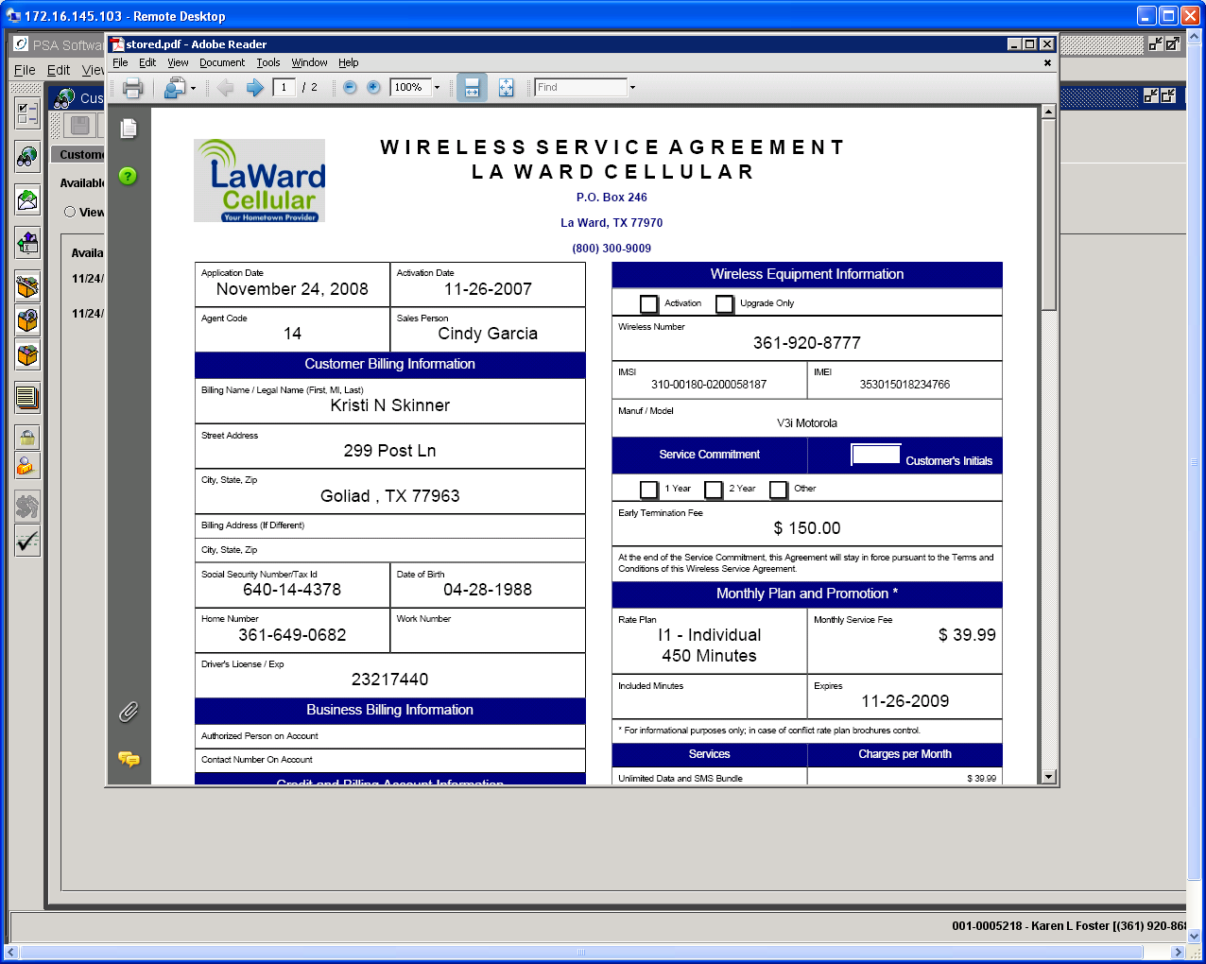

Account Level PDF’s

This can be used to store PDF images that are associated with the account and all services on the account.

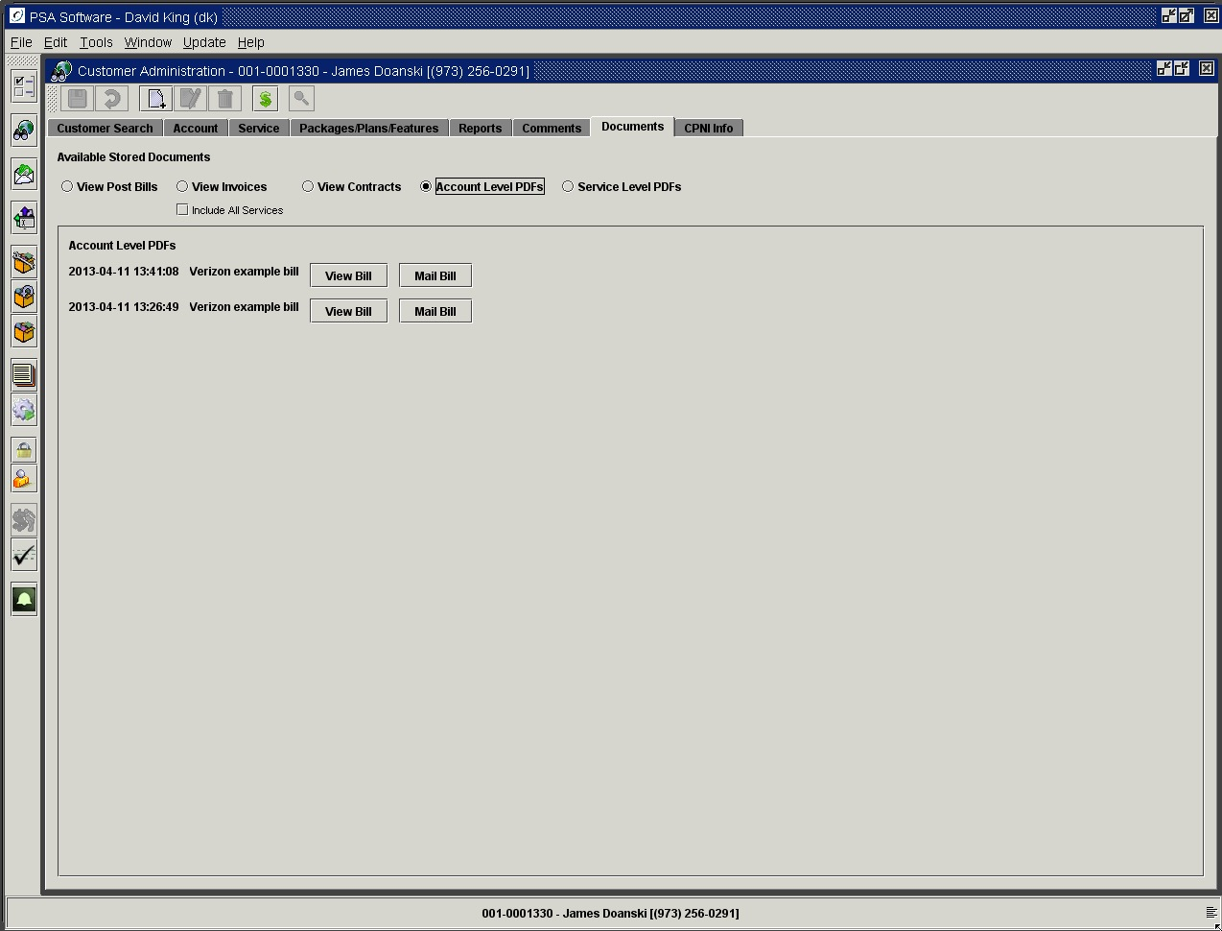

Service Level PDF’s

This is for storage of documents specific to the individual service number.

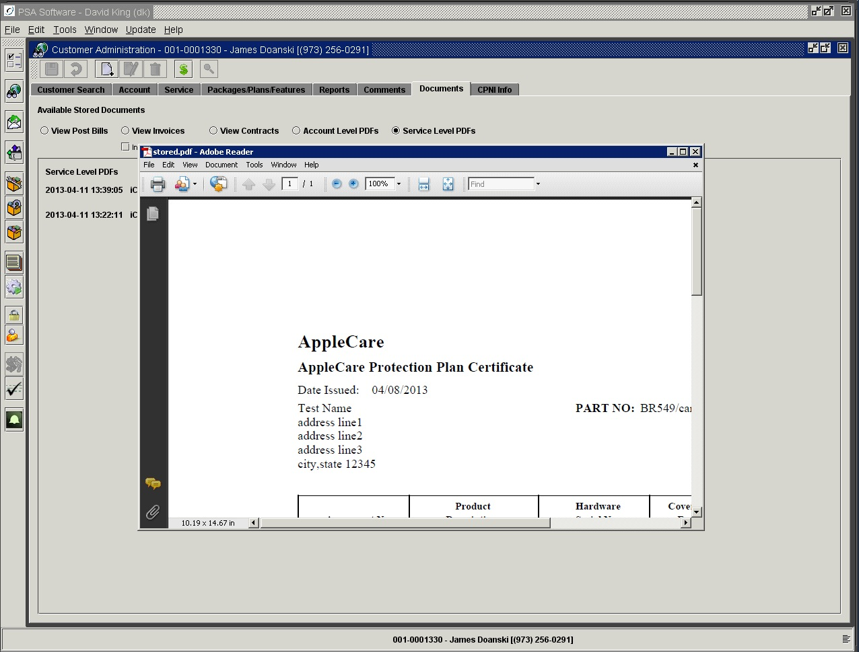

CPNI Tab

This tab will be produced initially whenever a customer account is being accessed. Once the data has been entered, only a display screen with the appropriate verification fields will appear on opening customer account, see example of CPNI attention popup below.

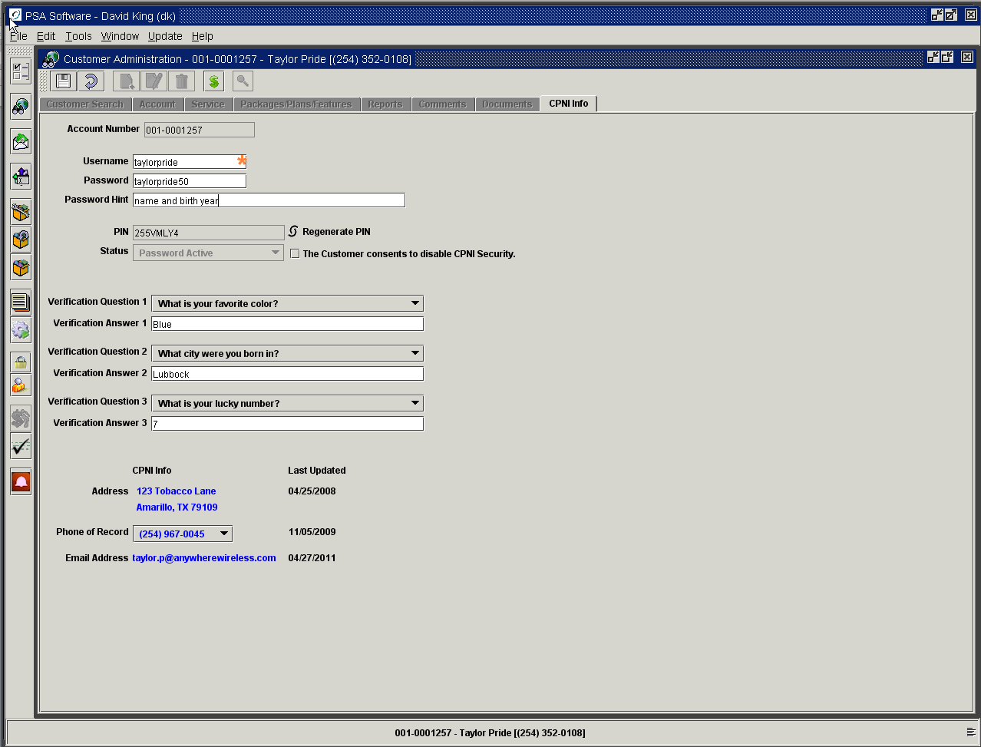

Username: The username is used in conjunction with the PSA web user application. When the user signs onto the customer self care website, they will use their username.
Password: This is the password used to identify the individual to release CPNI information. This is also the password used in conjunction with the above username to access the customer self care website.
Password Hint: This should be created by the customer to trigger their memory as to what password they have created.
PIN: Personal Identification Number, this is created initially for each customer to establish the initial CPNI information identity. This number will only be used when there is no password established or the old password has been disabled.
Regenerate PIN: If the customer cannot remember the password they established and needs to re-establish a unique identity, press the Regenerate button. This will generate a unique PIN and send that to the customer via the first valid PIN notification method: SMS, Email, or Letter. The text must be setup for PIN generation in the Options Setup.
Status: Shows whether the password or PIN is the valid identification field.
Customer consents to disable CPNI security: If the customer refuses to establish a password for CPNI, mark this box and all correspondence must be handled manually and in person.
Verification Question (1-3): Used as backup to identify the customer if they cannot remember their password. You may use 1 or 3 questions to establish identity.
Verification Answer (1-3): Answer fields for above questions.
CPNI Info: These are the fields used in the notification process when a chance has been made to the customer’s account. If the information is not at least 30 days old then the associated notification type will not be used.
Phone of Record is where SMS messages will be sent for CPNI notifications. There can only be one phone per account. You may change the phone by selecting an alternate phone number from the drop down list.
Last Updated: Shows the date the field was last updated.

CPNI challenge dialog box

This should be verified prior to releasing any information regarding the account. Refer to your company’s guidelines on how to use CPNI verification.

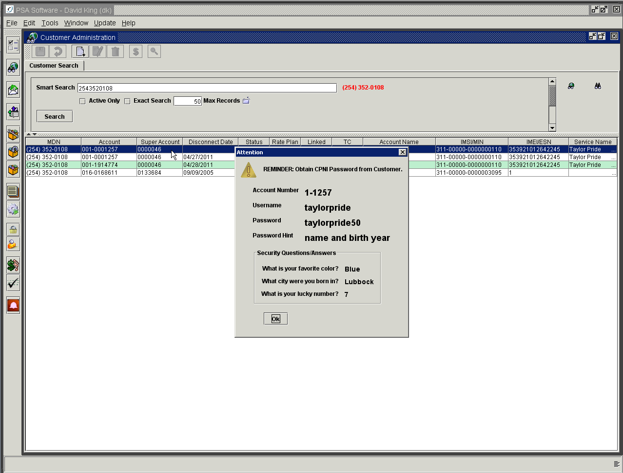

New Activations, Add-On Customers, Number Changes

Adding a New Customer
The Add New Customer function has several responsibilities within the scope of Desktop.
- Creates a new customer account, defining the services provided within the billing system
- Provisions the various switch components
- Creates contract for either electronic or manual signature, while storing an electronic copy for future use
- Optionally can check customer credit with affiliated credit bureaus
- Validate the address with USPS
- Handles point of sale transactions.

Activating a new customer begins with the ‘New’ icon on the search screen.

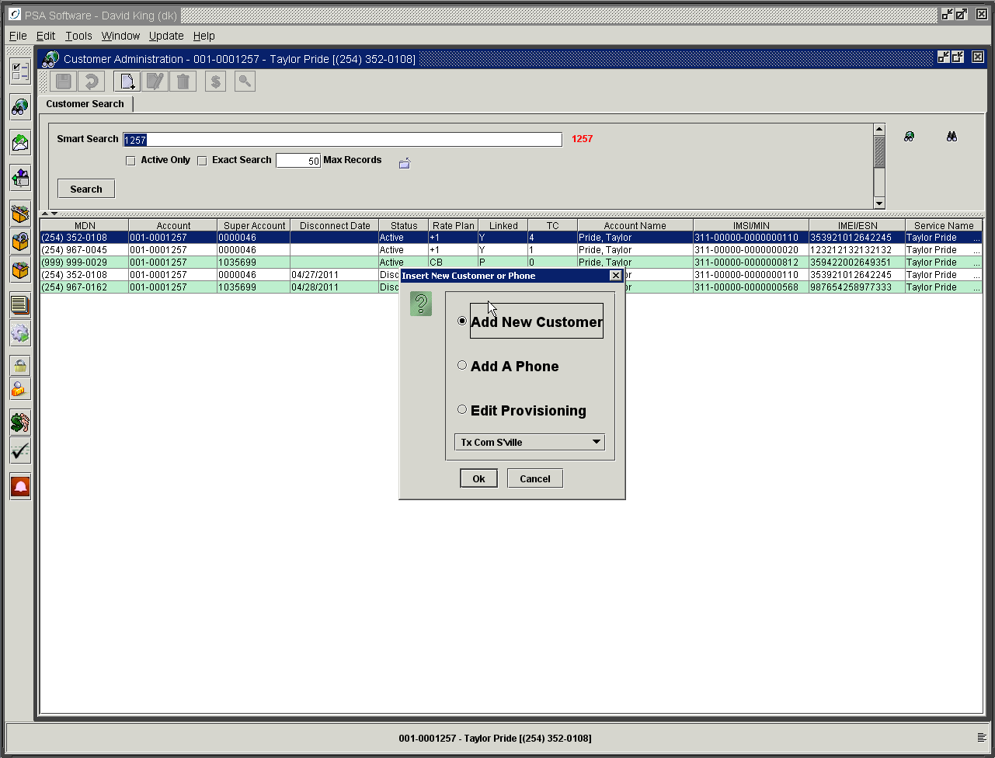
‘New’ icon

You will see three options:
New Customer: Creates a new account and allows a service to be activated.
Add A Phone: will allow additional services to be added to an existing account or reactivate permanently disconnected services on an account.
Edit Provisioning: permits editing of all areas of the customer account in one service order. MDN changes, IMSI/MIN changes and ESN/IMEI changes are submitted using this function.

The dropdown box allows the user to change the Point of Sale drawer for the transaction at the beginning of the service order. This is helpful if you control your inventory sales at the location level as well as Dealer sales where the dealer has their own inventory location. Pressing OK will open the new activation wizard. The wizard will step through the activation process from credit check to sales invoice.

If your company subscribes to the automated credit check, the next screen you will see is the credit check request screen. Once that has been completed, you will advance to the Insert Screen. If credit check is turned off you will move directly to the Insert Screen.

Credit Checking (optional)
Skip to Insert Screen if you don’t use this module.

This module allows controlled retrieval of credit reports for prospective customers from within the PSA Desktop. You may set restrictions on personnel as to information that can be viewed, even though a full credit check including the base reports will be collected. The levels of security are 1) only view the single character credit rating and deposit amount from the credit cross reference table, 2) see single character credit rating, deposit amount, and credit score returned from credit bureau, or 3) see single character credit rating, deposit amount, credit score, indicators and the full text credit report returned from credit bureau.

The process begins with entering the customer’s social security number. When you move off that field, the Desktop application checks your Wireless 9000 database for previous experience with that social security number. The first example screen shows no past accounts with your company and no credit checks have been pulled for the social entered.

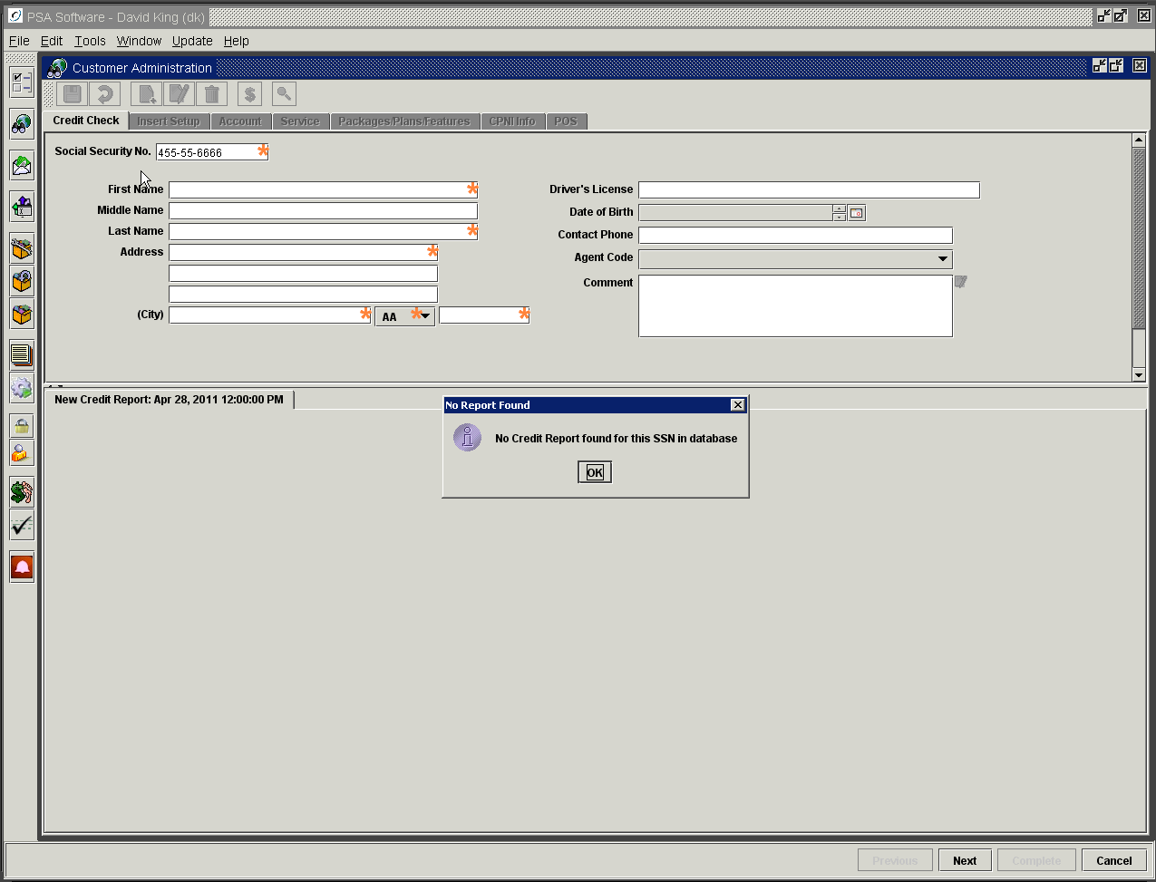

If the social security number gets a hit, then View Existing Accounts will appear to the right of the social security number field. See next example where there have been previous accounts attached to the social security number. In addition, there have been credit reports pulled previously and are available for review in the Select Report dropdown. Also if your company requires a credit check release form and a previous signoff exists; then the existing release will be displayed as a PDF. Closing the PDF frame will dismiss the form.

You will see the existing credit rating and credit score associated with the social security number.
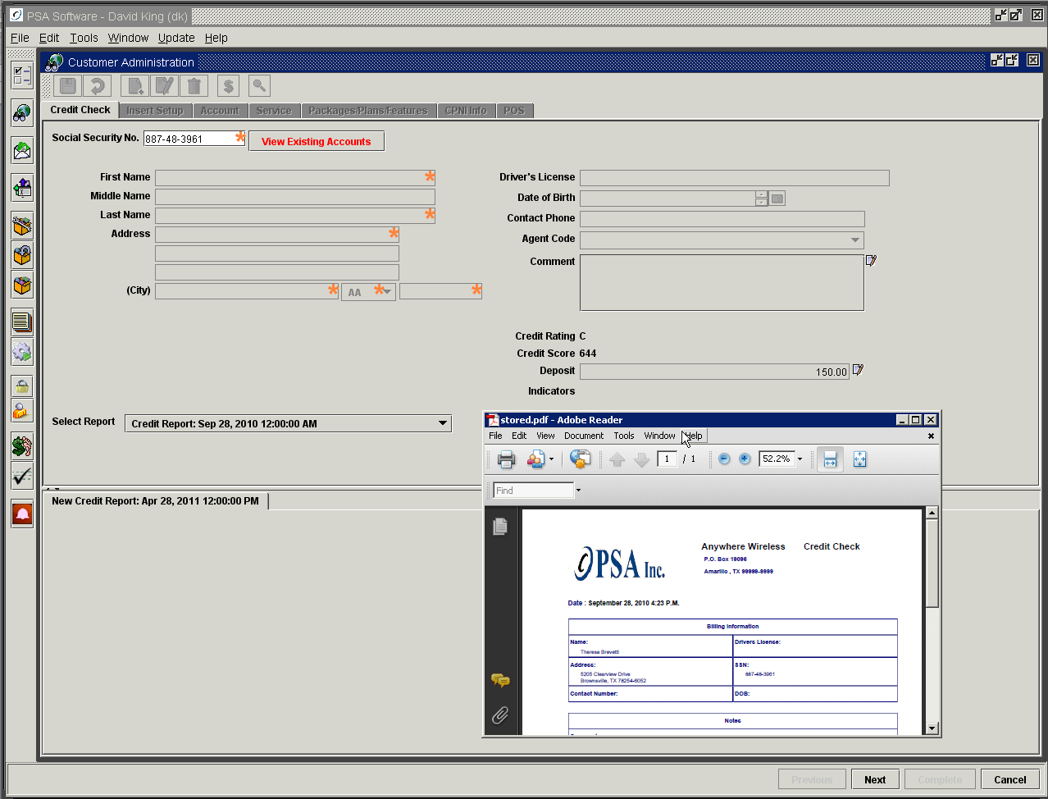

With the higher level of authority you may select a report from the dropdown for viewing in the bottom frame.

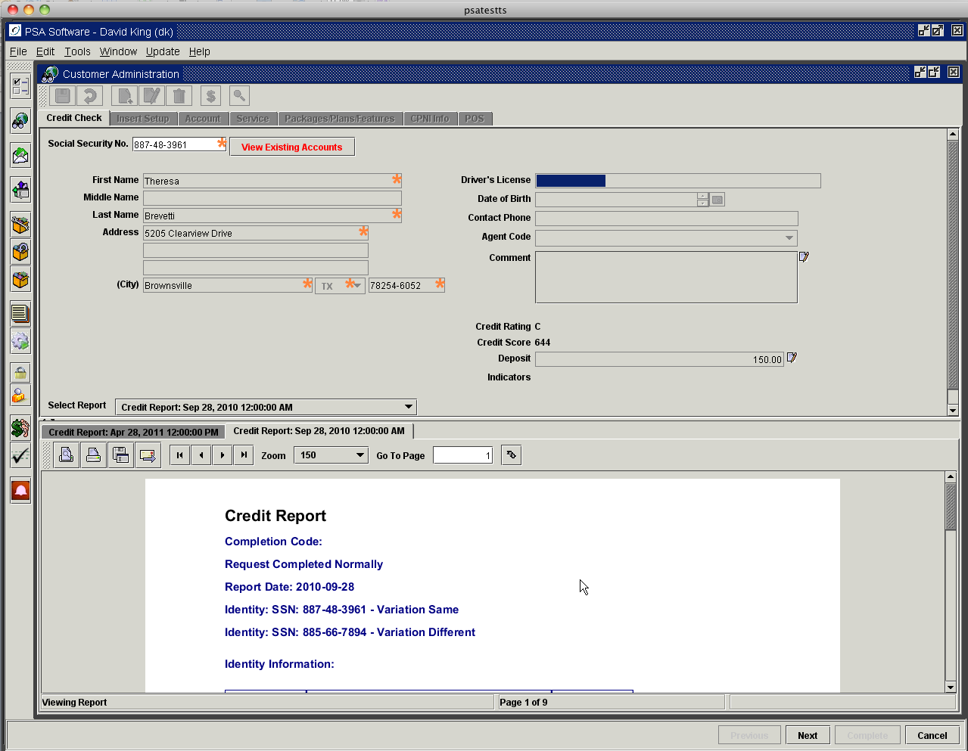

Pressing ‘View Existing Accounts’ brings up the listing of accounts associated with the social security number.

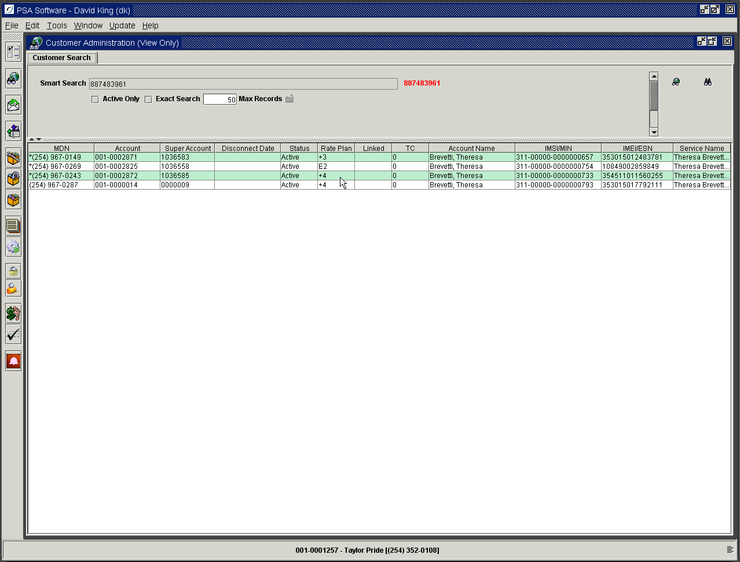

One area of particular interest would be the Status field on the search return field, which show any accounts that carry a Write Off balance. Another good indicator would be the accounts receivable report and notice tables associated with the account. Reviewing the Accounts Receivable Report would show any issues regarding account collection in the past. Double clicking the account will display the Account, Service, Packages/Plans/Features, Reports, Comments and Documents tabs in View Only Mode.

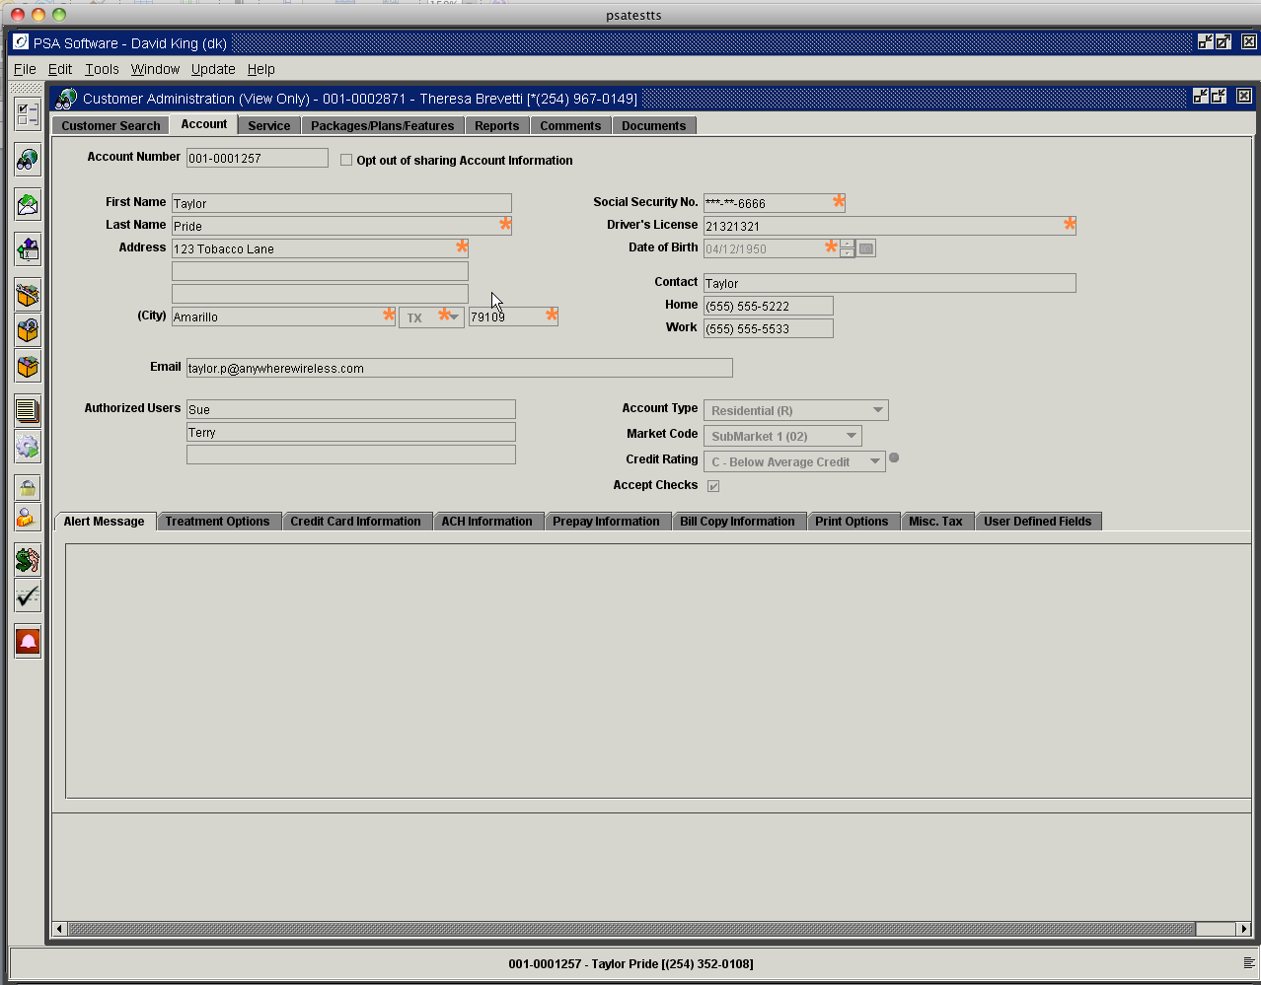

After reviewing the account information, press the X in the inner frame to return to credit check. This returns you to the credit check module.

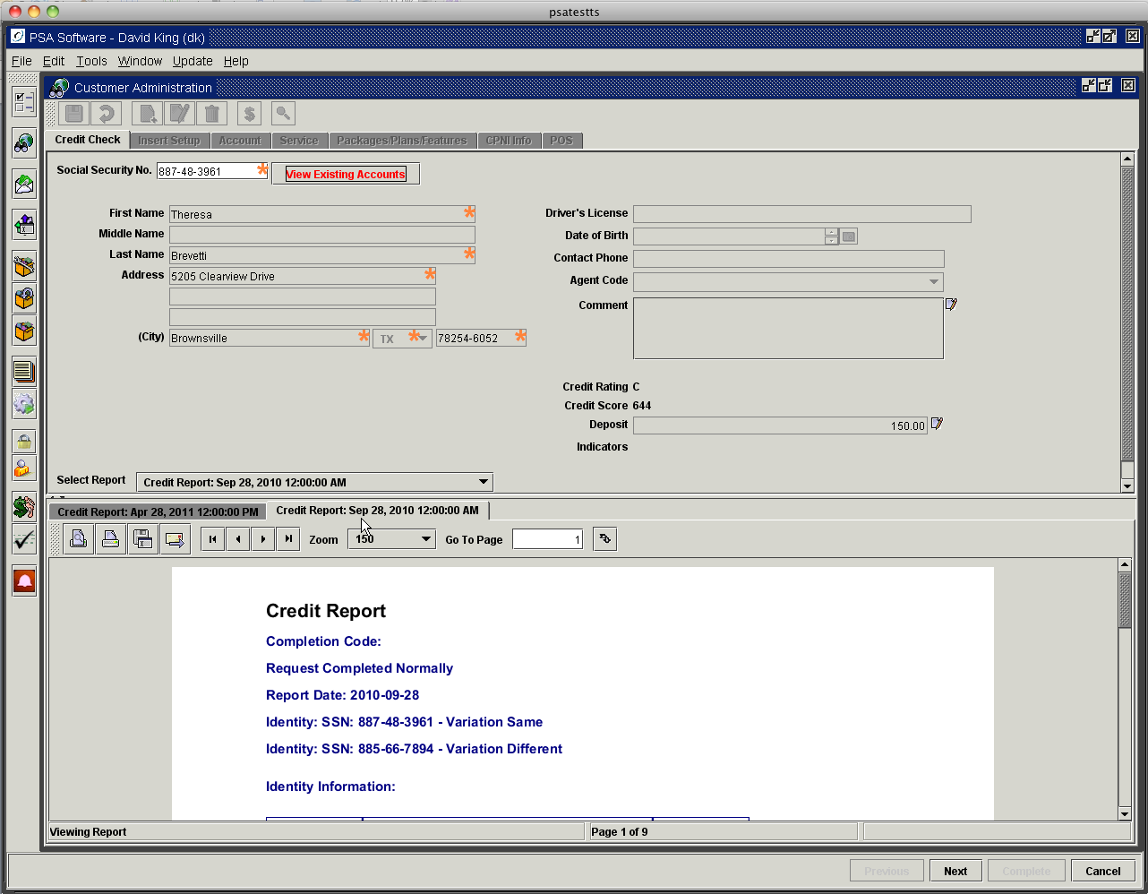

If there are previous credit reports that have been collected those reports will be shown in the Select Report drop down. Those reports will be displayed individually in the tabbed sub-field below the box and are available to print in PDF.

The default in the drop down is New Credit Report the current day’s date. If there are no previous reports or it is determined a new report should be retrieved, select New Credit Report.

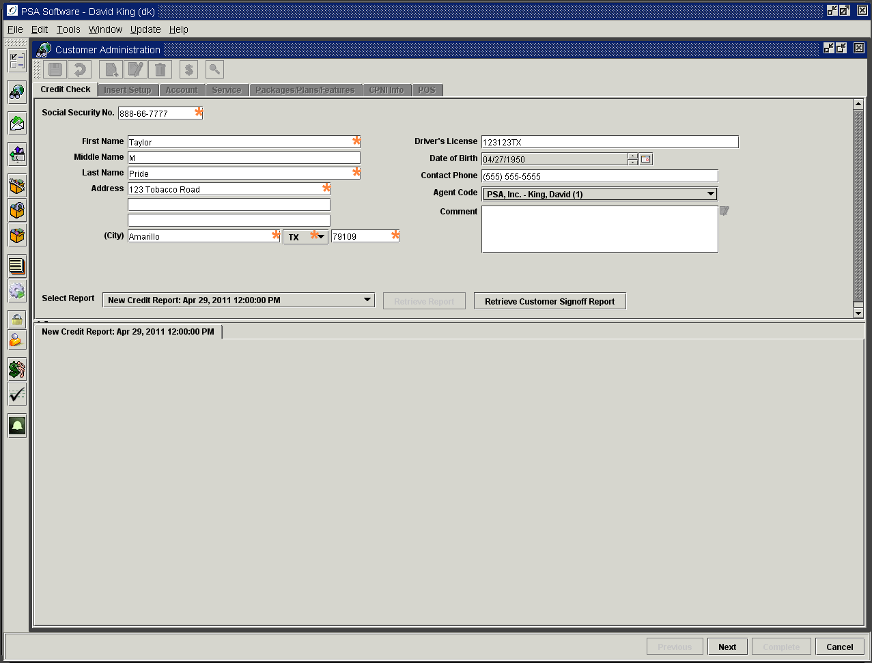

If your company requires a customer release to pull a credit report, complete all the fields and press the Retrieve Customer Signoff Report. This produces a signoff sheet that can be signed electronically or printed for manual signing.

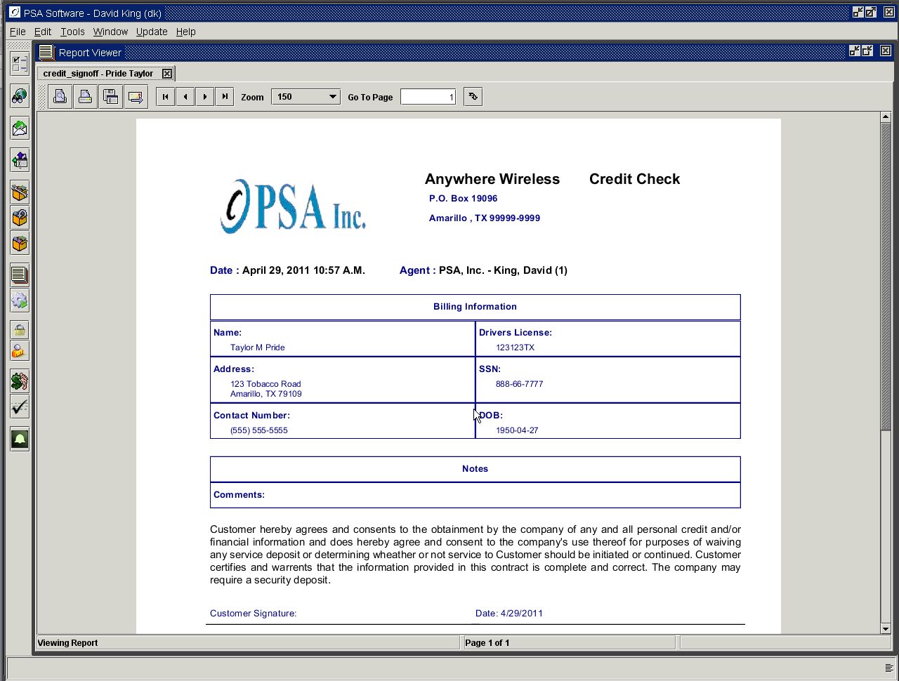

Once the signoff is completed, close the Report Viewer by pressing the ‘X’ on the Report Viewer frame. The Retrieve Report button is now active.

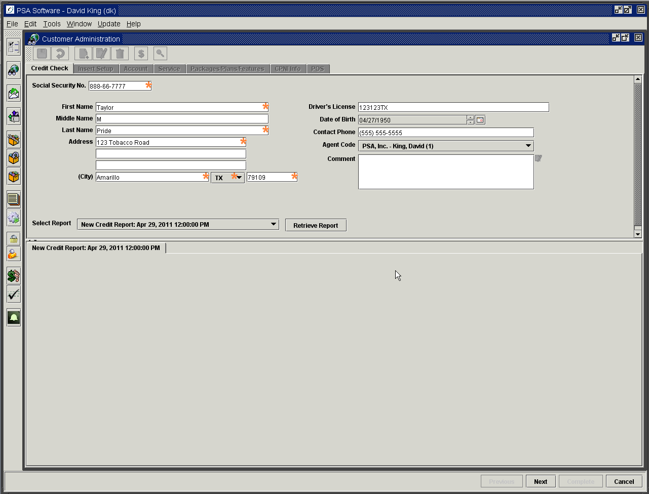

Pressing Retrieve Report accesses the credit bureau and returns any indicators, credit score and text of credit report in the sub-frame as a PDF. This report will be saved as a PDF. It can be printed if required.

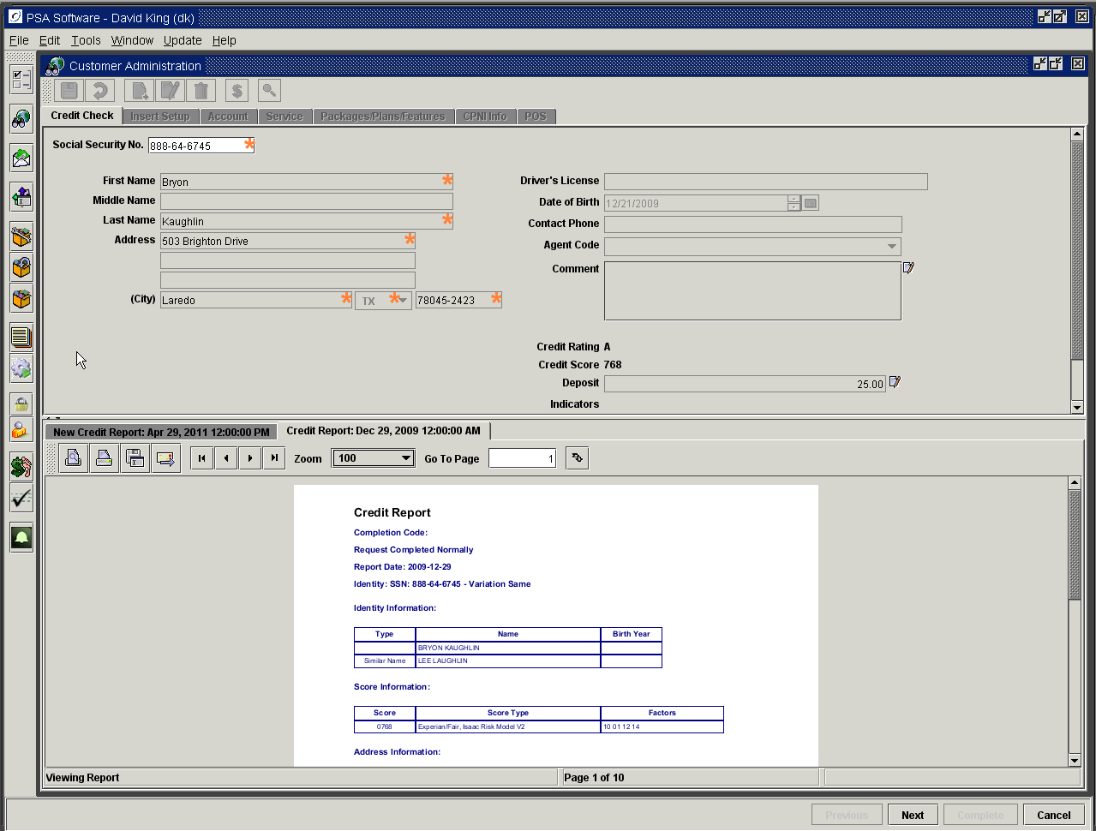

The credit rating is displayed along with credit score. If the company attaches a deposit requirement for this level of credit the deposit amount field will be data filled. If the deposit amount needs to be edited and the CSR has the correct authorities the edit icon will be active to the right of the field. If the CSR doesn’t have deposit edit authority, credit override is available by pressing the Red Ball near the Edit icon; someone with edit authority can sign in and change the deposit. If there are any indicators with the file such as WO for write off, these will display following the deposit field. The credit report itself will display in the reports frame.

Once the information has been reviewed the next step is to move into the Insert screen. If the credit does not meet the scoring standards set by your company but there are extenuating circumstances; the standards can be overridden with a supervisory authorization. Have the person overriding the standard enter their user name and password to allow the service order to continue. This override will be recorded in the system and accessed using the override report.

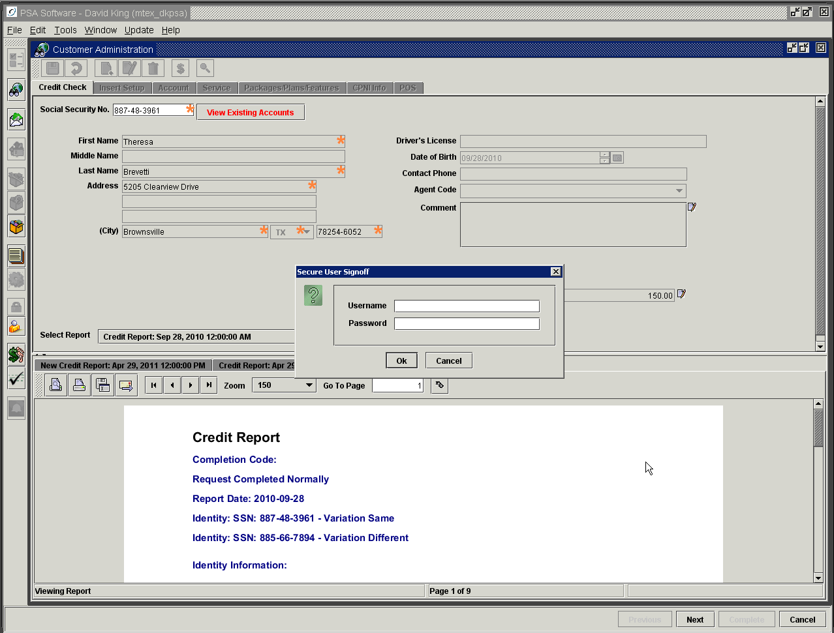

See Appendix A for list of potential errors/messages returned by Experian during credit check.
Select ‘Next’ for the Insert Setup tab and complete the New Customer service order wizard.

Insert Screen

This screen defines the parameters associated with the new service. The first step is to verify or change the effective date of the ‘New’ service. Use the calendar icon to the right of the date to make any necessary changes.

Account Number: This will be generated by Desktop and displayed in the first field on the screen.

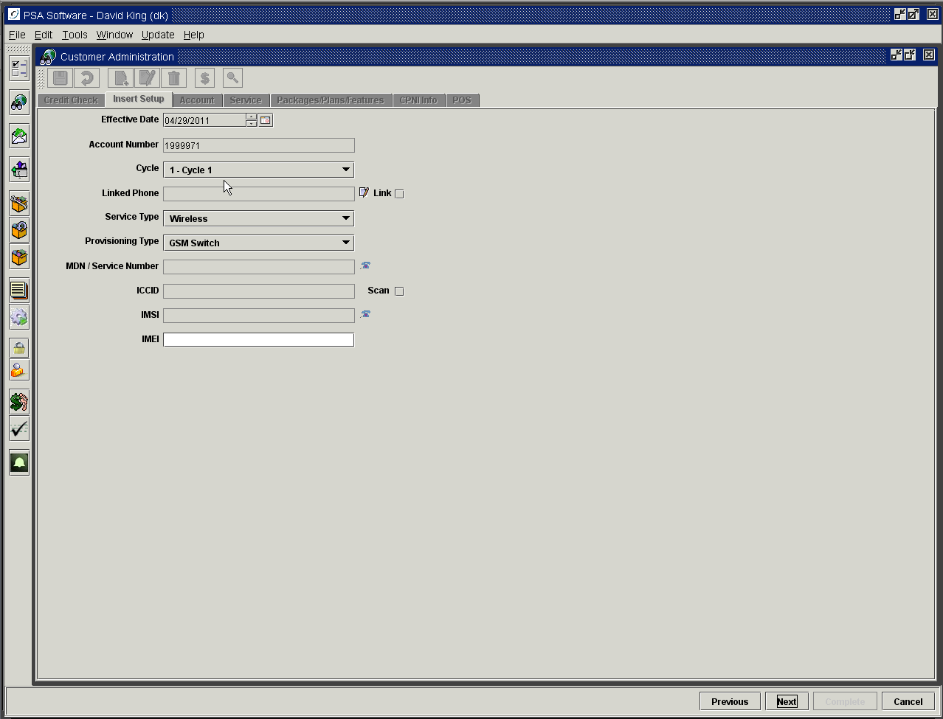

Cycle: If your company has multiple cycles, select the appropriate cycle for the ‘New’ customer. If this is an Add a Phone or Edit Provisioning service order, the cycle will be preselected and not editable.
Linked Phone: This field allows you to link the new service to existing services for plan minute sharing. The Linked Phone field will display different values according to the type of service order.
a) New Customer service order: the field will be blank, as you have no other services available to link to with a new customer account. You will leave this field blank on New Customer.
b) Add a Phone service order: The first step of Add a Phone is to select a customer record/account to which the new service will be added on the initial search screen. Within Add a Phone service order, on the Insert screen, the value of the Linked Phone field will be the service number of the customer selected from the search screen. If this is the number you want the new phone to share minutes with then mark the Link box to the right of the field. On completion of the service order both phones will have the same super account number, which causes them to share minutes. Phones will only share minutes if the plans attached to the phones are compatible regardless if they share a super account number.
c) Edit Provisioning service order: The value will be the super account number attached to the service number selected not the service number.

In either the Add a Phone or Edit Provisioning service orders, if you wish to link the service to another phone than the original selection you may locate a service number/super account number using Link Edit icon directly to the right of the field. This presents a search dialog; enter the information for the search and press Search (pressing the Enter key returns the CSR to the previous screen). Highlight the service in the list and press OK. This will place the service number of the selected phone in the Linked Phone field on the Insert Screen. You must complete the service order to post the change.

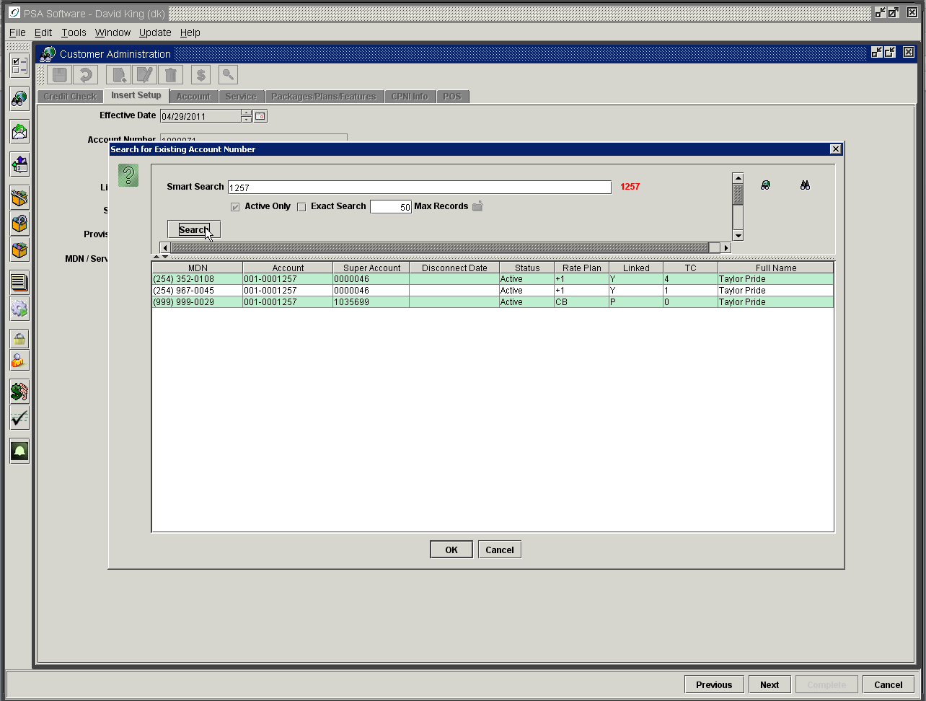

NOTE: Linking services in the PSA system allows for the sharing of free minutes or data elements over several services. Some companies allow sharing between technology types, some will allow services on different accounts to share, but most companies only allow sharing on services on the same account and of the same technology. PSA can handle any of those combinations. If your company allows linking across accounts, you might use the linking function while inserting the ‘New’ customer. Super account numbers for ‘New’ customers will be left blank and the service order will assign a super account number to the original service number. Subsequent services will be added to the same account via Add a Phone. Services with the same ‘Cycle’ and ‘Account’ number will share a statement but not necessarily free minutes. The Linked check box to the right of the field must be checked for the two services to be linked. Once the service order is posted both the services will have the same super account number and will show a ‘Y’ in the linked column. To see what services are linked for sharing minutes, you may search by the Super Account number in the search fields. In Smart search you must preface the number with a small ‘s’.
‘s1053847’ will find the linked phones for super account number 1053847.

Once the super account number is correct, put a check in the Link box to the right of the field. If checked, you will only be able to select packages or plans on the Packages/Plan/Features screen that are compatible with the rate plan on the number you selected on this screen. (See linking override in the package/plan/features section.)

Service Type: Select the type of service from the drop down box. Ex. GSM, CDMA, Wireless, Internet, etc. Service type can be used to limit the scope of the MDN selection. You can establish ‘service areas’ with a service type and only allow certain NPA/NXX ranges to show in the MDN selection.

Provisioning Type: If the default provisioning type is set on Service Type this field will be preloaded. If not, select the provisioning type related to the Service Type. This determination will establish the types of fields required for the rest of the screen. There is a special provisioning type to denote a ported-in number. The Port In provisioning type allows the CSR to enter a service number not owned by their company.

MDN/Service Number: To select the MDN, press the telephone icon to the right of the field.

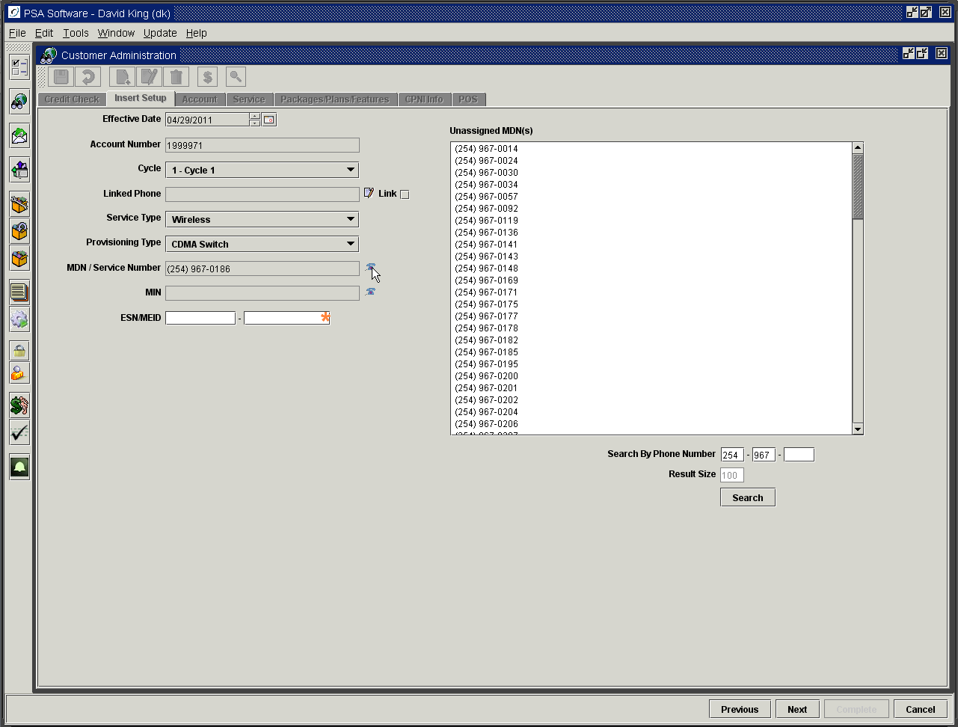

Line ranges may be tied to Service Types. The list shown will default the first available service number for the service type chosen. If line ranges are not tied to service type then the first available inactive number in the unassigned number pool will be displayed. If you need to find a specific MDN, enter the number in the fields provided below the list and press Search. If you only need to find the first available number within a NPA/NXX range, enter the NPA and NXX and press Search. This will start the list at the first available number that begins with that NPA and NXX. To choose a number, double click the number in the list.

CDMA provisioning type:

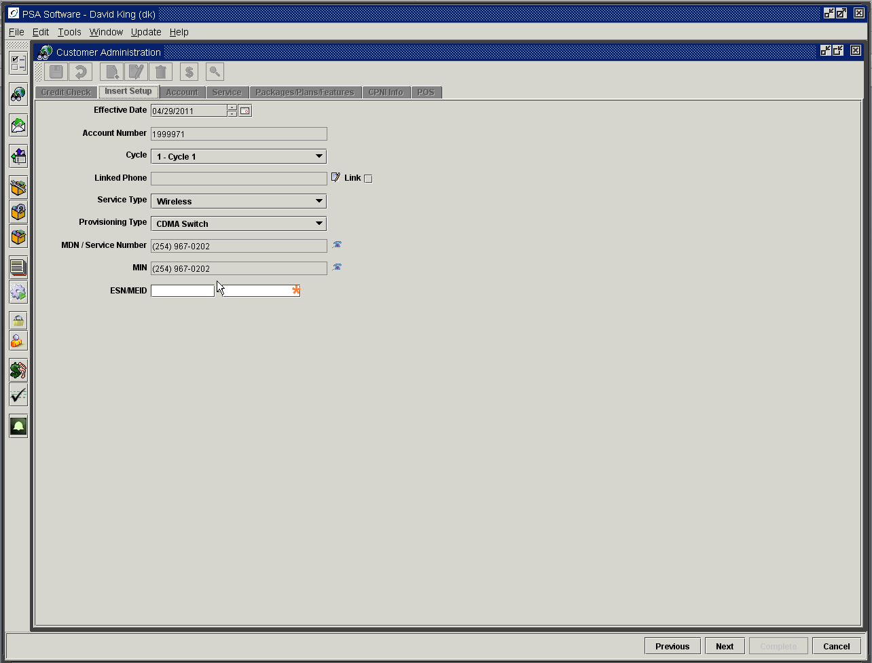

MIN: If there is a matching MIN for the previously selected MDN in the unassigned MIN database, that MIN will be preloaded in the MIN field. If the number is unavailable, select another MIN using the telephone icon next to the MIN field using the same procedure for selecting the MDN.
ESN/MEID: If you are using the ESN, enter that into the first field; if you are using the MEID, enter that into the second field. There are several formats for ESN: ESN 8 Hex, ESN 10 Decimal, and 11 Decimal. If you enter the 8 hex or 10 decimal into the first box it will be converted to the 11 decimal format. It is stored as 11 decimal but you can search for it as 8hex, 10 decimal or 11 decimal in any of the search areas.

If the ESN/MEID is available for sale and there are no other instances of the ESN/MEID then you will move to the next step in the service order.

PSA Desktop offers an optional crosscheck for ESN/MEID. If the option ‘Check with Message’ is activated you may see various messages on the status of the ESN. When the user presses ‘Next’ at the bottom, the application will check the database for existing handsets with that ESN/MEID. If the item is found on an active service or has been on another service in the past then a message will alert the user to that fact. A second option is available to determine if the ESN/MEID is available for sale in inventory. If the item is not found in the inventory or inventory location, a message will display as unavailable. The user can press OK and continue with the service order. This is option is a warning message only!

A higher level of control would be to ‘Block’ the continuation of the service order if (1) the item is not available in inventory or inventory location, (2) the number is showing as the ‘active’ ESN/MEID on an existing customer, or (3) the number is showing in History on an existing customer. This feature was designed to help stop sales of items not in inventory and find potential issues such as someone trying to activate a stolen phone.

There is an override function that can be extended to supervisors or managers if needed in conjunction with the Block function. This will display two fields; the supervisor can then enter their system username and password and the service order can be continued.

This is an example of warning message for CDMA checking the ESN/MEID only.

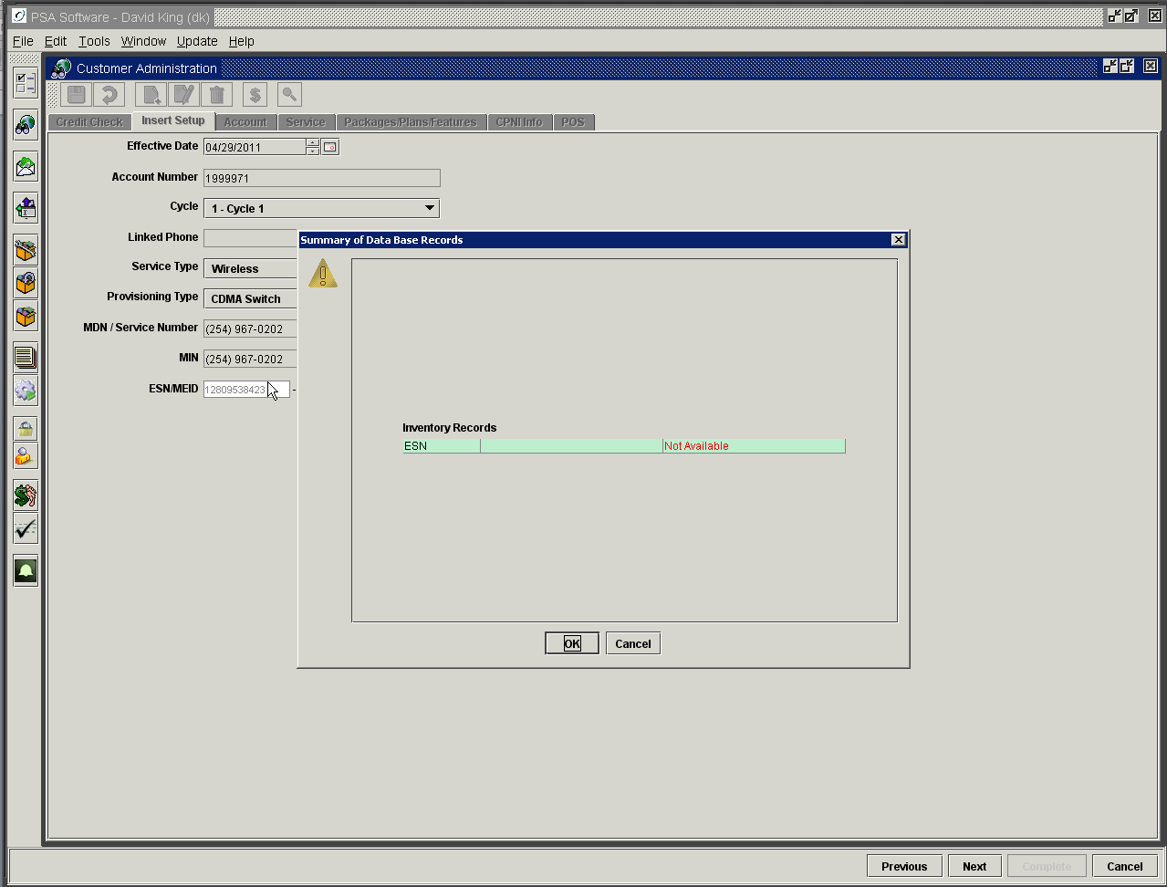

Here is an example of warning message for GSM with all check options selected; CDMA looks the same only using the ESN or MEID as the criteria.

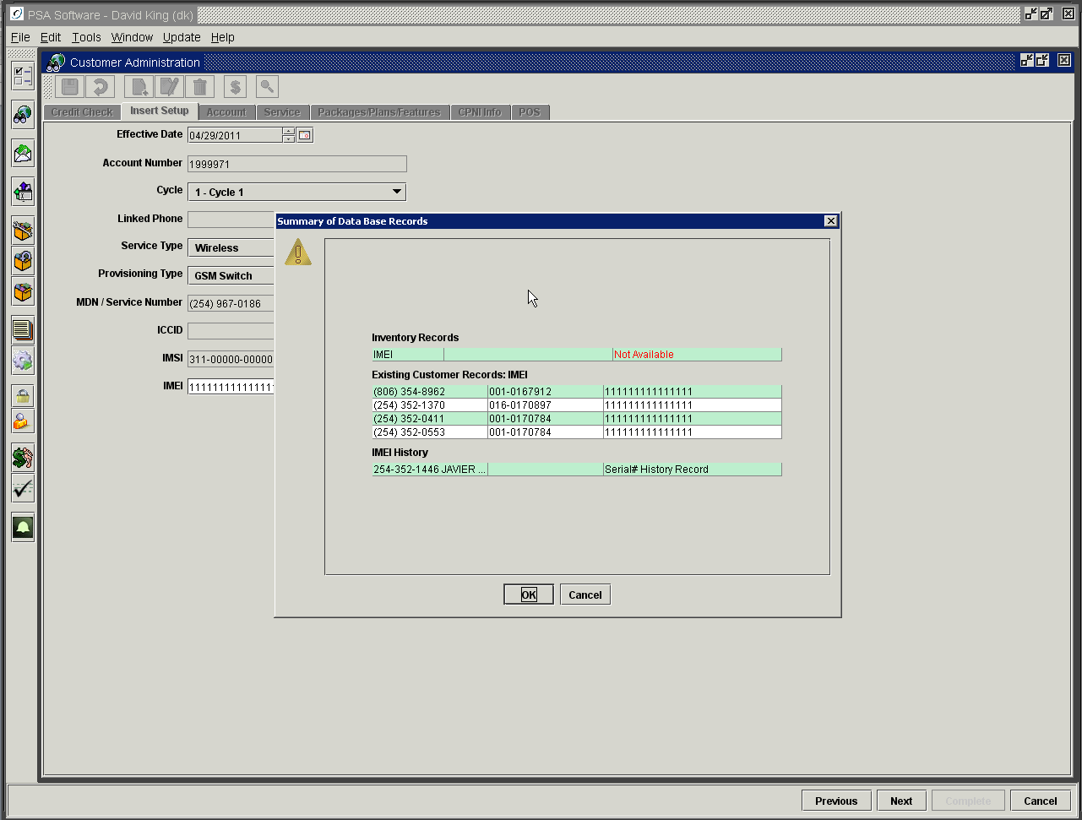

Here the phone is not in the inventory and will not be available for sale in Point of Sale. The CSR should set the handset aside and find another handset that is available for sale. Pressing OK will return the CSR to the Insert Screen if the message dialog is open.

Additionally there are several other service numbers that show the IMEI as the active IMEI on a service. These could be mistakes or possibly this is stolen phone trying to be activated.

IMEI history shows that the IMEI was once used by 254-352-1446 but is no longer the active IMEI on that phone. Again this could require further research per company instructions.

Your company can select to display messages for one, two or all three messages.

GSM Provisioning Type

This works like the CDMA provisioning type only it displays fields specific to GSM handsets.

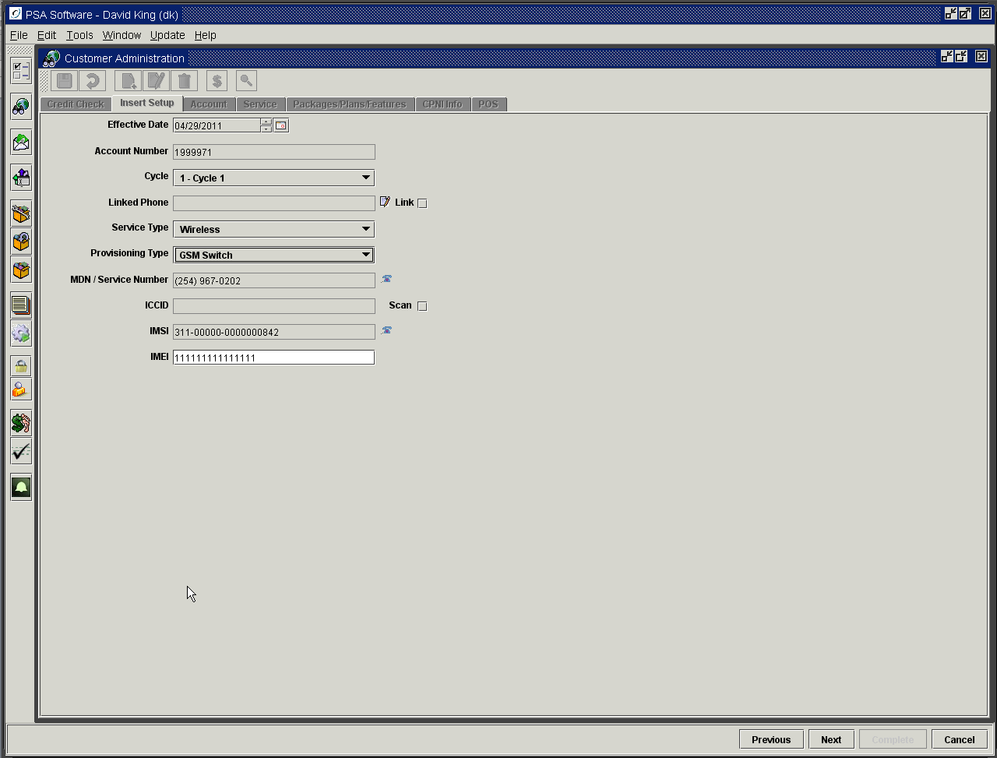

ICCID: Enter or scan the ICCID from the SIM card. The program will extrapolate the IMSI from that number and validate the IMSI is active. If the IMSI is active then the IMSI field will be populated automatically. If you do not have the ICCID number, you may skip the ICCID entry by un-checking the Scan box.

IMSI: For manual entry of the IMSI, use the telephone icon to display a list of active IMSIs. Double click the number in the list to select it.

IMEI: Scan or manually enter the IMEI from the handset or handset box. When the user moves off the IMEI field, the application will check the database for existing handsets with that IMEI. A second check will determine if the IMEI is available for sale in inventory. If the item is not found, the following message will display. If ‘Block’ is not turned on you may continue with the service order by pressing OK.

Internet Provisioning Type

This type may request an IP address as part of the setup.

Port-In Provisioning Type

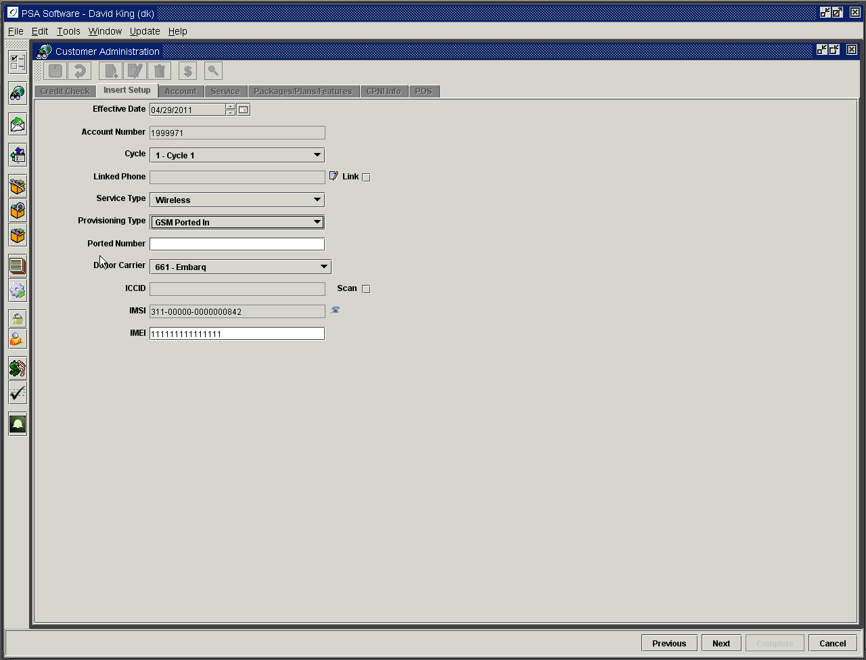

Ported Number: Enter the number being ported including the NPA. EX. 8063588928

Donor Carrier: Select the Carrier ID from the drop down. Only carriers capable of porting to your company will be shown in the list.

When the Insert screen is complete, the wizard steps the CSR through the remaining Account, Service, Packages/Plans/Features, CPNI, and POS screens to complete the setup. Each screen will have required fields and will not allow the CSR to move to the next screen until they are complete. This discussion will not cover the individual screens as the information has been previously discussed. Equipment items, auto deposit features and prorated amounts for the plan will be preloaded on the POS screen. These items should not be deleted or changed except to change from a ‘payment up front’ status to a ‘Bill To’ status for collection on the customers’ next statement. Additional equipment items, activation fee adjustments, etc can be added at this time in POS.

Address Validation (optional)

When address validation is turned on, the application will attempt to validate any new or changed address. This process will run in the background until either you move from the screen by pressing ‘Next’ or when you attempt to ‘Save’ the changes. At that point there are two potential displays.

Option 1
Your company may choose not to display the validation dialog if the address is validated or if a valid address is returned. If this is selected, the order will continue uninterrupted. If there is a difference on the returned address; that address will be loaded and you will move forward with the service order.
If the address cannot be validated then you will see a dialog box stating the address could not be found therefore it is not validated. Here you must respond to one of the statements:
Use entered values and proceed: this accepts the address as typed in the fields and allows you to continue with the service order unimpeded.
Resume Edit: returns the user to the screen where the address was entered or changed for editing of the address. This may continue until you enter an address that can be validated or you select the option above.

The following is an example of Address Not Found

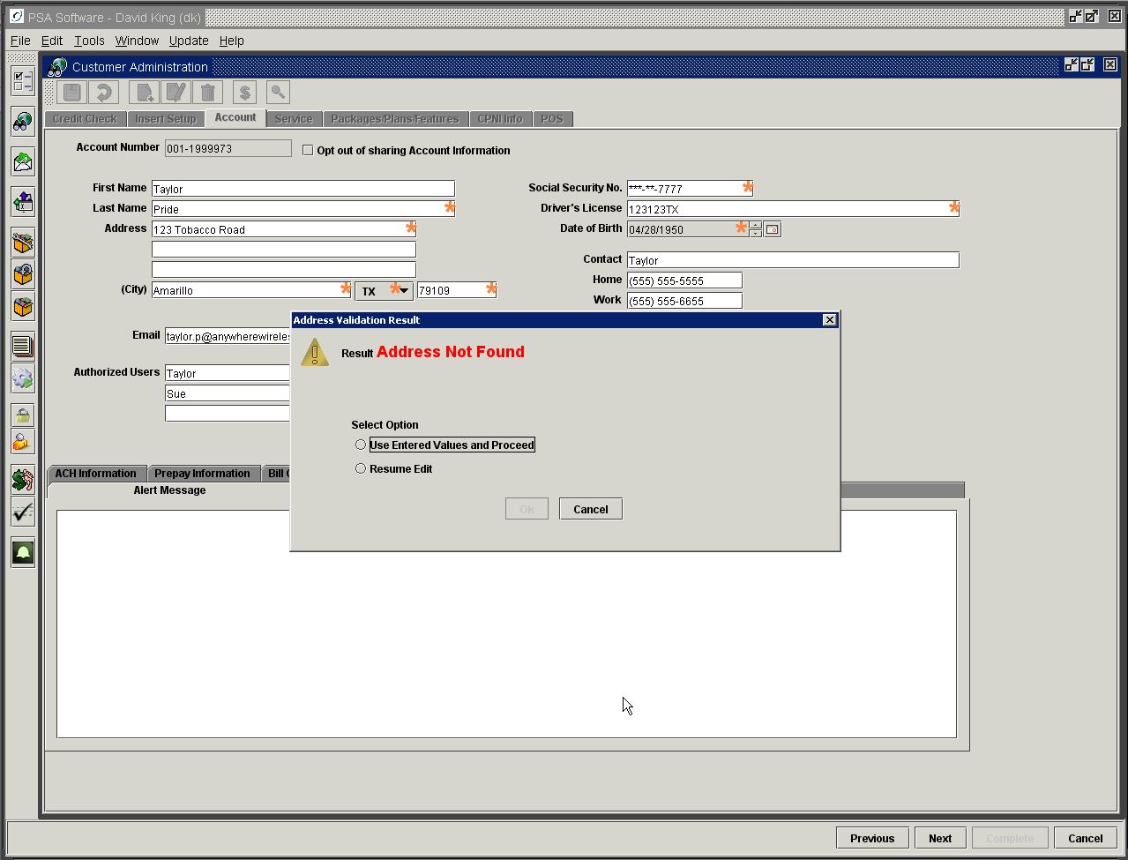

Option 2
Your company may choose to display the validation dialog, which allows the user additional options without auto-loading the validated address. Once the ‘Save’ or Next button has been pressed, this validation dialog will display requiring input from the user. The validated address is shown when available. If the address is not found, then you will have the same display as shown on the previous page. The user must respond with one of the following:
Use validated values and proceed: Accepts the address displayed in the dialog, makes changes to the address fields as needed and moves to the next step in the service order.
Use validated values and return to edit: Accepts the address displayed in the dialog, makes changes to the address fields as needed and returns to the same screen in the service order.
Use entered values and proceed: Rejects the returned validated address, leaves the address as entered by the CSR and moves ahead in the service order.
Resume Edit: Rejects the validated address and return the user to the screen for continuation of editing.

See the following example of display on Address Found.

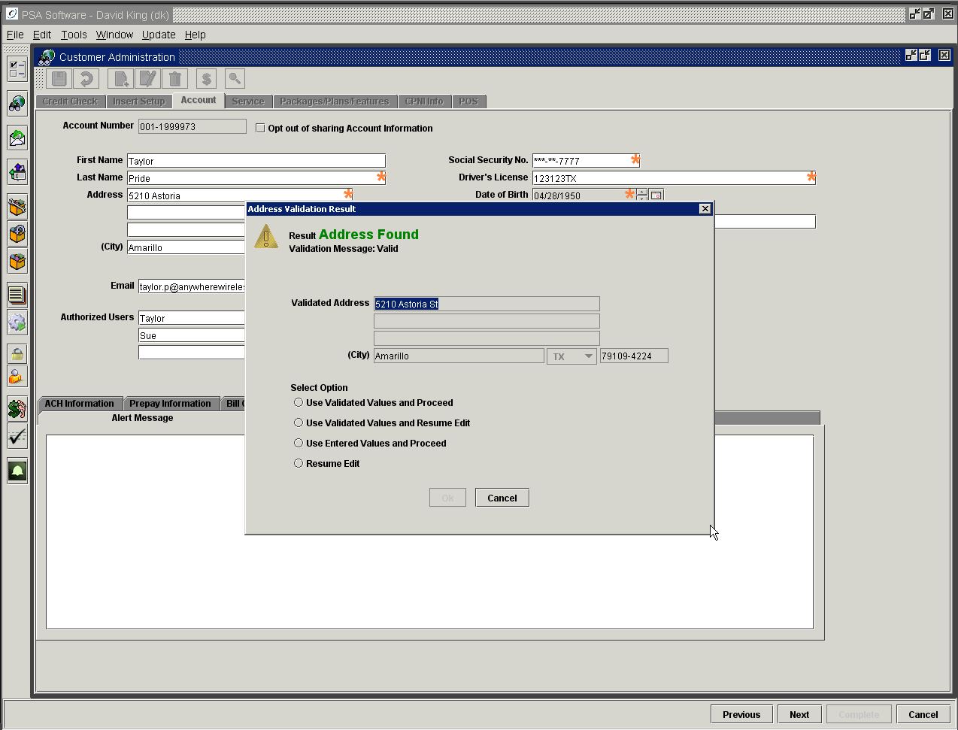

Completing the New Customer service order

If the address validation were turned off then you would move immediately to the service level screen for the next step.

The CSR would complete the required fields on the Service Level screen.
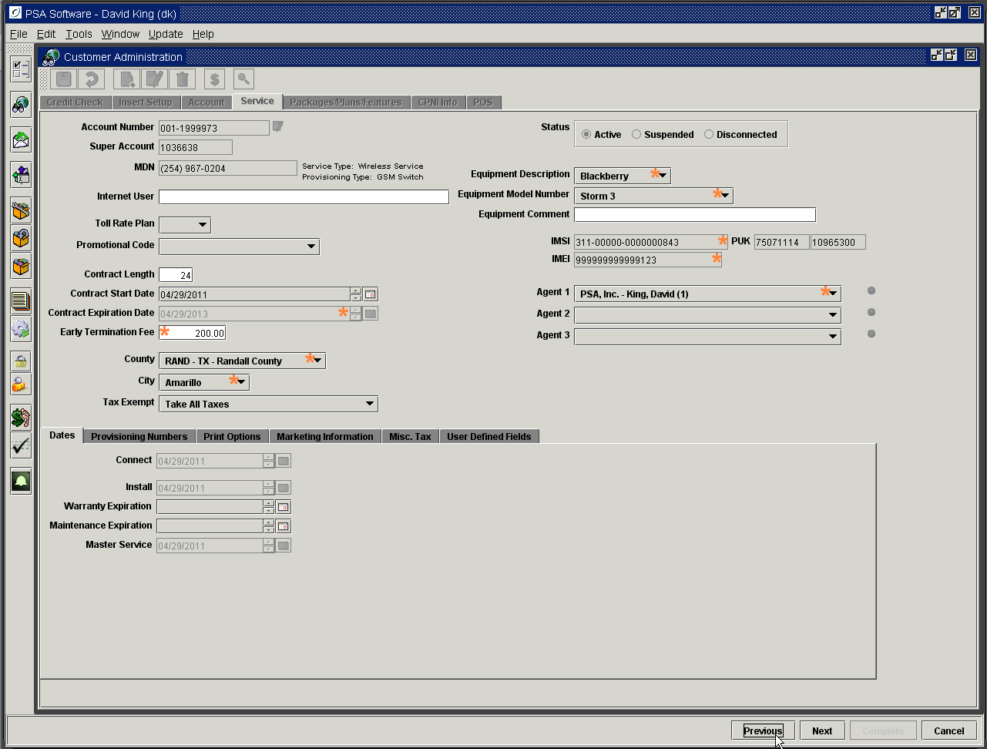

The next step would be to add a Package / Plan and additional features.

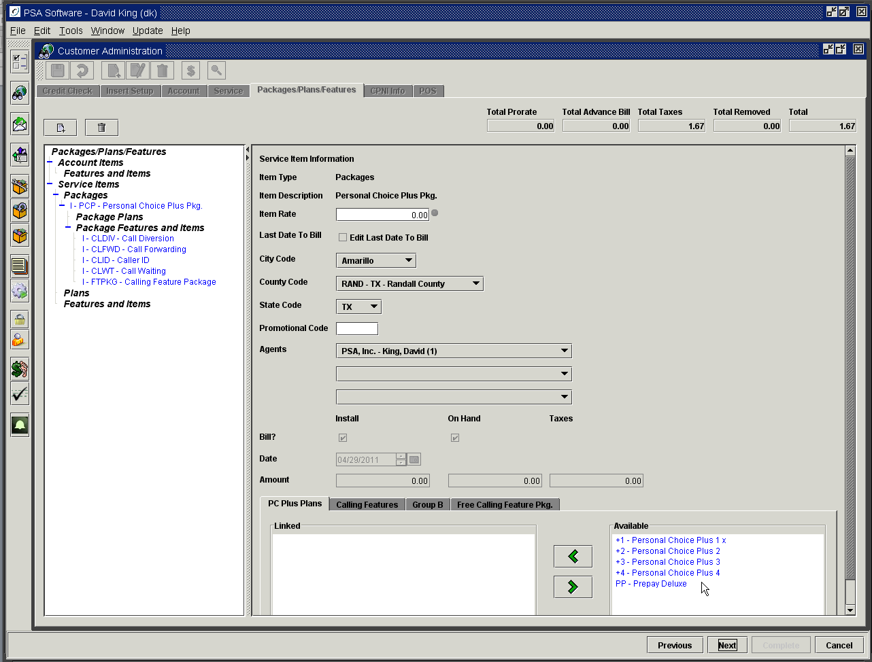

Establish the CPNI information for the new customer. This not only provides information to validate a call in customer’s identity but also allows access to PSA’s Electronic Bill Presentment and Payment website.
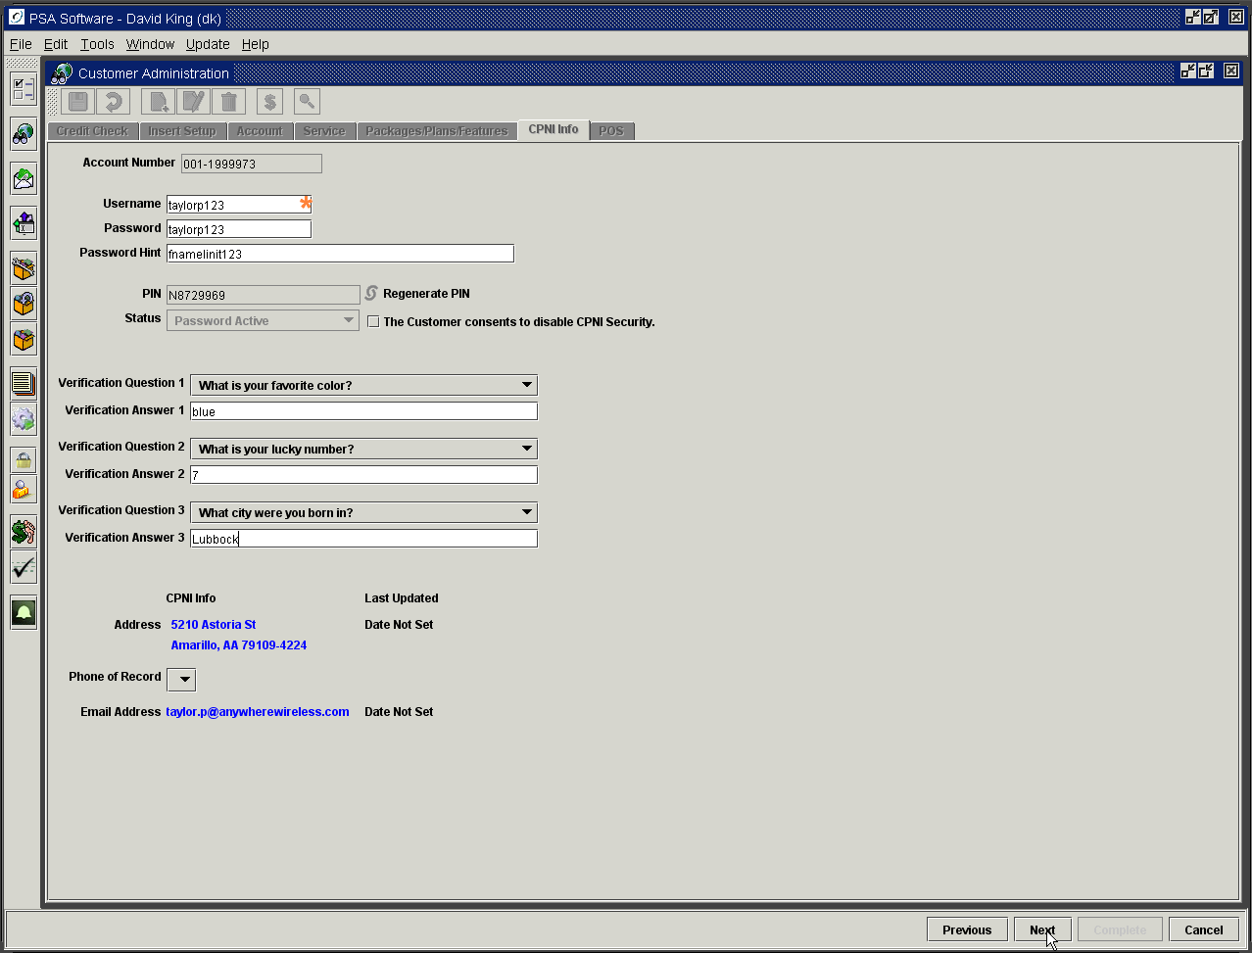

Add any additional equipment items or adjustments such as activation fees or promo offers to the invoice. Once all the equipment has been entered onto the invoice, the CSR would collect any monies owed on the activation on the Point of Sale screen.

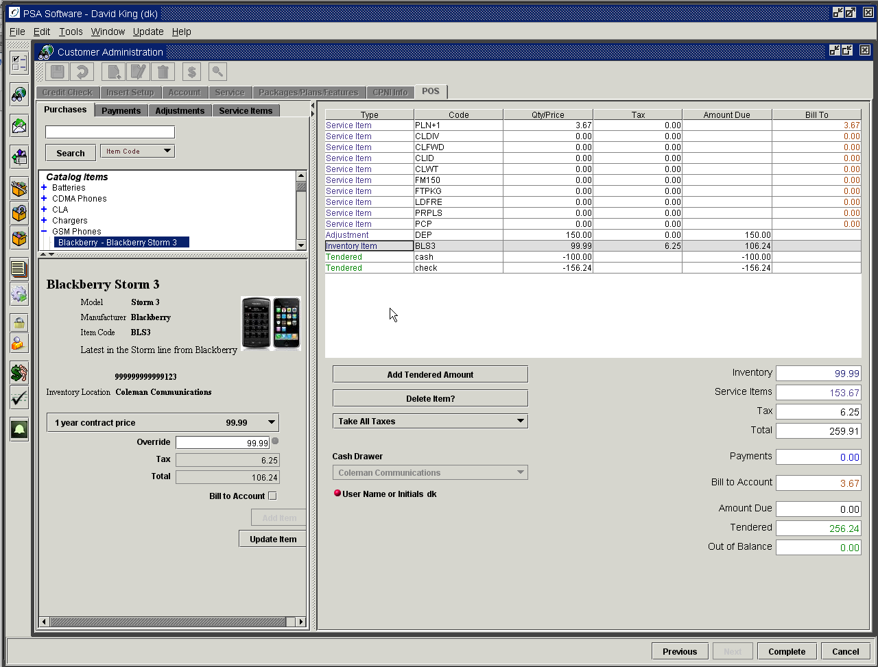
Point of Sale/Cash Drawer is the final screen on ‘New’ Customer, Add a Phone and Edit Provisioning service orders.

Pressing the Complete button will post the service order. Various procedures will take place:
- Provisioning of all switches with the appropriate numbers and features begins
- If contracts are used, a contract is generated
- An electronic signature request for Contract and/or Invoice will be presented (IntegriSign ePad shown) when available on the system

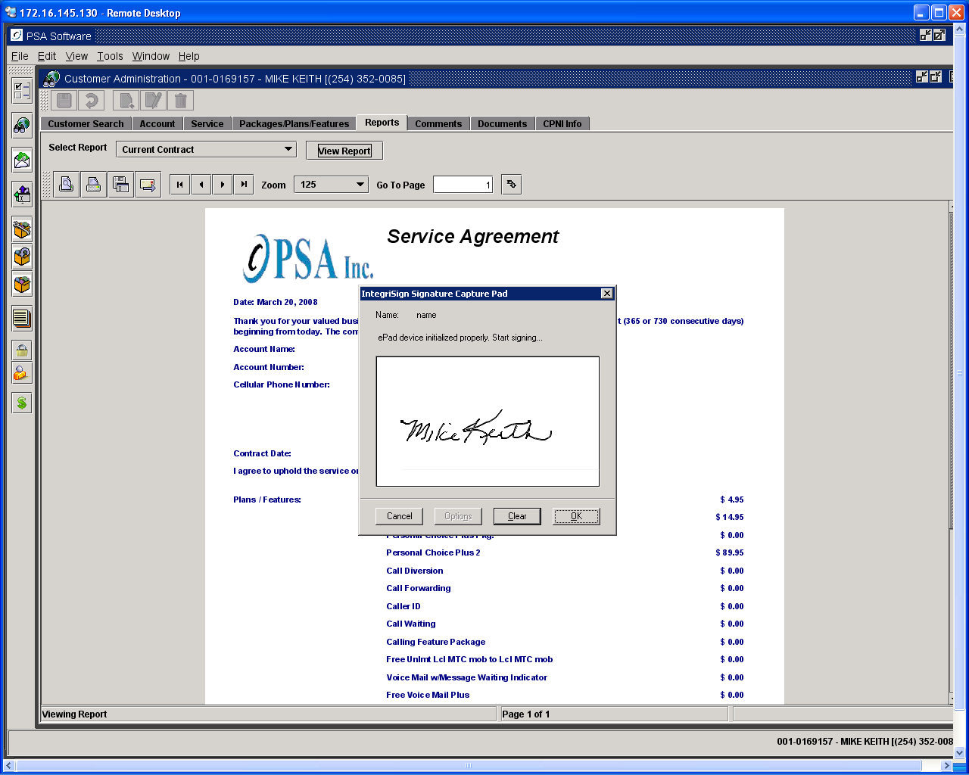

The CSR should have the customer sign the signature pad. You should be able to see the signing as it occurs. The Clear button will remove the signature for another try if you are not satisfied with current signature. Once they have signed and you are satisfied with the signature, press OK. You will then be given a final chance to change the signature. Press OK to commit the signature or ‘New’ Signature to change the signature.

- A receipt will print if desired
- An invoice with all the charges will be presented for printing, emailing, etc.

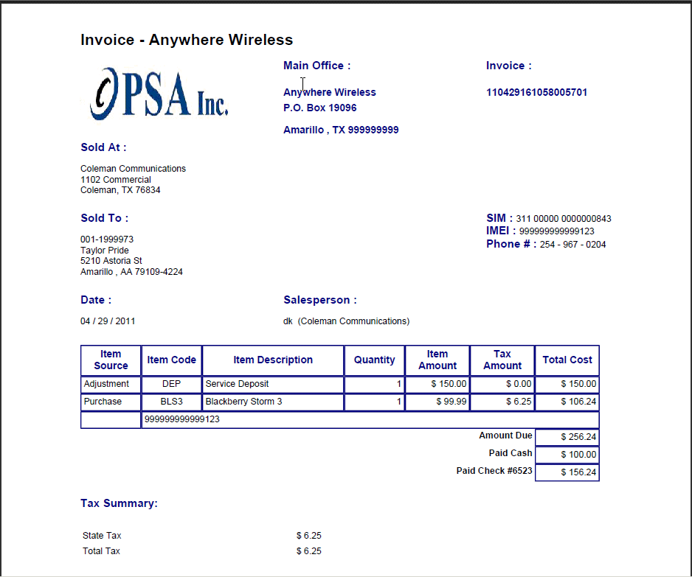

- A comment is created by the system and the CSR is requested to add a comment
- All the information is committed to the billing system
- If monies are to be collected or equipment purchased the cash drawer can be opened and transactions completed

Linking Phones For Minutes/Data Sharing

Linking service numbers allows the linked numbers to share any plan minutes or data elements available. When phones are linked together they will have the same Super Account number and will show a Y in the Linked column.
Linking of phones has nothing to do with whether or not they are on the same billing statement. To have phones on the same statement, the phones must have the same Cycle Number and Account Number.

Each super account group must have at least one sharing plan that has free minutes assigned to the plan or that group will pay for every minute used.

Example 1

In the above example, there are five services on a single account. Those five services will be printed on ONE billing statement. Family Plan A has 250 free sharing minutes. Family Plan B has 500 minutes to share. Family Add-on plans have no free minutes to share. 1002 and 1001 (super account 123000) will share 500 free minutes. 1000, 1003, and 1006 (super account 342000) will share 750 free minutes.

Example 2

This example super account number 123000 would have 500 minutes to share among the three services. Super account number 342000 would have 750 minutes to share between the two phones.

Example 3

Now super account 123000 would share 1000 minutes with 4 service numbers. While 342000 shares no minutes.

Example 4

Super account 123000, 352-1001 pays for all minutes used. Super account number 456789 will share 750 free minutes. Super account 342000 will have 250 free minutes not shared.

In ALL these instances the service numbers will remain on the same billing statement.

Pending Service Orders model

Optionally your company may want to create a service order yet not activate the service in billing until a later date. This method of service entry is a global setting and will apply to all new installs for the company. The initial service order sets the status of the service as ‘P’ (pending). This P status remains until a Process option is run over the service; this process changes the status and re-prorates any package, plan or feature pricing for the install using the effective date set in the process.

Open the Processes Module and select Pending Status Maintenance. To access the process the user must have the correct Process Sub Group authority in Security.
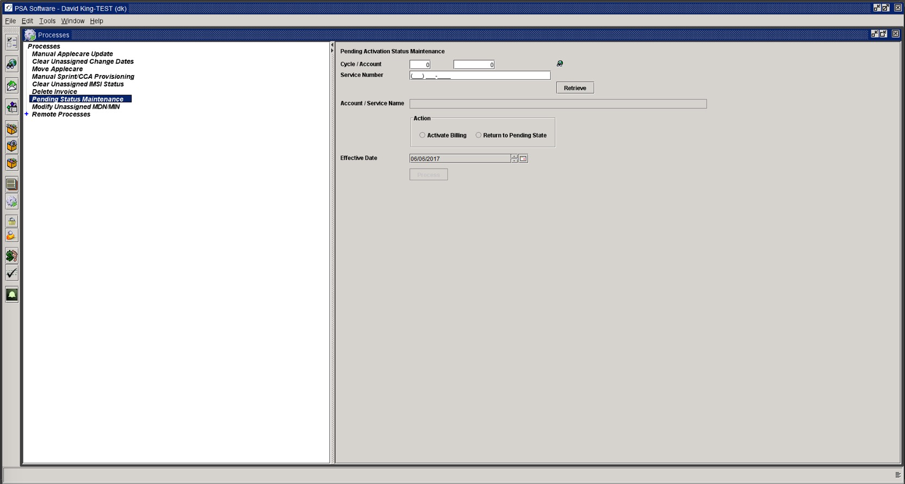
You must enter enough information in the following fields to uniquely identify the service to be changed; the Retrieve MUST BE PRESSED before the status can be changed.

Cycle: Enter the cycle number
Account: Enter Account Number
Service Number: Enter service number

Or if above information is not known:
Search: Press the search icon and then enter known information to locate the service to activate. Select service and press OK.

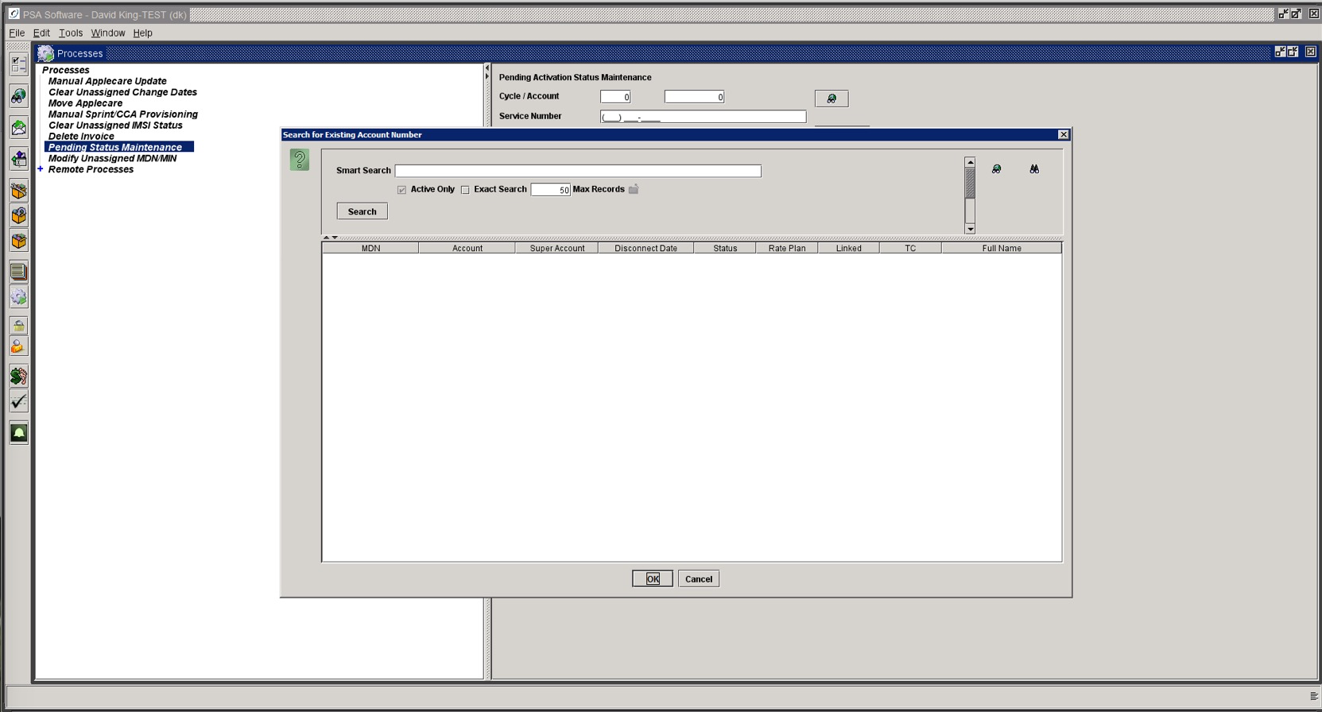
Press Retrieve to place the service in the queue. The account information will display for verification.
Action:
Activate Billing: This sets the install date and re-prorates all packages, plan, and features while changing the status to Active.
Return to Pending State: If the service was mistakenly activated in billing AND HAS NOT BEEN THROUGH A BILLING, then the service can be reinstated as Pending. This option will not be available after the service has been billed.
Effective Date: This will set the Install date on the service and will be the date used in proration.
Submit: This commits the process to activate or reinstate the pending status.

Add a Phone

This sub-function of ‘New’ allows the CSR to add a ‘New’ service to an existing account whether the account is currently active or is disconnected. This will be used to reactivate services on accounts with no active service. This follows the same routine as ‘New’ customer except the account level information and CPNI entry is skipped, as it already exists on the account. Add a Phone service orders begin with the search for and selection of a customer. Select the account on which you intend to add the ‘New’ service. Open the account and press the ‘New’ icon.

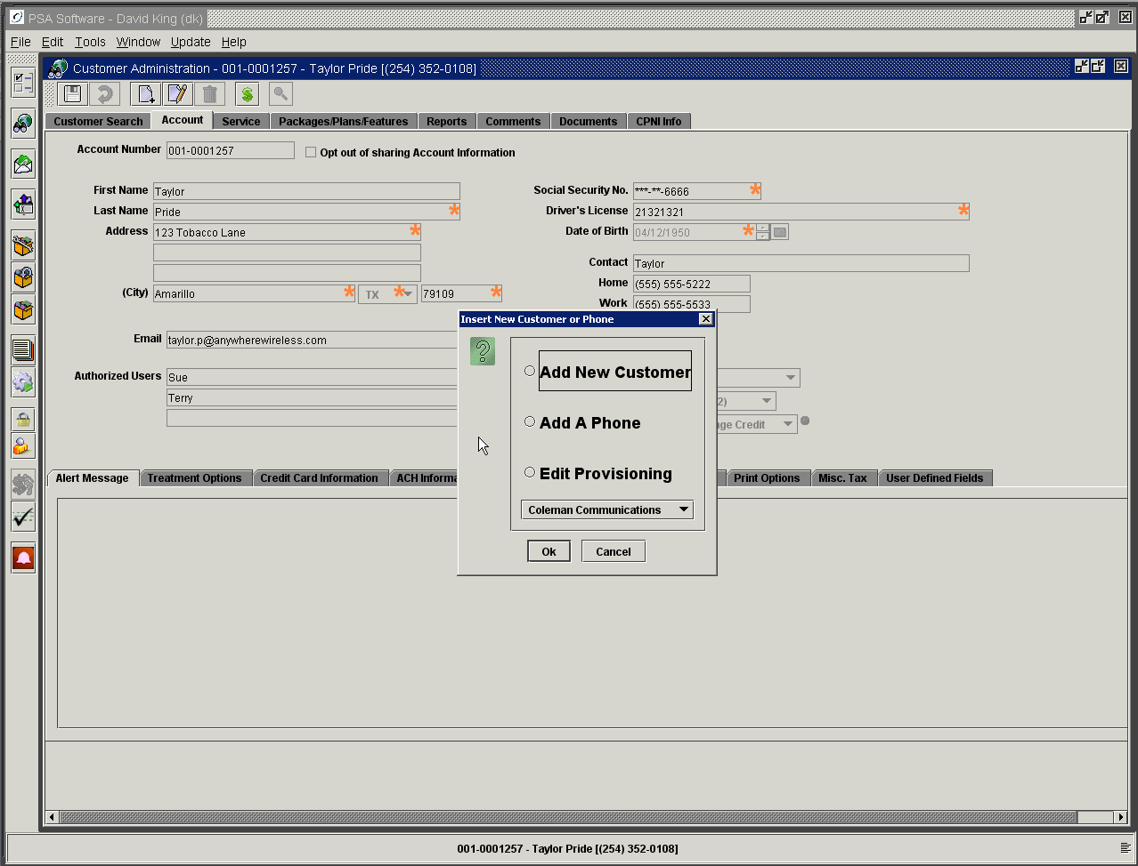
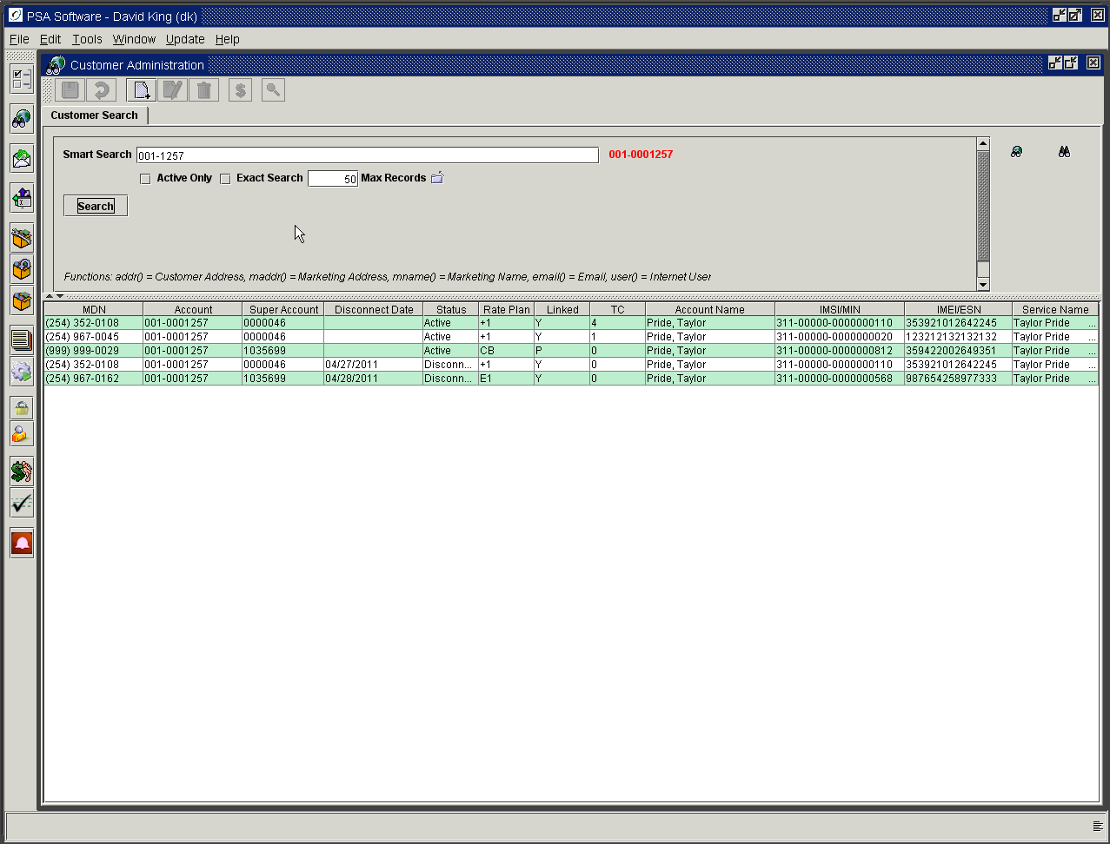
Depending on company settings Add a Phone may or may not open to the credit check screen. If Add a Phone does not require credit check then the first screen will be the Insert screen.

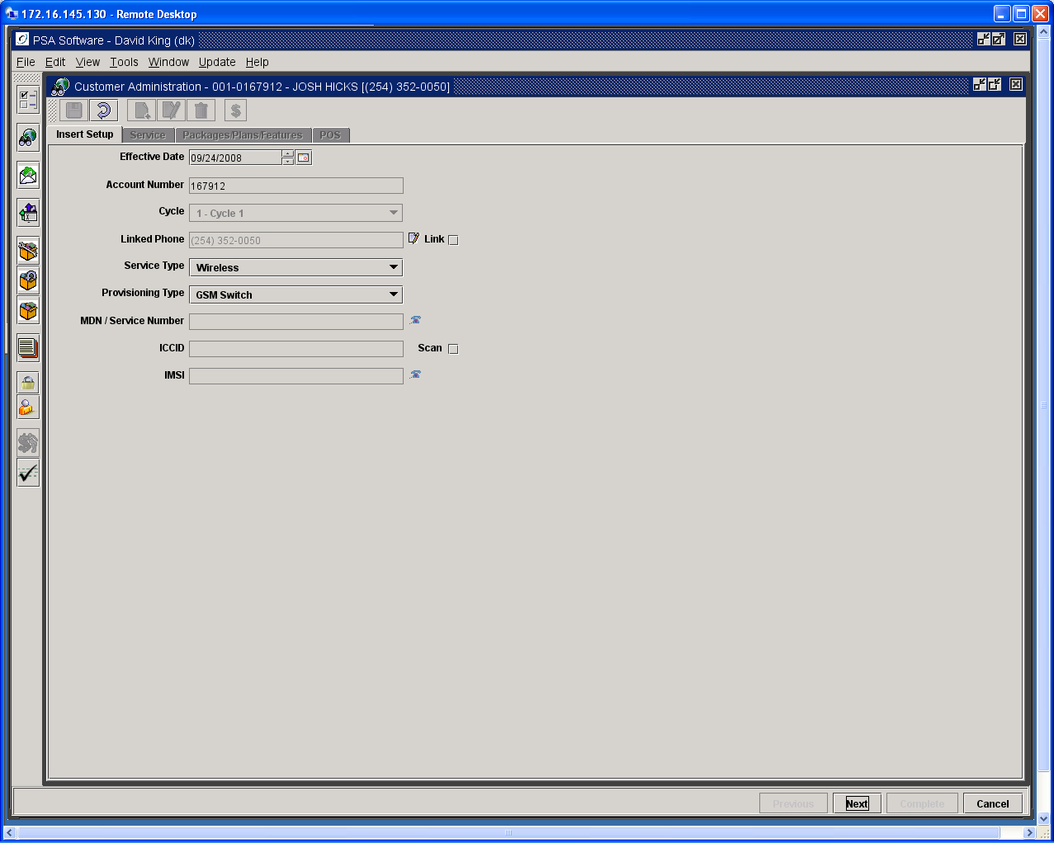

This is the service order type where linking is normally a common part of the service order. The first step to linking is to check the service number listed in the Linked Phone field; if it is the service that will share minutes with the new service then all that is necessary is to put a check in the box to the right of the field. To link a phone different than the one in the field, you press the link icon to the right of the field. This will display a search box. Search for the service number to which this service should be linked using Name, MDN, Super Account Number, or Account Number. You must press Search not ‘enter’ to locate potential services. Once the service has been found highlight the service and press OK. The Linked check box to the right of the field must be checked for the two services to be linked. Once the service order is posted both the services will have the same super account number and will show a ‘Y’ in the linked column. To see what services are linked for sharing minutes, you may search by Super Account number in the search fields. In Smart search you must preface the number with a small ‘s’. EX. s1053847 will find the linked phones for super account number 1053847

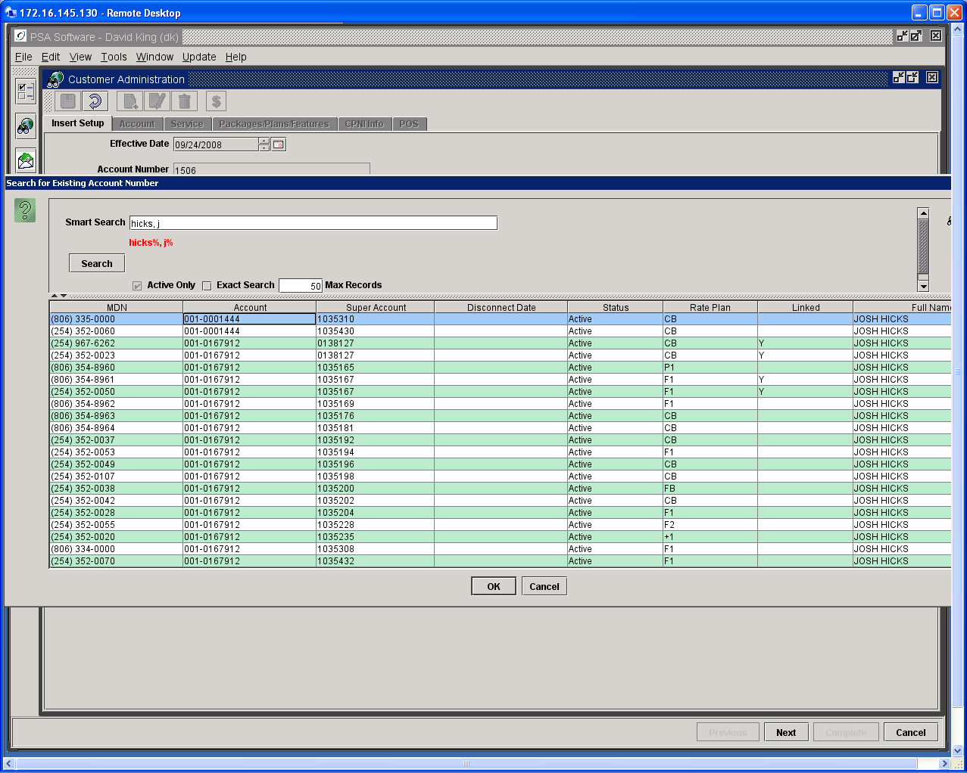

Link box to the right of the field determines whether the phone will share minutes or data elements. If checked, you will only be able to select packages or plans on the Packages/Plan/Features screen that are compatible with the rate plan on the number you have entered in the Linked Phone field. (See linking override in the package/plan/features section.)

After the linking has been addressed, you will need to select a service type, provisioning type, MDN, ESN/IMSI and IMEI/MEID to complete the screen. Pressing Next will move you to the Service screen. Complete all required fields and press Next to the Package/Plan/Feature screen for item selection. Once all plans and features have been selected you will move to the Point of Sale screen. Complete Point of Sale as described in New Customer. Pressing Complete posts the order and presents the invoice and contract while beginning the provisioning process. You may see the results by searching by account number and all services will be shown in the return section.

Edit Provisioning Options

Edit Provisioning service orders provide access and editing to all screens within service order. You may change most any field within the Edit Provisioning service order. The flow of the service order follows new customer without the credit checking process; it begins with the Insert screen. Begin Edit Provisioning by selecting the service to be edited, then advance to the fields requiring a change using the next or previous buttons at the bottom. Once the order is complete press the Complete button to post the changes. You may or may not receive an invoice or contract but you will be required to complete a Comment section. The user can change the POS drawer from the initial Edit Provisioning popup.

Edit provisioning as a sub-function of ‘New’ allows for changes on the service number or additional components of the service. The CSR can use this function to:
- Change the MDN/service number
- Change the ESN or IMSI
- Change the type of provisioning
- Change the service type
- Change information on the account or service screens
- Change the package, plan, or features
- Add comments
- Complete POS transactions
- Create a ‘New’ contract
All within a single service order.

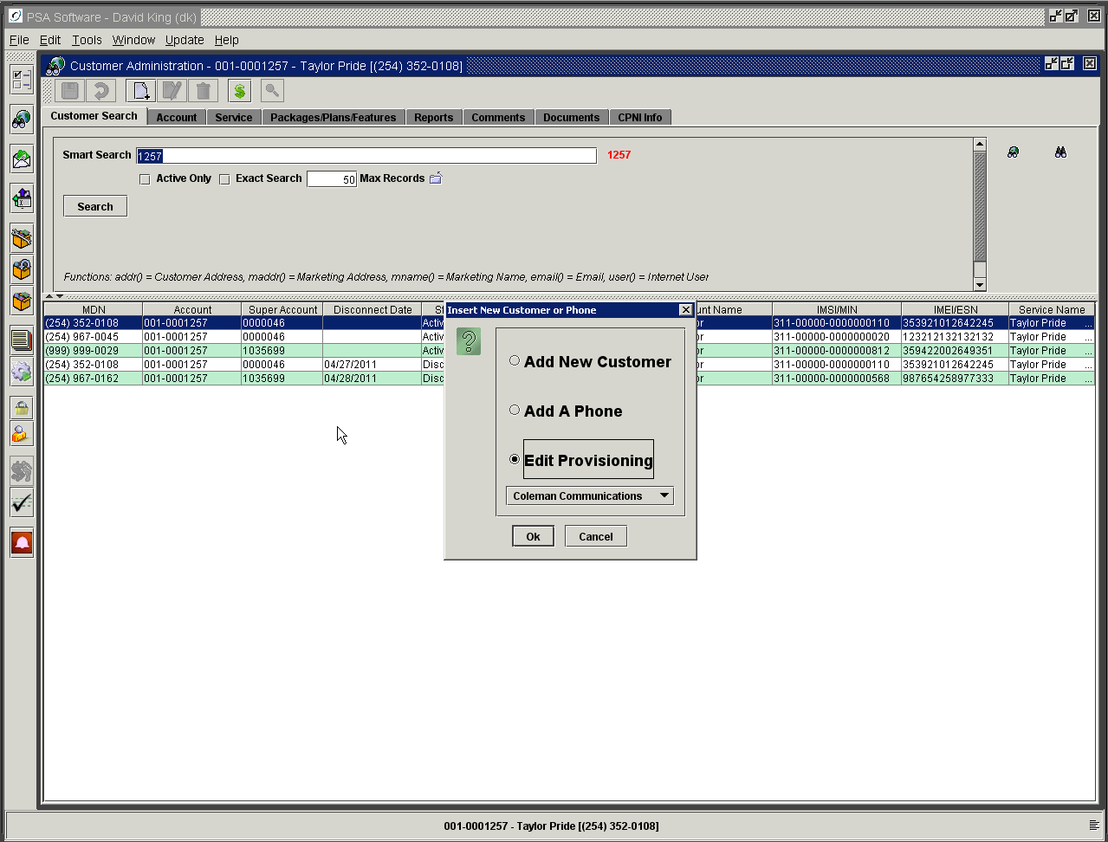

MDN/MIN/IMSI Change

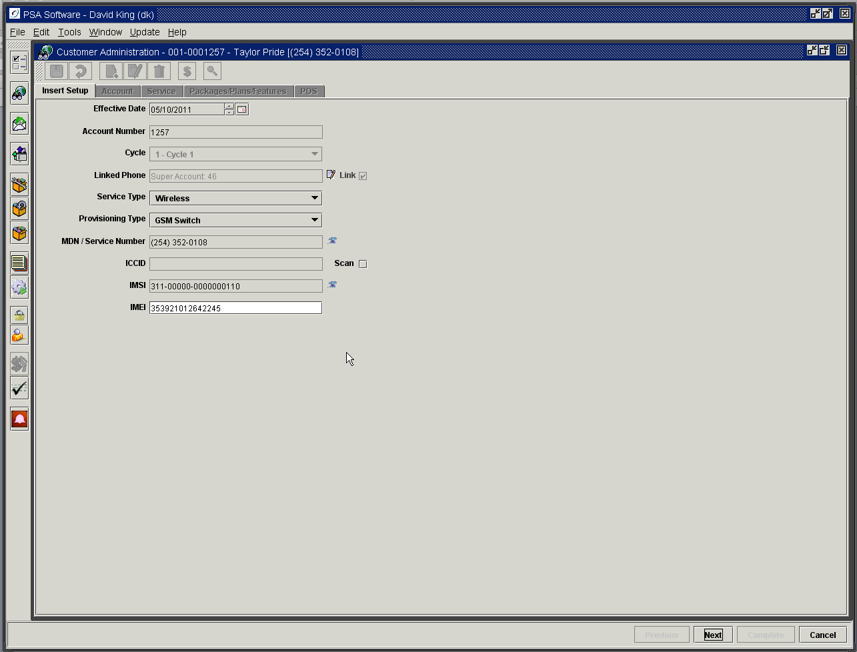

To change a MDN, press the telephone icon next to the MDN/Service Number field. Select the ‘New’ MDN and double click the number in the list. If you need to change either the MIN or IMSI you can use the same service order and same screen. Should you need to change the handset serial number (ESN/MEID or IMEI) delete the existing entry and scan or enter the new number. Once all the new numbers have been changed, press ‘Next’ to open the remaining customer information screens. You may change any of the fields on the account, service level or CPNI screens as well as changing packages or other features. Cycle through the service order until you have changed everything you need to change on the service. You can move forward or backward throughout the range of screens as seen in ‘New’ activation until all items requiring edit are complete.

Pressing Complete posts both Add a Phone and Edit Provisioning.

Rate Plan Changes and Linking
Rate plans can be changed in an Edit Provisioning service order or by using Edit on the Package/Plan/Feature screen. There are cases where changing of rate plans will cause problems with the linking function. If the ‘New’ plan is not the same type as the old plan or compatible with the other linked phones plans, then the linking will not work properly. The service order system can restrict selection to only compatible plans or allow via an additional security authority selection of any plan currently available. The next screen shows an example of only compatible plans setting. Here the only plan that is compatible is the FAM2 plan; if there were other plans allowed they would show in the drop down box.

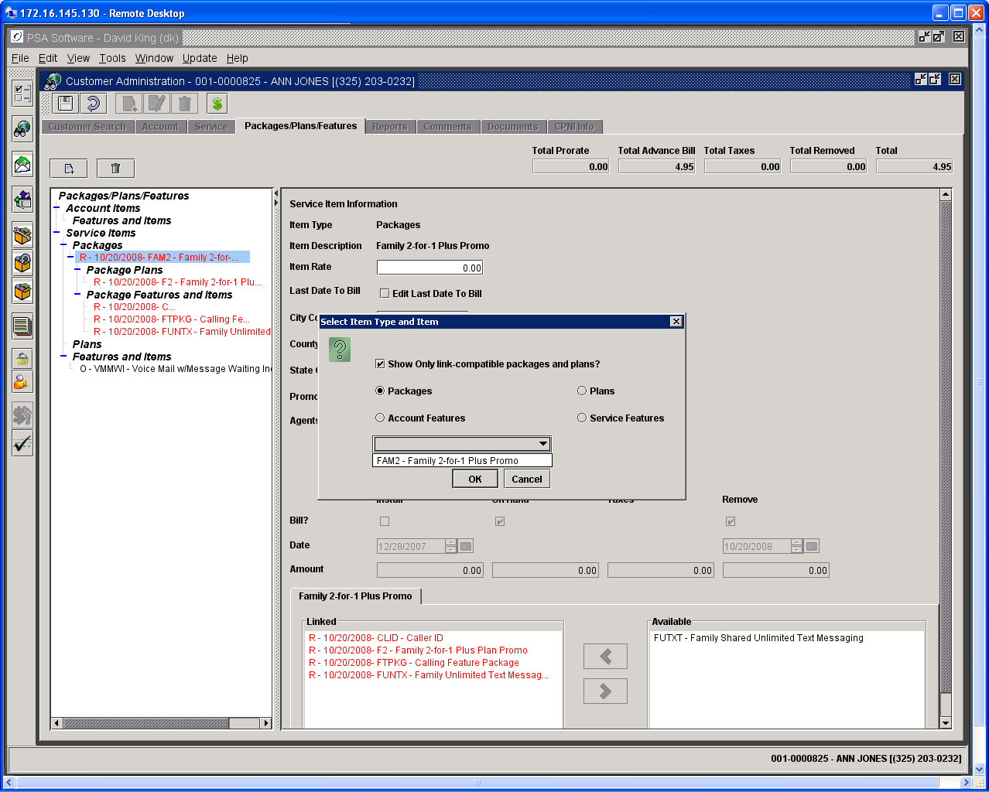

If the user has the Override Link Package/Plan Filter authority then the user can uncheck the box and see the full list of plans.

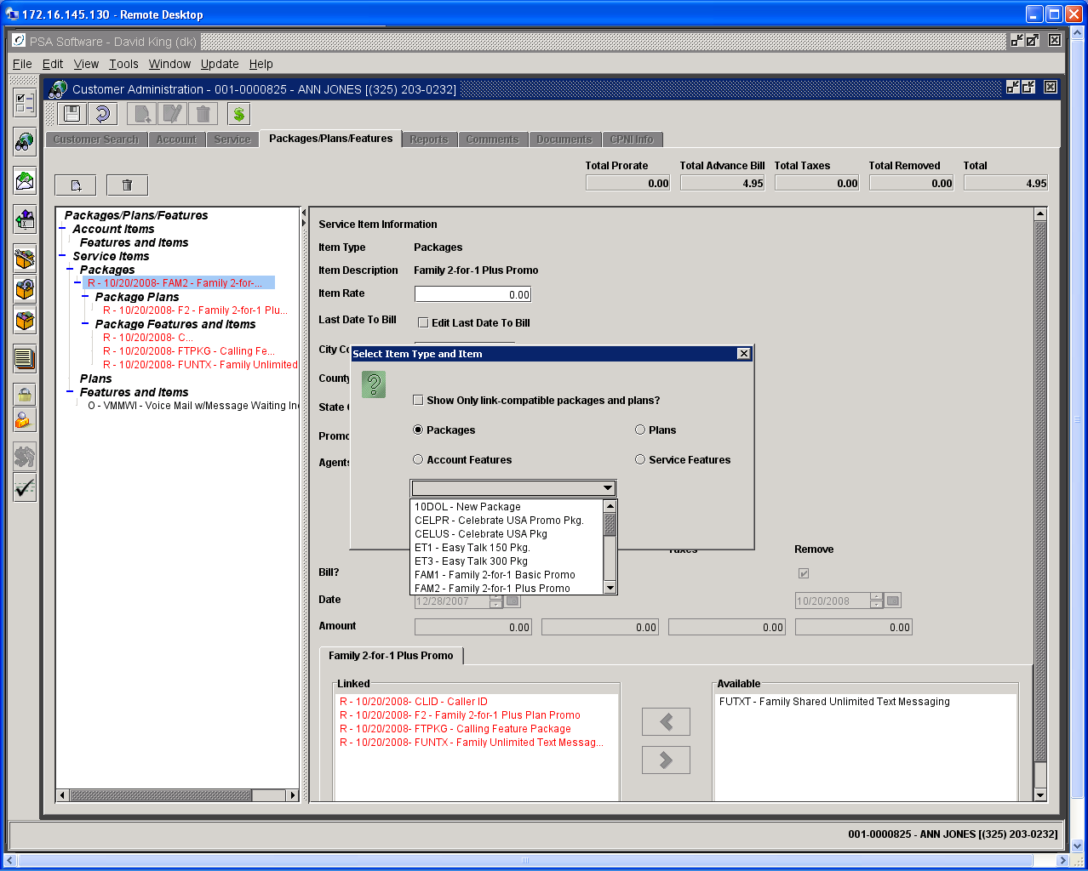

If the plan selection is overridden and a new plan is selected you will see the option to Preserve Service Link or Break Service Link. Break Service Link is the default selection and that will break the link by creating a unique super account number for this service number. If you select Preserve Service Link then the super account number will not be changed, but this service number will not share minutes with other phones until one or more service numbers on the account have plans added that are compatible with this service number’s plan. For this service number to share minutes, there will be a required plan change on one other service number to which it can be linked. Break Service Link assigns a unique super account number to this service.

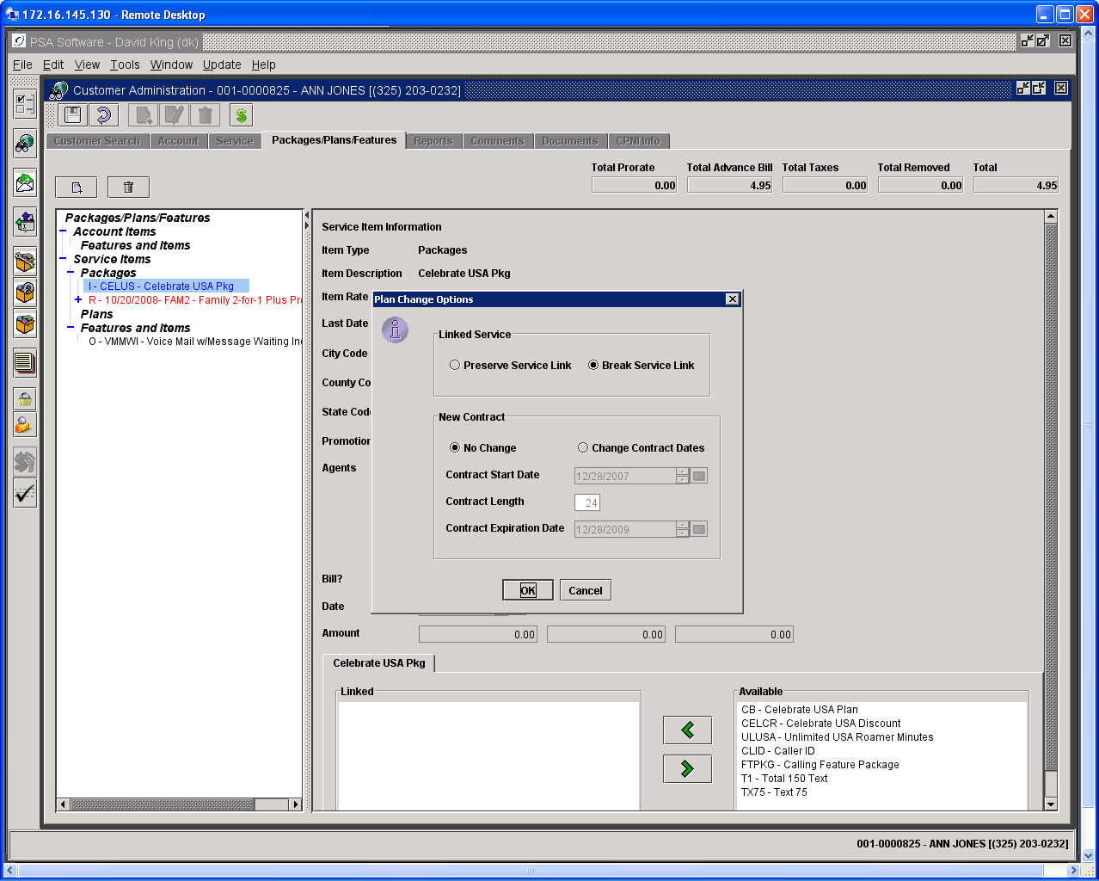

Complete the change either by pressing Complete or Save.

Linking Outside New, Add a Phone, or Edit Provisioning

Sometime you may find it necessary to change which service numbers share minutes or data. You may change the linking without using the Edit Provisioning by opening the service number to be changed to the Package/Plan/Feature screen. Search for the service number to be changed and open the customer record.

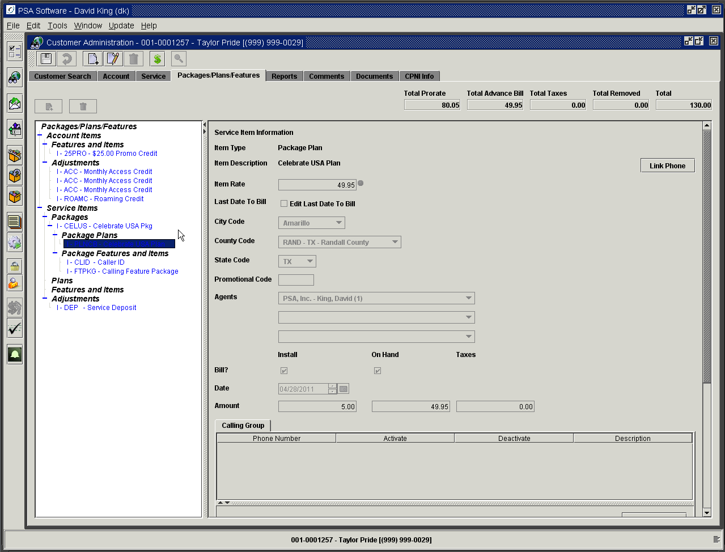

Highlight the plan and the Link Phone button will display on the right of the screen. Press Link Phone and you will be given a search box which will allow you to search for the other number you wish to link to. Select the number by highlighting the number and press OK.

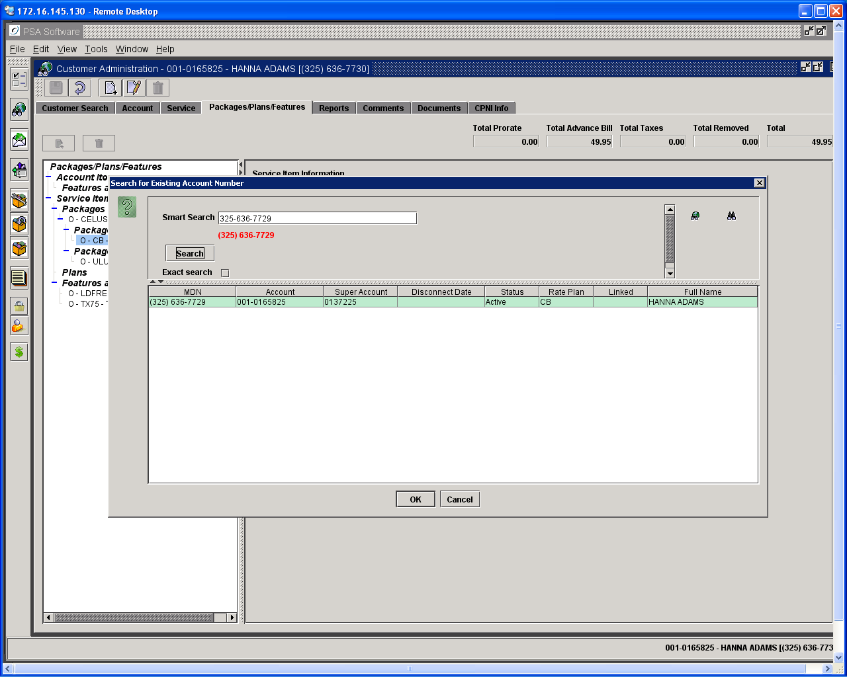

‘Save’ the changes and enter your comment. The phones now share any available minutes. You can verify that the service numbers are linked by going back to the Customer Search screen. Press Search again; this refreshes the customer information. The data will be updated and will show the same super account number for both services and the Linked column will contain a Y for each.

There may be instances where phones/services cannot be shared. This could be incompatibility of the two rate plans due to plan configuration or one or more of the plans are stand-alone plans. If this is the case, you will receive an error message. Press Ok to clear the messages; the plans will not be linked. To link phones in such a case you will have to change one or more of the plans to compatible plans and try linking again. (See following example of incompatible rate plan message.)

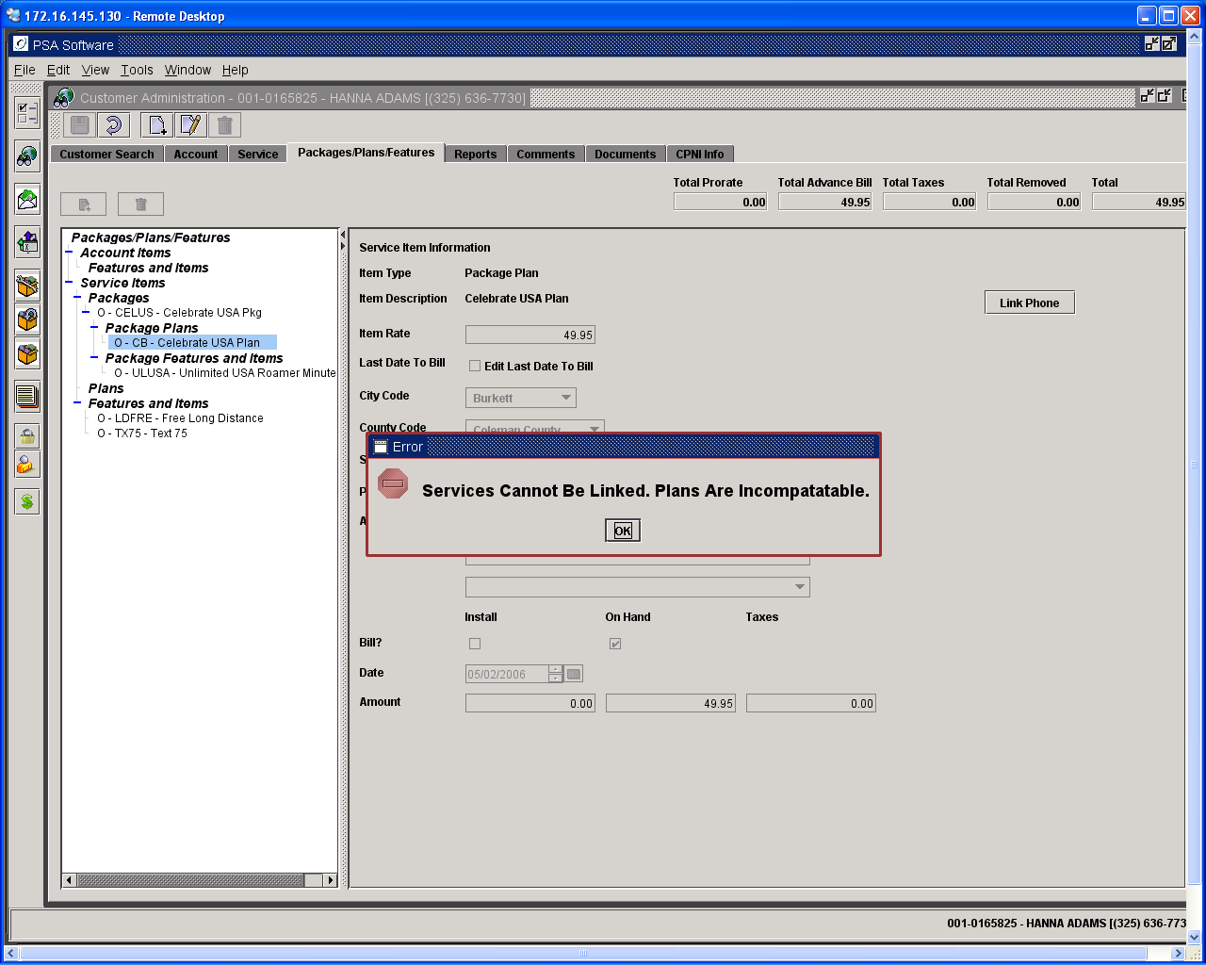

Unlinking Phones

If you need to remove a service number from a linking status, select the service number and open to the Packages/Plan/Features screen. Next highlight the plan and on the right side of the screen will be an Unlink Phone button. Press this button to break the sharing on this service number. You will then be asked to confirm the removal of the link on this number. Press Save to complete the change. The original number will now have a unique super account number and the status will be P (previously linked) until the bill run when it will change to N.

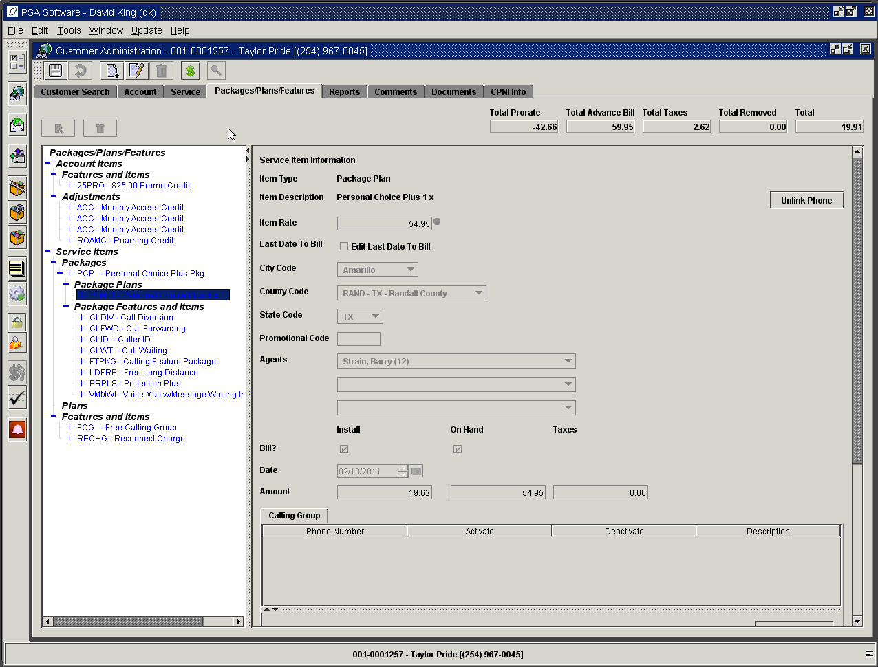

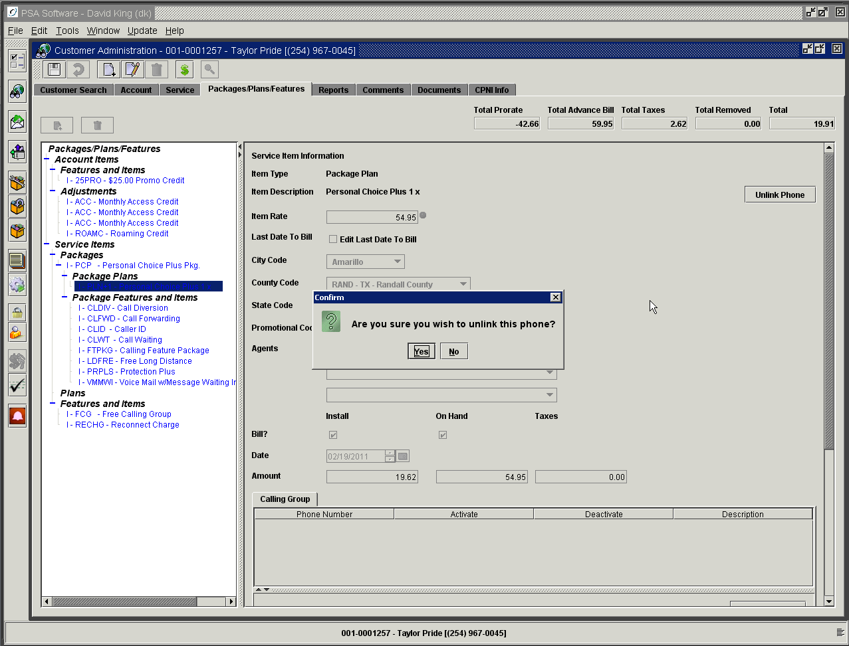

Adding Bonus Certificates
If your system suspends data in the switch at a certain threshold you may create one time limited duration data certificates to add more data to the service and reinstate the service. To add bonus certificates for data you must go through Edit Provisioning to add the certificate; you cannot go directly to POS and ‘sell’ the data certificate item to reactivate the data certificate. Select the customer and open with Edit Provisioning; you will advance through the screens to Package, Plans and Features screen. You will press the ‘New’ icon to add a feature; choose Service Features. Select the data certificate from the dropdown and press OK. Press Next to POS screen; now you can collect for the data certificate and press Complete to create an invoice and reprovision the switch. Again you must add this in Edit Provisioning>Packages, Plans and Features otherwise the new certificate won’t reconnect in the switch restoring service.

Edit Provisioning>Package, Plans, Feature screen addition.

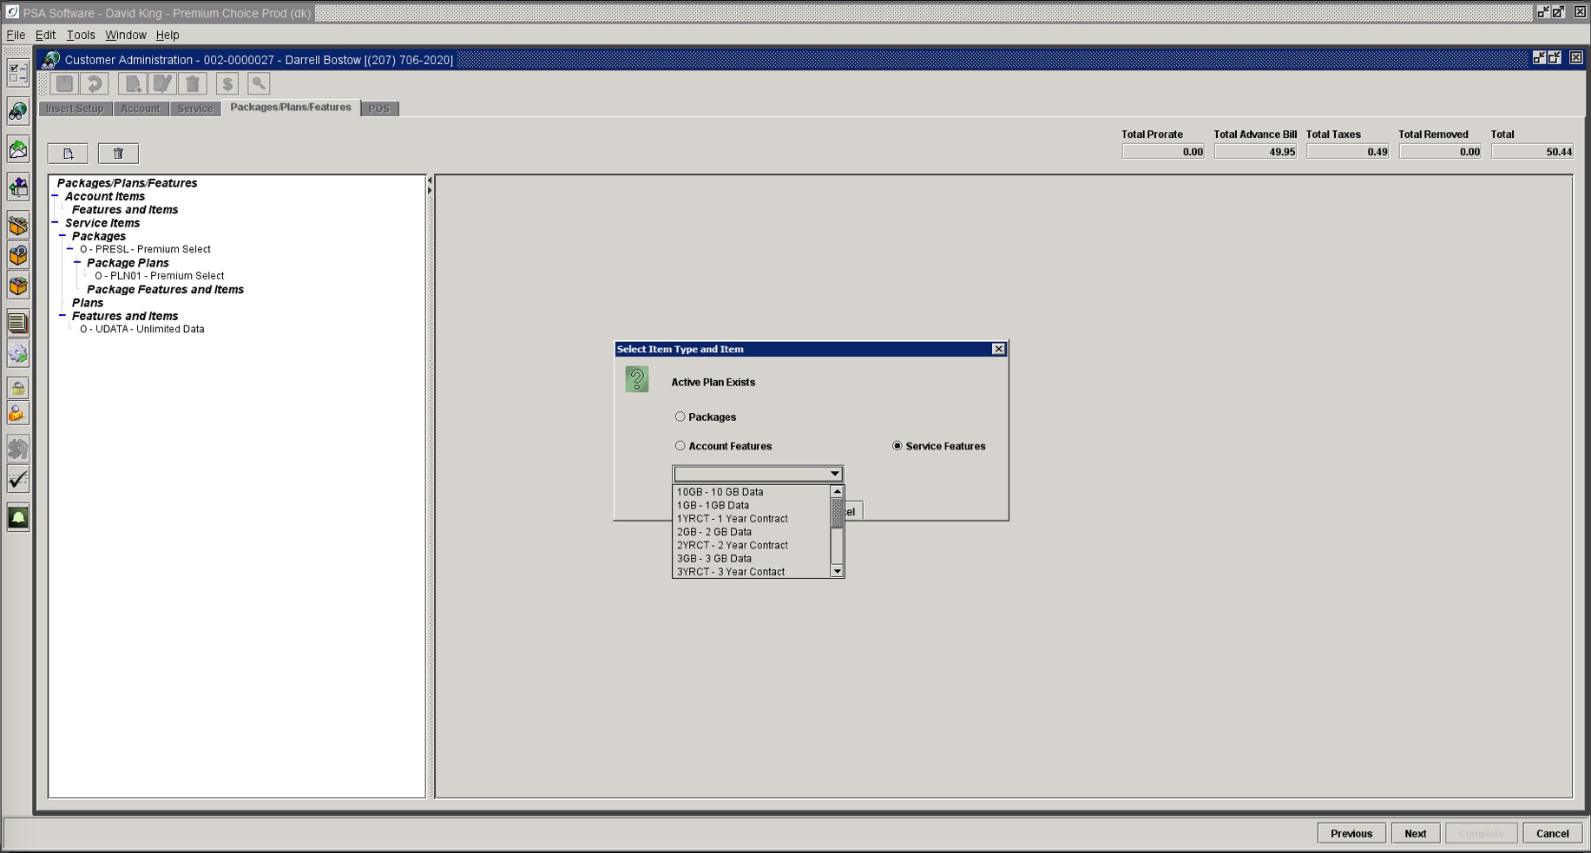

Point of Sale/Cash Drawer

Point of Sale allows a CSR to sell equipment, do returns on equipment sales, take payments or make adjustments. Point of Sale can be accessed once a service number has been opened by pressing the green ‘$’ dollar sign in the tool bar.

Purchases

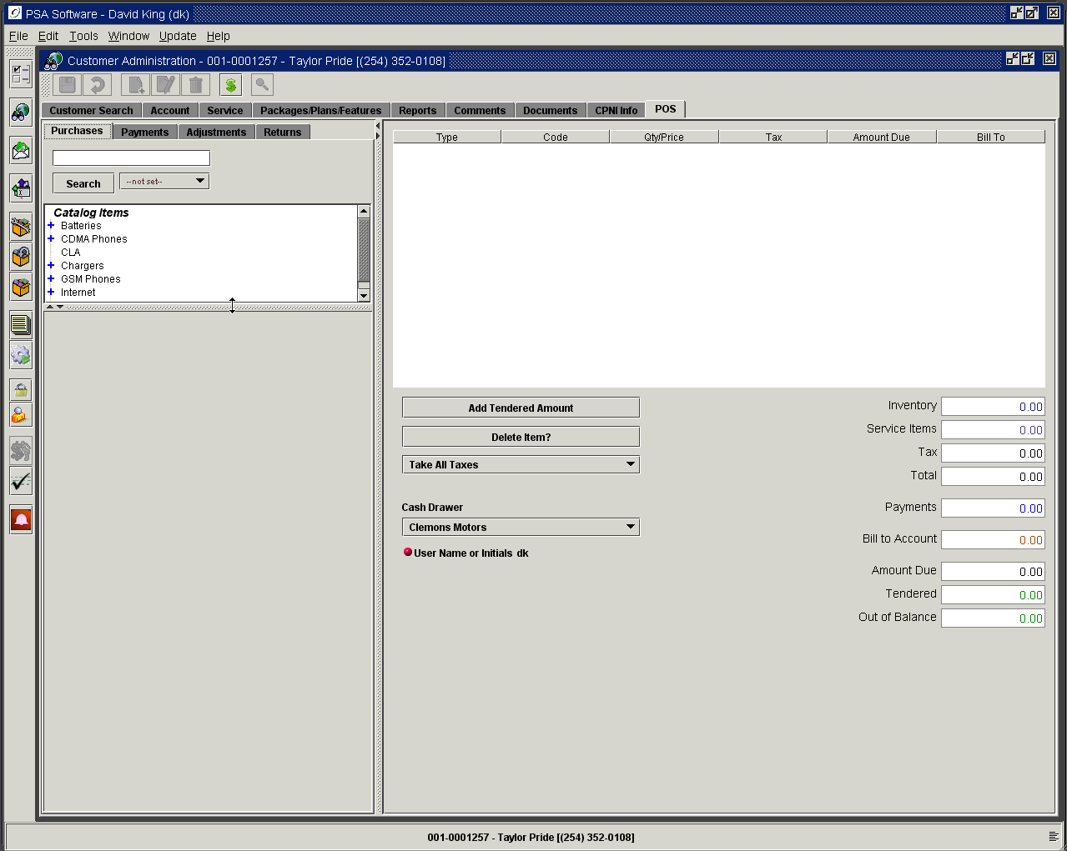

Finding items for sale on the Purchases tab

Open the Purchase tab and find the empty field above the Search box. You may manually enter the data or scan in barcoded information. You may search by serial number (MEID/IMEI/ICCID), manufacturer, item description, item number, vendor barcode or by a PSA barcode.

Type of Search: The dropdown box to the right of the Search button will allow the user to define what type of search for equipment they would like to use.

Not Set: Uses the default search criteria as defined in initial setup:

During the setup of the database, you will need to select the properties to control the searches in POS.

Property 1 - Select Initial Search
  - Yes = Existing Search
    - Search for 5 alphanumeric characters or less will search Billing Link only.
    - Search for 6 alpha characters or more will search Item Description only
  - No = Enhanced Search
    - Any search will use the default search defined in step 2.
    - Billing Link search will only be available using the formatted searches.

Property 2 - Define Default Search – this will be the field searched if an alpha string is entered in the field. These are all from the fields setup on each catalog item.
  - Item Description - wild card search
  - Item Code
  - Manufacturer – wild card search
  - Item Description and Long Description (from Catalog setup on Item POS Information tab) – wild card search.
Wild card searches will return an item that matches any of the characters in the search. Ex. ‘Nok’ will return Nokia, Nokia 6100, Nokia faceplate, etc.

Item Code: Search by the Billing ID defined on each catalog item.
Unit code: Searches by the Unit Code defined on each catalog item.
Manufacturer: Searches by the Manufacturer described on each catalog item.
Description: Searches by the Description field on each catalog item.
All: Searches all text fields: manufacturer, description and unit code.
Serial: If this is set the only search will be done on serial number fields, IEMI/ESN/MEID/ICCID or user defined serial types.

If an item is found on any search, the item or items will be opened in the catalog tree, highlighted in the list and the first item will be opened in the Add Item section.

You may also use the tree itself to locate bulk items. You open each section by pressing the ‘+’ sign next to the category. Then highlight and double click the item. Enter the quantity and price. Press the Add Item button to move onto the invoice.

Serialized Items
Serialized items can be true serial numbers (IMEIs, MEIDs, or ICCIDs) or company defined serial numbers. These items are selected or located by using the field directly above the Search button. Enter or scan the number into the field and press the search button. If the item is available for sale, the information will be displayed in the purchases box. The quantity field does not exist on serialized items. The dropdown box displays the catalog pricing for the item. The ability to change the amount of the item is controlled by security authorities. With the appropriate authority a user can manually change the price of the item. If they don’t have that level of authority there is a supervisor ‘Override’ field to allow the price change.

Serialized phones that are added on the Insert screen during a New Customer or Add a Phone are transferred to Point of Sale automatically. The price can be adjusted for this or any item by double clicking the description in the invoice section. That will reopen the item for editing in the description frame. Make the appropriate changes and press Update Item button. The new information will be transferred to the invoice frame. The Bill to Account check box when checked will allow you to charge the item to the customer’s next statement.

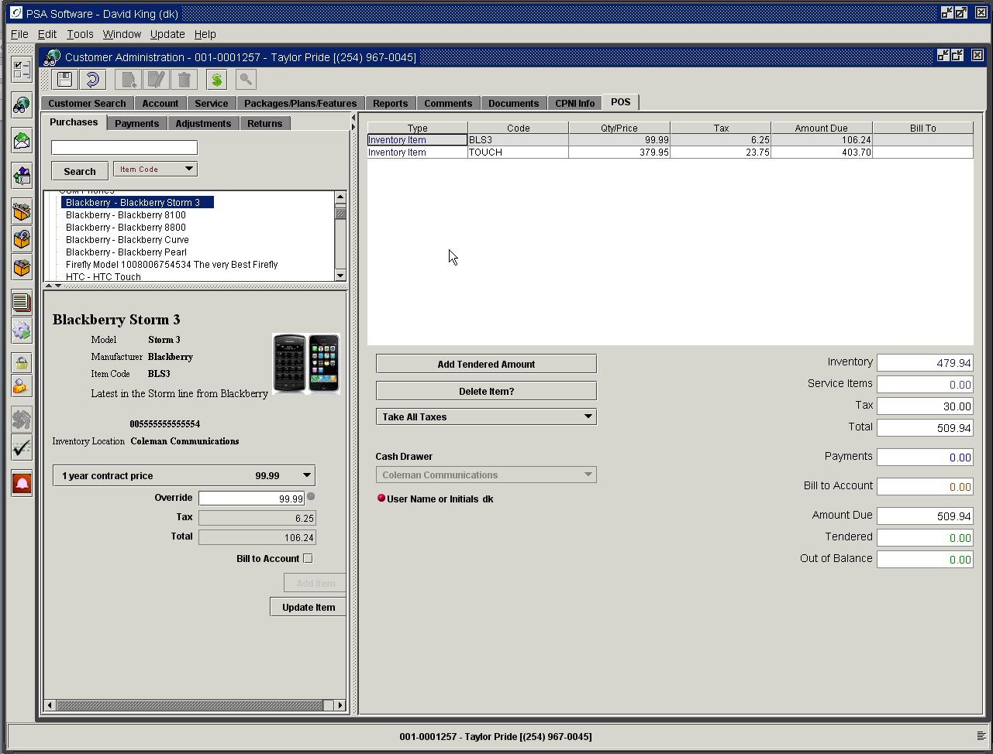
Double click the item in the invoice frame to edit.

Taxes will be calculated according to the tax structure on the item setup. If the service is tax exempt change the setting of the Tax drop down from Take All Taxes to the appropriate level of exemption. Once you have added all the equipment items, press Add Item or Update Item button. The information will be added to the invoice section and the corresponding subtotal fields with be updated.

If the item in the invoice is an equipment item, adjustment item, a payment item or an amount tendered amount the line item can be deleted using the Delete Item button. Highlight the item and press the delete button; you will be asked to confirm the deletion. Service item cannot be deleted with this function. If there is something wrong with the item you must return to the Packages/Plans/Feature screen and make the changes there.

You must select the correct Cash Drawer either at the beginning of the service order or here to locate items for sale. Each cash drawer has an inventory location and a return location assigned to the drawer. If the item is not available in the location assigned to the Cash Drawer or there are not available quantities of the item then you will not be able to retrieve the item for sale.

Creating serialized items in inventory via Point of Sale. If your company elects to use this option, serialized items can be added on the fly. If you entered an IMEI/ESN on the Insert screen or entered the number in the search field on the Purchases tab and the serialized item was not found; you may enter the item via the inventory tree.

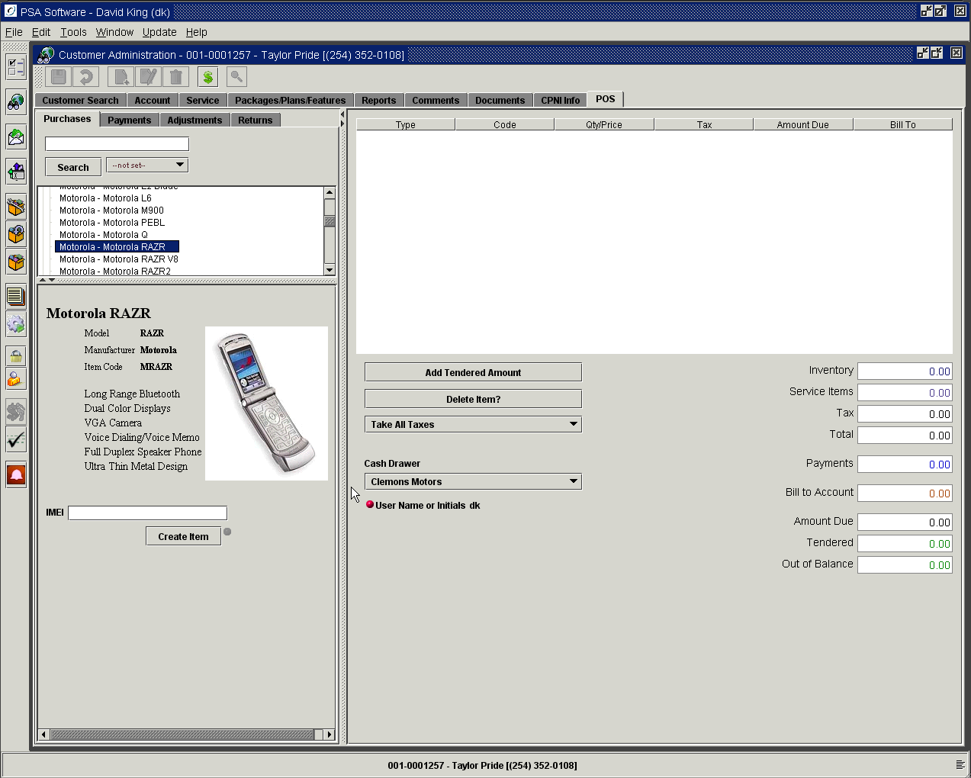

Select the item from the inventory tree and double click to open the item. Enter or scan the IMEI/ESN into the field under the item and press Create Item. This will create the item in inventory as either a sold item or as an exception according to company preference. The item will be shown in the location defined as the Inventory Location on the Drawer Setup. The display will change to the normal purchases screen. You can sell the item as you would normally.

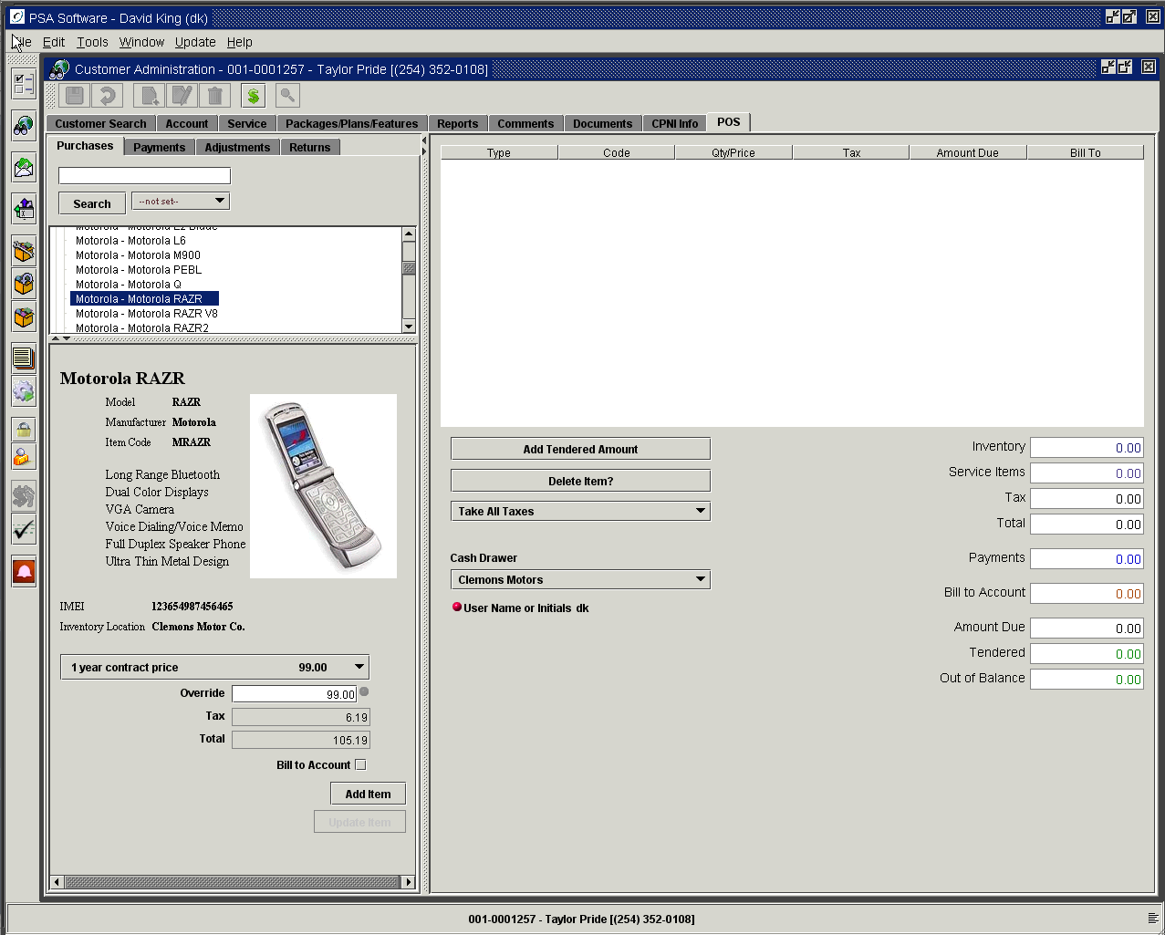

Serialized Items on Installments

Your company may allow customers to purchase equipment and pay for them in installments. If you allow installment you will see an ‘Installment Button’ below ‘Update Button’.

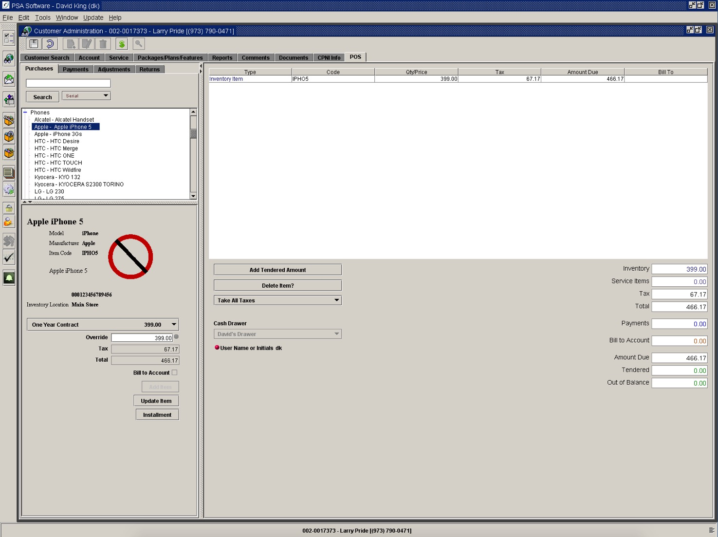

If you want to use the company’s default price if sold in installments simply press Installment. If you want to choose a price for the equipment to be sold on installments select the price in the drop down box and then press Installments.

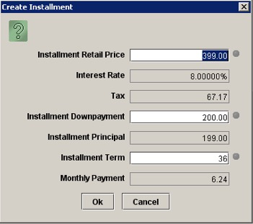

Review the information and if it is correct press OK to setup the installments. If you need to change any of the fields you may change them or get an override if your authority isn’t high enough. You may change the Price, Downpayment or Installment Term. The Downpayment field may have a minimum amount which you cannot go under without override; if they want to pay more down then you will be able to increase the downpayment which reduces the Monthly Payment. The Monthly Terms has a maximum length; you may enter a shorter term but if you want to make the term longer you will need an override. Press OK to setup the installments

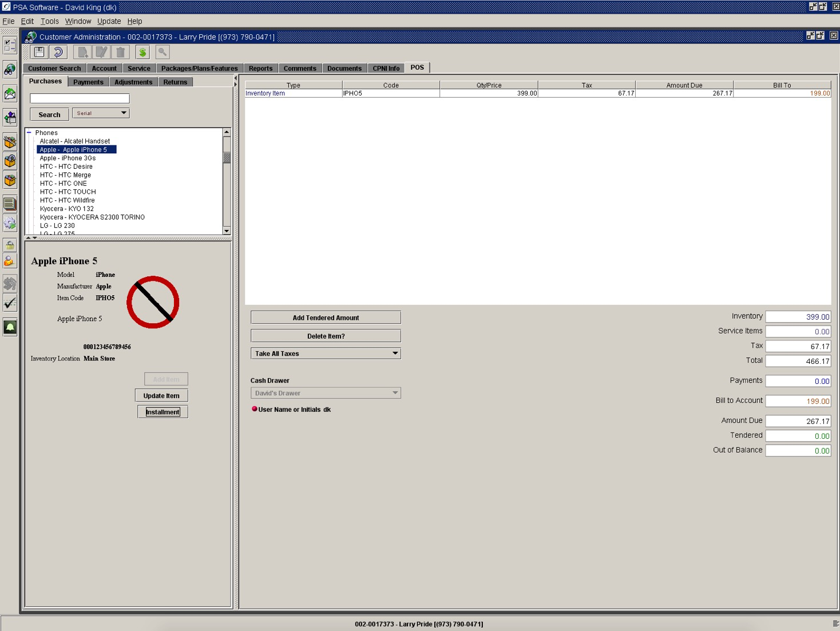

Now on the invoice you will be required to collect the downpayment and the full taxes for the equipment. The remainder of the balance will be shown as Bill To and be collected on the monthly statement. If you need to change the installment setup you must change that before you Save. Press Installments and the dialog box will display. Now press Cancel; this will remove the installments and return the invoice to its original state. Press Installments a second time to make the necessary changes and then press OK. When the invoice is correct press Save or if you are in a new activation, add a phone or edit provision press Complete. You now have the installments setup for the account.

You will receive an invoice with the terms of the installment and an Installment Agreement.

Removal of the Installment Item: Removing the billing item on the Packages/Plan/Features screen does not automatically charge the balance (if any) on the Installment. You must manually adjust the balance using one of the installment adjustment items.

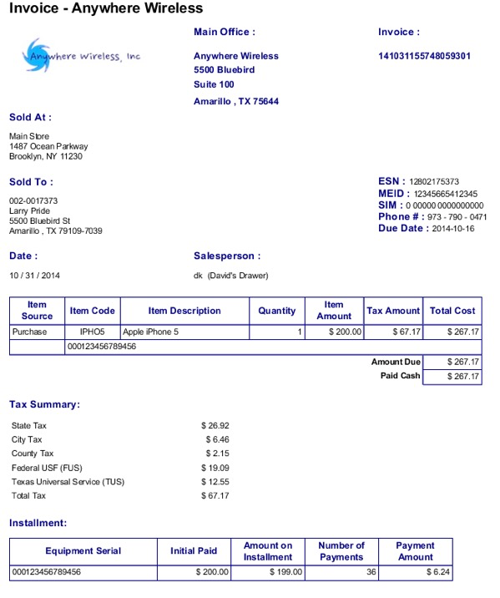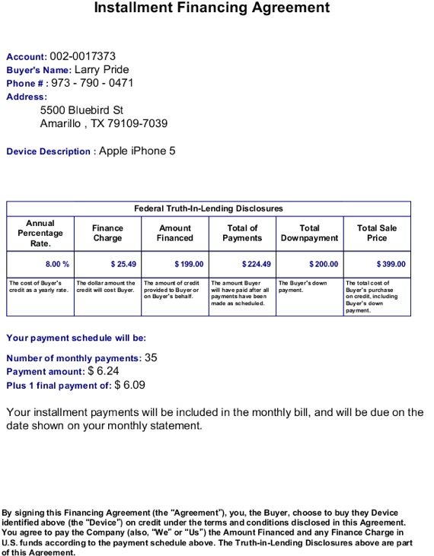

Non-Serialized Items

These items will be selected using the search functions or the Catalog Items tree. You may open the category by pressing the ‘+’ next to the item. Select the group and scroll down to the item and double click the item. The default quantity is 0 and a quantity must be entered. The price can be selected from the drop-down box or manually changed in the Override field with the appropriate authority. Press ‘Add Item’ and the item will appear in the invoice box to the right.

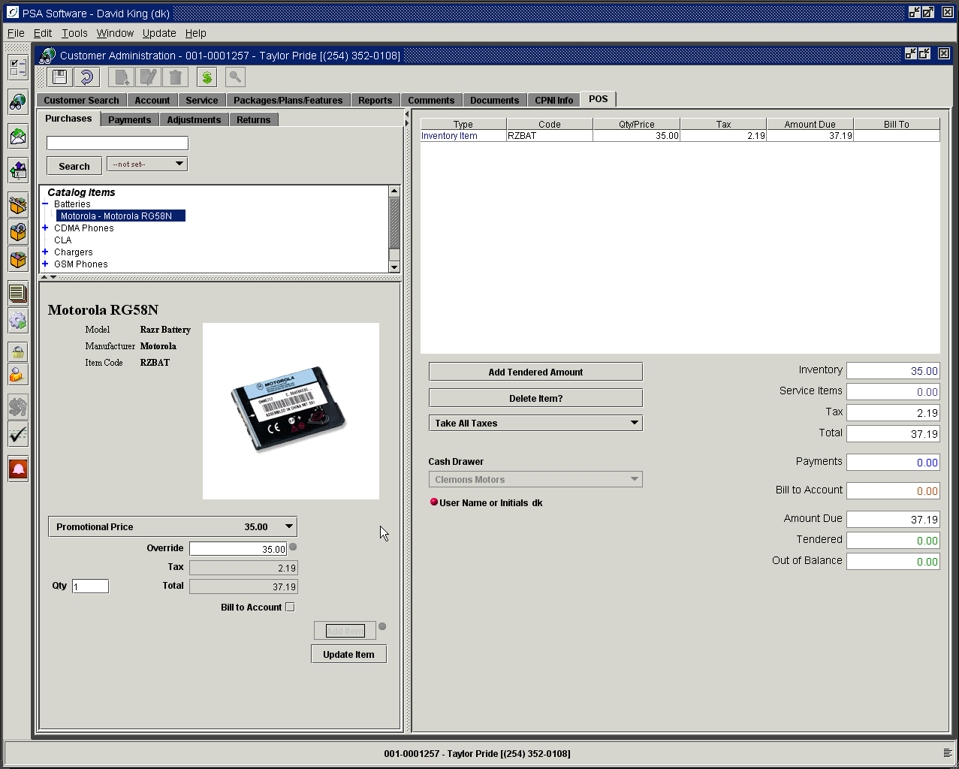

Should the item selected not have a sufficient quantity to meet the number entered then you will receive a notification as follows.

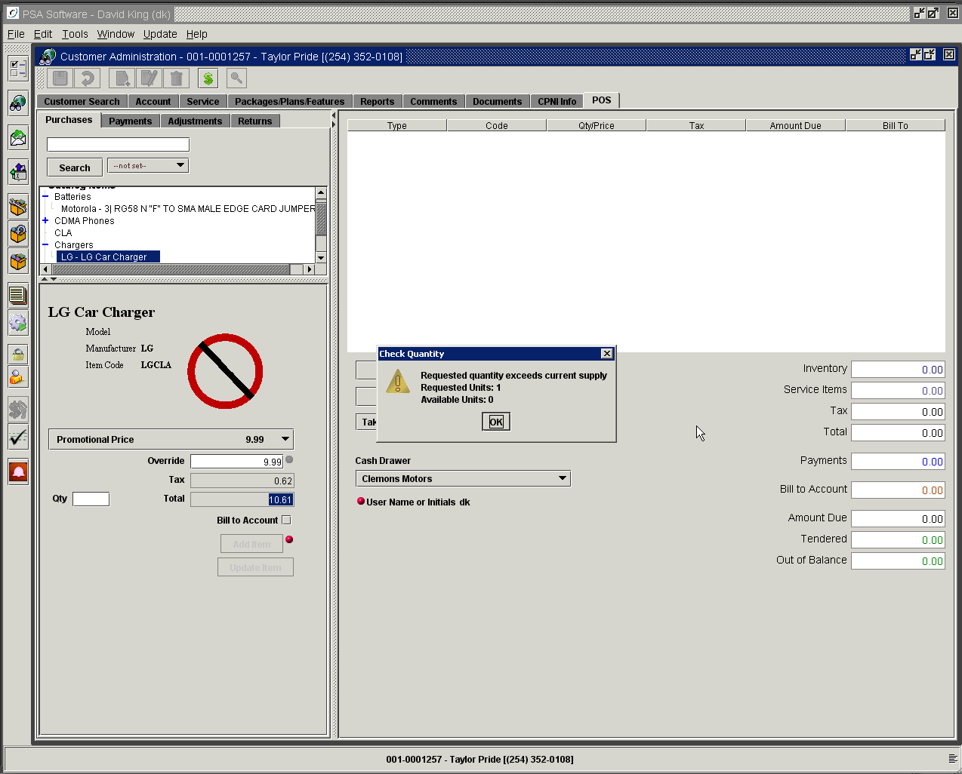

Collecting Monies for Transactions

Add Tendered Amount button displays new display message box with two tabs.

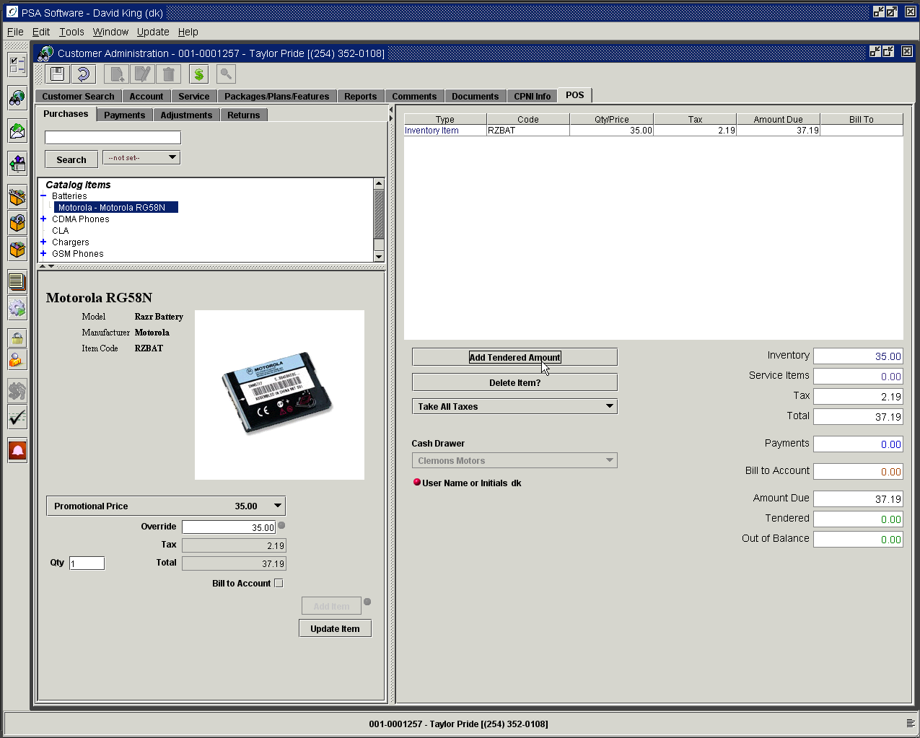

Tendered Worksheet Tab

To zero the Amount Due field you must select one of the following types of funds for the transaction: (1) Cash – which displays an amount field, (2) Check – which displays an amount field, and an alphanumeric check number field, (3) Credit Card – which has an amount field, CC number field, name field and an expiration date or one of the user defined Tendered Types. You may manually enter the credit card information or swipe the card. If you use electronic signature capture, the customer will be given a chance to sign the invoice at the end of the transaction. Selecting the type will display the required fields for that type of transaction. You may use one or more types per invoice. As amounts are entered for each type the Amount Due will update on the tendered worksheet. The Amount Due on the invoice will update when OK is pressed. Each type of payment will show as a line item on the invoice for ease of understanding. If the reference or description fields are available and the user enters data into the field those will appear on the invoice and the reference will show on the Draw Balancing Reports.

Example: Payment of $100.00 using multiple types of Tender.
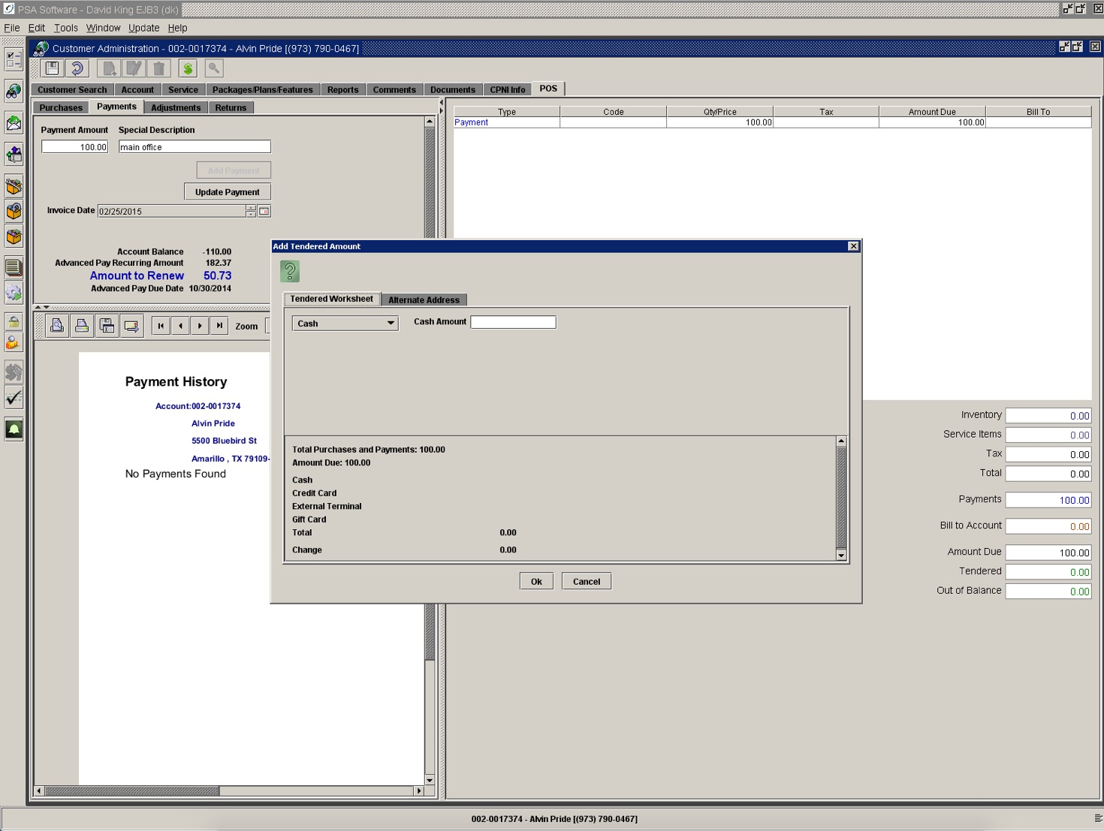

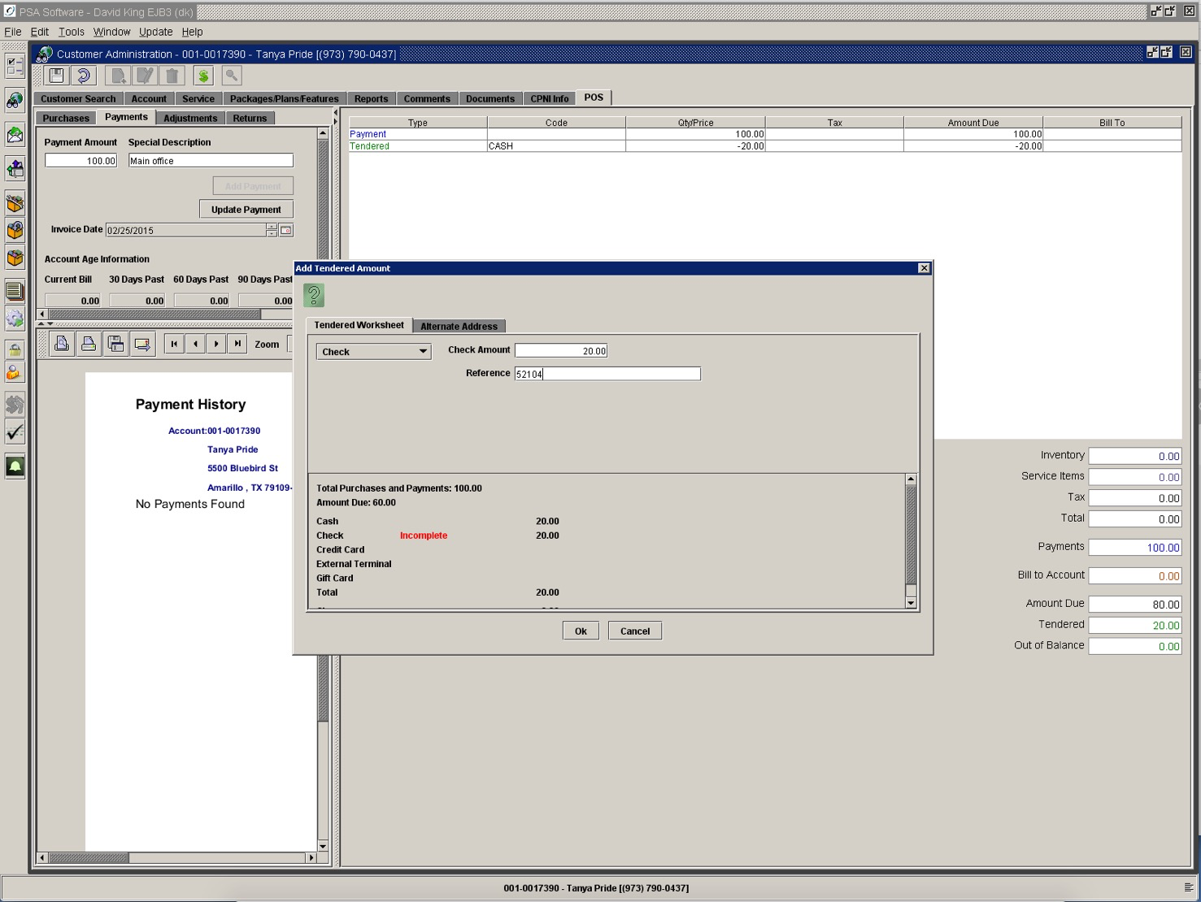

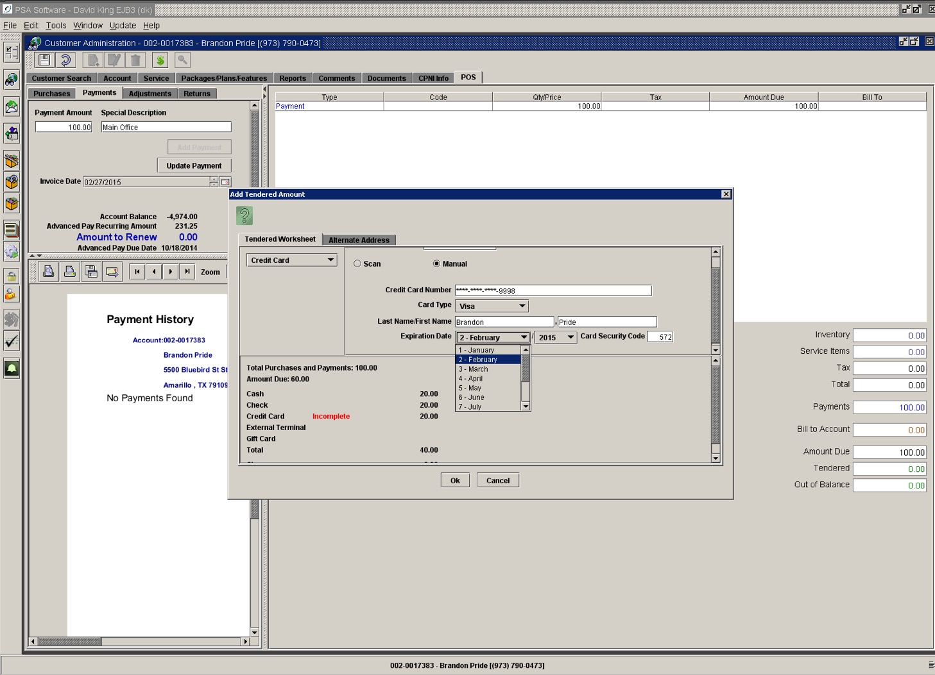

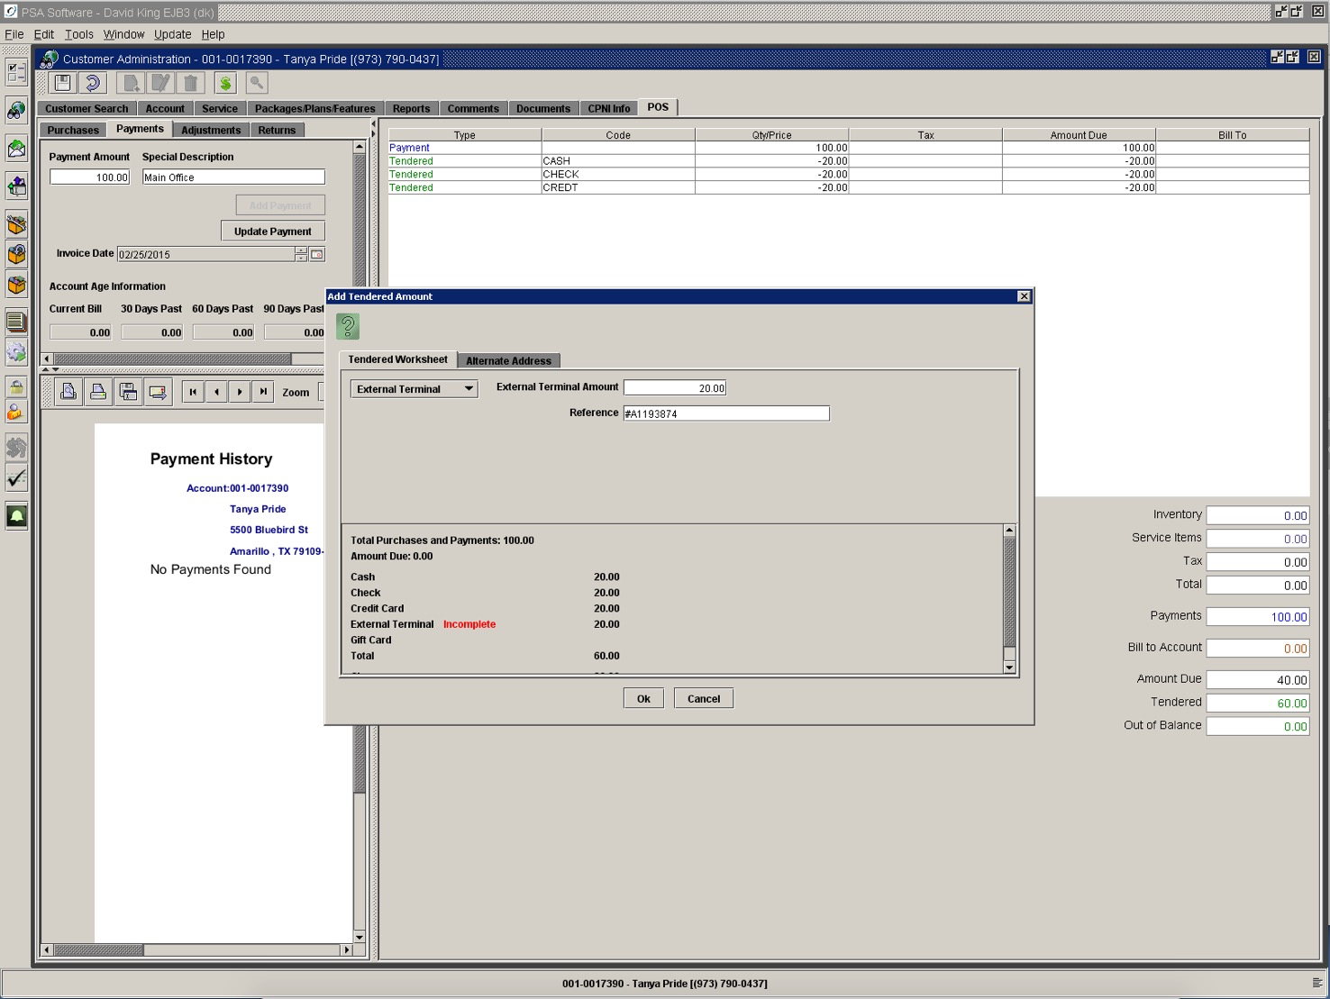

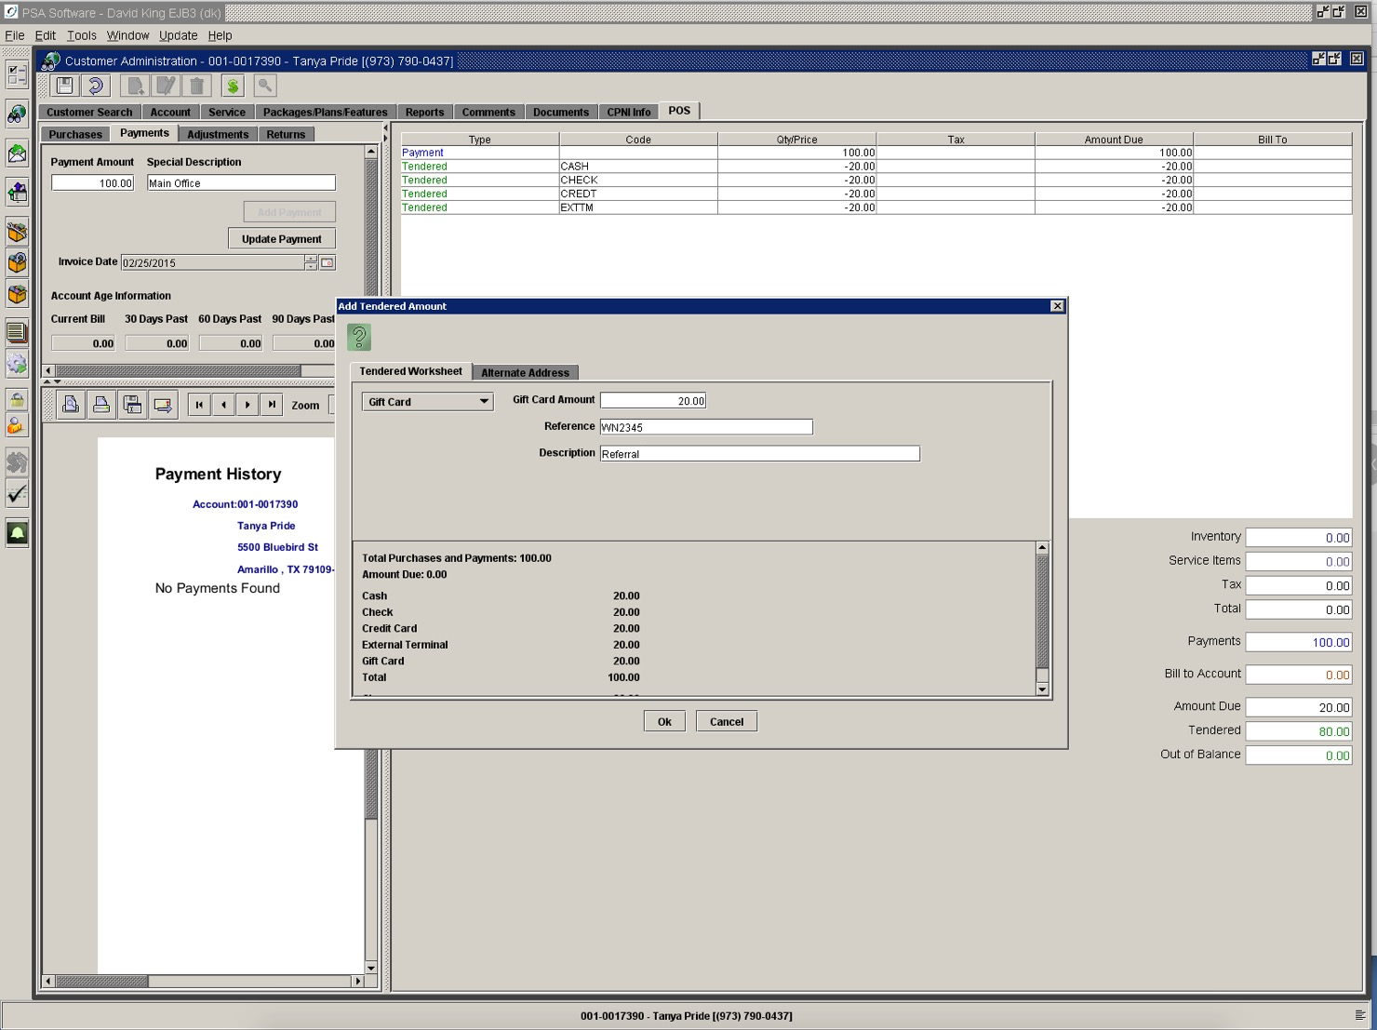

All Tendered Types will show as a line item for the amount of the type.

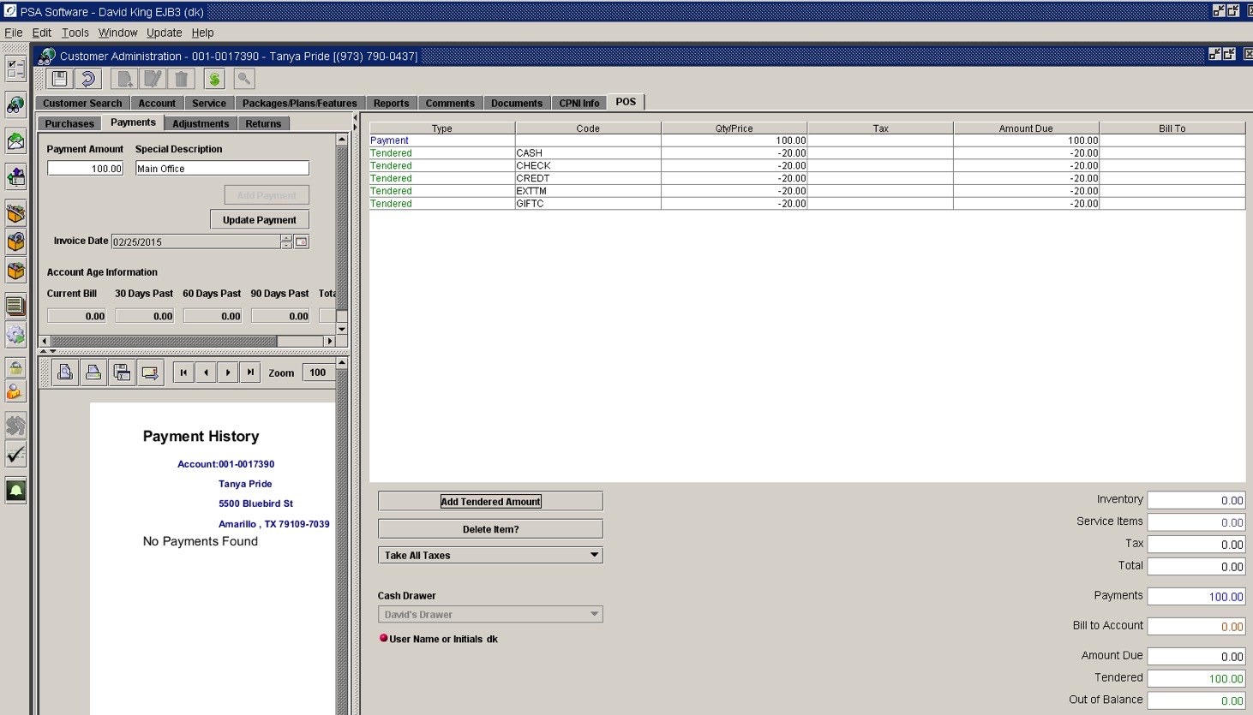

Alternate Address Tab

Used almost exclusively for Walk-Ins transactions but could be used to change the buyer information on the invoice. With Walk-In transactions, this will allow the user to put a name and address on the invoice.

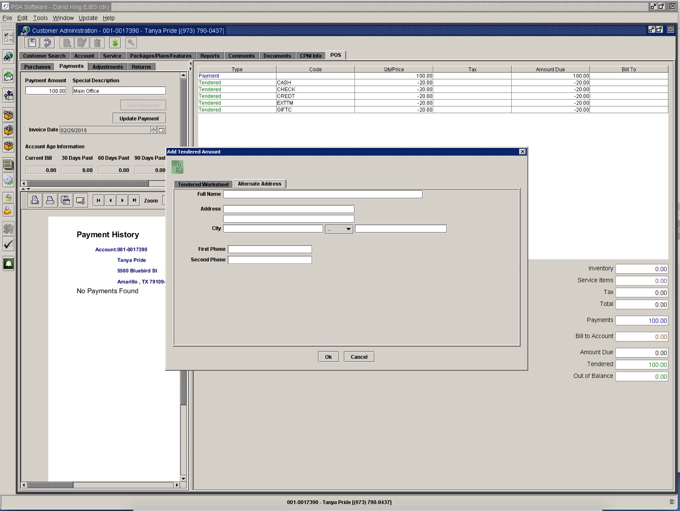

Additional fields in Point of Sale

Delete Item removes the highlighted item from the invoice list. Some items may not be available for deletion by company preferences.

Taxing Status defaults to Take all Taxes. If the item is tax exempt select the appropriate exempt status from the dropdown box.

Cash Drawer drop-down allows the user ‘controlled’ access to virtual or physical cash drawers. There are several settings for accessing drawers.
Option 1 allows the user to select the drawer once initially. The drawer will be remembered for all following transactions.
Option 2 requires that the user sign-in with a password for each transaction. Option 2 does not require the CSR to select a drawer prior to each transaction, just to sign into the last drawer used on the PC. This is used when multiple users are using the same PC and cash drawer. Each transaction is marked with user ID and time stamp.
Option 3 allows an intermittent user access to the cash drawer. The user will press the red User Name or Initials radio button, which will require a sign on and password for one transaction only. Once the transaction is complete the ownership of the drawer reverts to the original user ID.

Subtotal Fields
Inventory – subtotals only inventory items.
Service Items – subtotals items brought forward from the Packages/Plans/Features.
Tax – is calculated by the user address for Service Items and by the drawer setup for Inventory items.
Total – Total of all previous items

Payments – this field is for Payments on Account only. A payment on an account is monies paid to satisfy the monthly statements.
Bill To Account – the subtotal of the items that will be billed on the customer’s next statement.

Amount Due – this amount must be collected to complete the service order, this will include any payment on account shown in the previous subtotals.

Tendered – displays the subtotal of all monies. T
The amount due can be collected by cash, check, credit card or a combination of all types.

Out of Balance – delivers a new popup, which displays the overpayment amount for the invoice. There are two options to resolve the difference.

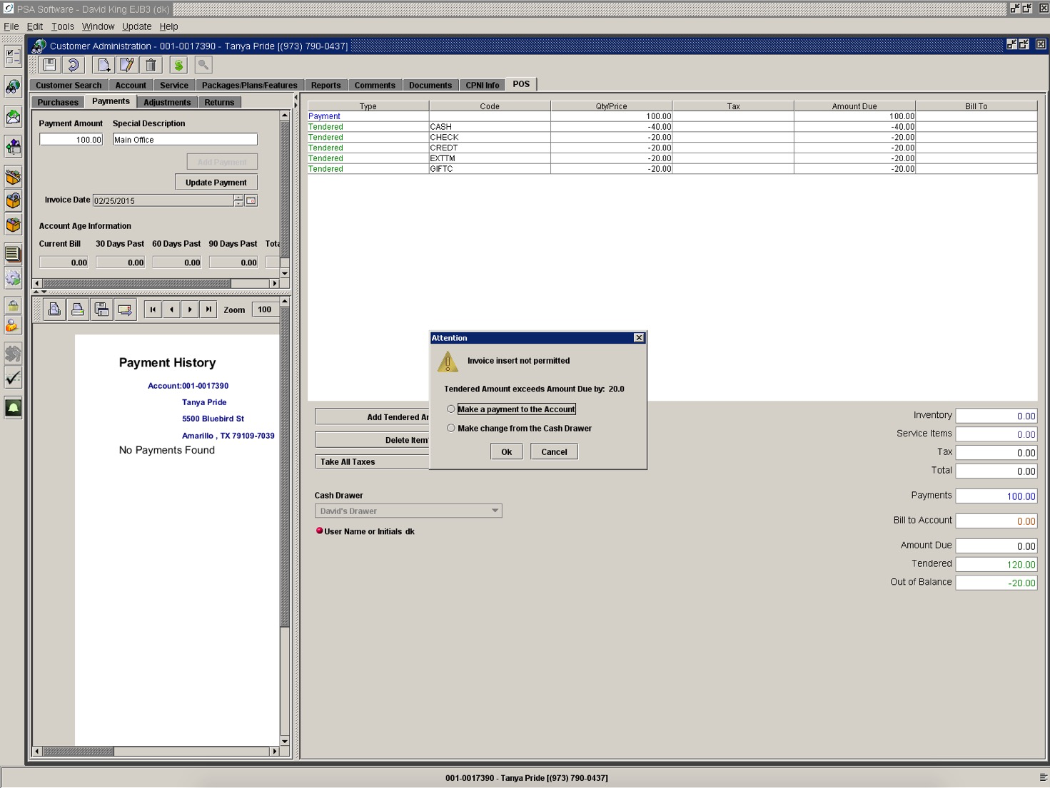

Make a payment to the Account applies the overage as a payment on account against future monthly statements and completes the transaction. If you are using electronic signature pads, a request for signature will display. Once signed, the receipt and invoice are printed.

Make change from the Cash Drawer opens the cash drawer and completes the transaction. If you are using electronic signature pads, a request for signature will display. After signature the receipt and invoice are printed.

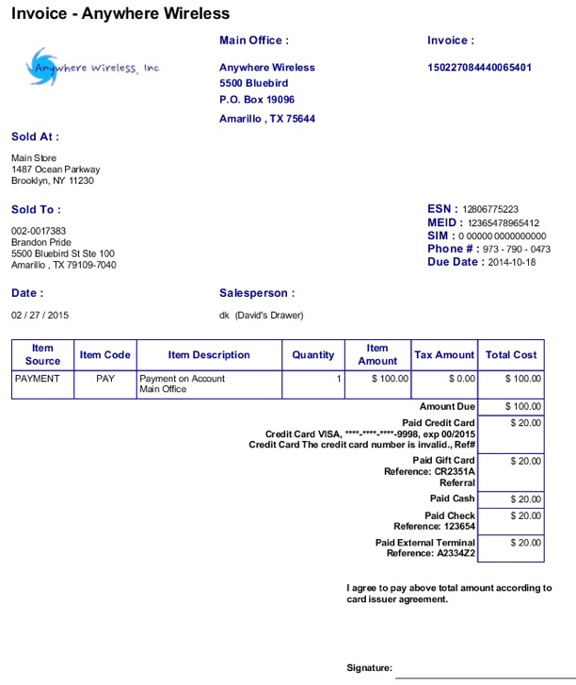

The invoice shows any Tendered Type reference or descriptions entered by each type. The credit card will display type of card, last four digits, expiration code and the approval code on accepted transactions.

Payments

Payments on Monthly Charges

Selecting the Payment tab allows you to review accounts receivable, payment history and enter payments for the account selected. Determine the payment amount and enter that in the Payment Amount field.

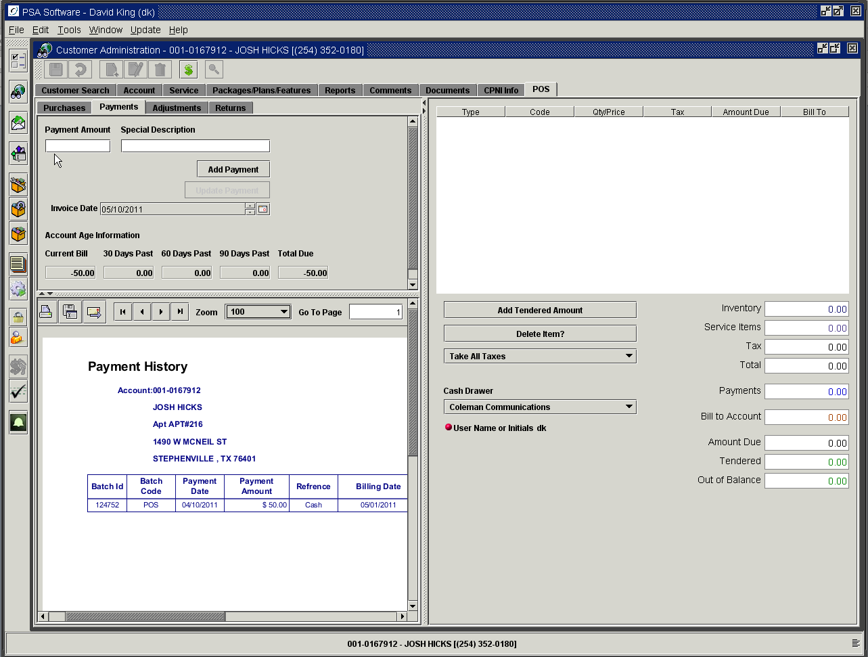

Special description is an optional text field to be used at the user’s discretion. This description will display on the invoice as a short comment. This will not show on the payment or transaction history reports.
Add Payment button will move the amount to the invoice. To edit the amount once it has been placed on the invoice, double click the line item. You may now change the amount or special description. Press the now active Update Payment button.
Each POS payment will show as an individual line item on the payment reports. The reports will show the Drawer ID as Originating Place.

Use Add Amount Tendered to enter the type of payment, and press Save to finish the transaction. You will be presented with a receipt if you use the receipt printer; otherwise an invoice will be produced that can be printed or emailed as a receipt for the payment.

You may also print or email the Payment History report as needed from this section.

Payments Against the Principal on Installments (with optional installments module)

If the customer would like to reduce the balance owed on an installment you will use a designated Adjustment to effect the change.

To see the balance of the installments open the customer and go to the Reports tab. View the Installment Report.

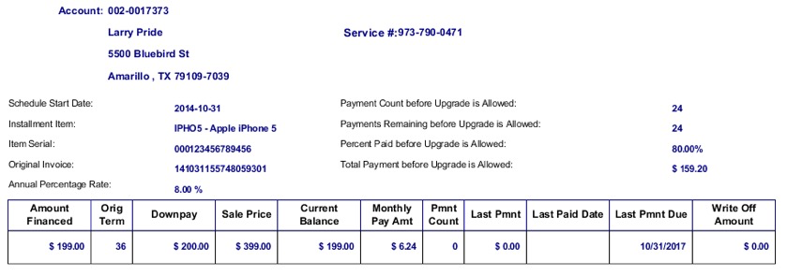
To make the payment, open POS and select the Adjustments tab. Select the designated installation principal adjustment.

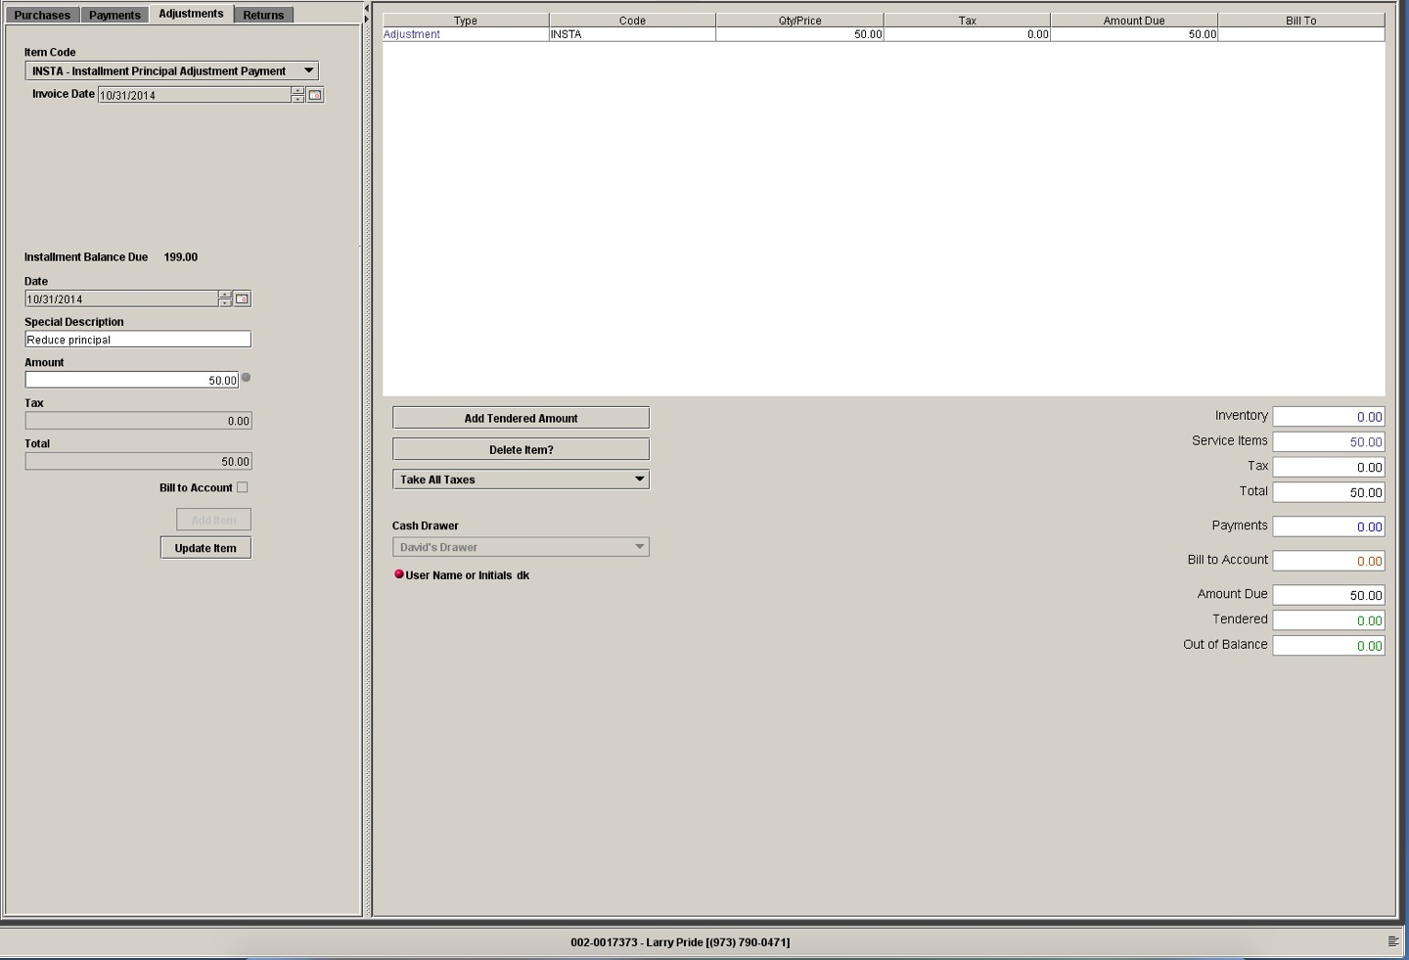

Collect the amount and press Save. That will reduce the outstanding balance on the installment schedule, which in tern will reduce the number of payments left on the schedule.

Adjustments

Adjustments such as activation fees or promotional credits can be added in ‘New’ Customer and Add a Phone service orders; or as an individual adjustment to the account or service in Point of Sale. Adjustment items, which affect the account receivable balance, can either post immediately upon Save or can be directed to an adjustment batch for review and posting. Temporary items can be allowed in the drop down list. These items will NOT affect the accounts receivable balance until the monthly billing run. You will be able to see both items after Save and Refresh on the Packages/Plans/Features screen until the next monthly billing run if the Bill To flag is checked. These items will be cleared with the bill run but can be reviewed on the Transaction History report under Customer Administration.

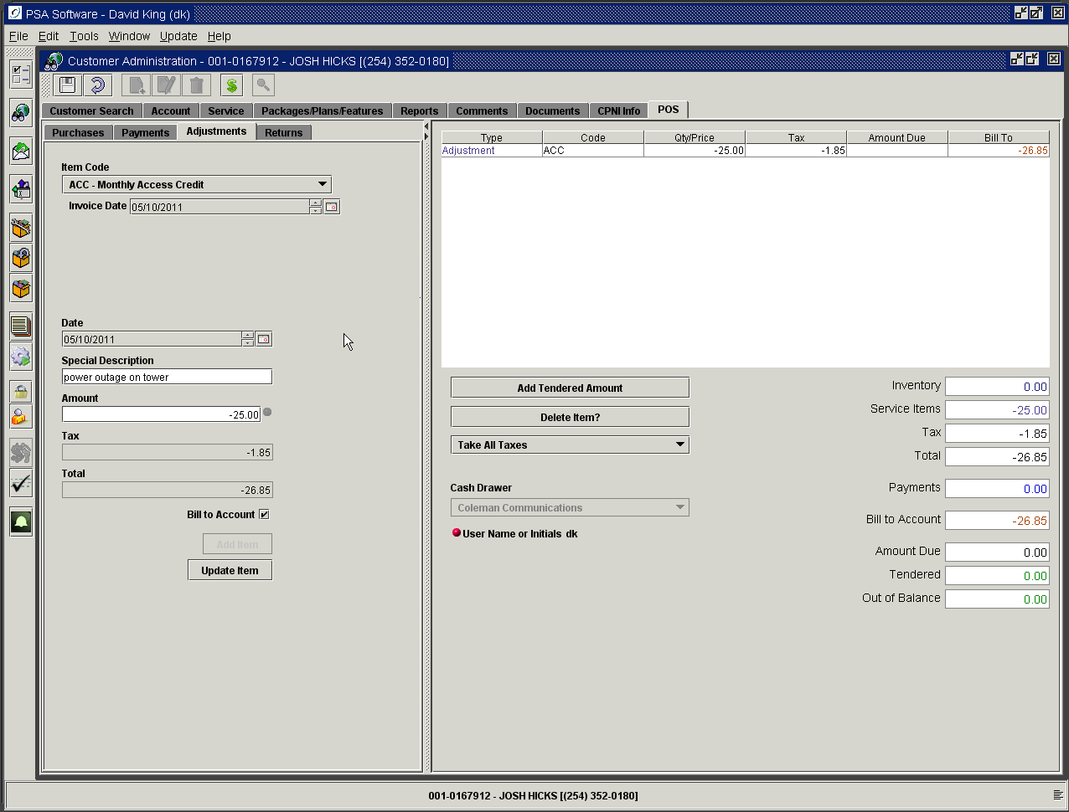

The adjustment items are added into the service items subtotal. If the adjustment item has a preset default dollar value that will show in the Amount field when the item is selected from the dropdown.

Special Description is an additional field where you can enter more information regarding the nature of the adjustment. This information will be in the comments column on the Adjustment report and will be shown on the invoice with the adjustment line item.
Tax will be calculated if taxes apply to the adjustment. Not all adjustments will have a tax associated with them.

Bill To Account: When this is checked the adjustment will apply to the account NOT the Amount Due on the invoice. If you wish to adjust the invoice, leave this unchecked; the adjustment will then affect the Amount Due field. This type adjustment will not be seen in the Transaction History. All adjustments will be shown in the Adjustments Section of the Daily Balancing Report. If ‘Bill To Account’ is checked the adjustment will be written to the Transaction History report. Pressing Add Item will add the adjustment to the invoice. To edit the adjustment before completion, double click the adjustment line item, make any changes and press Update Item.

To give a credit, place a minus sign before the amount of the adjustment. To complete this adjustment, press ‘Complete’ or ‘Save’ to finalize the transaction. If the Amount Due is a positive balance then you must use the Add Tendered Amount to collect the monies to clear the invoice. Adjustments will be added to the invoice that will be stored on the Documents tab under Customer Administration. The invoice can be printed or emailed if the customer
would like copy of the transaction.

Writing Off Account

If the account has been determined to be uncollectible and you want to remove the balance on the account you must use the specific write off adjustment item for your company. The amount should be entered in as a NEGATIVE amount. To reduce the write off balance on an account, so will need to use the same write off adjustment code as you used for the original write off but the amount should be a POSITIVE amount.

Writing Off Installment Balance

To completely remove the balance go to POS and use the designated Installment Principal Write Off adjustment. The amount on this type write off is POSITIVE unlike normal write off. This only clears the balance of the installment account; it does nothing to the Accounts Receivable balance.

Creating a Deposit on Account

Deposits can be created using the Point of Sale section or be auto-generated using the Credit Rating. If the Credit Level requires a deposit, the service order wizard will add that to the invoice in Point of Sale without CSR intervention. If you manually add deposits, you will need to add them via Point of Sale or Batch Processing as an Adjustment. There can be several deposit items within the system. You must define the “Prefix” (such as DEP) to identify a deposit item in Billing Administration>General Information>Service Type. You must use only adjustment items that are setup specific to deposits or the adjustment will be added to the invoice or accounts receivable rather than being written to the Deposit Master. Pressing Add Item will add to the Amount Due and should be collected as part of the service order. There are exceptions where some companies allow the Deposit to Account to be added as part of the next billing statement. If you company allows this and it is appropriate, uncheck the Bill To Account box.

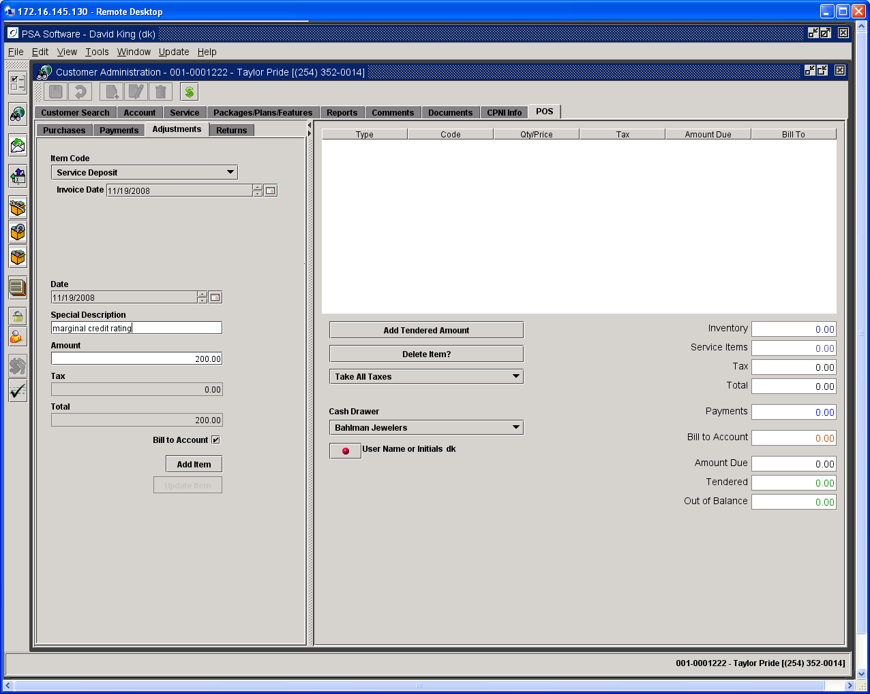

When the order with the adjustment is posted you will notice a ‘New’ tab on the customer’s service screen - Deposit. You will be able to view or refund the deposit on this tab.

You can add a deposit in the Batch Adjustments module also. Use the correct deposit item and post the batch to see the ‘Deposit’ tab on the customer. If you add the deposit here, you need to make a Payment for the amount on the account to offset the charge on the statement.

Service Items

Service item details cannot be changed on this tab. With proper user authority, the tab allows the CSR to change whether or not the item must be paid for up-front or added to the customer’s next statement. To change the service item details you must go back to the Packages/Plans/Features screen and make changes there.

Returns

If the end user wants to return an equipment item, select the specific service number on which the item was sold and open point of sale. Invoices are tied to service numbers not account numbers. If you don’t find the item on an invoice for the service number you should review invoices on other service numbers on the account. Select the Return Tab which open a list of invoices. Invoices are in date order.

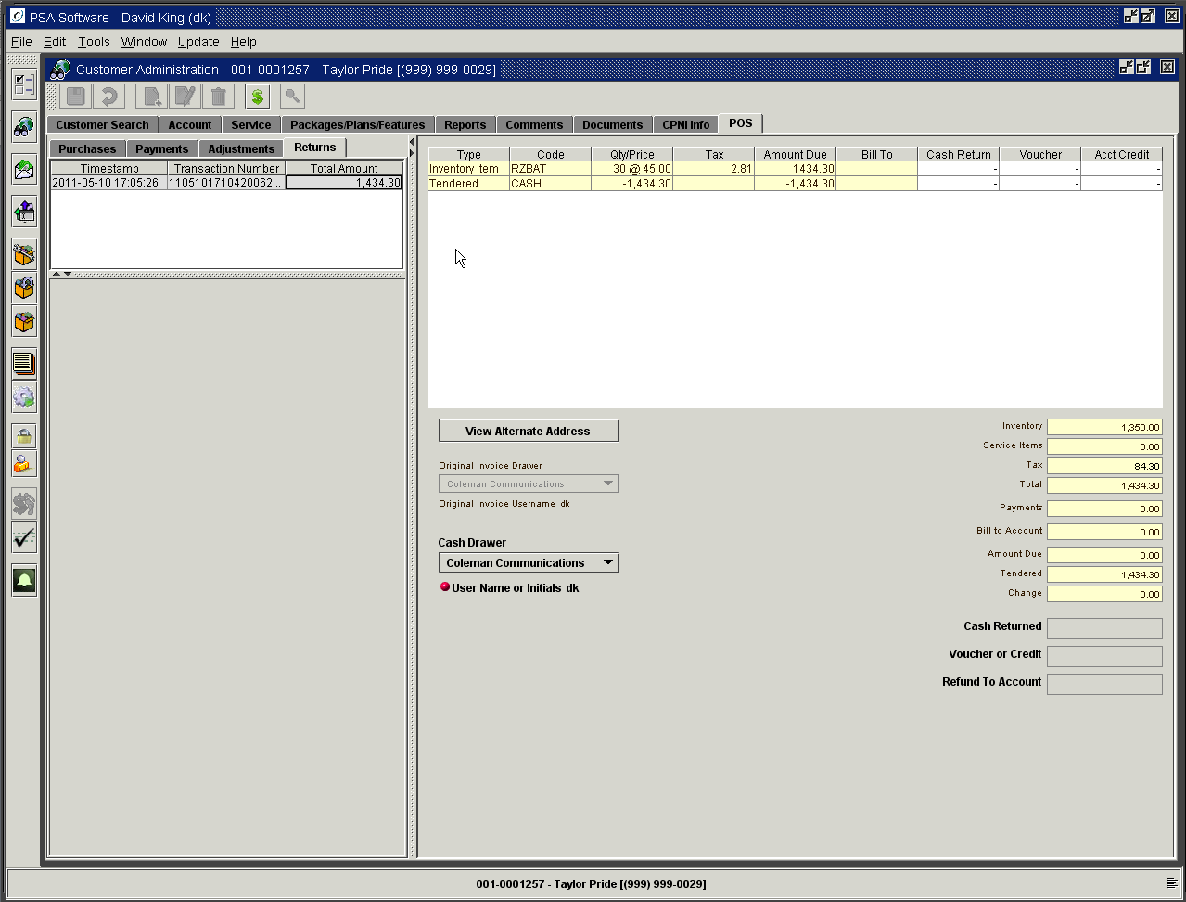

Select the transaction number by double clicking the line. This will open the original invoice displaying all equipment available for return. Double click the line item on the invoice to open the return. If the item will not display then it potentially has already been returned on a different transaction.

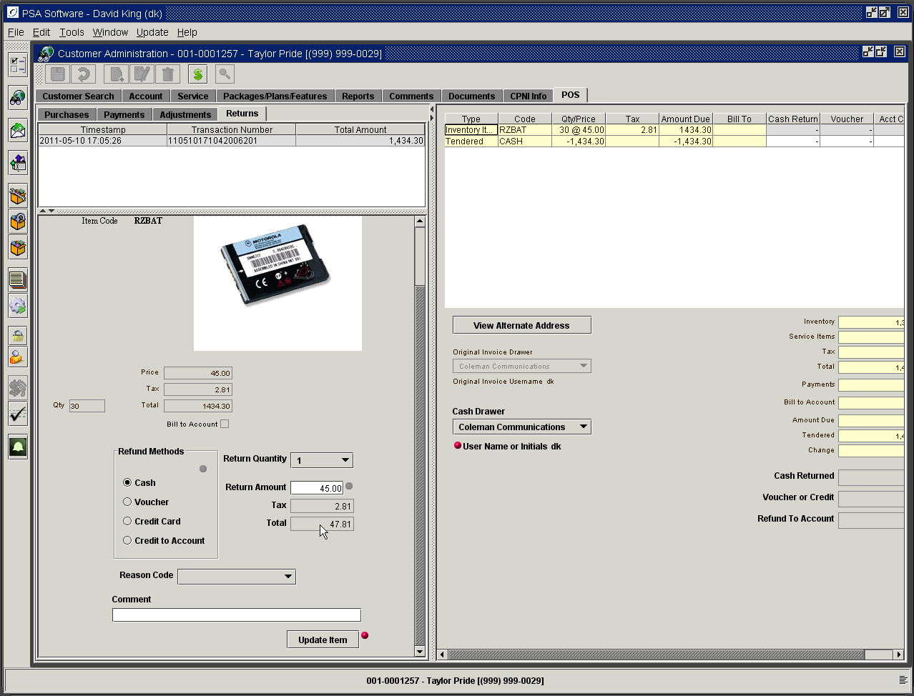

The item will reload in the secondary box. Items not in bold fonts cannot be edited. Refund method will default to the same method of payment as was used on the original sale. If the user has the authority, they may change the type using the radio buttons to the left. If the type was originally cash, but the ‘Cash Amount Allowed to be Paid at One Time’ field in the drawer setup is less than the amount, cash will not be an option. If the original invoice was paid by check, the program will check to verify that the ‘Days Allowed for Checks to Clear’ restraint has been met. If it has been met the Voucher type will be displayed. Where a credit card was tendered on the original invoice this option will be marked as required method. Pressing Save will print an invoice that can be taken to accounting for creation of a return check or post the amount to the credit card. The Return Amount will be defaulted with the value from the original sale; with the appropriate authorities, the return amount can be changed. You must select a return reason code to complete the return. The Comment field will be displayed on the return invoice immediately under the return line item. The service order process creates a system-generated comment on the service number. You may get a listing of these comments via Reports>Customer Reports>Comments Report. Press the Update Item to adjust the item on the invoice. Pressing Save, which creates a new invoice, completes posting of the return. The new return invoice can be printed or emailed as required. You may see the returned invoice under Documents tab >View Invoices on the date of the return.
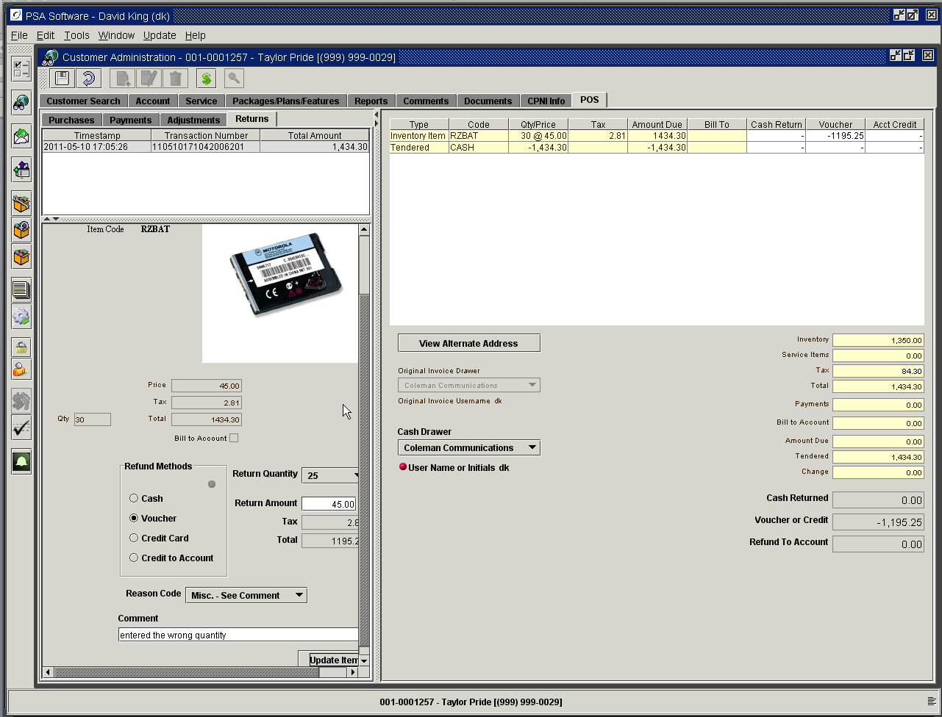

The return amount will display in the appropriate column in the invoice frame. The balance to refund will be shown in the totals column at the bottom.

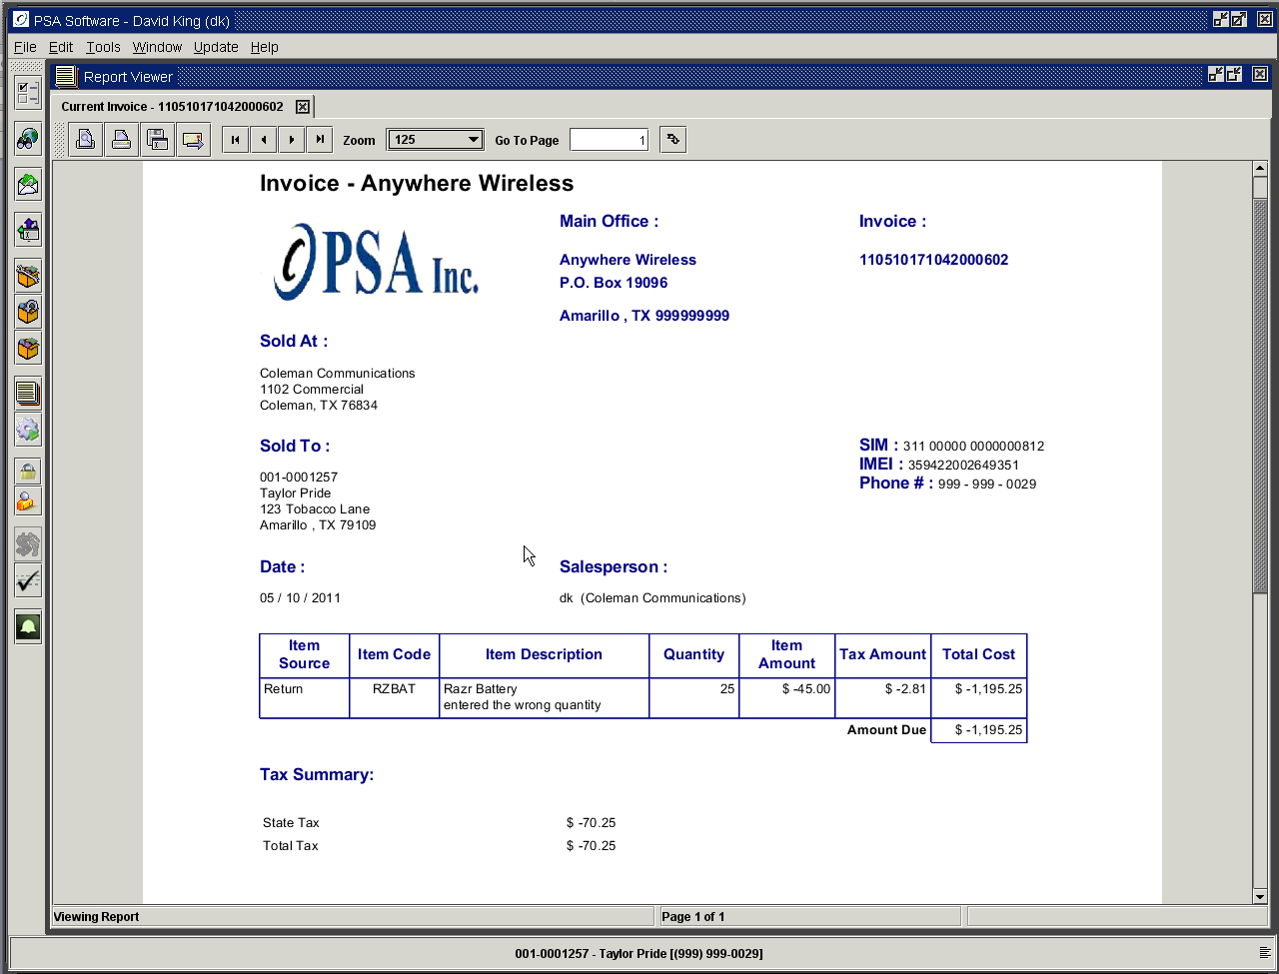

You can see a summary listing of any return invoices for a service number under Customer Admin>Reports>Sales Return Report.

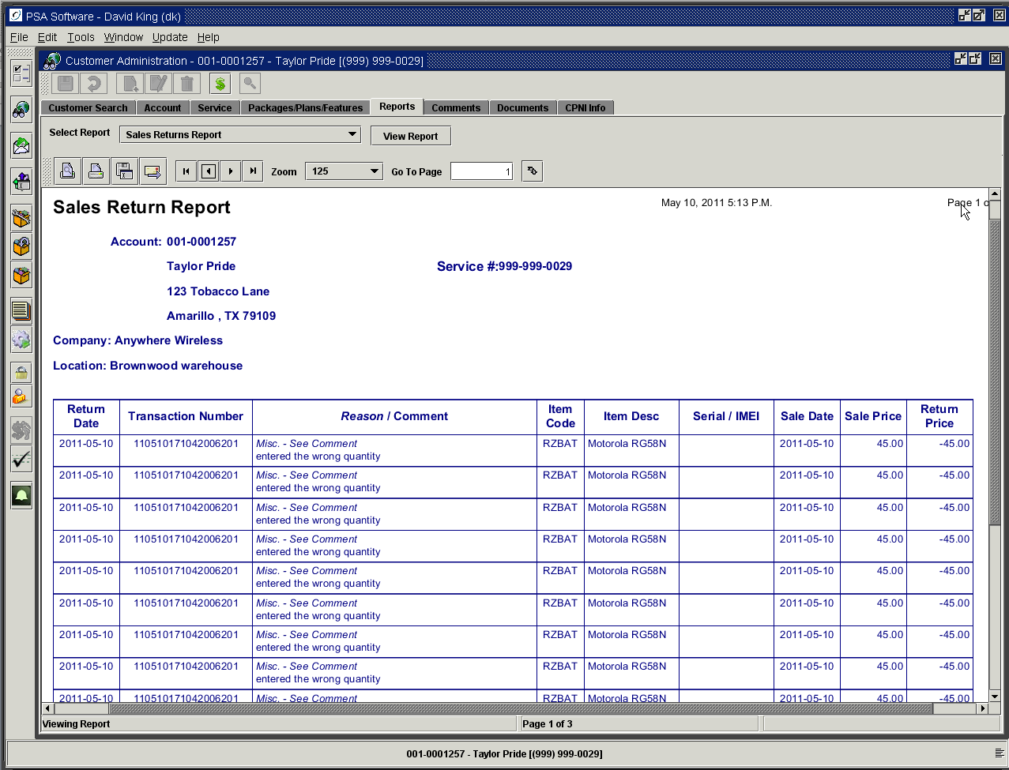

Returns for Entire Invoice

If you want to return all equipment and cancel all service items you can use the Full Invoice Return button on the invoice screen. This option will only be valid if all Service Items are the same and ‘active’ on the service; if not the return will not be allowed. This return will change the status of the equipment, remove all features, reverse any adjustment and reverse any payments on the invoice.

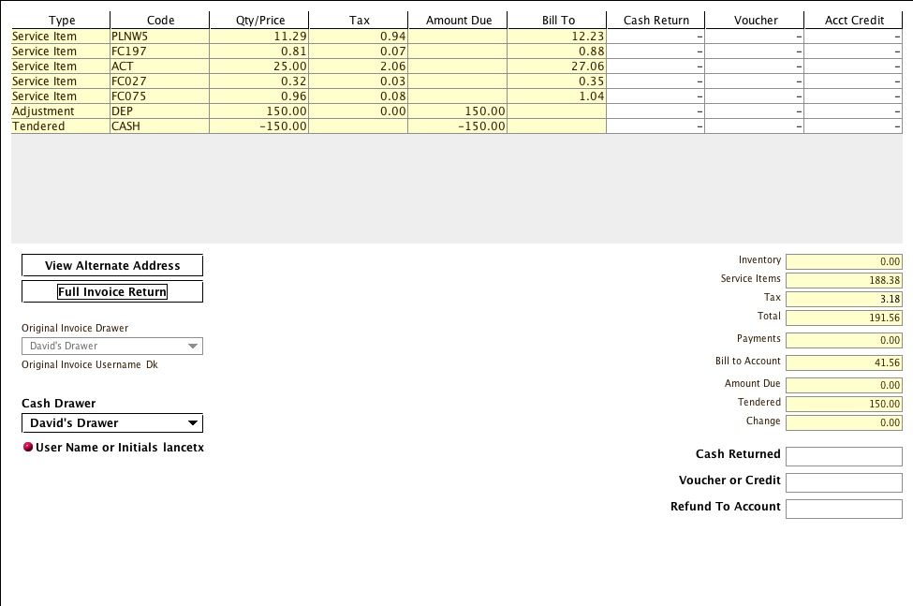

Since the customer can use multiple tendered types the return on entire invoice can become complex. If the user does not have the authority POS – Override Return Method then the only option available to them will be Refund to Original Tendered. This method will read the invoice and determine what amounts were tendered for each type and create a return invoice showing the breakdown.

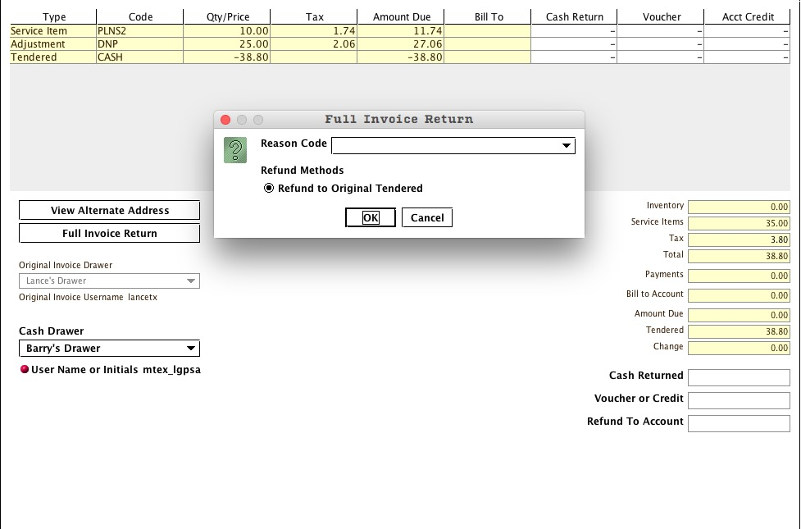

Example: If 100.00 was tendered as Cash and 100.00 was tendered as credit card on the original invoice; the return would credit the credit card 100.00 and allow the user to refund 100.00 from the cash drawer.

The return method respects all the drawer settings such as number of days required before return is allowed when paid by check. If you cannot override the return method and the number of days set has not passed, the system will not allow the return. This will be the screen presented with no other options.

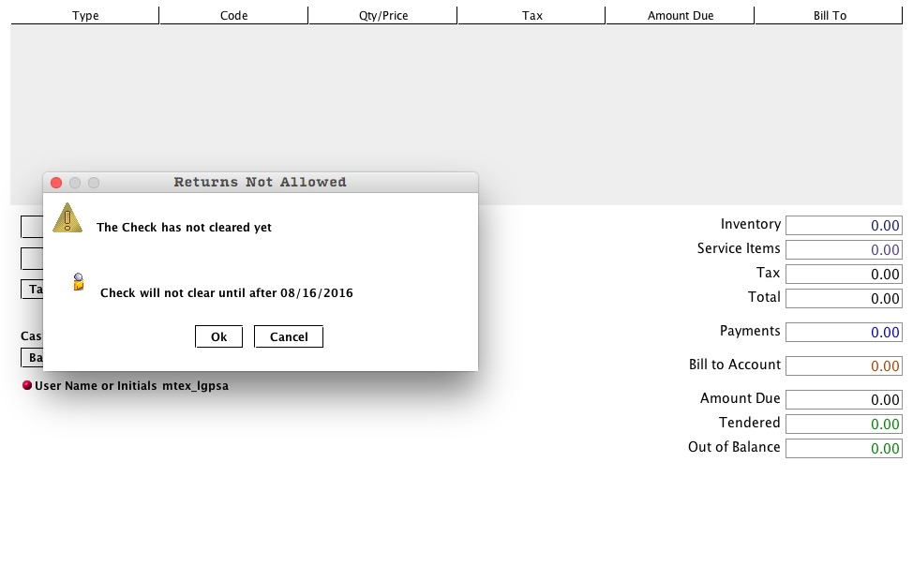
If they have the Override Return Method, this will be the display on voucher return not valid.

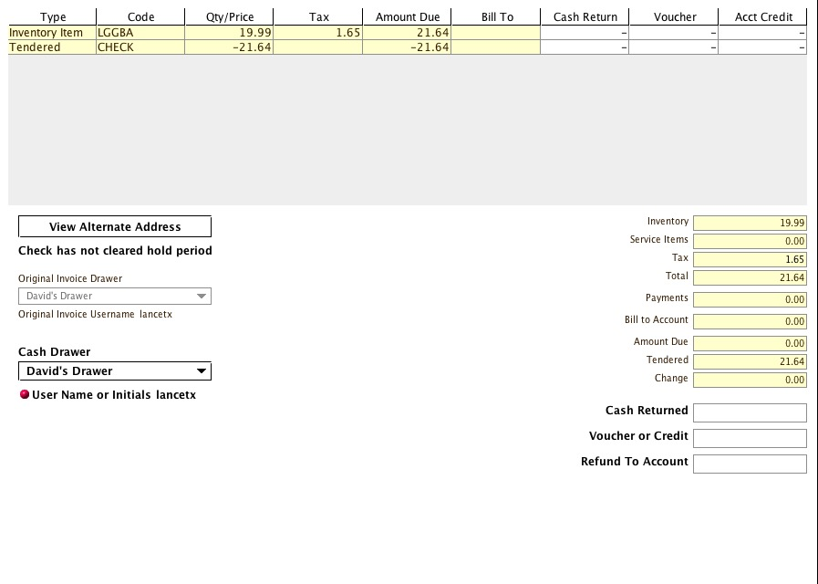

The following screen shots are where the user has the ‘POS – Override Return Method’ authority. The user will select the invoice to be returned and choose a return Reason Code from the dropdown box.

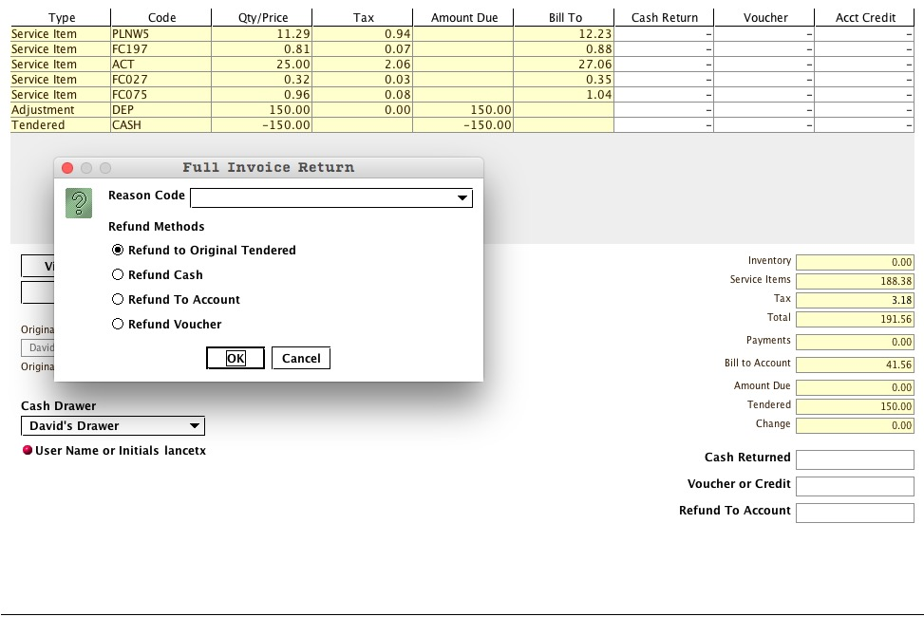

In this example the default is Original Tendered and would offer the same option to pay out of the cash drawer as Refund Cash since Cash is the only Tendered type. Refund to Account would credit the accounts receivable for the $150.00. Refund Voucher creates an invoice with an amount to take to accounting to have a check written for the refund.

If multiple tendered types are used on the original invoice the return can become quite complicated. In this example the customer paid with Cash and Credit Card. These are the options that will be available for the return.

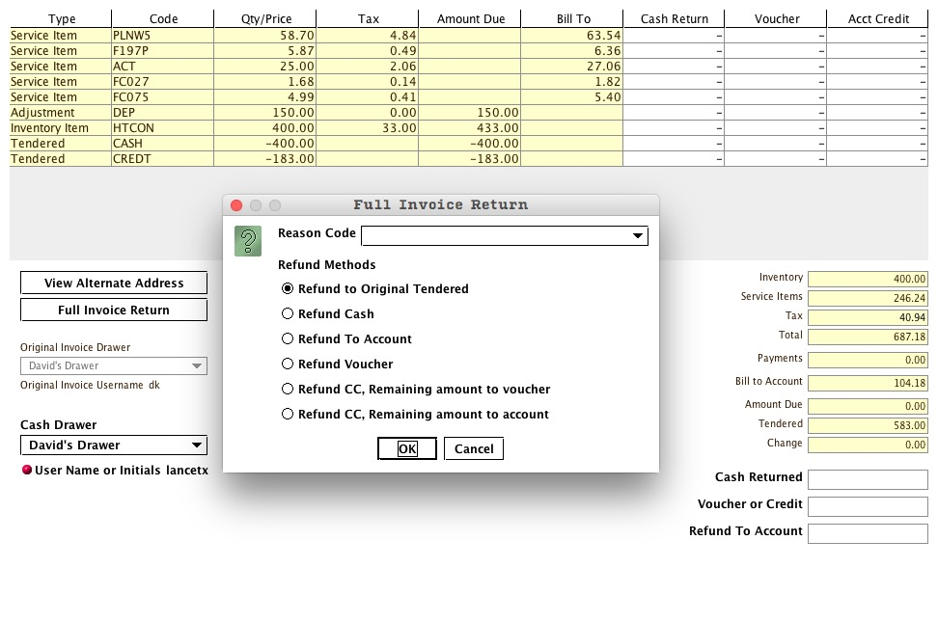
Refund to Original Tendered: Cash returned 400.00; Credit Card credited 183.00
Refund to Cash: Cash returned 583.00
Refund to Account: 583.00 will be credited to accounts receivable.
Refund to Voucher: Invoice created with 583.00 value to take to accounting.
Refund CC, Remaining amount to voucher: 183.00 is credited to the card and the invoice shows remaining balance of 400.00 to show to accounting requesting a check/voucher.
Refund CC, Remaining amount to account: 183.00 is credited to the card and the remaining 400.00 is credited to the account.

Additionally the 5 Service Items are removed from the account, the inventory item is returned to the return location on the drawer as Used and an offsetting entry is made for the adjustment item.

Should the user select a partially returned invoice the Full Invoice Return will not be available. Only equipment can be returned on a partially returned invoice or an invoice where service items have been changed since the invoice was created.

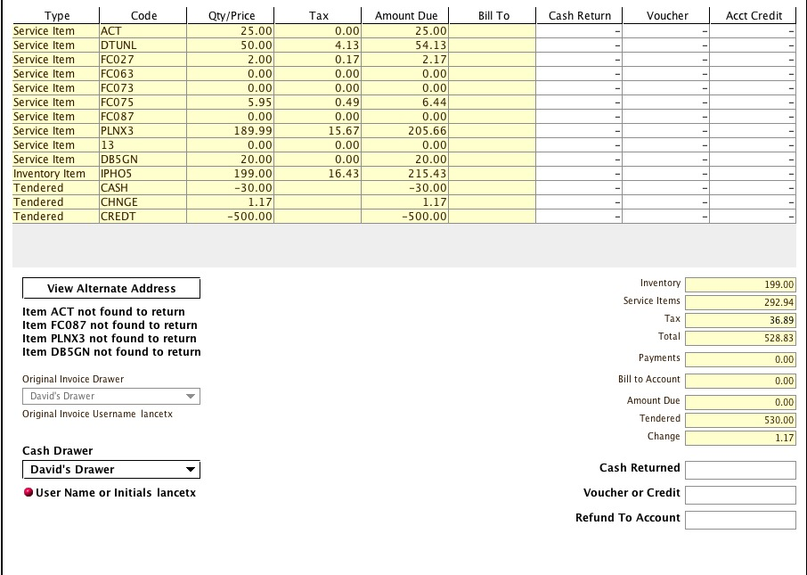

If you are doing a Full Invoice return on an Advance Pay account and the return would remove the active plan; then the system will force a disconnect on the service. If the plan was removed and allowed to remain active, the customer would have free service until the next renewal and since the return is refunding the money paid for the service up to the renewal date, the system will force a disconnect to remove the service in the switch. There will be a warning in red letters notifying the user if a force disconnect will be required. If you continue you must complete with a disconnect there is no cancel once you begin the Full Invoice return.

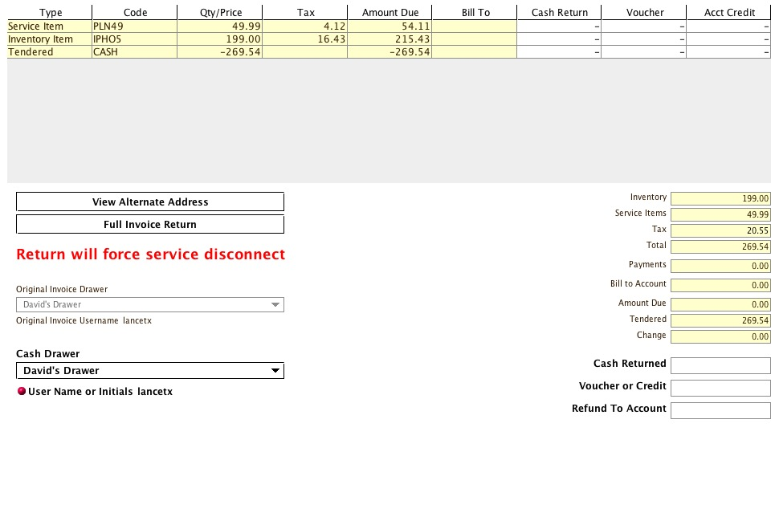

If you press Full Invoice return you will see and respond to the return dialog box. Pressing OK on the return dialog will complete the return and open the following disconnect dialog.

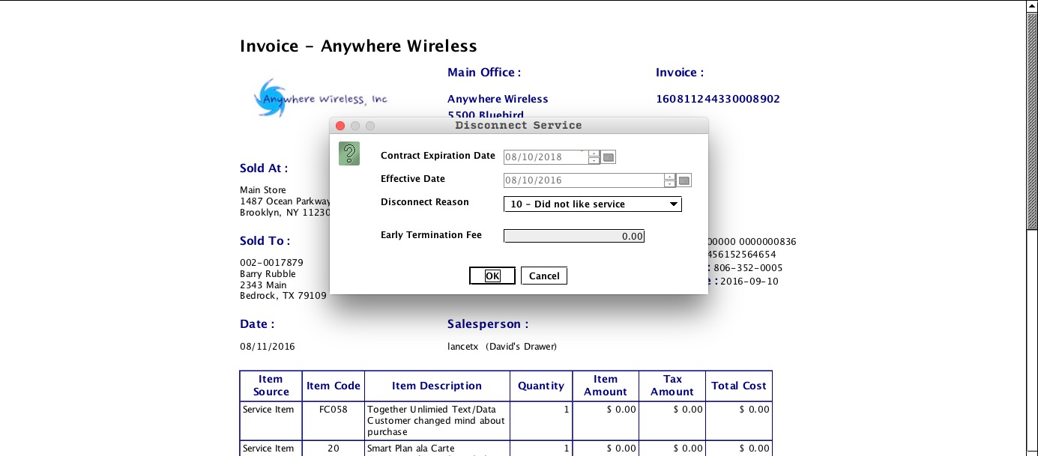

Select a disconnect reason code and accept the ETF of zero. If you press cancel you will see the following dialog; the disconnect cannot be canceled. Press OK to return to the disconnect.

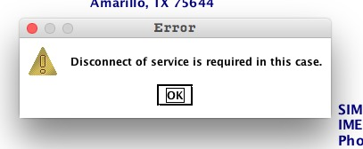

You must finish the disconnect dialog and press OK. Pressing OK will complete the disconnect.

Walk-In Point of Sale

This allows consumers who do not have an account with your company to purchase inventory items from your location. Only the Purchases and Returns tabs are available. The functions and controls are the same as in the normal Point of Sale. Use the Alternate Address tab under Add Tendered Amount to capture information on the customer. This information will be printed on the invoice in the same area as the account information for a regular account holder. Recording this customer information will be helpful if a return is requested on one of the items. Pressing ‘Save’ is the final step in Walk-In transactions. An invoice will be available for printing or emailing. If a return needs to be done on a Walk-In sale, ALL walk-in sales are listed by date and time stamp by transaction number under the Returns tab after opening the Walk In Module.

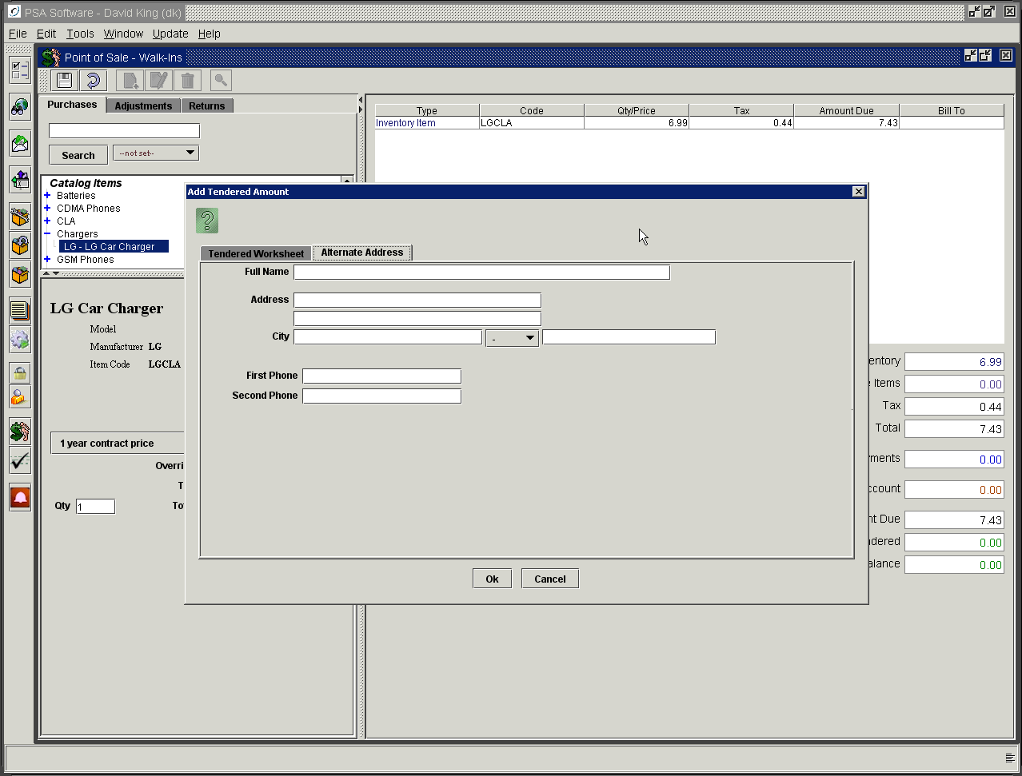

Drawer Balancing
At the end of each shift, each cash drawer should be reconciled and the totals reset for the next shift.
This option allows you to balance the drawer, reset totals, print trial balance reports and print final balancing report.

The program opens with the drawer description in the upper left corner of the screen. If that is not the drawer you wish to balance, select the drawer from the drop-down box immediately to the right. If the Auto Load Balance Totals is checked, the totals for currency, checks and credit cards will be calculated from the shift’s transactions and displayed in the right hand column midway down the screen. These will be the totals you will need to match to balance the drawer.

You may select from two options to calculate the cash portion of the drawer. The first option is Enter Number of Denomination Items. This requires the user to count the number of 100-dollar bills, ten-dollar bills, quarters, pennies, etc. and enter the count, not the amount, in the corresponding fields. The amount will display next to the field when you move off the count field. If there is no count for that denomination, enter a zero in the adjacent field. The grand total of currency is entered in the first field below the individual fields. The second option would be to check the Enter Total Currency Amount radio button. You would then count the monies in the drawer and provide a single amount for all the currency in the corresponding field.

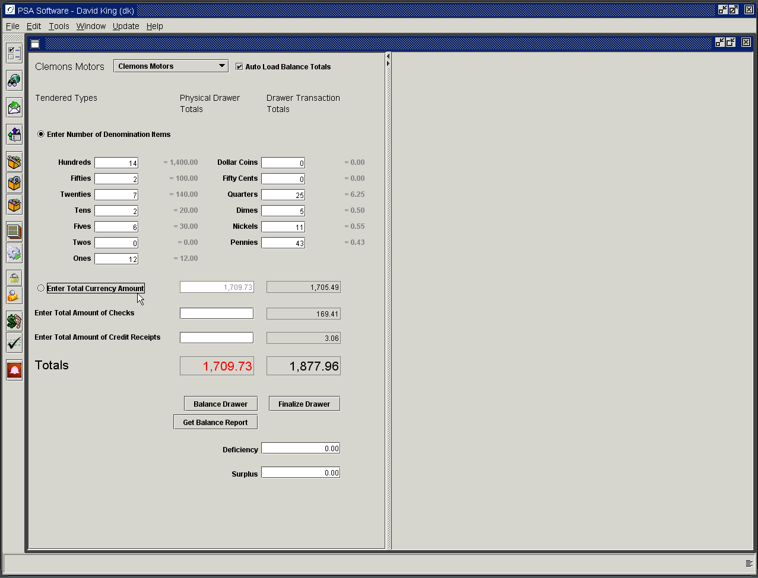

Once the currency has been totaled, total the checks and credit card receipts. Enter these totals in the corresponding fields.

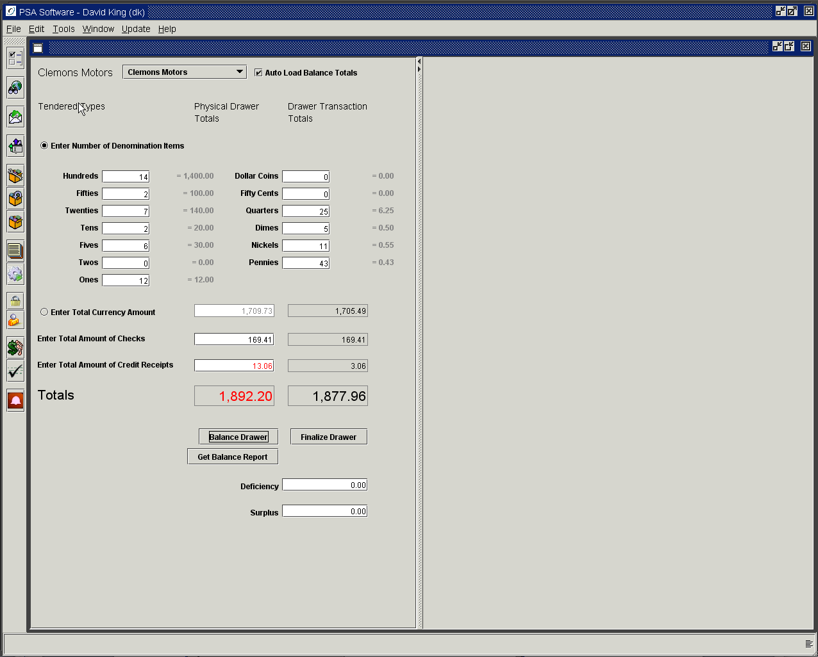

If the totals do not match you can display a trial balance report to check for inconsistencies. Press Get Balance Report.

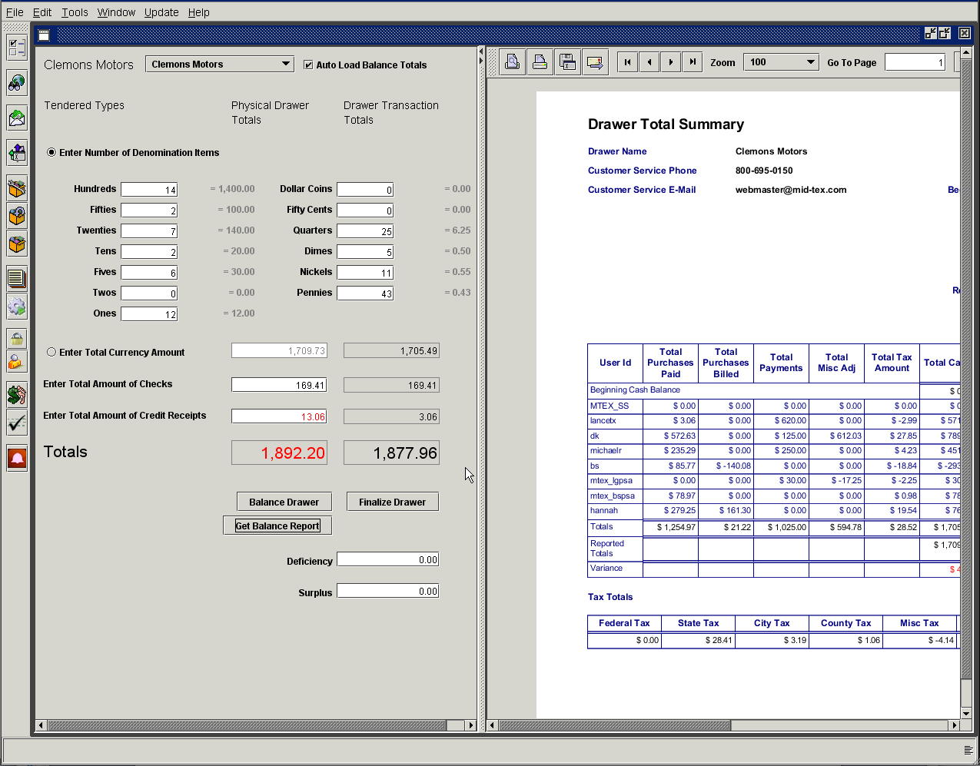

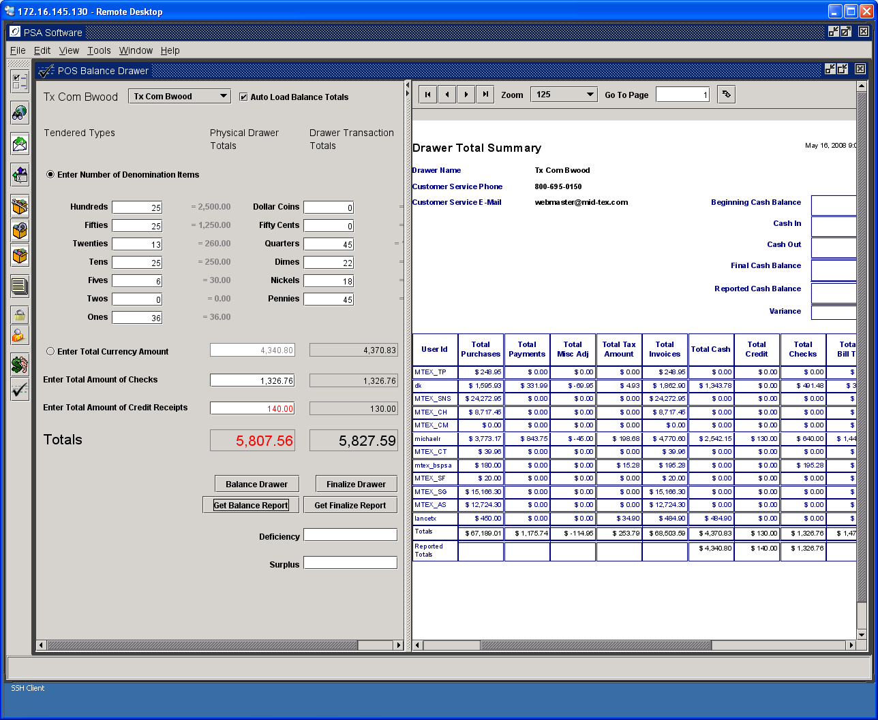

You can now see all the transactions and their values. Page forward to see all the detail behind the summary page. You will potentially have a detail section for each column of the drawer summary except for taxes. Taxes are broken out in a separate section on the summary screen. If you have transactions involving cash, then each invoice where cash was involved will be shown in the cash detail section. If you have credit cards then they will be broken out on the Credit Card portion. Bill To items will be shown separately in its own section. If you clear the invoice with two or more types, cash and credit card, then there will be an entry on both the cash detail and the credit card detail page.

Un-posted Invoices
Occasionally for various different reasons the application may not be able to fully post an invoice. If there are any un-posted invoices they will be shown at the end of the Drawer Balancing report. Any un-posted invoices should be dealt with prior to finalizing the drawer. Please contact PSA to determine the issue and get the invoice posted.

Examples of Detail on Balancing Report

Summary Page

The summary section includes the cash reconciliation, summary totals for each user id using the drawer and a breakdown of taxes. If multiple CSRs are using the same virtual cash drawer there will be a line summary on the first page and the user id will be shown with the individual transactions on each of the detail pages. Following the summary are details for each of the columns where there was activity. If no returns were done this day, the Returns Detail section will not be created.

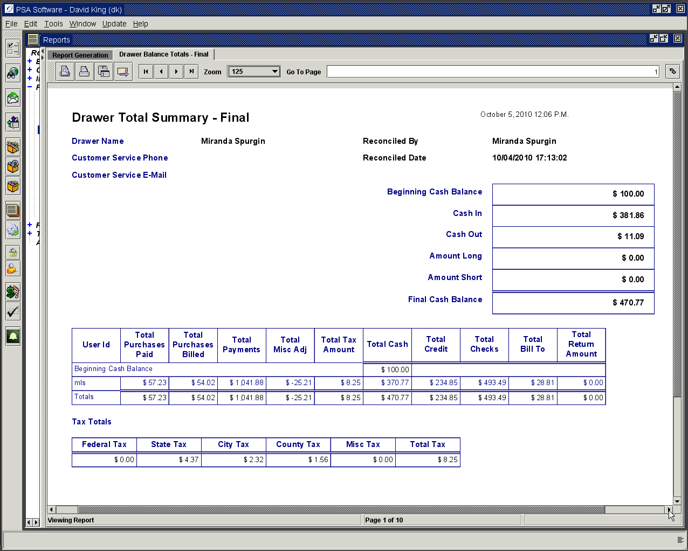

Cash Detail

Every invoice where cash was used to satisfy a whole or partial Amount Due is shown with received amount and change amount where appropriate. Also shown are the types of items involving the cash transaction such as purchases, adjustments, payments or returns. If the return of equipment involves cash, that invoice will be shown here as well as in the Returns Detail.

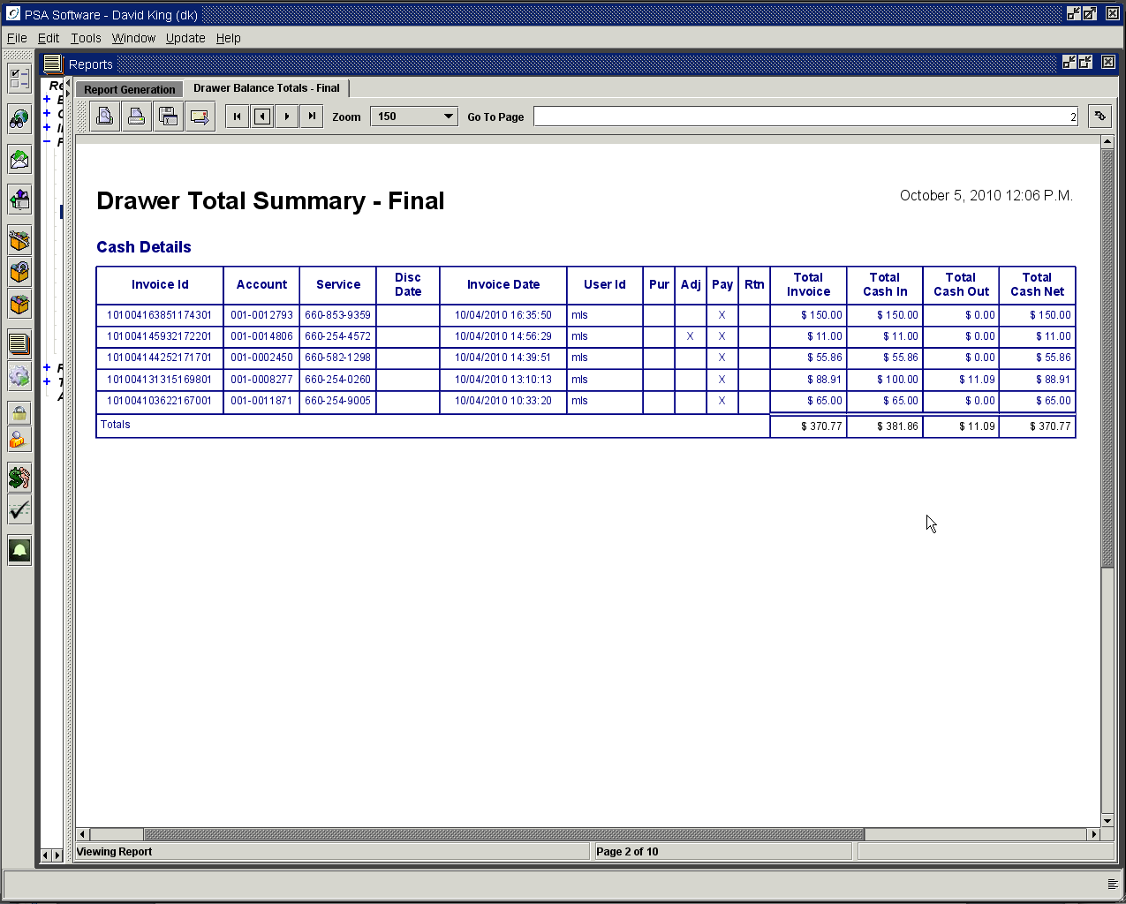

Purchases Paid Detail

This section lists all invoices where equipment was sold via the Point of Sale. These invoices could be included in one or more of the Cash Detail, Check Detail, or Credit Detail sections. The monies for these invoices were collected at the time of sale.

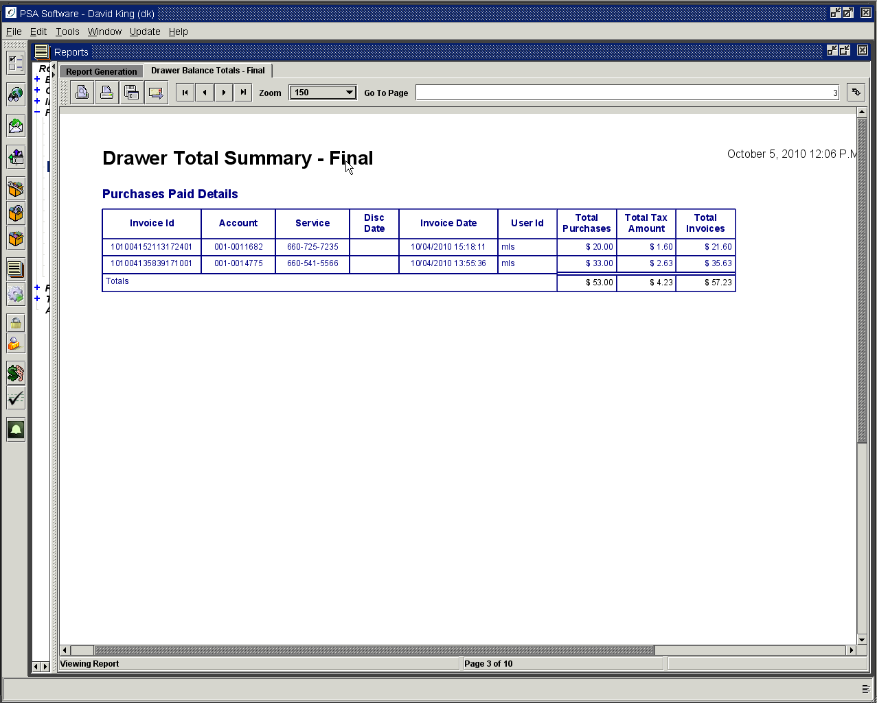

Purchases Billed To Account

When an item is charged to the account and applied to the next billing statement, the invoice number and the amount to be applied to the statement will be listed here. These items are not included in any cash detail, check detail or credit card detail but will be shown in the Bill To Detail. The invoices can involve equipment, adjustments or temporary items.

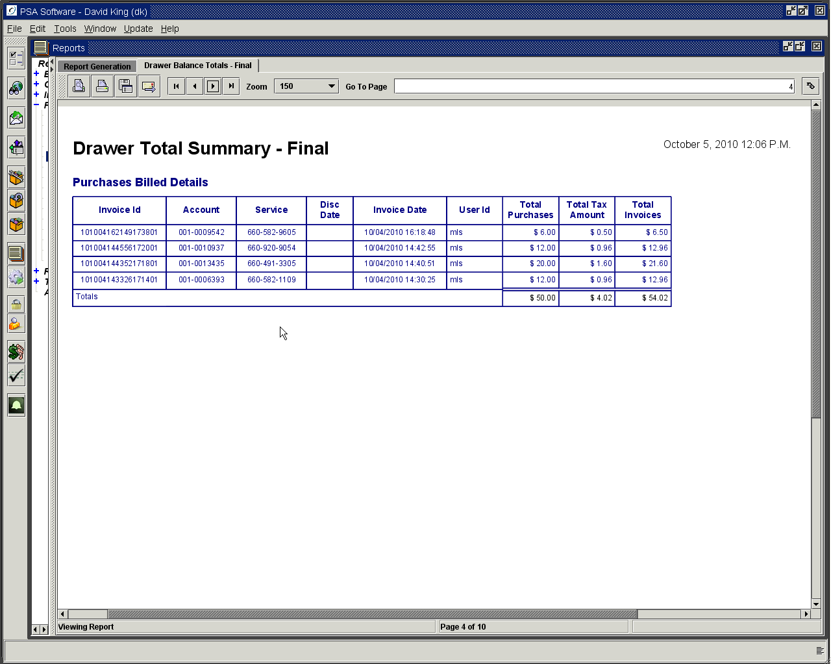

Payment Details

Payments in this section are monies paid to reduce the total amount due on the customer’s account. These monies are applied to the accounts receivable and are shown on the Payment reports and Transaction History in other sections of the application. These invoices will be shown in other sections of the balancing summary depending on which type(s) of Amount Tendered was used. (If a payment was made with cash and credit card, both the Cash Detail and Credit Detail section will show the invoice and the amount tendered for each type.)

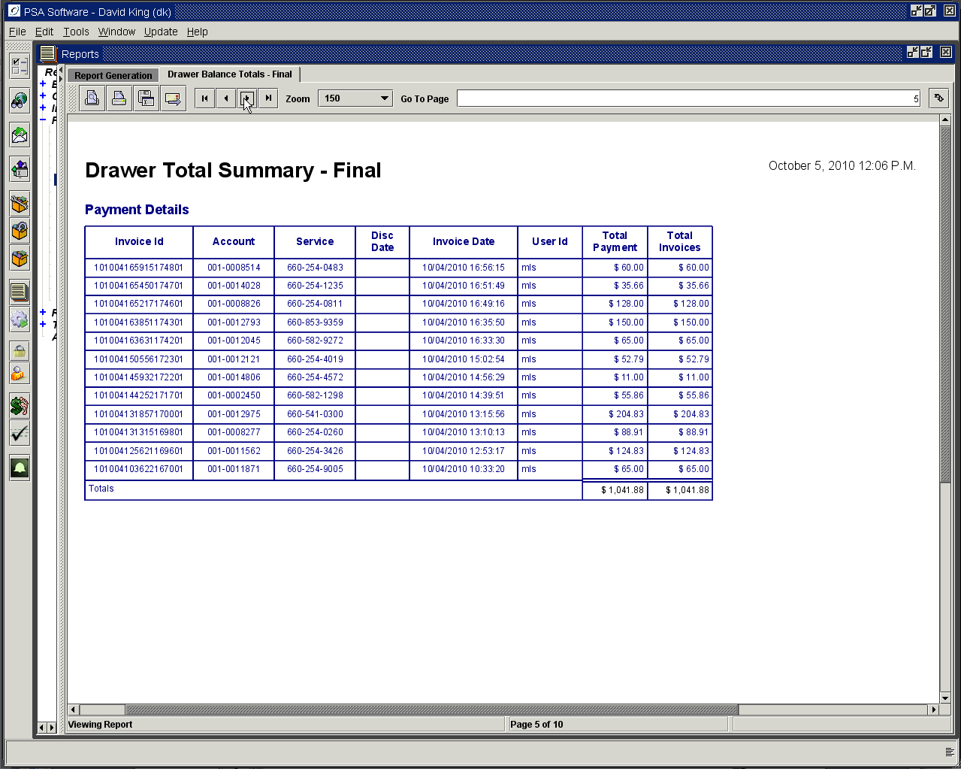

Adjustments Detail

Listed in this section are adjustments that affected the individual invoice. These adjustments affect the balance to be collected on the invoice. NOTE: These adjustments do not apply to the accounts receivable balance; those adjustments are on ‘Bill To’ detail.

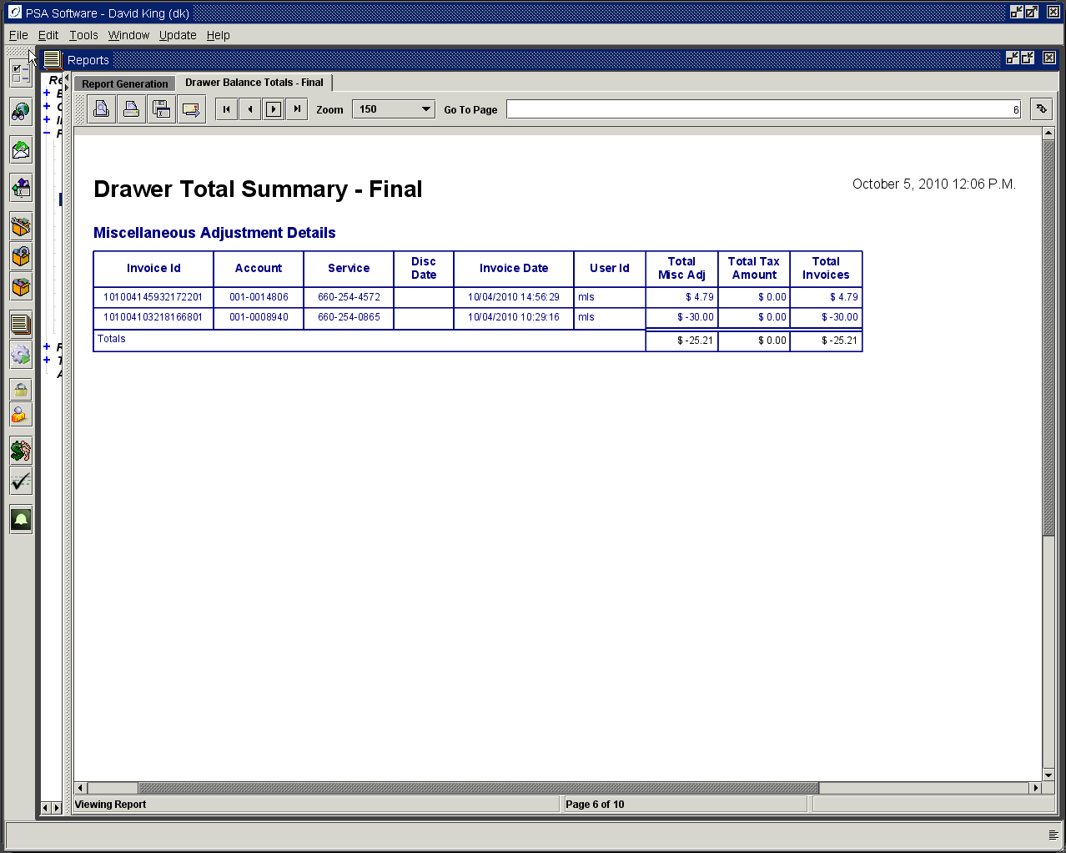

Credit Card Detail

Transactions that were in part or wholly charged to a credit card will be listed in this section. The Total Credit is the amount charged to the credit card not necessarily the total of the invoice.

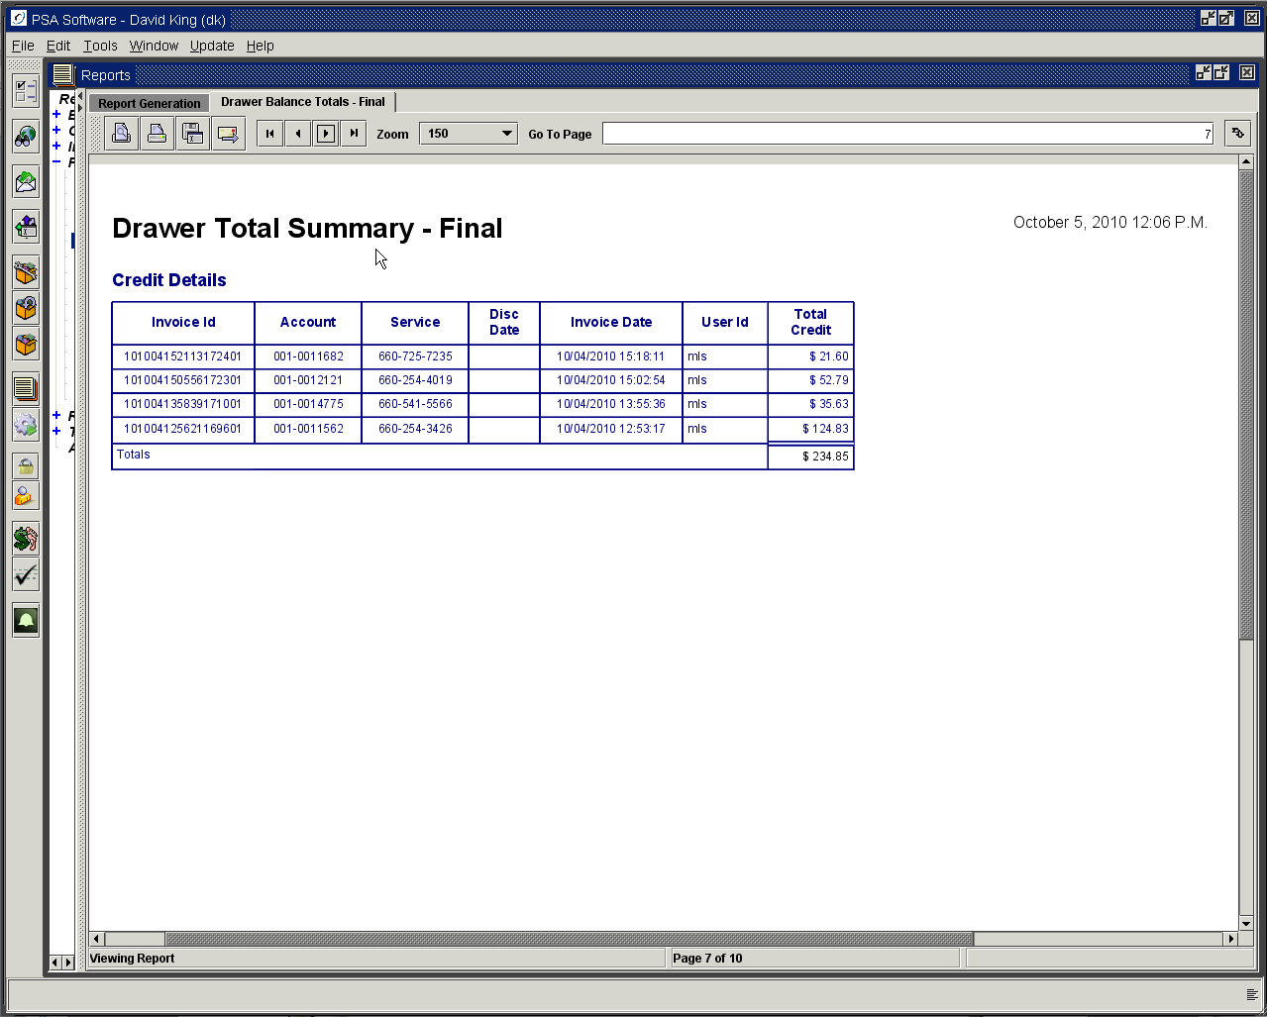

Check Detail

Any invoice where a check was written for an amount tendered will be shown in this section. It does not matter whether the check was only part of the amount tendered or written for the whole amount.

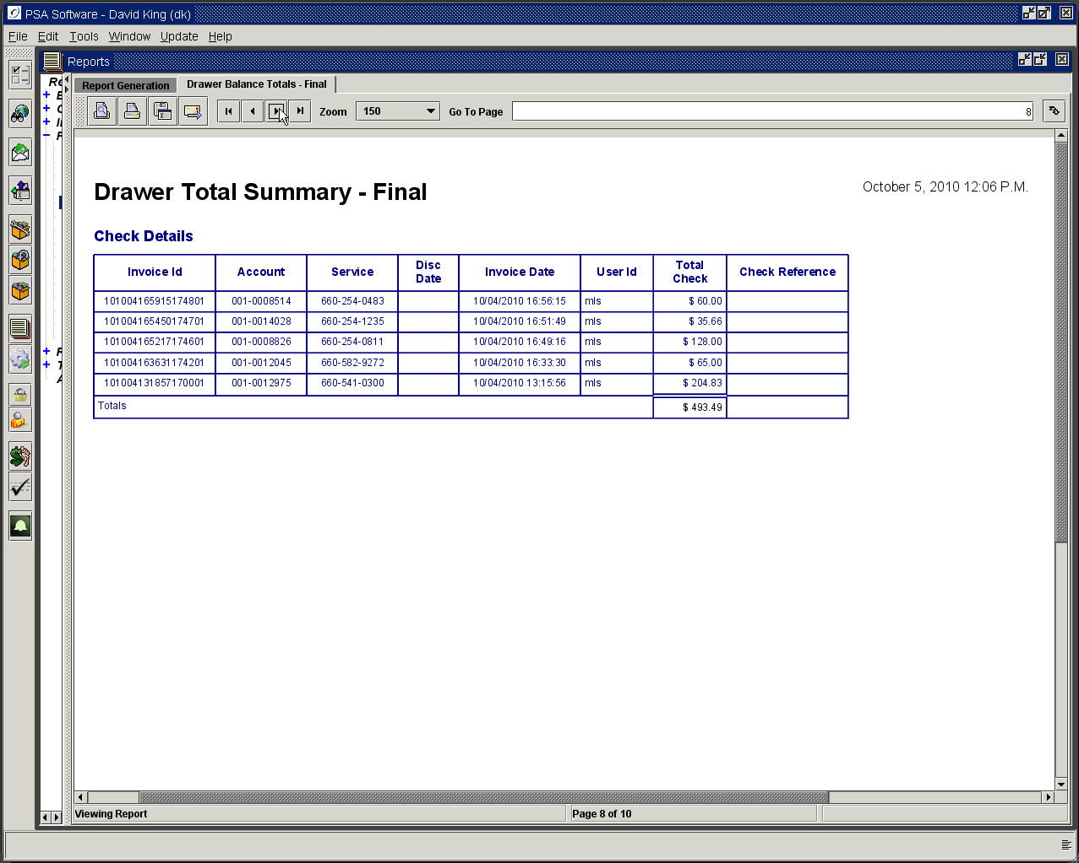

Bill To Detail

This section contains any transaction that will be accounted for on the customer’s next statement. These items could be equipment, adjustments or temporary items. This could be the entire invoice or individual items from the invoice.

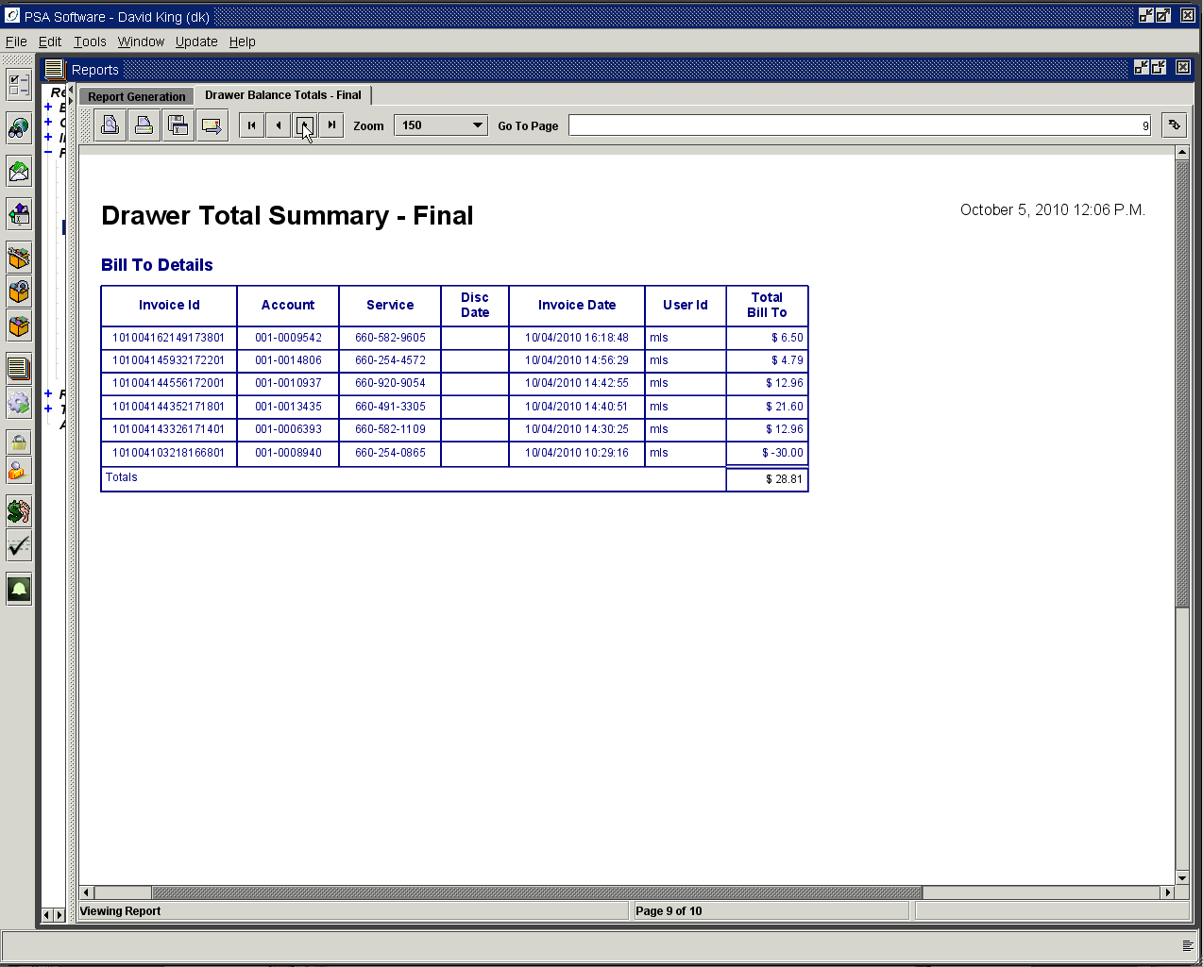

Returns Detail

If an item is returned, an invoice is created for tracking and receipt to the customer. If the return involves returning cash to the customer, the amount of cash given will be shown here as well as in the summary of cash section. If the return is credited back to the customer’s credit card, the invoice will show in both this section and the Credit Detail section. (If you are following the examples and reconciling the individual report back to the summary, this example of a return is a separate and not included in the summary)

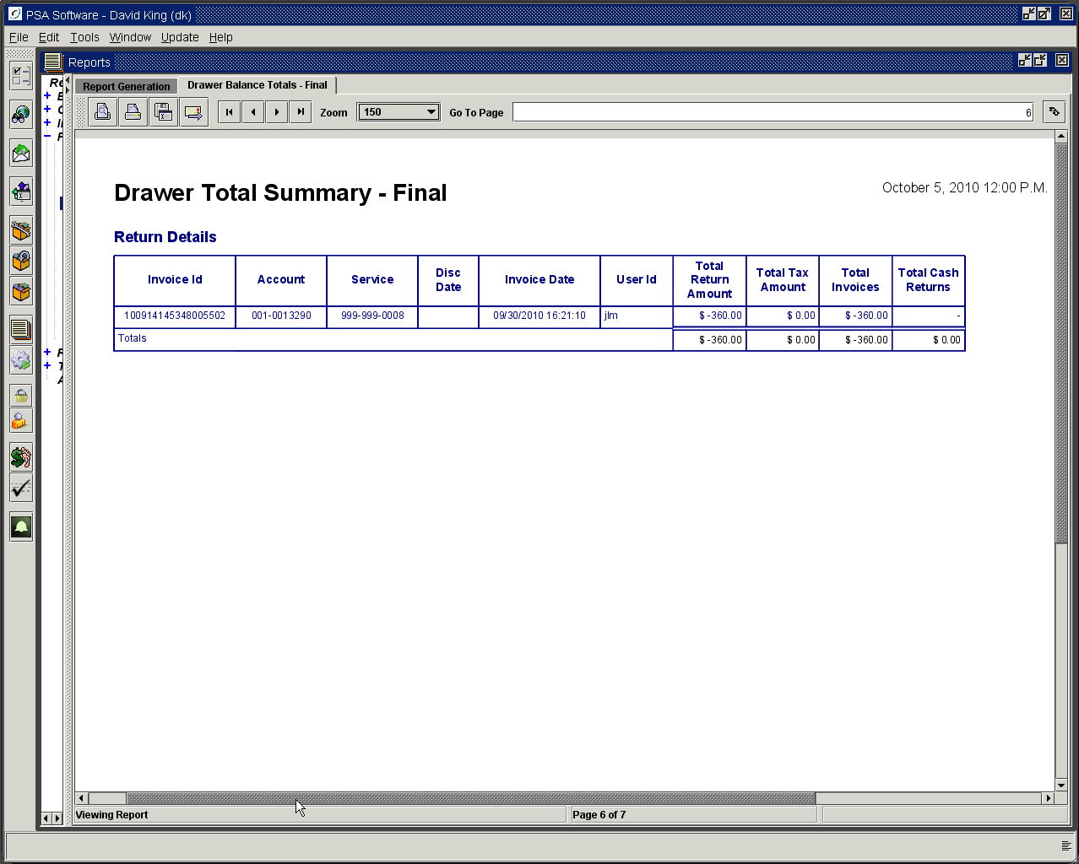

If the totals cannot be reconciled then you have the Deficiency and Surplus fields. Enter the amount over in the surplus field or the amount under in the deficiency field and press Finalize Drawer. Finalize Drawer resets the totals and sets the beginning drawer balance. Now press Get Finalized Report, you may view, print or email the report.

Unposted Invoice

Should an invoice fail to post during the day that invoice will be shown here. Please contact PSA to see if the invoice can be repaired and posted. It would be best to repair the invoice and post it before you finalize the drawer.

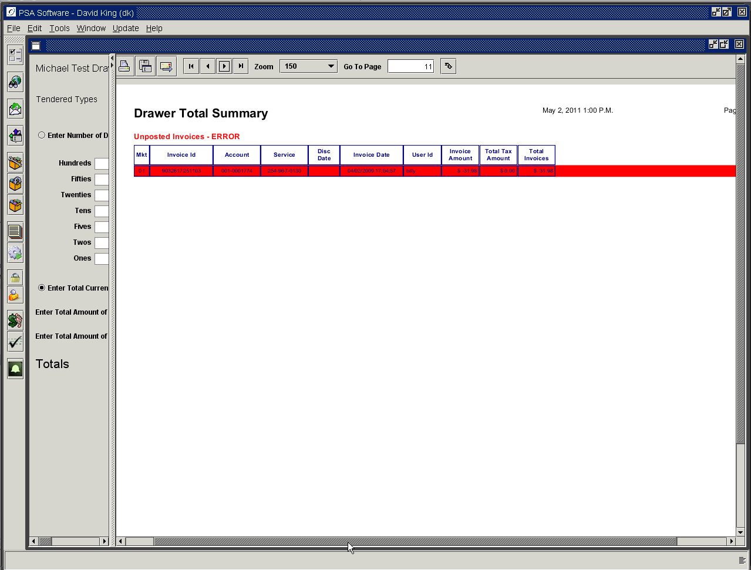

NOTE: Until the drawer is finalized the totals continue to accrue values so if you want to see daily reports, you must finalize the drawer daily.

Overrides

Overrides allow individuals with the higher levels of authority to sign in within a CSR’s session and make changes to fields not editable by the CSR. When an override is available, it will be shown next to a field as a small red ball. For a person to be able to use the override, they must have the authority in the Security module. If the ball is gray then the user has authority to change the field without an override.

Point of Sale Overrides

Drawer Override
If someone wants to take ownership of a transaction in Point of Sale without opening a separate session, they may press the red ball below the Cash Drawer dropdown. They will be asked for Login and Password. This now changes the user ID on this one specific transaction. At the end of the day when balancing the drawer, this drawer will have at least two summary lines, one for the original person and one for the override. As soon as the transaction is complete the ownership goes back to the original user ID. This can be used if two people need to share a single session virtual drawer. (No additional security)

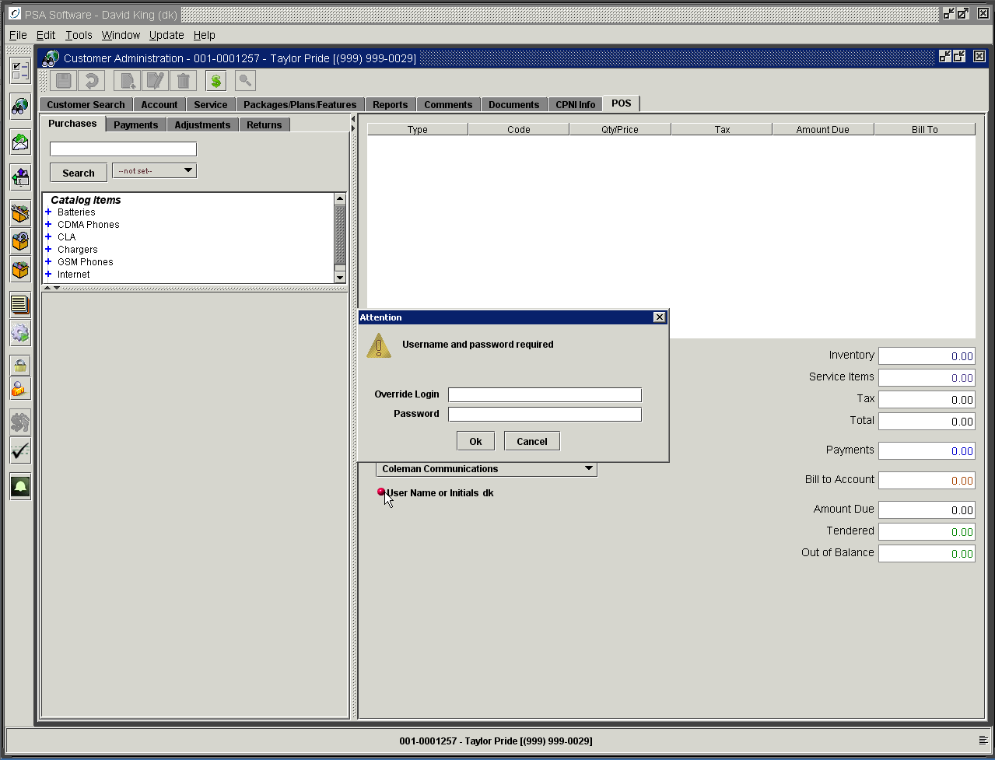

Purchase Amounts Override

When a CSR’s authority is not set to allow price override and they can only choose the price via the dropdown box; an override is available. Anyone with the POS – Allow Override of Purchase Amounts authority will be able to override. After the sign on is complete the field selected will be editable. This authority override is only valid on the single change. (Requires: Allow Override of Purchase Amounts authority)

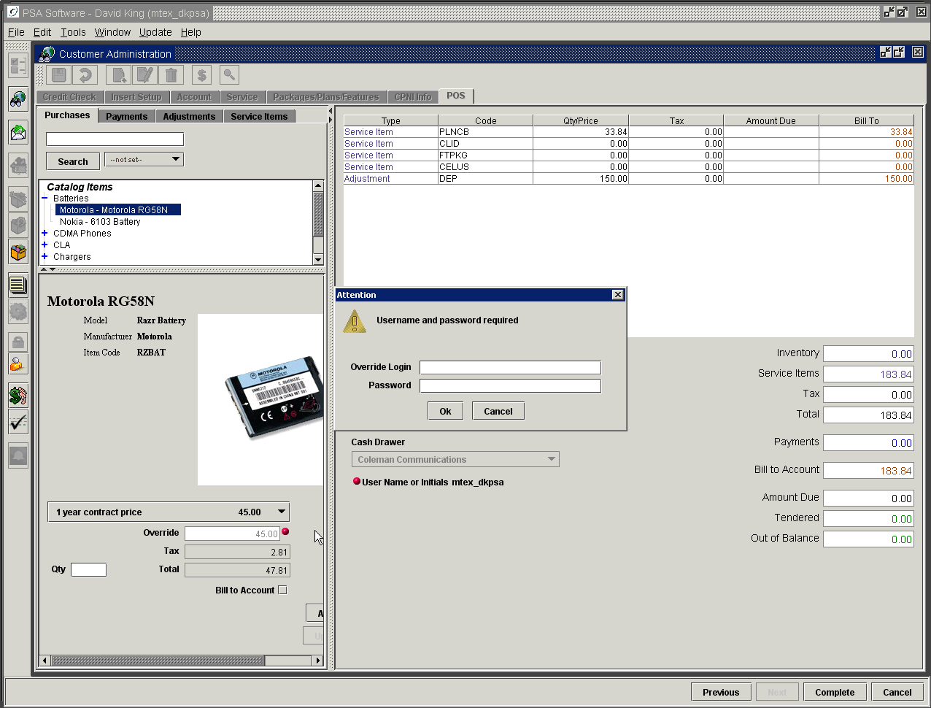

Override to Create Items – Allows creation of an item not in inventory. If an IMEI/ESN/MEID is not found during a ‘New’ Customer or Add a Phone service order, you will be allowed to enter the phone into inventory and enter selling price. Non-serialized items will require you to enter a quantity and a selling price before pressing Add Item to move the item(s) to the invoice. If you are adding a serialized item you will need the serial number to enter or scan. (Requires: POS – Allow Override of Insert Inventory Item). This will only be needed if Inventory selling options are set to either Sell serial items only if item is in Inventory, Sell bulk items only if item is in Inventory, Sell serial only if item is in Location Inventory or Sell bulk items only if item is in Location Inventory. If none of the preceding options were set, you will not need this override or authority.

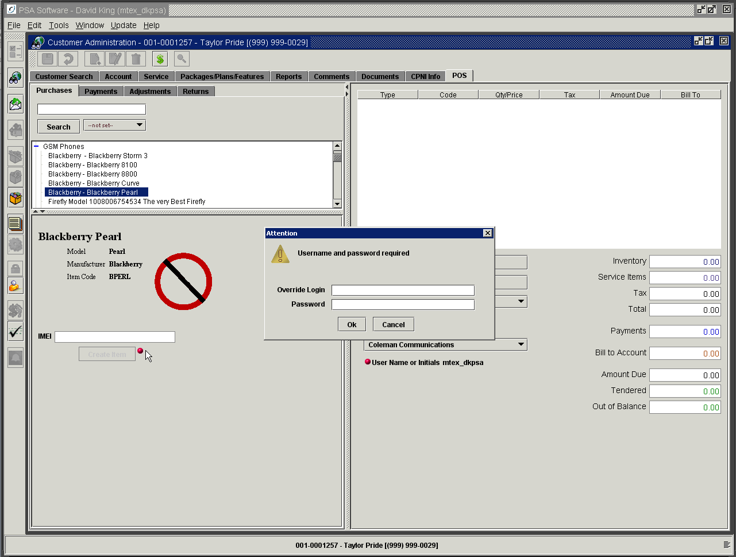

Sign in on the override and the Create Item button will become active. Enter or scan the serial number into the field and press Create Item. Now enter the price and press Add Item to move the equipment to the invoice.

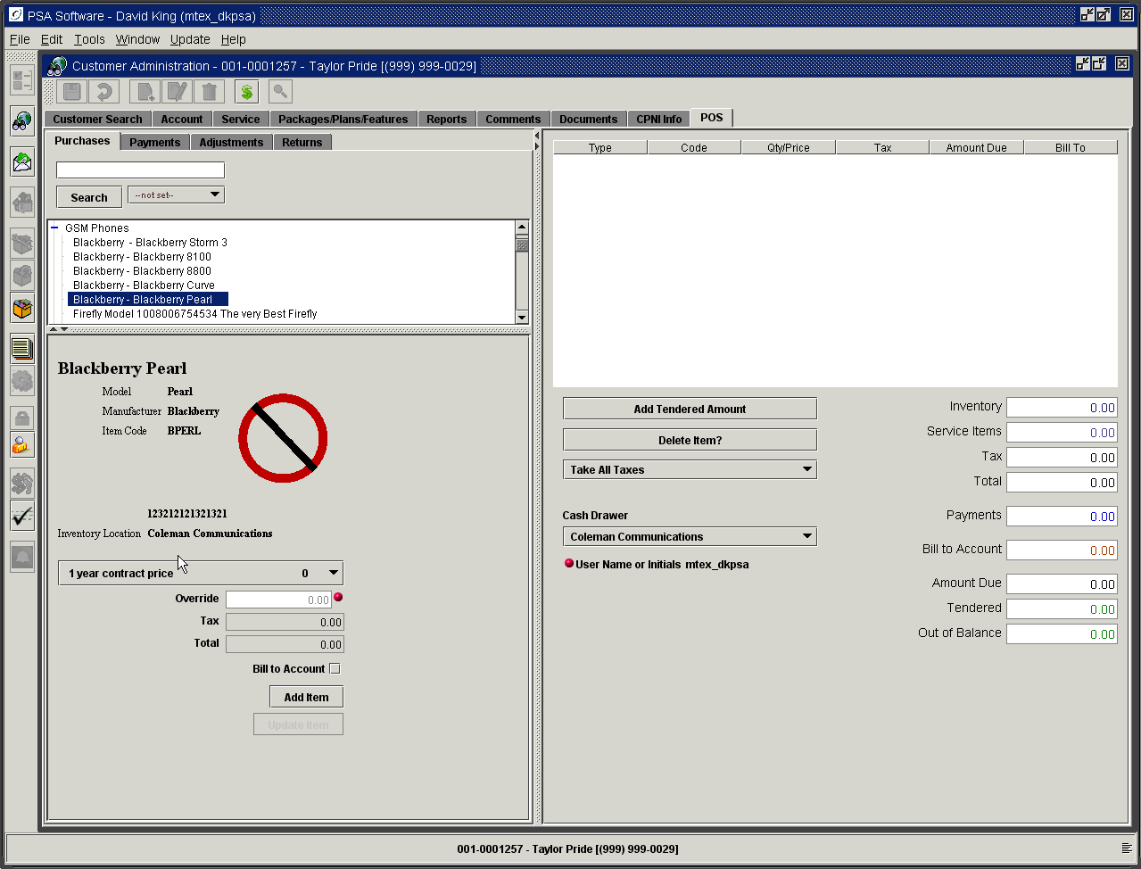

Override Adjustment Amounts – changes the amount field to be editable for the single transaction. (Requires: POS – Allow Override of Adjustment Amounts)

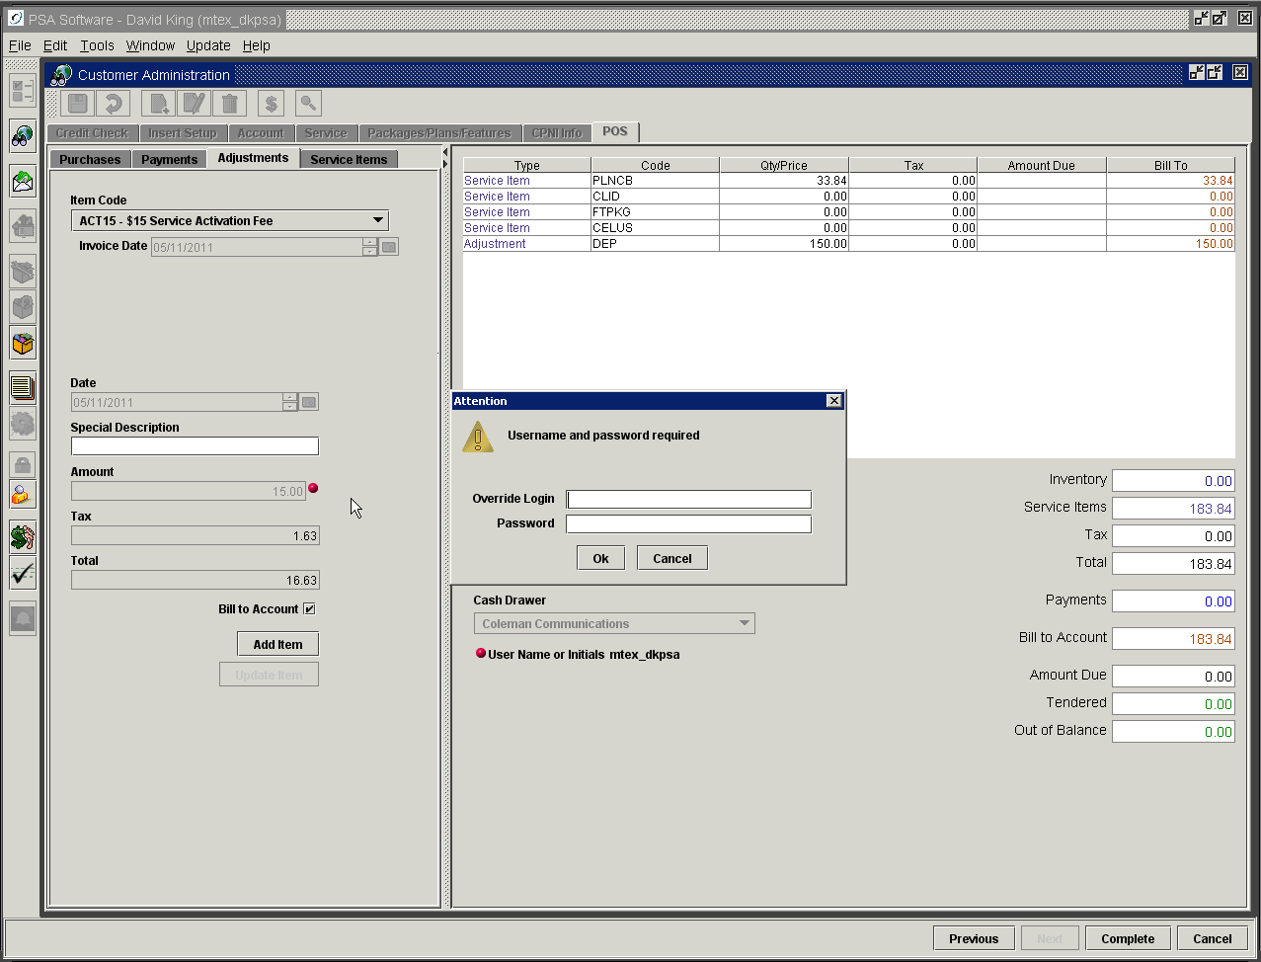

POS Return Overrides

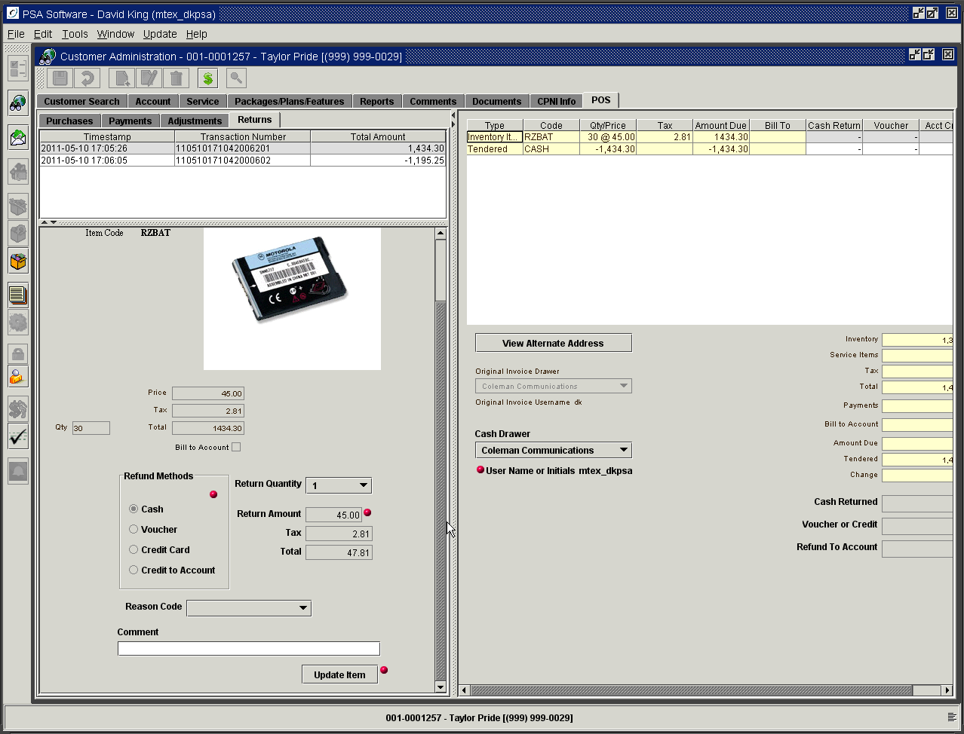

Override Return Methods – allows the return type of the refund to be changed from defaulted type. (Requires: POS – Allow Override of Return Methods)
Override Return Amounts – allows the amount of the return to be changed from the original selling price. (Requires: POS – Allow Override of Return Amounts)
Override of Return of Non Cleared Check – allows the return to continue even though the length of time for check clearing has not been met. (Requires: POS – Allow Override of Return of Non-cleared Check)
Override of Return Cash to Exceed Max Amount – If the ‘Amount that can be paid from drawer at one time’ field (see next screen) has an entry and the return method is to return by cash more than that amount, you will have an opportunity to override the return amount. (Requires: POS – Override return cash to exceed max amount)

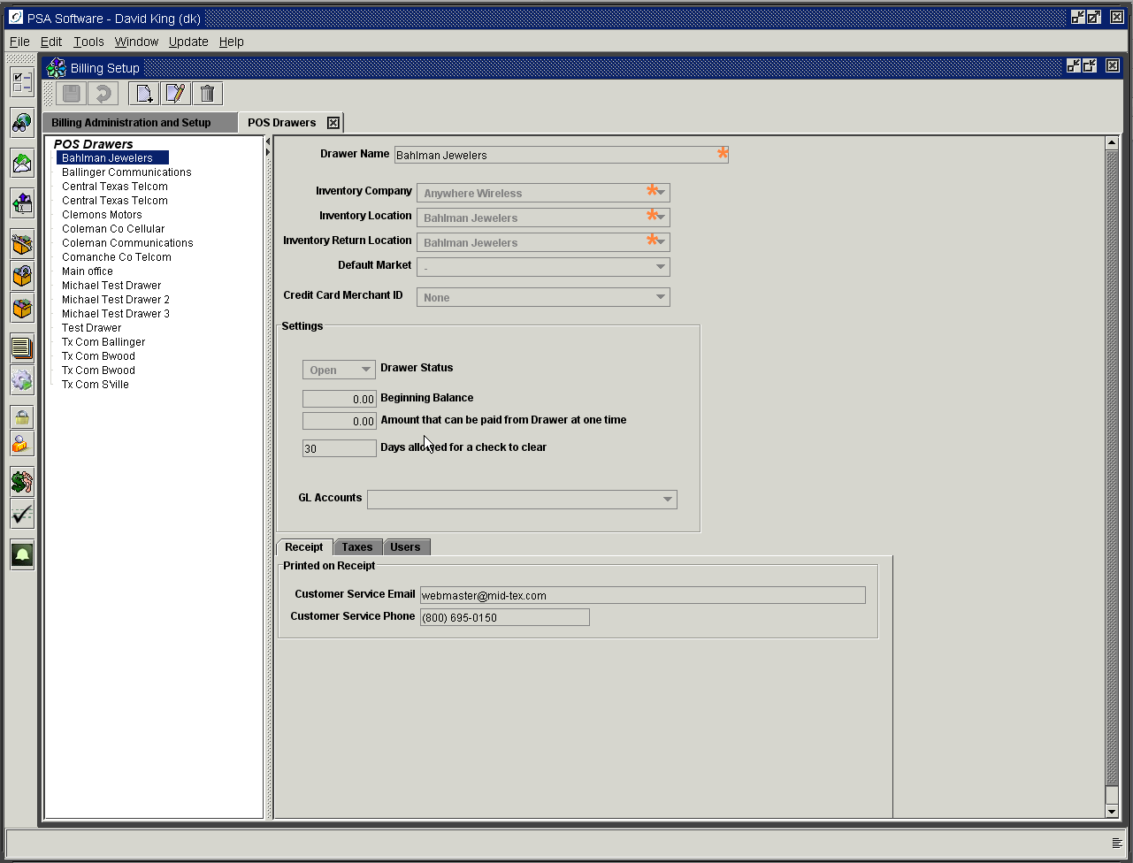

Service Order Overrides

Service Order – Bypass Credit Check - if the credit does not meet the scoring standards set by your company but there are extenuating circumstances; the standards can be overridden with the correct authority. (Requires: Service Order – Override Credit Level)

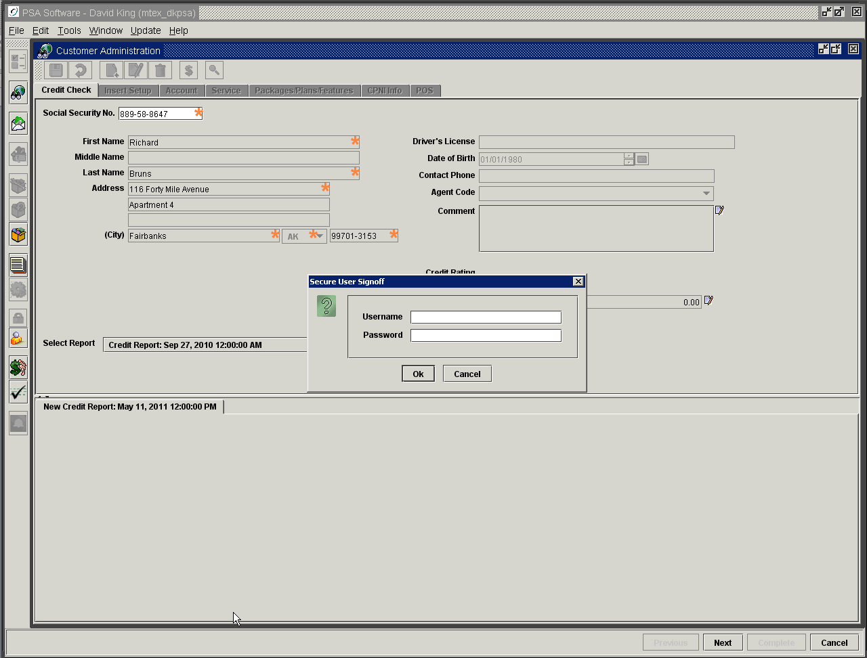

Override Credit Rate - allows changing the Credit Rating field.

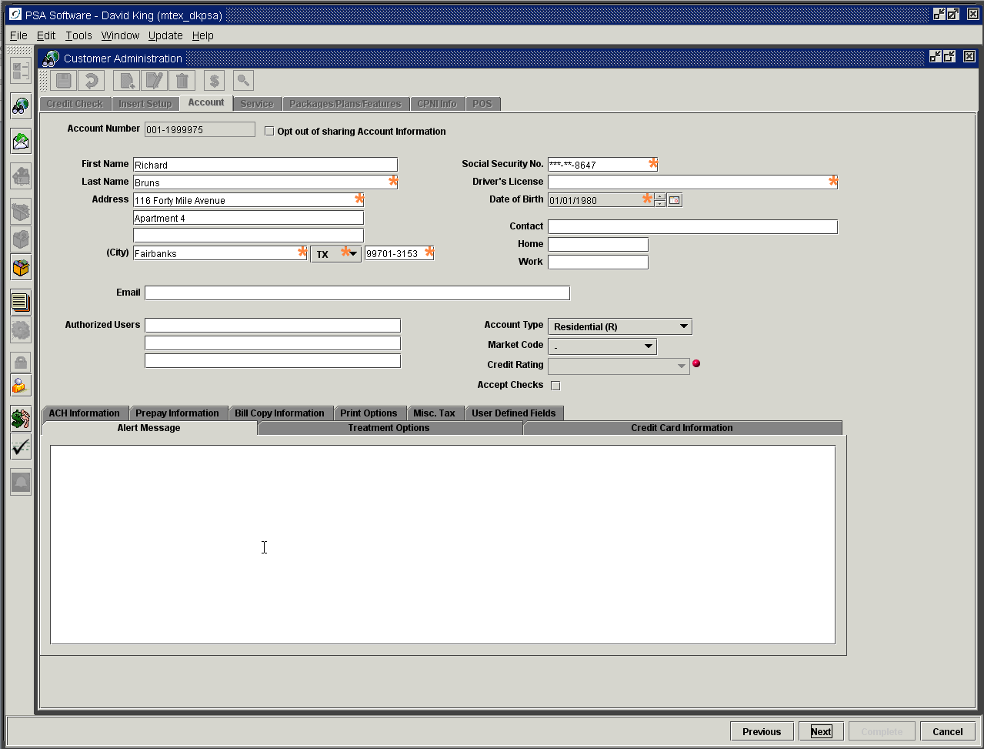

Override Service Screen Edit – allows editing of the Service screen on disconnected phones to refund security deposits. (Requires: Service Order – Service Edit)

Override Service Item Rate – allows the rate on packages, plans, or features to be changed from default value. (
Requires: Service Order – Items - Override Rate)

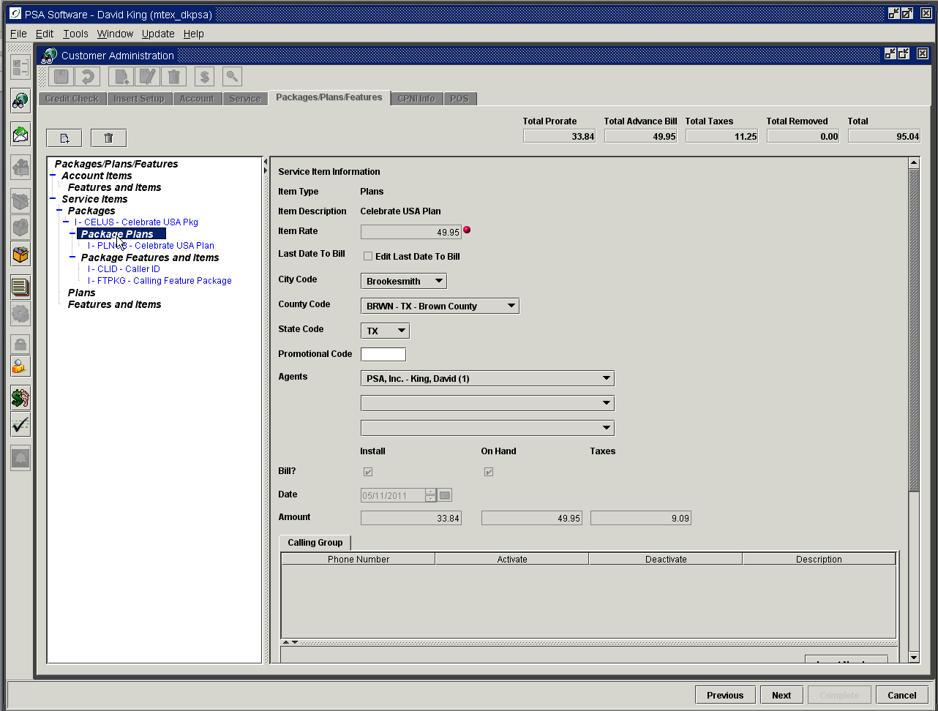

Ticket System Overrides

The ticket system allows all users with the Tickets module to create tickets. However once the ticket is created/saved those fields cannot be changed unless (1) the user has the authorities listed or (2) a supervisor uses the override next to the field.
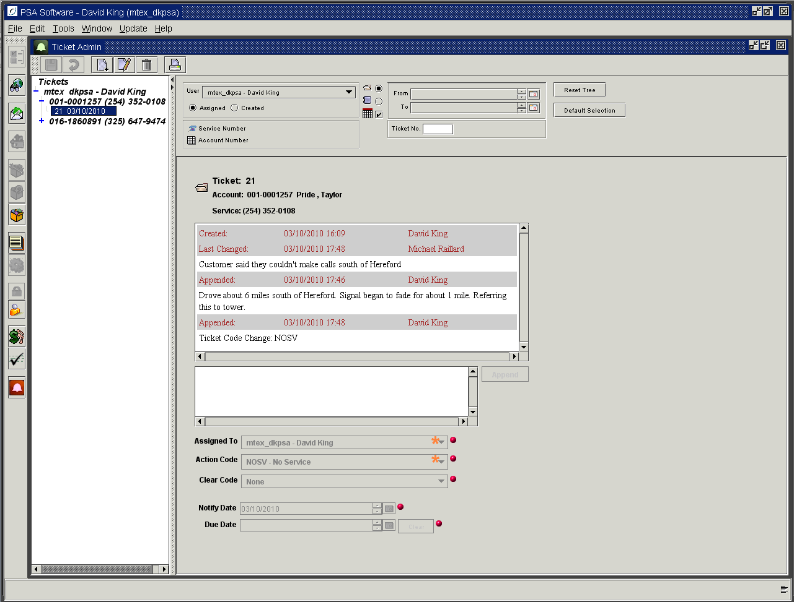

Tickets – Allow Override of Assigned User – allows the Assigned To field to be changed by editing user.
Tickets – Allow Override of Action Code – allows the user to change the action code.
Tickets – Allow Override of Clear Code – allows field to be edited in new creation or during edit.
Tickets – Allow Override of Notify Date – allows editing after creation
Tickets – Allow Override of Due Date – allows editing after creation.

User Information/Password Maintenance

This module allows the user to change his personal information on the system as needed. The only limitation will be that the username is not editable. If the username is no longer acceptable, then the username will need to be deleted in Security Administration and a ‘New’ username created. Usernames are not reusable; they remain in the system even if the user has been deleted. If necessary, PSA can clean up the username list. To make changes to the information press the Edit button in the tool bar.

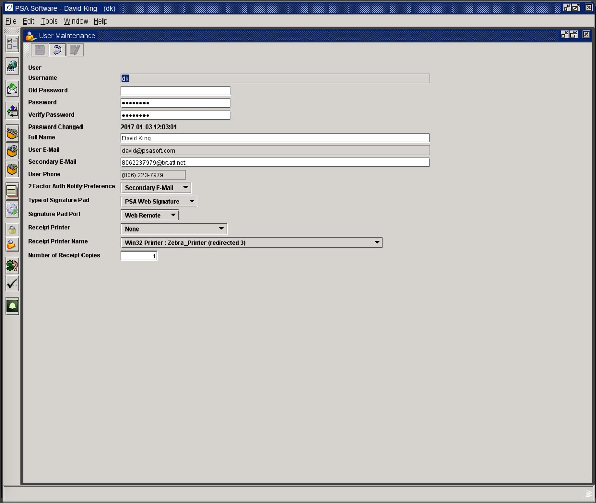

Username: must be unique and must be 6 to 10 alphanumeric characters.
Old Password: This is the current password. For the user to change a password, they must enter their current password and then enter a ‘New’ password twice. If the user cannot remember their old password then the password will need to be reset using the Security Module.
Password: This will be the ‘New’ password after ‘Save’.
Verify Password: Enter the ‘New’ password a second time to verify you typed the ‘New’ password correctly.
Full Name: This is the user name and will be displayed in various areas of the application. Welcome screen would be one example.
User Email: This email address will be the default email address when you request to send reports via email.
Secondary Email: This is an alternate email address for delivery of the PIN code.
User Phone: This number will be used to send the PIN code via SMS. The phone must be 10 digits in the following formats: 8063588928, 806 358 8928 or 806-358-8928. Slashes are invalid 806/358/8928.
2 Factor Authorization Notify Preference: When using 2 Factor Authentication for V3 this will be the method to deliver the authentication PIN code to the user using one of the fields above the dropdown.
- User email is the existing email address; code will be send to this address when required.
- Secondary E-Mail is an alternate email address for delivery of the code
- User Phone will send the code via SMS to the user phone number listed in User Phone. The phone must be 10 digits in the following formats: 8063588928, 806 358 8928 or 806-358-8928. Slashes are invalid 806/358/8928.
Type of Signature Pad:
None: Select none if you don’t have a signature pad attached to the PC and you will not be prompted for signatures.
ePad (Interlink): Select this option if the PC is using ePad and the Windows Remote Terminal to connect to the application.
SignatureGem (Topaz): Select this option for the Topaz pad and the Desktop application is installed directly on the the PC and not Window Remote Desktop.
Signature Pad Port: Select the correct connection port for the signature pad. Most pads are now USB.
Receipt Printer:
None: No receipt printer is attached to the PC.
Auto Print Invoice: This skips the receipt printer and automatically prints the invoice on 8 ½ X 11 printer.
Pertech: This is a generic PCL format, and will work with most receipt printers. PSA will let you know which format your printer uses.
Ithaca: This is a proprietary format, PSA will let you know which format your printer uses
Receipt Printer Name: Select the receipt printer from the dropdown. If it is installed on the PC then it should be in the list.
Number of Receipt Copies: Indicate the number of copies to print per transaction on the selected receipt printer.

Appendix A

List of potential return codes provided by Experian. Some are error codes, some are warnings, and some indicate the account status. PSA only displays the codes and has no explanation other than what is implied. Please contact Experian for more detailed information. This list is not exhaustive.

IO error please resubmit
Input SSN recorded as deceased
Bankruptcy reported
Write Off
Collections
Dispute
Extended ID required
No record found
Consumer is a minor
Caution Experian security
Input SSN invalid
No association between SSN and name
No credit information available

